1.Create an arraylist of user-defined data type Book. it should have:-

i)Name of the Book ii)Author of the book

iii)year of publication of the book

iV)number of copies sold. sort the array list based on the year of publication.

//code

**package** SBA2;

**import** java.util.ArrayList;

**import** java.util.Collections;

**import** java.util.Comparator;

**class** Pbook{

**private** String name,author;

**private** Integer cpy,year;

**public** Pbook(String name,String author,Integer cpy, Integer year) {

**this**.name=name;

**this**.author=author;

**this**.cpy=cpy;

**this**.year=year;

}

**public** Integer getYear() {

**return** year;

}

@Override

**public** String toString() {

**return** " date="+year+", name="+name+", author="+author+",cpy="+cpy+"\n";

}

}

**public** **class** Q1 {

**public** **static** **void** main(String[] args) {

ArrayList<Pbook> bk=**new** ArrayList<Pbook>();

bk.add(**new** Pbook("wings of fire","APJ ABDUL kALAM",400,2000));

bk.add(**new** Pbook("an i deniel","ashlin",120,1997));

bk.add(**new** Pbook("Tw States","Chethan Bhagat",500,2003));

bk.add(**new** Pbook("The Alchemist","Paulo Coelho",1500,1988));

System.***out***.println(" beforesorting:\n"+bk);

bk.sort((source,target) -> {**return** (source.getYear() -

target.getYear());});

bk.sort(Comparator.*comparingInt*(Pbook::getYear));

System.***out***.println(bk);

}

}

OUTPUT

beforesorting:

[ date=2000, name=wings of fire, author=APJ ABDUL kALAM,cpy=400

, date=1997, name=an i deniel, author=ashlin,cpy=120

, date=2003, name=Tw States, author=Chethan Bhagat,cpy=500

, date=1988, name=The Alchemist, author=Paulo Coelho,cpy=1500

]

[ date=1988, name=The Alchemist, author=Paulo Coelho,cpy=1500

, date=1997, name=an i deniel, author=ashlin,cpy=120

, date=2000, name=wings of fire, author=APJ ABDUL kALAM,cpy=400

, date=2003, name=Tw States, author=Chethan Bhagat,cpy=500

]

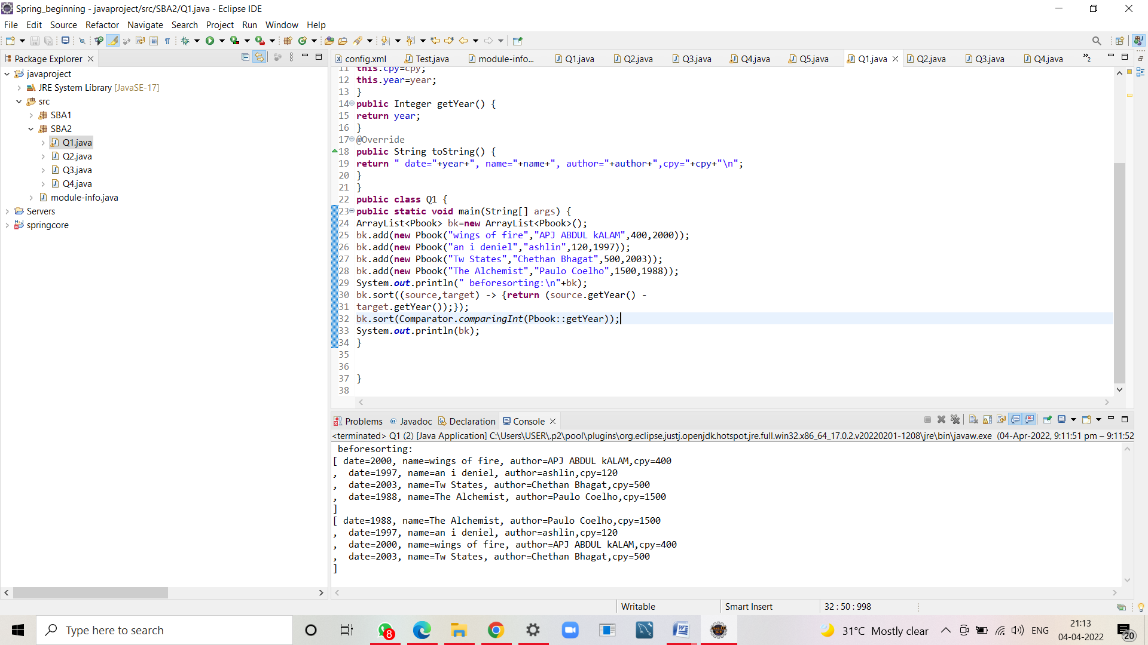

2.Write a program to create, write and read from a file.

//code

**package** SBA2;

**import** java.io.File;

**import** java.io.IOException;

**import** java.io.PrintWriter;

**import** java.io.FileReader;

**import** java.io.*;

**public** **class** Q2 {

**public** **static** **void** main(String[] args) {

**try**

{

File file=**new** File("SBA2_2.txt");

**if**(!file.exists())

{

file.createNewFile();

}

//content for file

PrintWriter pw= **new** PrintWriter(file);

pw.println("'this is the content'");

pw.println("file exists");

pw.close();

System.***out***.println("file created and adding content = Done");

System.***out***.println();

System.***out***.println("****Reading from the file****");

**try**{

FileReader fr = **new** FileReader("SBA2_2.txt"

);

**int** i;

**while** ((i = fr.read()) != -1)

System.***out***.print((**char**)i);

}

**catch** (IOException e) {

e.printStackTrace();

}

}

**catch** (IOException e) {

e.printStackTrace();

}

}

}

//output

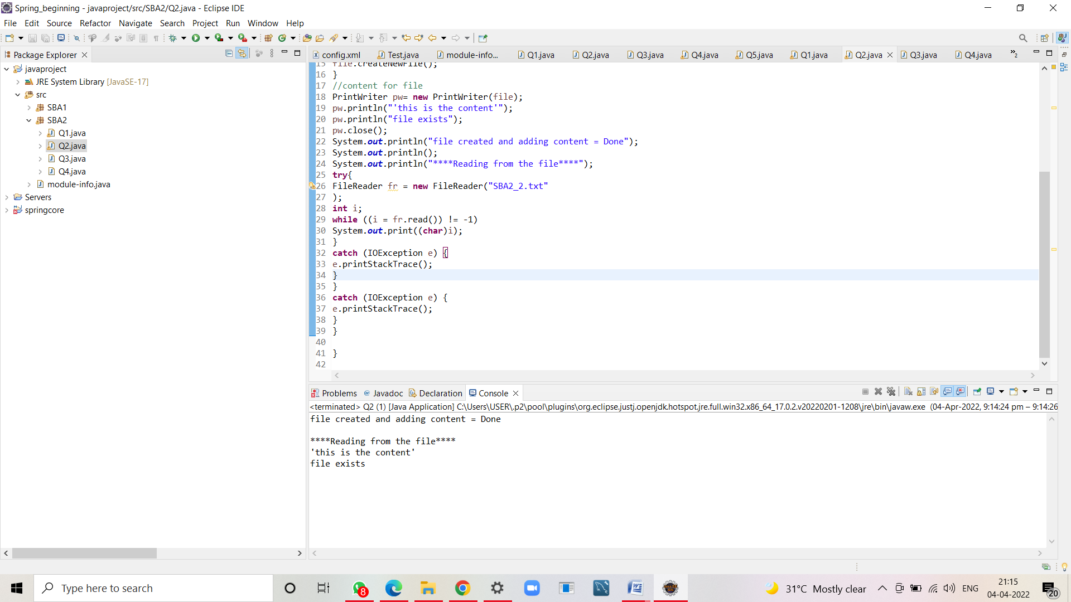

file created and adding content = Done

****Reading from the file****

'this is the content'

file exists

3.Write a program to get the information about the file.

//code

**package** SBA2;

**import** java.io.*;

**public** **class** Q3 {

**public** **static** **void** main(String[] args) {

File f=**new** File("SBA2_2.txt");

**if**(f.exists())

{

System.***out***.println("File Name :"+f.getName());

System.***out***.println("File Path :"+f.getAbsolutePath());

System.***out***.println("File Free Space :"+f.getFreeSpace());

System.***out***.println("File Writable :"+f.canRead());

System.***out***.println("File Readable :"+f.canWrite());

System.***out***.println("File useSpace :"+f.getUsableSpace());

System.***out***.println("File TotalSpace :"+f.getTotalSpace());

}

**else**

{

System.***out***.println("file doesn exists");

}

}

}

//output

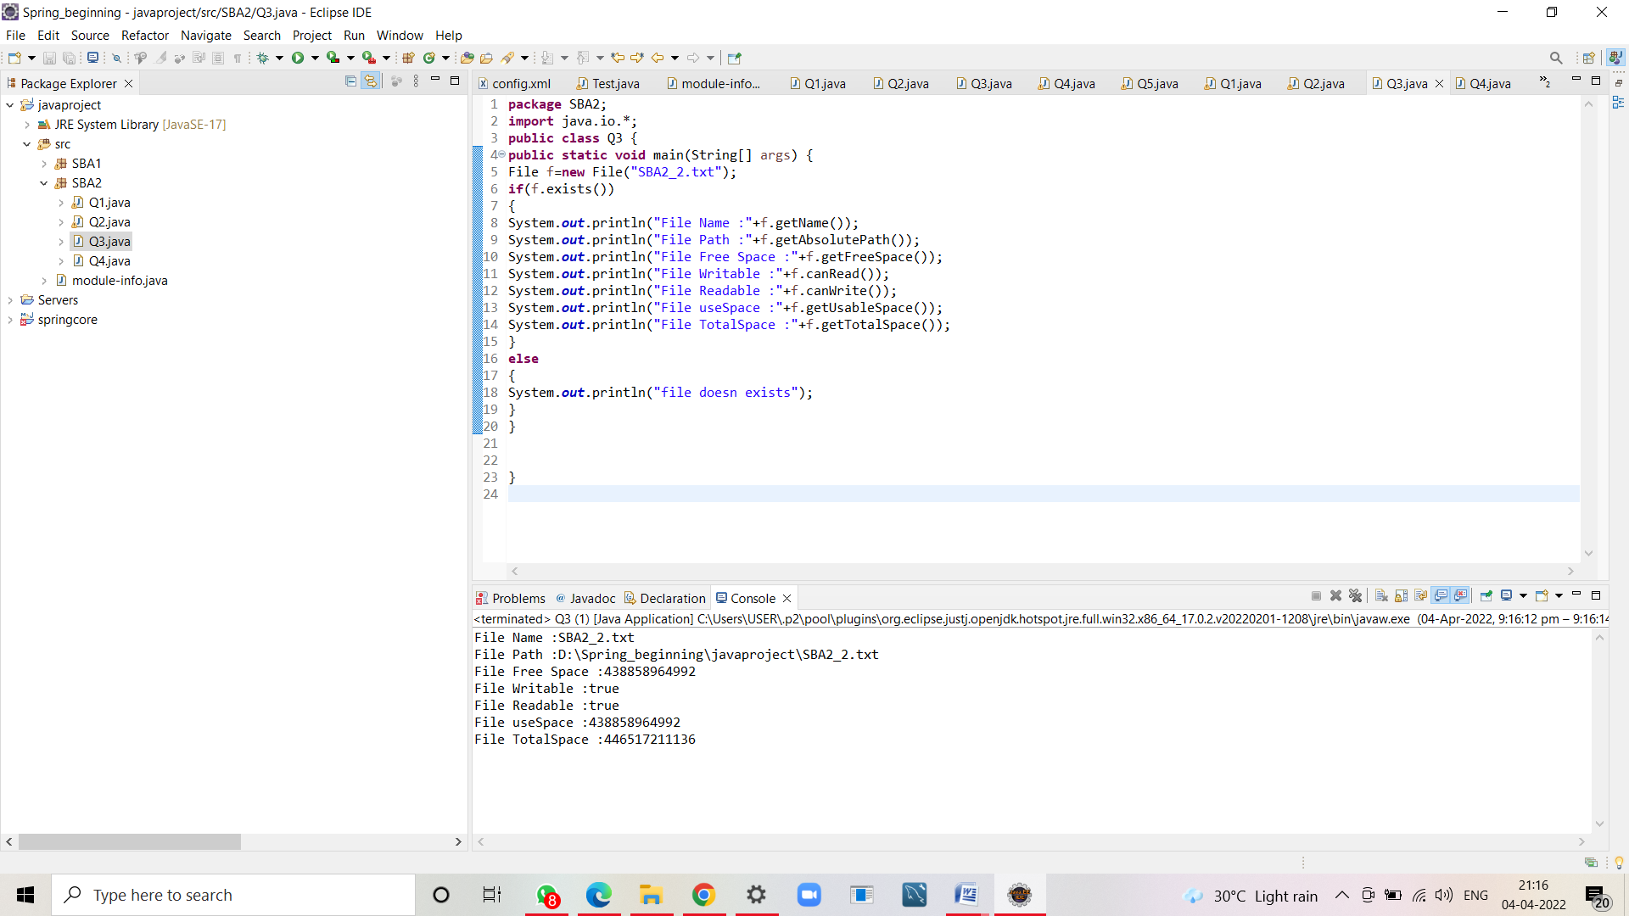

File Name :SBA2_2.txt

File Path :D:\Spring_beginning\javaproject\SBA2_2.txt

File Free Space :438858964992

File Writable :true

File Readable :true

File useSpace :438858964992

File TotalSpace :446517211136

4.Write a program Implement the filereader until the file ending character is “-1” and print all the data of the file.

//code

**package** SBA2;

**import** java.io.*;

**import** java.io.FileReader;

**public** **class** Q4 {

**public** **static** **void** main(String[] args) **throws** IOException

{

**try** {

FileReader file=**new** FileReader("SBA2_2.txt");

**int** data=file.read();

**while**(data!=-1) {

System.***out***.print((**char**)data);

data=file.read();

}

file.close();

}

**catch** (FileNotFoundException e)

{

e.printStackTrace();

}

}

}

//output

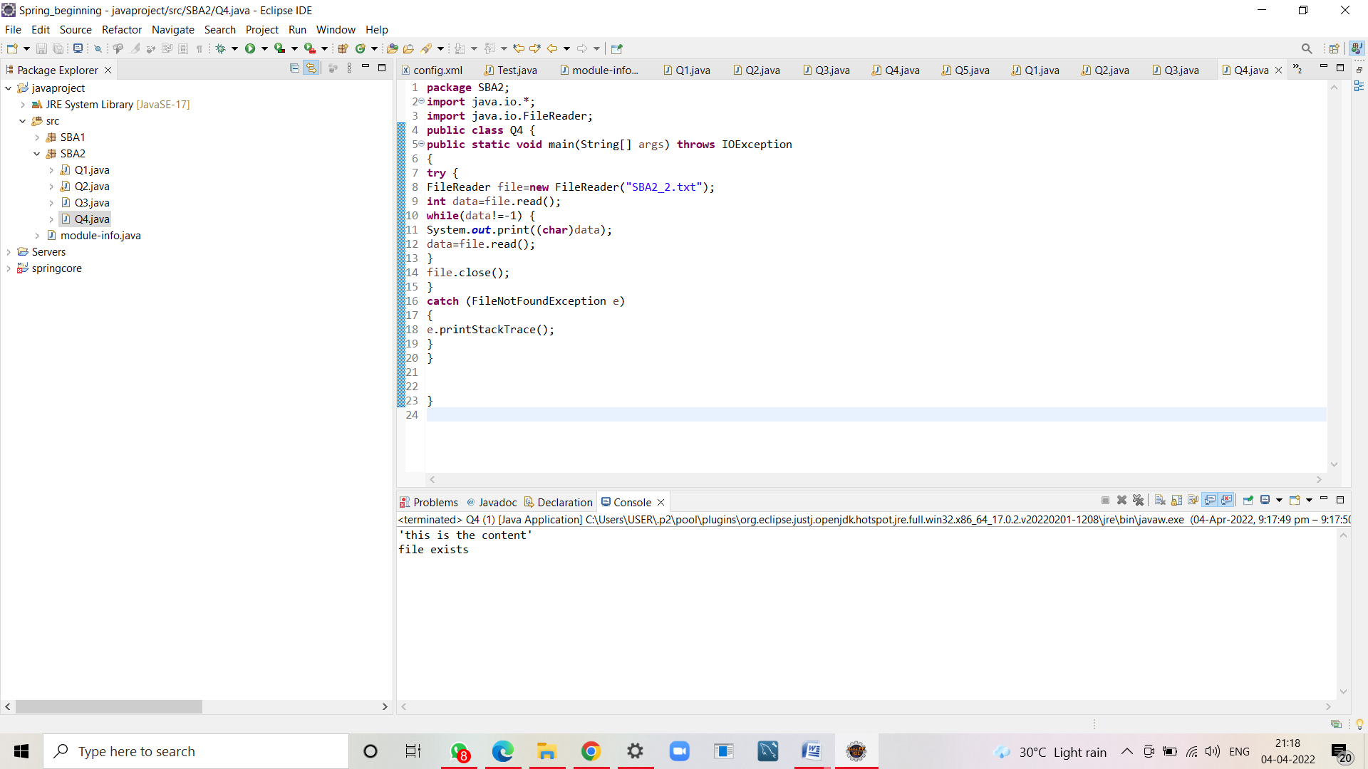

'this is the content'

file exists