QUESTION 1

Implement an ArrayDequeue and all of its methods such as add(), addFirst(), addLast(), element(), poll(), push(), remove.

**package** SBA3;

**import** java.util.ArrayDeque;

**public** **class** Q1 {

**public** **static** **void** main(String[] args) {

ArrayDeque<String> animals = **new** ArrayDeque<>();

// Using add()

animals.add("Dog");

// Using addFirst()

animals.addFirst("Cat");

// Using addLast()

animals.addLast("Horse");

System.***out***.println("ArrayDeque: " + animals);

// Using poll()

String element = animals.poll();

System.***out***.println("Removed Element: " + element);

System.***out***.println("New ArrayDeque: " + animals);

// Using pollFirst()

String firstElement = animals.pollFirst();

System.***out***.println("Removed First Element: " + firstElement);

// Using pollLast()

String lastElement = animals.pollLast();

System.***out***.println("Removed Last Element: " + lastElement);

// using push()

animals.push("Rabbit");

animals.push("cow");

animals.push("goat");

System.***out***.println("After push method ArrayDeque: " + animals);

// using element()--returns element present in the head

System.***out***.println("Head element by element() method: " +

animals.element());

// Using remove()

String element1 = animals.remove();

System.***out***.println("Removed Element: " + element1);

System.***out***.println("New ArrayDeque: " + animals);

// Using removeFirst()

String firstElement1 = animals.removeFirst();

System.***out***.println("Removed First Element: " + firstElement1);

// Using removeLast()

String lastElement1 = animals.removeLast();

System.***out***.println("Removed Last Element: " + lastElement1);

}

}

OUTPUT

ArrayDeque: [Cat, Dog, Horse]

Removed Element: Cat

New ArrayDeque: [Dog, Horse]

Removed First Element: Dog

Removed Last Element: Horse

After push method ArrayDeque: [goat, cow, Rabbit]

Head element by element() method: goat

Removed Element: goat

New ArrayDeque: [cow, Rabbit]

Removed First Element: cow

Removed Last Element: Rabbit

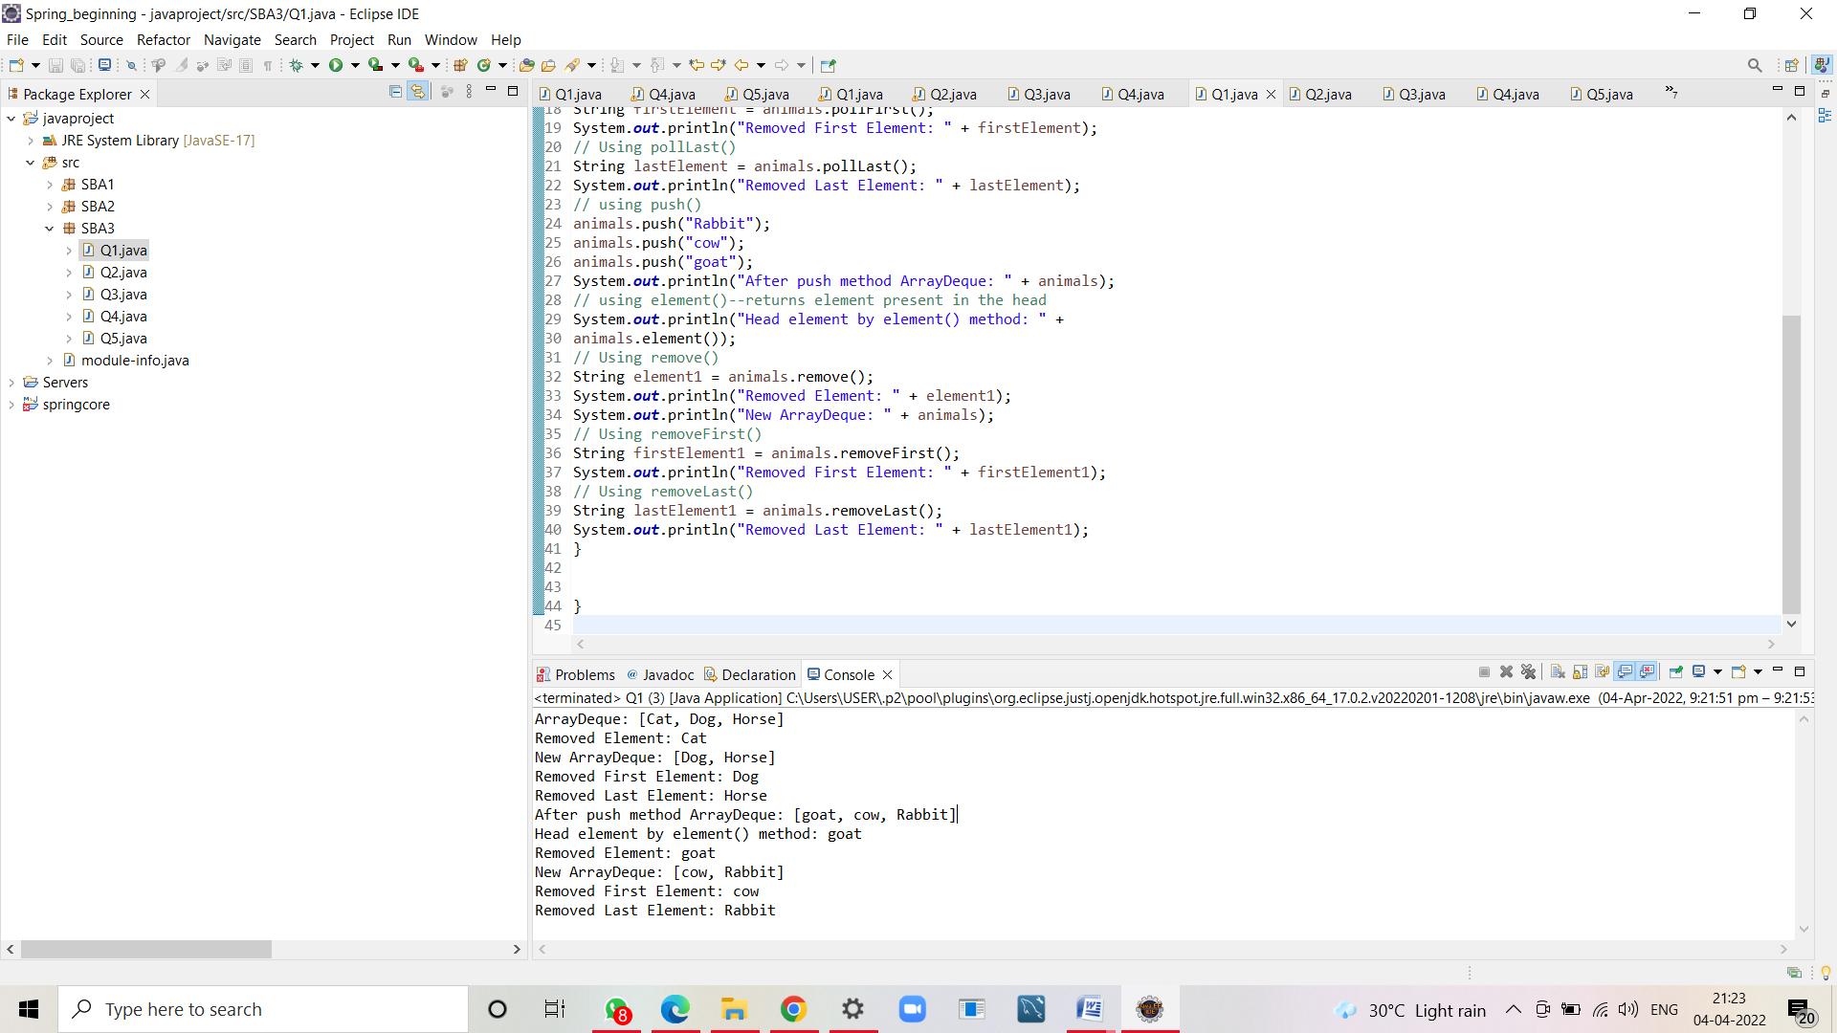

QUESTION 2

Implement a PriorityQueue and use all the methods.

**package** SBA3;

**import** java.util.Iterator;

**import** java.util.PriorityQueue;

**public** **class** Q2 {

**public** **static** **void** main(String[] args) {

// Creating empty priority queue

PriorityQueue<Integer> pQueue = **new** PriorityQueue<Integer>();

// Adding items to the pQueue using add()

pQueue.add(10);

pQueue.add(12);

pQueue.add(20);

pQueue.add(100);

pQueue.add(155);

System.***out***.println("the priority queue: " + pQueue);

// Creating an iterator

Iterator <Integer>value =pQueue.iterator();

// Displaying the values after iterating through the queue

System.***out***.println("The iterator values are: ");

**while** (value.hasNext()) {

System.***out***.println(value.next());

}

// Check for "4" in the queue

System.***out***.println("Does the Queue contains 12? "+pQueue.contains(12));

// Inserting using offer()

pQueue.offer(1000);

pQueue.offer(2000);

// Displaying th final Queue

System.***out***.println("Priority queue after Insertion: " +pQueue );

// Printing the top element of PriorityQueue

System.***out***.println("top element of PriorityQueue: " + pQueue.peek());

// Printing the top element and removing it

// from the PriorityQueue container

System.***out***.println("top element and removing from the PriorityQueue container: " + pQueue.poll());

// Printing the top element again

System.***out***.println("new top element: " + pQueue.peek());

// using the method

pQueue.remove(12);

System.***out***.println("After Remove - " + pQueue);

//to find size

System.***out***.println("the size of queue: "+pQueue.size());

//element()

System.***out***.println("The head of the element"+pQueue.element());

// Creating an iterator

//clear()

pQueue.clear();

System.***out***.println("after clear method the pqueue is: "+pQueue);

}

}

OUTPUT

100

155

Does the Queue contains 12? true

Priority queue after Insertion: [10, 12, 20, 100, 155, 1000, 2000]

top element of PriorityQueue: 10

top element and removing from the PriorityQueue container: 10

new top element: 12

After Remove - [20, 100, 1000, 2000, 155]

the size of queue: 5

The head of the element20

after clear method the pqueue is: []

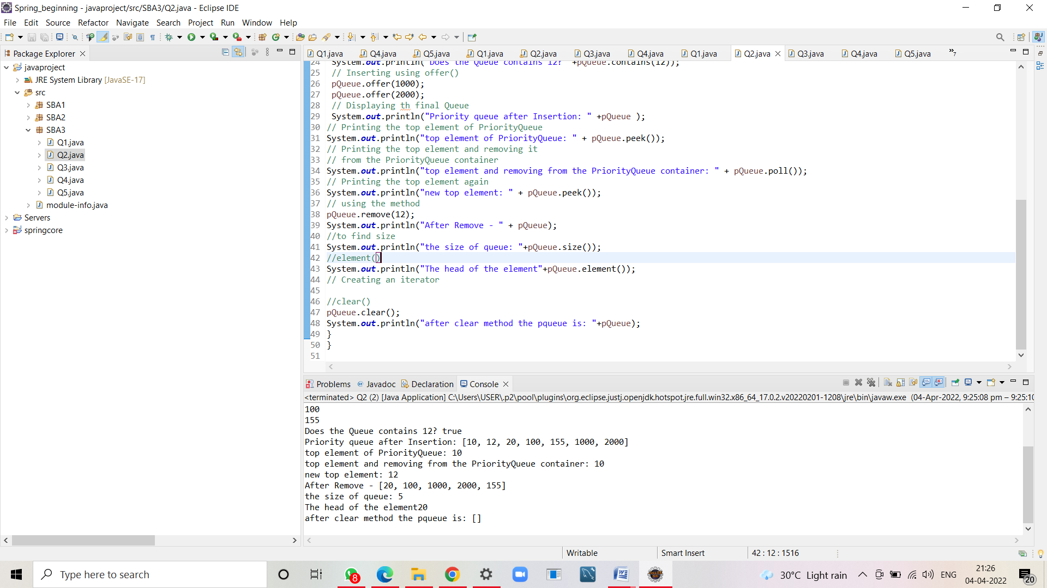

QUESTION 3

Implement a Stack and all of its methods peek(), push(), pop(), and to determine the size of

the stack.

**package** SBA3;

**import** java.util.Stack;

**public** **class** Q3 {

**public** **static** **void** main(String[] args) {

// Creating an empty Stack

Stack<Integer> stk = **new** Stack<Integer>();

// Use add() method to add elements

stk.push(10);

stk.push(15);

stk.push(30);

stk.push(20);

stk.push(5);

// Displaying the Stack

System.***out***.println("Initial Stack: " + stk);

// Removing elements using pop() method

System.***out***.println("Popped element: "

+ stk.pop());

System.***out***.println("Popped element: "

+ stk.pop());

// Displaying the Stack after pop operation

System.***out***.println("Stack after pop operation "

+ stk);

// Fetching the element at the head of the Stack

System.***out***.println("The element at the top of the"

+ " stack is: " + stk.peek());

// Displaying the Stack after the Operation

System.***out***.println("Final Stack: " + stk);

// Displaying the size of stack

System.***out***.println("The size is: " + stk.size());

}

}

OUTPUT

Initial Stack: [10, 15, 30, 20, 5]

Popped element: 5

Popped element: 20

Stack after pop operation [10, 15, 30]

The element at the top of the stack is: 30

Final Stack: [10, 15, 30]

The size is: 3

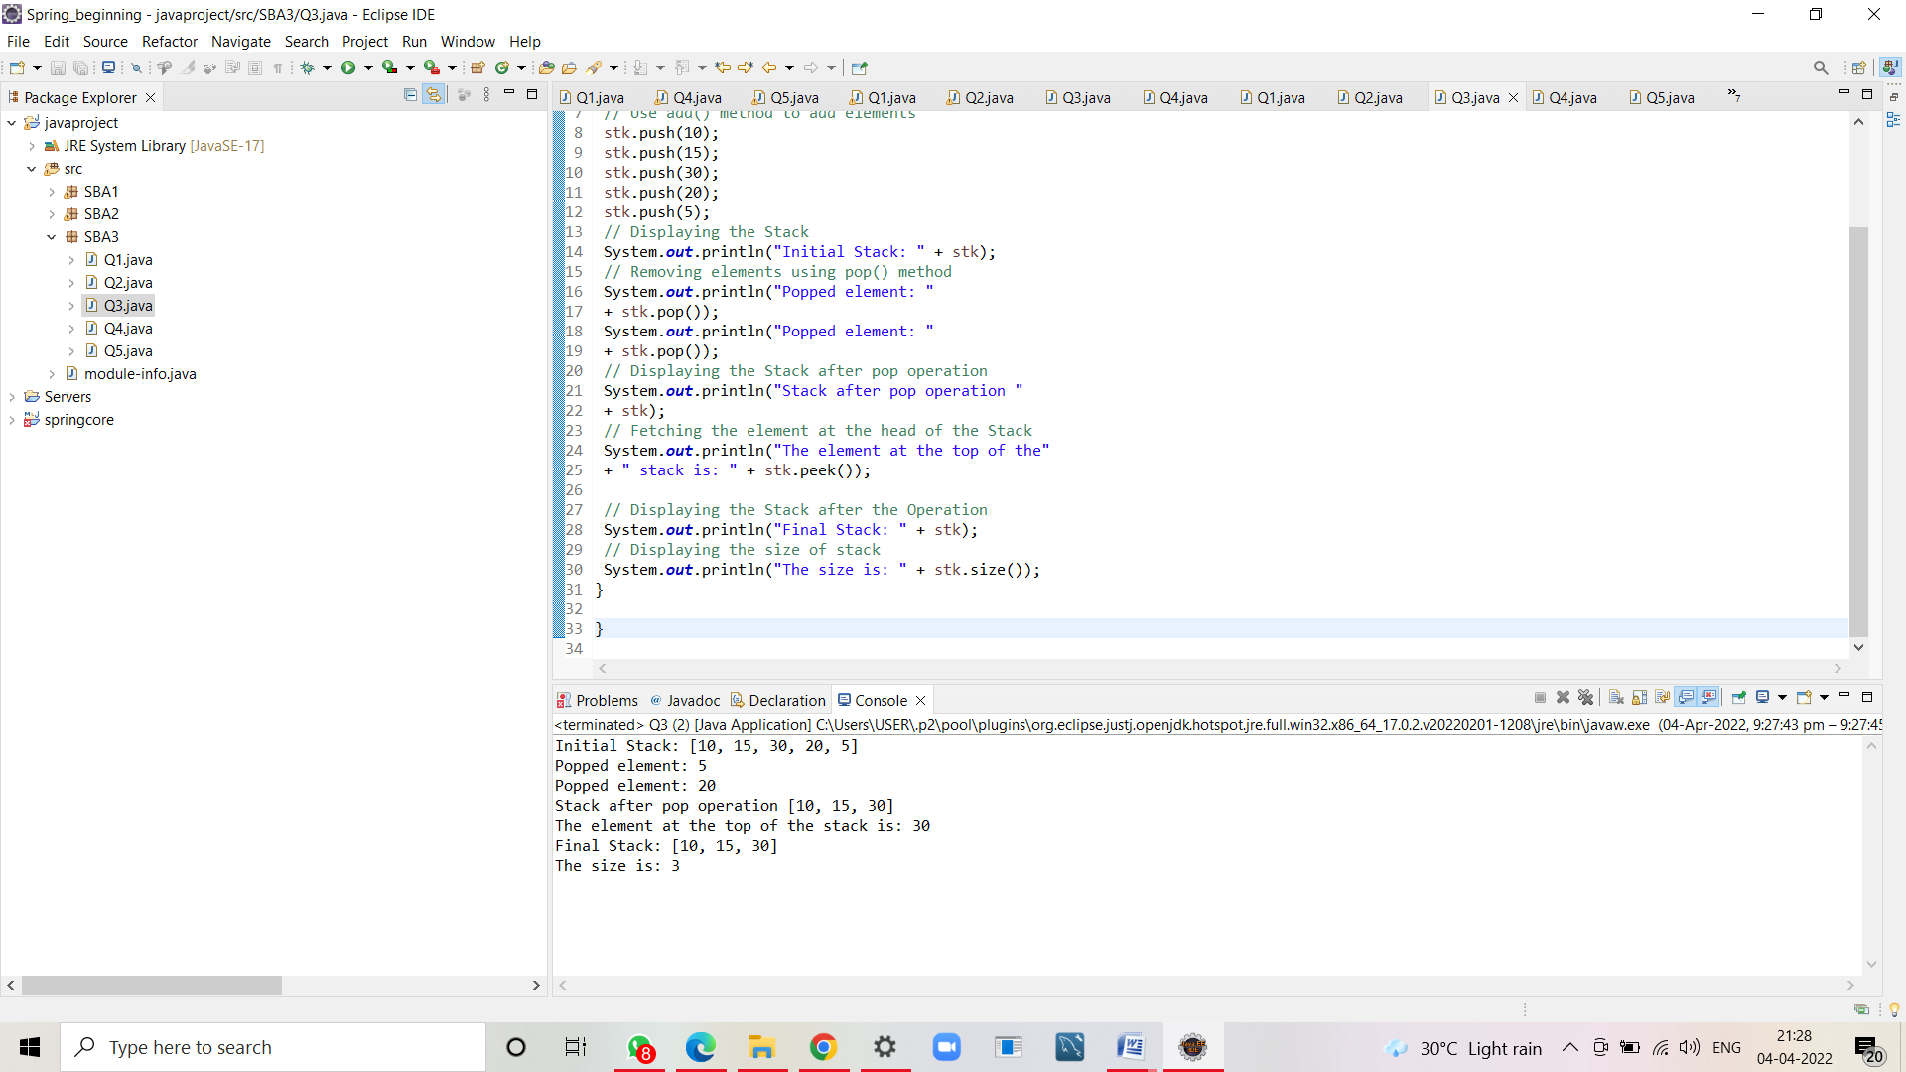

QUESTION 4

Write a program to implement insertion sort.

**package** SBA3;

**public** **class** Q4 {

**public** **static** **void** main(String[] args) {

**int** a[]= {25,55,2,90,45};

**int** temp,j;

**for**(**int** i=1;i<a.length;i++)

{

temp=a[i];

j=i;

**while**(j>0 && a[j-1]>temp)

{

a[j]=a[j-1];

j=j-1;

}

a[j]=temp;

**for** (**int** k=0; k<a.length; ++k)

{

System.***out***.print(a[k]+" ");

}

System.***out***.println();

}

**for**(**int** i=0;i<a.length;i++)

{

System.***out***.print(a[i]+ " ");

}

}

}

OUTPUT

25 55 2 90 45

2 25 55 90 45

2 25 55 90 45

2 25 45 55 90

2 25 45 55 90

