1.Write a program to create a arraylist of double element and add the elements. sort the elements in descending order and print it.

//code

**package** SBA1;

**import** java.util.*;

**import** java.util.Collections;

**public** **class** Q1 {

**public** **static** **void** main(String[] args) {

ArrayList<Double>list =**new** ArrayList<Double>();

list.add(36.50);

list.add(19.10);

list.add(58.88);

System.***out***.println("before sorting:");

**for**(**double** newlist:list)

{

System.***out***.println(newlist);

}

Collections.*sort*(list,Collections.*reverseOrder*());

System.***out***.println("AFTER SORTING:");

**for**(**double** newlist:list)

{

System.***out***.println(newlist);

}

}

}

Output

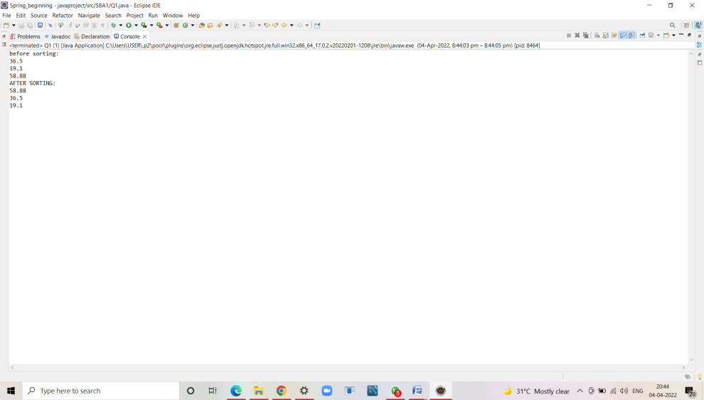

2.Create a arraylist of integers and find the sum and average of the entire list.

//code

**package** SBA1;

**import** java.util.*;

**public** **class** Q2 {

**public** **static** **void** main(String[] args) {

List < Integer > list = **new** ArrayList < Integer > ();

list.add(10);

list.add(90);

list.add(30);

list.add(40);

list.add(70);

list.add(100);

list.add(60);

System.***out***.println("Elements in List : " + list);

Integer a[] = **new** Integer[list.size()];

list.toArray(a);

System.***out***.print("Elements in List : ");

**for** (Integer obj : a) {

System.***out***.print(obj + " ");

}

**int** sum = *sumOfArray*(a, a.length - 1);

System.***out***.println();

// Print the sum returned above

System.***out***.println("Sum of elements : " + sum);

**int** avg;

avg=sum/2;

System.***out***.println("Average:"+ avg);

}

**public** **static** **int** sumOfArray(Integer[] a, **int** n) {

**if** (n == 0)

**return** a[n];

**else**

**return** a[n]+*sumOfArray*(a, n - 1);

}

}

//output

Elements in List : [10, 90, 30, 40, 70, 100, 60]

Elements in List : 10 90 30 40 70 100 60

Sum of elements : 400

Average:200

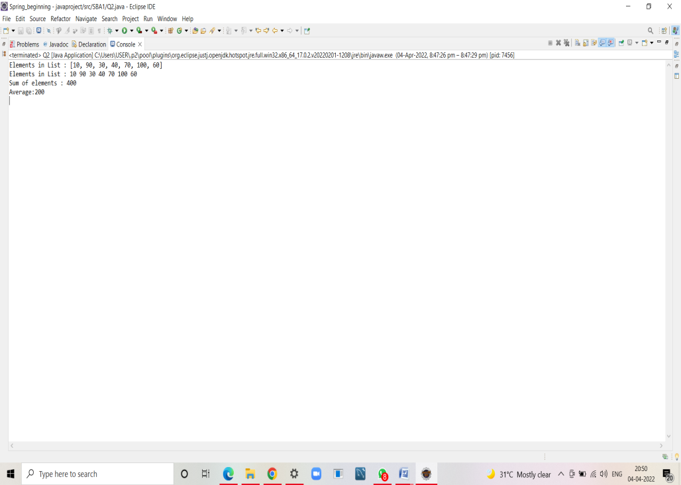

3.Create two arraylist of strings to take First_name and Last_name of the students, and print their whole name.

//code

**package** SBA1;

**import** java.util.*;

**public** **class** Q3 {

**public** **static** **void** main(String[] args) {

List<String> firstName = **new** ArrayList<String>();

List<String> lastName = **new** ArrayList<String>();

String string1 = "ANUPRIYA";

firstName.add(string1);

String string2 = "PRADEEP";

firstName.add(string2);

// /////inserting last name

String string3 = "ROCKY";

lastName.add(string3);

String string4 = "ROBIN";

lastName.add(string4);

Iterator<String> iterator = firstName.iterator();

Iterator<String> iterator1 = lastName.iterator();

List<String> name = **new** ArrayList<String>();

**while** (iterator.hasNext()&& iterator1.hasNext() )

{

name.add(iterator.next()+" "+iterator1.next());

}

Iterator<String> iterator11 = name.iterator();

**while**(iterator11.hasNext())

System.***out***.println(iterator11.next());

}

}

//output

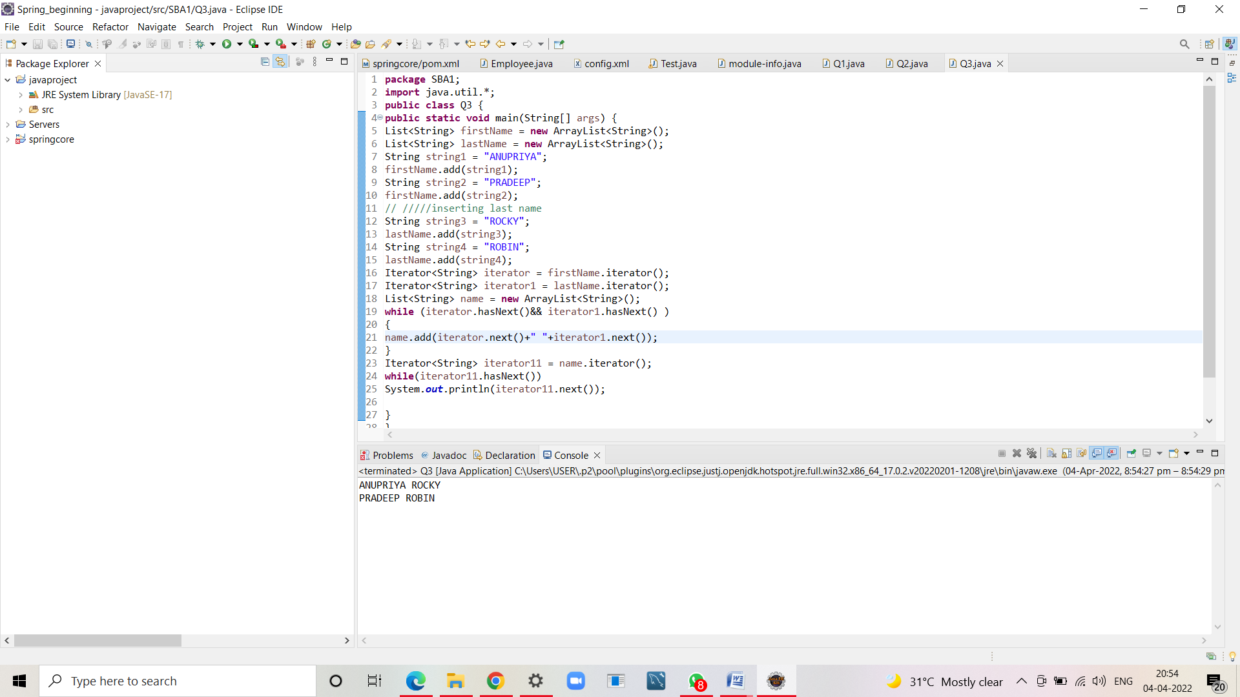

ANUPRIYA ROCKY

PRADEEP ROBIN

4.Write a program to check for the occurrence of a particular character in a string and display how many times it has occurred. note: take the String and the character to be checked as a input from the user.

//code

**package** SBA1;

**import** java.util.*;

**public** **class** Q4 {

**public** **static** **void** main(String[] args) {

Scanner sc=**new** Scanner(System.***in***);

String s1;

**int** count =0;

System.***out***.println(" Enter the string");

s1=sc.nextLine();

//s1=s1.replace(" ","");

System.***out***.println("Enter the element to be searched with count");

**char** c = sc.next().charAt(0);

**for**(**int** i=0;i<s1.length();i++)

{

**if**(s1.charAt(i)==c)

count++;

}

System.***out***.println(" "+c+" appears "+count+" times");

}

}

OUTPUT

Enter the string

anu

Enter the element to be searched with count

an

a appears 1 times

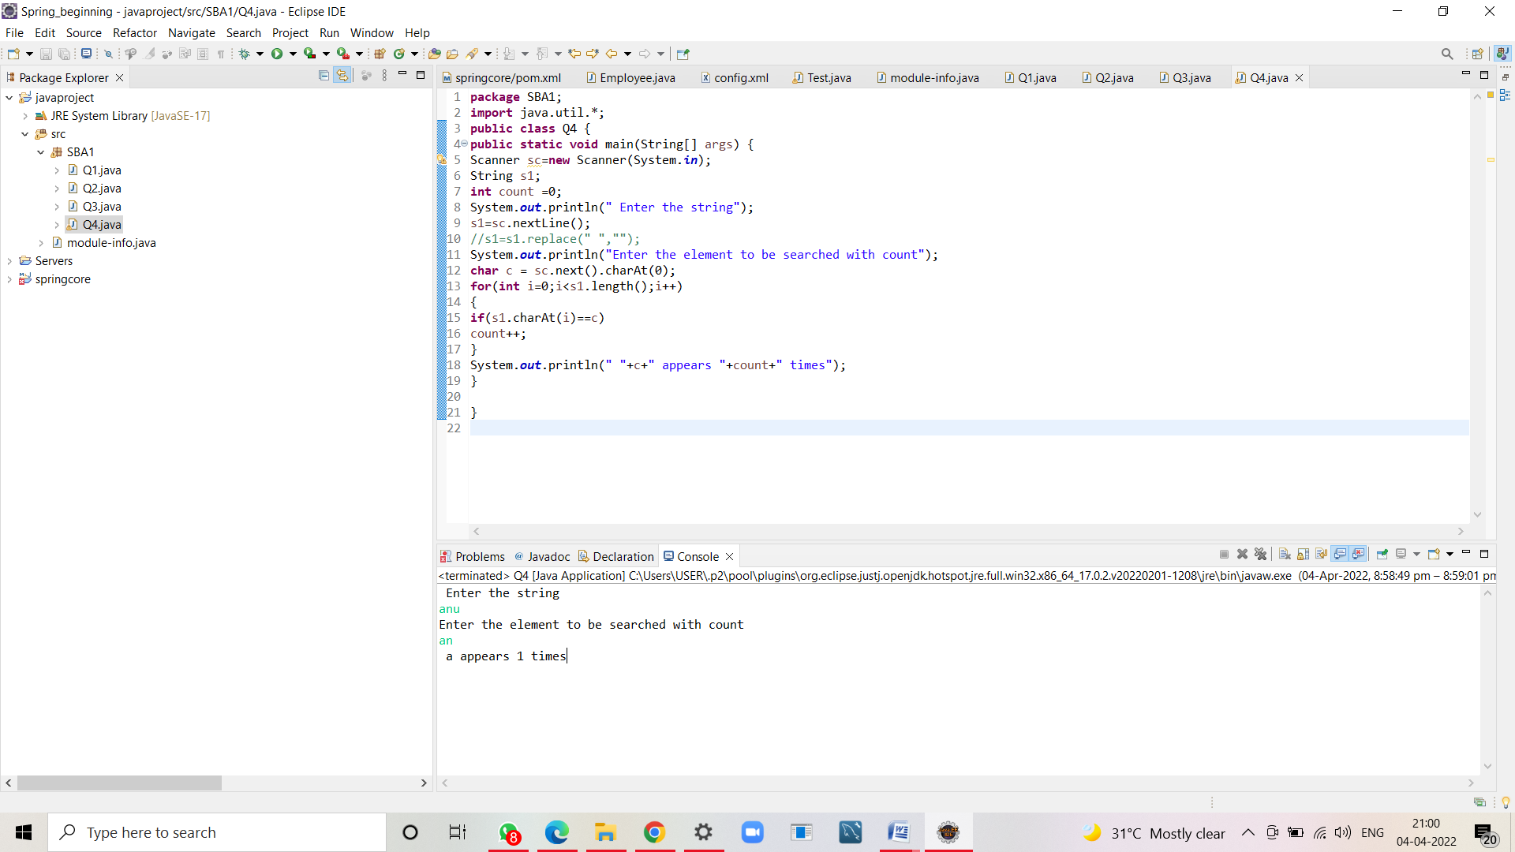

5.Write a program to take an input of a string with multiple words and convert it into a string array, and check if every element of that array is a Palindrome. Note: Palindrome is a word which when reversed also is the same.

//code

**package** SBA1;

**import** java.util.Scanner;

**public** **class** Q5 {

**public** **static** **boolean** checkpalindrome(String str)

{

**int** len =str.length();

**for**(**int** i=0;i<len/2;i++) {

**if**(str.charAt(i)!=str.charAt(len-i-1))

**return** **false**;

}

**return** **true**;

}

**public** **static** **void** main(String[] args) {

Scanner sc=**new** Scanner(System.***in***);

System.***out***.println("enter the sentence");

String str=sc.nextLine();

String[] arr=str.split(" ");

**int** n=arr.length;

**for**(**int** i=0;i<n;i++)

**if**(Q5.*checkpalindrome*(arr[i])) {

System.***out***.println(arr[i]+" is palindrome");

}

**else**

System.***out***.println(arr[i]+" is not a palindrome");

}

}

//output

enter the sentence

im anu

im is not a palindrome

anu is not a palindrome

