1.Write a program to take an integer array from the user and give the user a choice to sort using bubble sort (or) selection sort.

//Sort the array elements according to the selected algorithm of the user and display the sorted array.

**package** SBA4;

**import** java.util.Scanner;

**public** **class** Q1 {

**void** bubbleSort(**int** arr[])

{

System.***out***.println("bubble sorting started");

**int** n = arr.length;

**for** (**int** i=0;i<n-1;i++)

**for** (**int** j=0;j<n-i-1;j++) {

**if** (arr[j] > arr[j+1]) {

**int** temp = arr[j];

arr[j] = arr[j+1];

arr[j+1] = temp;

}

}

}

**void** bubbleprint(**int** arr[]) {

System.***out***.println("bubble Sorted array :");

**int** n = arr.length;

**for** (**int** i=0; i<n; ++i) {

System.***out***.print(arr[i] + " ");

}

}

**void** selectionsort(**int** arr[]) {

System.***out***.println("selection sorting started");

**int** n =arr.length;

**for** (**int** i =0; i<n-1; i++)

{

**int** min_idx=i;

**for** (**int** j=i+1; j<n;j++)

{

**if** (arr[min_idx]>arr[j])

min_idx=j;

}

**int** temp=arr[min_idx];

arr[min_idx]=arr[i];

arr[i]=temp;

}

}

**void** selectionprint(**int** arr[]) {

System.***out***.println("selection Sorted array");

**int** n = arr.length;

**for**(**int** i=0; i<n; ++i)

System.***out***.print(arr[i]+" ");

}

**public** **static** **void** main(String[] args) {

Scanner sc=**new** Scanner(System.***in***);

System.***out***.println("enter the number of elements"); **int** n=sc.nextInt();

**int** [] arr=**new** **int**[n];

System.***out***.println("enter the numbers");

**for**( **int** i=0;i<n;i++) { arr[i]=sc.nextInt();

}

System.***out***.println("enter the mode of sorting :either press '1' for bubble sort or '2' for selection sort");

**int** a=sc.nextInt(); Q1 ob=**new** Q1(); **if**(a==1)

{

ob.bubbleSort(arr);

ob.bubbleprint(arr); }

**else**{

ob.selectionsort(arr);

ob.selectionprint(arr);

}

}

}

//Output

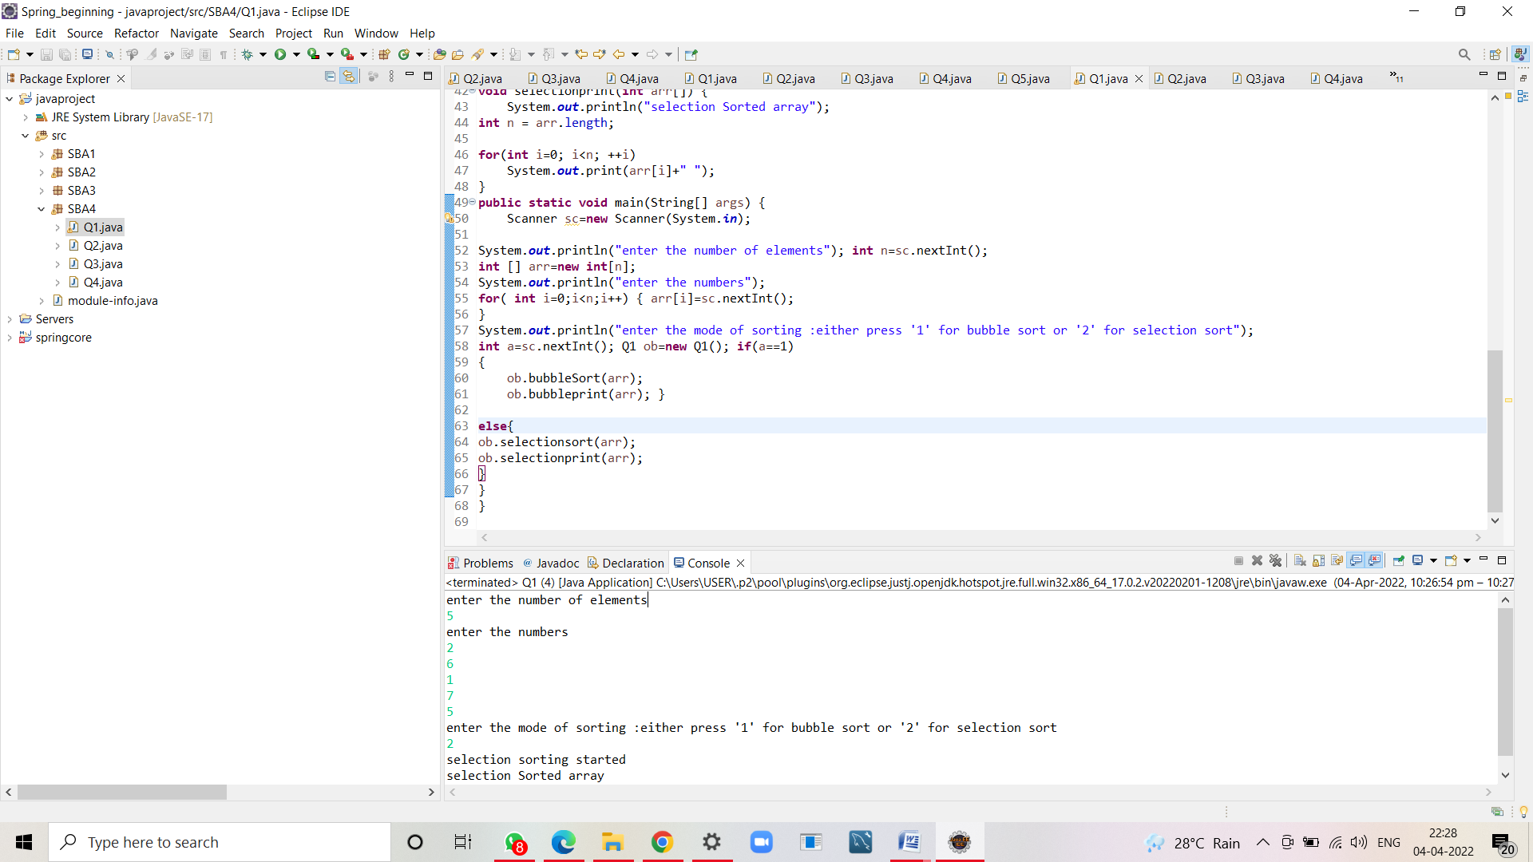

enter the number of elements

5

enter the numbers

2

6

1

7

5

enter the mode of sorting :either press '1' for bubble sort or '2' for selection sort

2

selection sorting started

selection Sorted array

1 2 5 6 7

2. Write a program to implement insertion sort

**package** SBA4;

**public** **class** Q2 {

**public** **static** **void** insertionSort(**int** array[]) { **int** n=array.length;

**for** (**int** j =1; j<n;j++) {

**int** key= array[j];

**int** i=j-1;

**while** ((i>-1)&&(array[i]>key)){

array [i+1] = array [i];

i--; }

array[i+1] = key;

}

}

**public** **static** **void** main(String a[]){

**int**[] arr1 = {2,5,0,12,29,13,62}; System.***out***.println("Before Insertion Sort"); **for**(**int** i:arr1){

System.***out***.print(i+" "); }

System.***out***.println();

*insertionSort*(arr1);//sorting array using insertion sort

System.***out***.println("After Insertion Sort"); **for**(**int** i:arr1){

System.***out***.print(i+" "); }

}

}

//Output

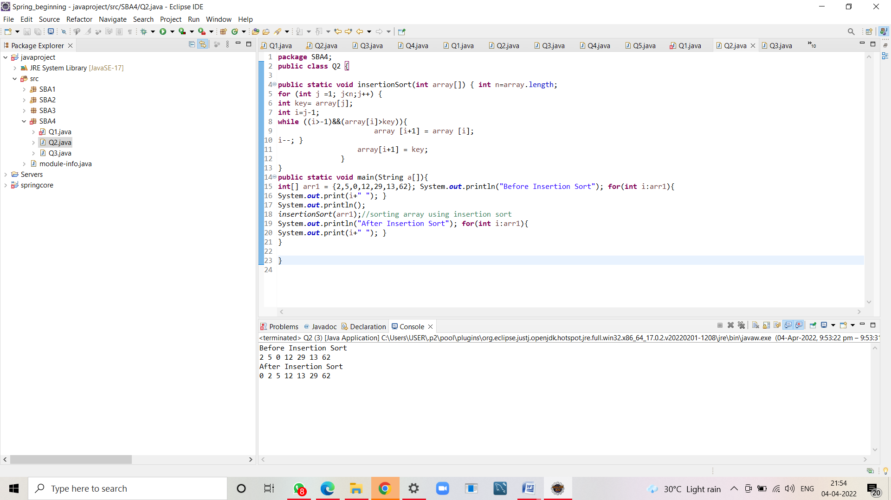

Before Insertion Sort

2 5 0 12 29 13 62

After Insertion Sort

0 2 5 12 13 29 62

3. Write a pgm to implement hash table and add add atleast 4 values into it, implement the putIfAbsent() method.

**package** SBA4;

**import** java.util.Hashtable;

**public** **class** Q3 {

**public** **static** **void** main(String[] args) {

Hashtable<Integer,String> map=**new** Hashtable<Integer,String>();

map.put(100,"Amit");

map.put(102,"Ravi");

map.put(101,"Vijay");

map.put(103,"Rahul"); System.***out***.println("Before remove: "+ map); // Remove value for key 102 map.remove(102);

System.***out***.println("After remove: "+ map);

//checking empty or not

System.***out***.println("map is empty? "+map.isEmpty());

//Here, we specify the if and else statement as arguments of the method System.out.println(map.getOrDefault(101, "Not Found")); System.out.println(map.getOrDefault(105, "Not Found"));

//Inserts, as the specified pair is unique

map.putIfAbsent(102,"Gaurav");

System.***out***.println("Updated Map: "+map);

//Returns the current value, as the specified pair already exist map.putIfAbsent(101,"Dhamu");

System.***out***.println("Updated Map: "+map);

//Replace the value at key 100

map.replace(100,"Kelu");

System.***out***.println("Updated Map: "+map);

//Checking values in map

System.***out***.println("Dhamu in map? "+map.contains("Dhamu"));

System.***out***.println("Kelu in map? "+map.contains("Kelu")); //Checking key in map and getting the value

**if**(map.containsKey(101)==**true**) {

System.***out***.println("Vlaue of key 101 is "+map.get(101)); }

//printing all values in map

System.***out***.println(map.values());

**if**(map.replace(103,"rahul","Raju")==**true**) {

System.***out***.println("Replaced Rahul...");

System.***out***.println("Updated Map: "+map);

}

}

}

//Output

Before remove: {103=Rahul, 102=Ravi, 101=Vijay, 100=Amit}

After remove: {103=Rahul, 102=Ravi, 101=Vijay, 100=Amit}

map is empty? false

Updated Map: {103=Rahul, 102=Ravi, 101=Vijay, 100=Amit}

Updated Map: {103=Rahul, 102=Ravi, 101=Vijay, 100=Amit}

Updated Map: {103=Rahul, 102=Ravi, 101=Vijay, 100=Kelu}

Dhamu in map? false

Kelu in map? true

Vlaue of key 101 is Vijay

[Rahul, Ravi, Vijay, Kelu]

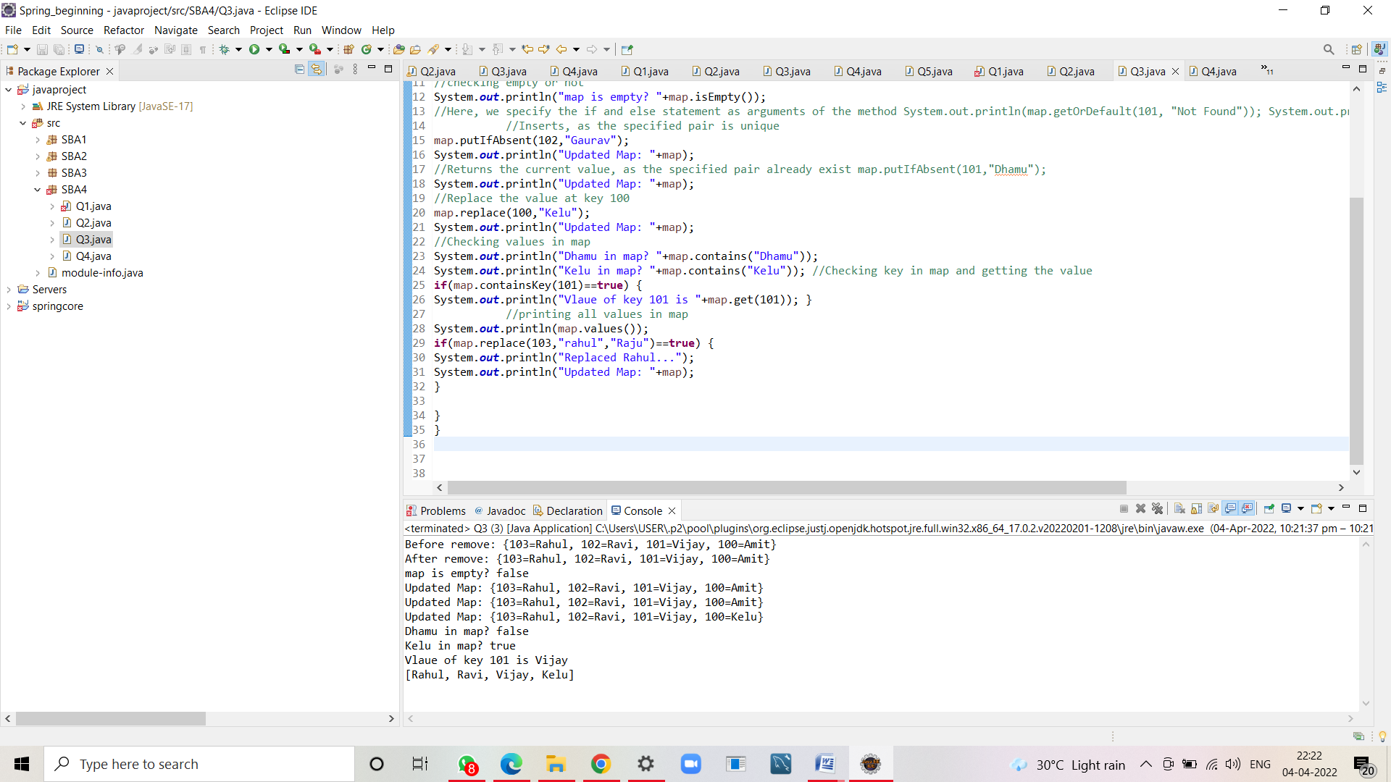

4.Create a class of Books with attributes: a)id

b)name

c)author

d)publisher

e)quantity sold.

Implement a Hashtable to implement the objects of Books type. Print all the details of books by traversing through the Hashtable

**package** SBA4;

**import** java.util.Hashtable;

**import** java.util.Map;

**class** Book {

**int** id;

String name,author,publisher;

**int** quantity;

**public** Book(**int** id, String name, String author, String publisher, **int** quantity) {

**this**.id = id;

**this**.name = name; **this**.author = author; **this**.publisher = publisher; **this**.quantity = quantity;

}

}

**public** **class** Q4 {

**public** **static** **void** main(String[] args) {

//Creating map of Books

Hashtable<Integer,Book> map=**new** Hashtable<Integer,Book>();

//Creating Books

Book b1=**new** Book(101,"Let us C","Yashwant Kanetkar","BPB",8);

Book b2=**new** Book(102,"Data Communications & Networking","Forouzan","Mc Graw Hill",4);

Book b3=**new** Book(103,"Operating System","Galvin","Wiley",6); //Adding Books to map

map.put(1,b1);

map.put(2,b2);

map.put(3,b3);

//Traversing map

**for**(Map.Entry<Integer, Book> z:map.entrySet()) {

//Output

**int** key=z.getKey(); //key=3

Book b=z.getValue(); //b=b3

System.***out***.println(key+" Details:");

System.***out***.println(b.id+" "+b.name+" "+b.author+" "+b.publisher+" "+b.quantity);

}

}

}

//Output

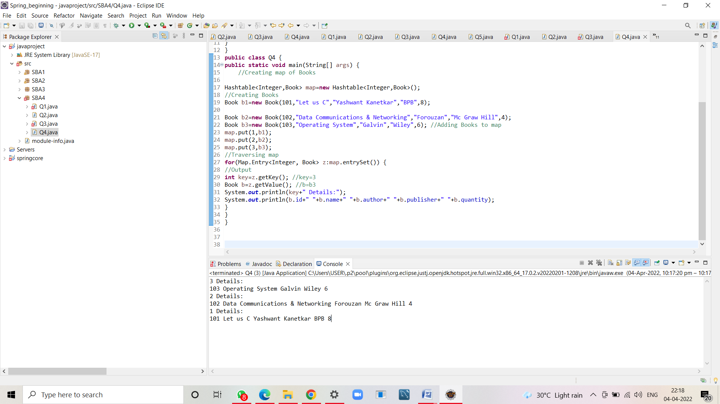

3 Details:

103 Operating System Galvin Wiley 6

2 Details:

102 Data Communications & Networking Forouzan Mc Graw Hill 4

1 Details:

101 Let us C Yashwant Kanetkar BPB 8