**Online Library Management System**

Unit Testing Report

By

Anupriya Palanisamy(309140)

**Unit:**

* LoginPage.rb
* Loginpage.html
* Loginpage.css

**Source Files:** unit_test.feature

**Date:** 11/02/2023

**Engineers:** Anupriya Palanisamy

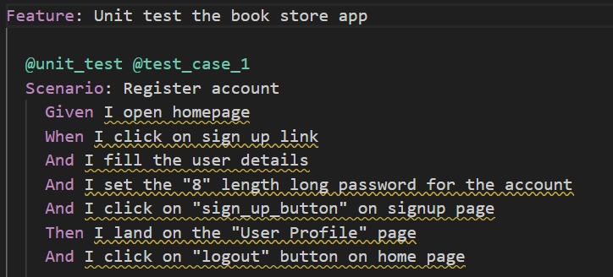

**Test Methodology: Behavior-Driven Development (BDD)**

**Test Cases for the Given Scenario:**

1. **Given I open homepage**
   * Test that the homepage is successfully loaded.
2. **When I click on sign up link**
   * Test that the sign-up link is clickable.
   * Test that clicking on the sign-up link navigates the user to the sign-up page.
3. **And I fill the user details**
   * Test that the user details form is present and fillable.
   * Test that filling the user details correctly does not trigger any errors.
4. **And I set the "8" length long password for the account**
   * Test that the password input field accepts a password of exactly 8 characters.
   * Test that setting a password of less than 8 characters triggers an error.
5. **And I click on "sign_up_button" on signup page**
   * Test that the sign-up button is clickable.
   * Test that clicking the sign-up button processes the form submission.
6. **Then I land on the "User Profile" page**
   * Test that after successful sign-up, the user is redirected to the user profile page.
   * Test that the user profile page displays the correct user information.
7. **And I click on "logout" button on home page**
   * Test that the logout button is clickable.
   * Test that clicking the logout button logs the user out and redirects them to the homepage.

**Unit:**

* LoginPage.rb
* Loginpage.html
* Loginpage.css

**Source Files:** unit_test.feature

**Date:** 11/02/2023

**Engineers:** Anupriya Palanisamy

**Test Methodology: Behavior-Driven Development (BDD)**

**Test Cases for the Given Scenario:**

1. **Given I open homepage**
   * Test that the homepage is successfully loaded.
2. **When I click on "sign_in" button on home page**
   * Test that the sign-in button is clickable.
   * Test that clicking the sign-in button navigates the user to the sign-in page.
3. **And I fill the user details for "existing" customer**
   * Test that the user details form on the sign-in page is present and fillable.
   * Test that filling the correct user details for an existing customer does not trigger any errors.
4. **And I click on "sign_in" button on sign page**
   * Test that the sign-in button on the sign-in page is clickable.
   * Test that clicking the sign-in button processes the form submission.
5. **Then I land on the "User Profile" page**
   * Test that after successful sign-in, the user is redirected to the user profile page.
   * Test that the user profile page displays the correct user information for the logged-in customer.
6. **And I click on "logout" button on home page**
   * Test that the logout button is clickable.
   * Test that clicking the logout button logs the user out and redirects them to the homepage.

**Unit:**

* SignupPage.rb
* Signuppage.html
* Signuppage.css

**Source Files:** unit_test.feature

**Date:** 11/02/2023

**Engineers:** Anupriya Palanisamy

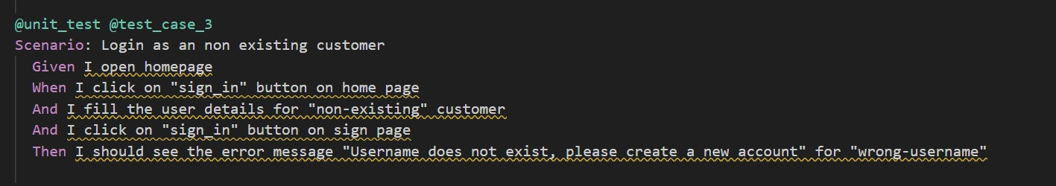

**Test Methodology: Behavior-Driven Development (BDD)**

**Test Cases for the Given Scenario:**

1. **Given I open homepage**
   * Test that the homepage is successfully loaded.
2. **When I click on "sign_in" button on home page**
   * Test that the sign-in button is clickable.
   * Test that clicking the sign-in button navigates the user to the sign-in page.
3. **And I fill the user details for "non-existing" customer**
   * Test that the user details form on the sign-in page is present and fillable.
   * Test that filling incorrect user details for a non-existing customer does not trigger any errors (e.g., incorrect username or password).
4. **And I click on "sign_in" button on sign page**
   * Test that the sign-in button on the sign-in page is clickable.
   * Test that clicking the sign-in button processes the form submission.
5. **Then I should see the error message "Username does not exist, please create a new account" for "wrong-username"**
   * Test that the correct error message is displayed when a non-existing username is entered during sign-in.
   * Test that the error message appears prominently and clearly on the sign-in page.

**Unit:**

* SignupPage.rb
* Signuppage.html
* Signuppage.css

**Source Files:** unit_test.feature

**Date:** 11/02/2023

**Engineers:** Anupriya Palanisamy

**Test Methodology: Behavior-Driven Development (BDD)**

**Test Cases for the Given Scenario:**

1. **Given I open homepage**
   * Test that the homepage is successfully loaded.
2. **When I click on "sign_in" button on home page**
   * Test that the sign-in button is clickable.
   * Test that clicking the sign-in button navigates the user to the sign-in page.
3. **And I fill the user details for "wrong-password" customer**
   * Test that the user details form on the sign-in page is present and fillable.
   * Test that filling incorrect password for an existing customer does not trigger any errors (e.g., incorrect password for the correct username).
4. **And I click on "sign_in" button on sign page**
   * Test that the sign-in button on the sign-in page is clickable.
   * Test that clicking the sign-in button processes the form submission.
5. **Then I should see the error message "Password did not match, please re-try" for "wrong-password"**
   * Test that the correct error message is displayed when an existing customer enters an incorrect password during sign-in.
   * Test that the error message appears prominently and clearly on the sign-in page.

**Unit:**

* HomePage.rb
* Homepage.html
* Homepage.css

**Source Files:** unit_test.feature

**Date:** 11/02/2023

**Engineers:** Anupriya Palanisamy

**Test Methodology: Behavior-Driven Development (BDD)**

Test Cases for the Given Scenario:

1. **Given I open homepage**
   * Test that the homepage is successfully loaded.
2. **When I click on "sign_in" button on home page**
   * Test that the sign-in button is clickable.
   * Test that clicking the sign-in button navigates the user to the sign-in page.
3. **And I fill the user details for "existing" customer**
   * Test that the user details form on the sign-in page is present and fillable.
   * Test that filling correct user details for an existing customer does not trigger any errors.
4. **And I click on "sign_in" button on sign page**
   * Test that the sign-in button on the sign-in page is clickable.
   * Test that clicking the sign-in button processes the form submission.
5. **And I validate if the books are visible**
   * Test that all books are displayed on the homepage after logging in.
   * Validate that the number of displayed books matches the expected number.
6. **And I validate my profile details are displayed**
   * Test that the user's profile details (e.g., name, email, avatar, etc.) are visible after logging in.
   * Validate that the profile details match the expected information of the logged-in user.

**Source Code:**

**Expected Output:**

All the test cases should pass

1. Able to create an account
2. Able to login to the account successfully
3. Verify user information on the home page

**Actual Output:**

1. Able to create an account
2. Able to login to the account successfully
3. Verify user information on the home page

