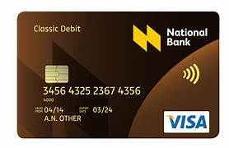

DEBIT CARD BANK NAME

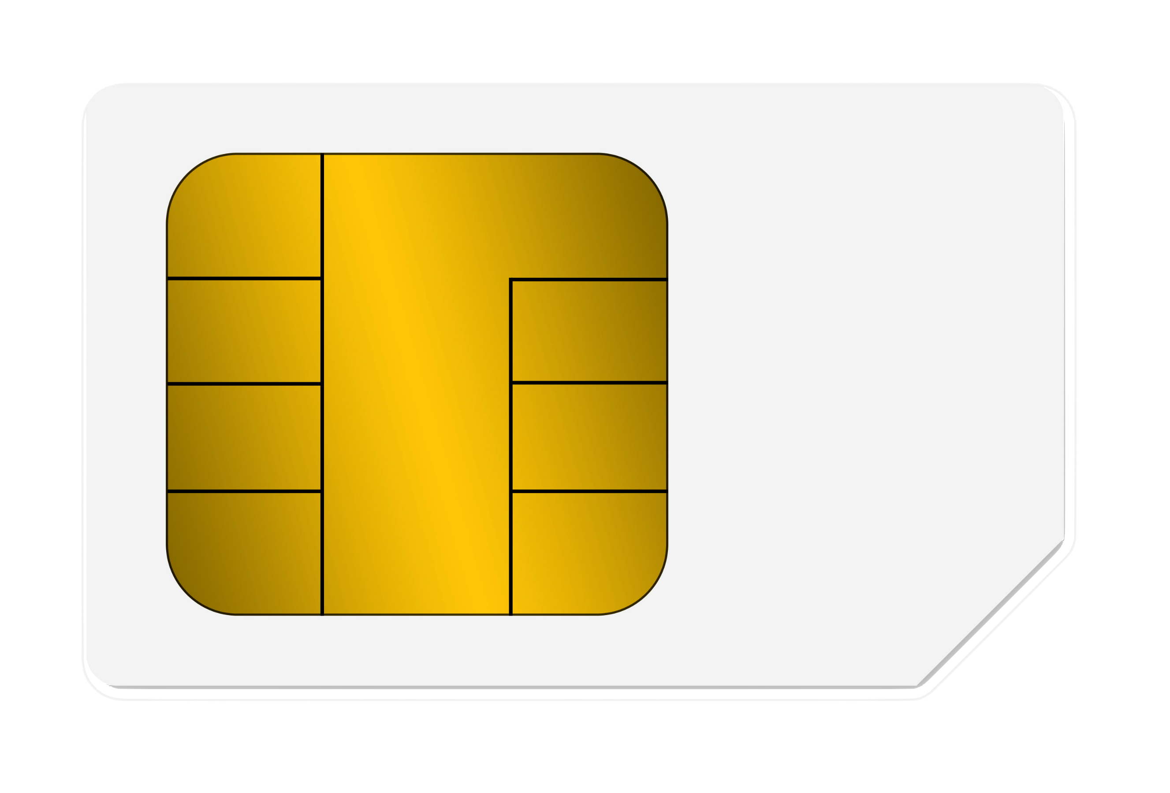

1234 1234 1234 1234

VALID THRU 01/2007

SALMAN KHAN 