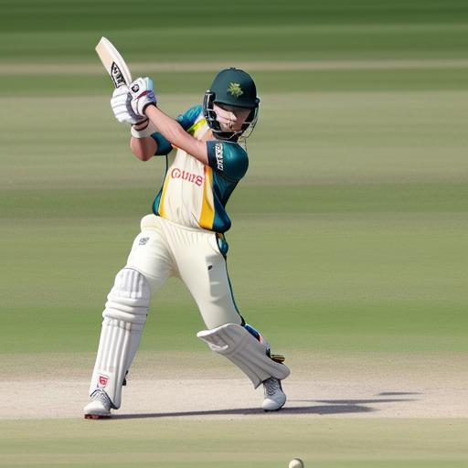

Chapter Names

## Chapter1: Introduction to Cricket

## Chapter2: Playing Field and Equipment

## Chapter3: Playing Positions and Roles

## Chapter4: Batting Basics

## Chapter5: Bowling Basics

## Chapter6: Fielding Techniques

## Chapter7: Rules and Regulations

## Chapter8: Scoring Runs and Winning the Game

## Chapter9: Different Formats of Cricket

## Chapter10: Strategies and Tactics

## Chapter11: Practice Drills and Training Tips

## Chapter12: History and Evolution of the Sport