Social_Media SQL Analysis

1. Select * from Social_Media

To show all content in table Social_Media

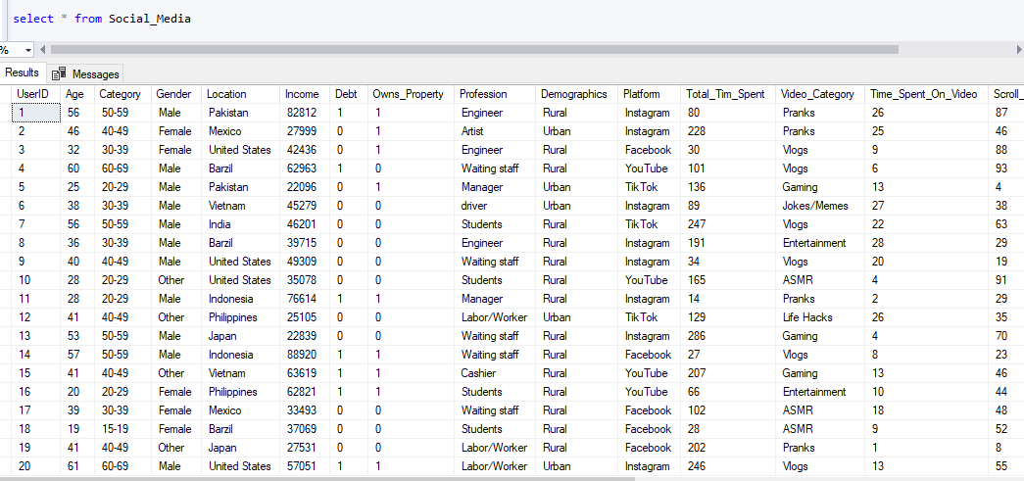

2. This query retrieves the count of users (UserID) for each country (Location) and orders the results from the highest to the lowest number of users

SELECT Location AS Country, COUNT(UserID) AS UserCount

FROM Social_Media

GROUP BY Location

ORDER BY UserCount DESC;

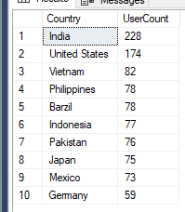

3. This query calculates the total number of users (UserID) for each Category and sorts the results so that the category with the highest number of users appears first

SELECT Category, COUNT(UserID) AS UserCount

FROM Social_Media

GROUP BY Category

ORDER BY UserCount DESC;

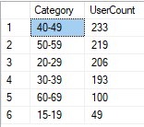

4. This query retrieves the count of users (UserID) for each Profession and orders the results from the highest to the lowest number of users.

SELECT Profession, COUNT(UserID) AS UserCount

FROM Social_Media

GROUP BY Profession

ORDER BY UserCount DESC;

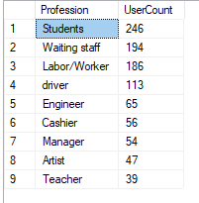

5. This query calculates the total number of users (UserID) for each Video_Category and sorts the results so that the category with the highest number of users appears first.

SELECT Video_Category, COUNT(UserID) AS UserCount

FROM Social_Media

GROUP BY Video_Category

ORDER BY UserCount DESC

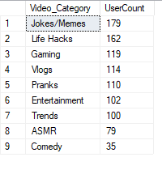

6. This allows you to see which platforms are most popular within each demographic group.

SELECT Demographics, Platform, COUNT(UserID) AS UserCount

FROM Social_Media

GROUP BY Demographics, Platform

ORDER BY Demographics, UserCount DESC;

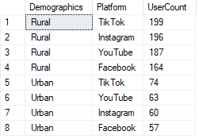

7. This allows you to identify the most popular operating systems within each demographic group.

SELECT Demographics, OS, COUNT(UserID) AS UserCount

FROM Social_Media

GROUP BY Demographics, OS

ORDER BY Demographics, UserCount DESC;

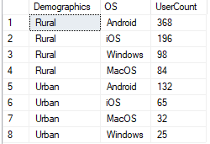

8. Allowing you to see which watch reasons are most common among users.

SELECT Watch_Reason, COUNT(UserID) AS UserCount

FROM Social_Media

GROUP BY Watch_Reason

ORDER BY UserCount DESC;

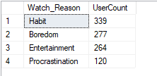

9. The result shows the distribution of user frequency as a percentage of the total user base.

SELECT Frequency, FORMAT(COUNT(UserID) * 100.0 / (SELECT COUNT(*) FROM Social_Media), 'N2') AS Percentage

FROM Social_Media

GROUP BY Frequency

ORDER BY Percentage DESC;

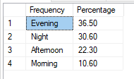

10. This query calculates the average scroll rate for each Category

SELECT Category, AVG(Scroll_Rate) AS AverageScrollRate

FROM Social_Media

GROUP BY Category

ORDER BY AverageScrollRate DESC

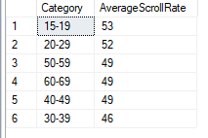

11. showing the categories with the most time spent first.

SELECT Video_Category, SUM(Time_Spent_On_Video) AS TotalTimeSpentin_Min

FROM Social_Media

GROUP BY Video_Category

ORDER BY TotalTimeSpentin_Min DESC;

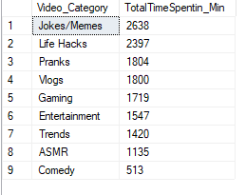

12. Connection type with the highest user count is returned.

SELECT ConnectionType, COUNT(UserID) AS UserCount

FROM Social_Media

GROUP BY ConnectionType

ORDER BY UserCount DESC

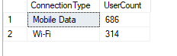

13. This querie should help you identify which videos are most popular in specific locations or for specific videos in any given location.

SELECT Location AS Country, Video_Category, COUNT(UserID) AS UserCount

FROM Social_Media

GROUP BY Location, Video_Category

ORDER BY Location, UserCount DESC;

