

Dynamic Blood Bank Management

ANURAAG KUNTA



# Research Papers

We have taken three papers from the IEEE Explore website which are as follows.

* A Web-based Blood Bank System for Managing Records of Donors and Receipts.

<https://ieeexplore.ieee.org/document/9844389>

* The Prospect and Significance of Lifeline: An E-blood bank System Publisher: IEEE Cite. <https://ieeexplore.ieee.org/document/9043193>
* A Secure Cloud Computing Based Framework for the Blood bank <https://ieeexplore.ieee.org/document/8537351>

# Report

Ensuring access to safe blood transfusion services remains a pressing challenge in Nigeria and other African nations, prompting the need for innovative solutions. This report presents a holistic strategy for managing blood banks, harnessing technological advancements to enhance accessibility and operational efficiency. By integrating cloud-based systems, online platforms, and mobile applications, the proposed framework aims to streamline blood donation procedures, mitigate shortages, and prioritize patient safety. Initial findings indicate promising outcomes, particularly in remote regions.

The perilous consequences of unsafe blood transfusions, compounded by the difficulty in meeting WHO blood requirements, underscore the urgency for transformative measures, especially in regions like Nigeria. This initiative aims to elevate blood transfusion services through innovative technological interventions, ensuring equitable and secure access for patients in need. Existing blood transfusion infrastructures in sub-Saharan Africa grapple with myriad challenges, including infection risks and insufficient supplies. While various solutions, such as SMS-based platforms, have been proposed to optimize blood management, they often neglect crucial aspects of emergency response and donor-patient matching.

Adopting a model-driven strategy, the methodology emphasizes maximizing safety and operational efficiency in blood bank management. The approach entails developing online interfaces, mobile applications, and cloud-based repositories to facilitate donor-patient matching, database administration, and seamless communication among stakeholders.

The executed system integrates USSD codes, SMS notifications, and online portals to expedite access to blood donation services. Through user surveys, positive feedback and promising outcomes were observed, indicating high acceptance rates and system reliability. The proposed blood bank system presents a viable solution to Nigeria's blood transfusion challenges, addressing critical issues such as exploitation, scarcity, and procedural inefficiencies. Successful implementation hinges on robust collaboration with hospitals and stakeholders, coupled with recommendations for future enhancements, including mobile application development and barcode utilization.

***References & Citations:***

* + T. Hilda Jenipha and R. Backiyalakshmi, "Android Blood Donor Life Saving Application in Cloud Computing" in American Journal of Engineering Research (AJER), 2014.
  + E. Osaro and T. Adias, "The challenges of meeting the blood transfusion requirements in Sub- Saharan Africa: the need for the development of alternatives to allogenic blood", Journal of Blood Medicine, pp. 7, 2011.
  + A. Shah, D. Shah, D. Shah, D. Chordiya, N. Doshi and R. Dwivedi, "Blood Bank Management and Inventory Control Database.
  + A. A. Kayode, A. E. Adeniyi, R. O. Ogundokun and S. A. Ochigbo, "An Android based blood bank information retrieval system", Journal of blood medicine, vol. 10, pp. 119, 2019.
  + O. Dahiya, K. Solanki, S. Dalal and A. Dhankhar, "Regression Testing: Analysis of its Techniques for Test Effectiveness", International Journal of advanced trends in computer science and engineering, vol. 9, no. 1, pp. 737-744, 2020.

# Aarogya

## Motivation/Purpose:

The main motivation behind the dynamic blood bank management system is to ensure that blood is available when and where it is needed. There are several challenges in managing blood donation and distribution, such as shortage of blood supply, poor coordination between hospitals and blood banks, and inadequate infrastructure for storing and transporting blood. The purpose of this project is to develop a cloud-based system that can address these challenges and improve the efficiency and effectiveness of blood donation and distribution processes.

The system will allow hospitals and blood banks to easily monitor the availability of blood, track blood donations, and manage blood inventory. The system will also provide real-time information on the demand for blood, which will help hospitals and blood banks make informed decisions about blood donation and distribution. Additionally, the system will enable patients to easily find the blood they need and donors to easily donate blood, which will encourage more people to donate blood.

Overall, the dynamic blood bank management system has the potential to save lives by ensuring that blood is available when and where it is needed. Our team is committed to delivering a high-quality system that meets the needs of all stakeholders involved in blood donation and distribution.

## System Architecture:

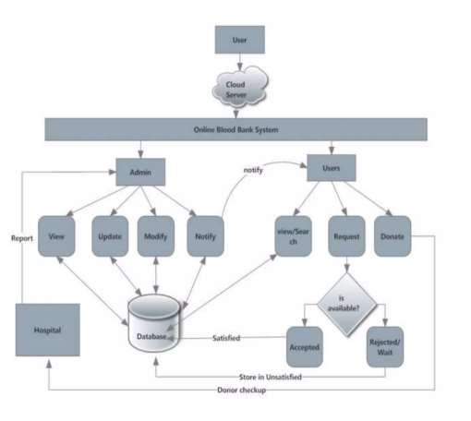+ The system architecture for the Aarogya is designed to ensure that the system is highly available, scalable, and secure. The system consists of three main components: the front-end, the back end, and the database.

+ The front-end of the system is responsible for displaying the user interface of the application. The front-end is built using HTML, CSS, and JavaScript and is deployed on a web server hosted on AWS Elastic Beanstalk. The front-end communicates with the back end of the system via RESTful APIs.

+ The back end of the system is responsible for handling the business logic of the application. It receives requests from the front-end, processes them, and sends the appropriate responses back to the front-end.

+ The database is responsible for storing all the data required to run the application. It stores information about blood donors, patients, blood banks, and blood units. Patient details and donor details (NAME, SEX, AGE, WEIGHT, ADDRESS, DISEASE, EMAIL, DATE) will be saved in

separate tables. Admin can add the donor, add the blood units, and they can request blood. The database is designed to be scalable, with the ability to handle a large volume of data and transactions. It is built using MySQL and is hosted on AWS RDS.

# Home Page

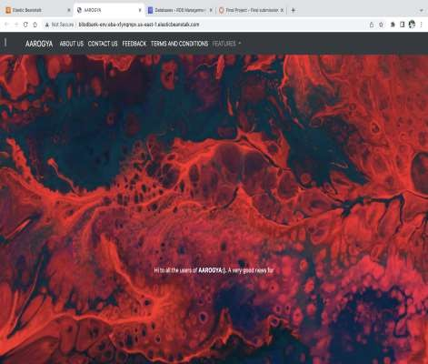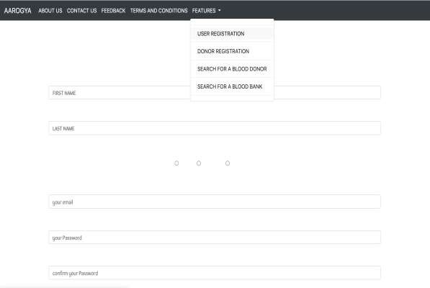

Login Page **Donor Registration**

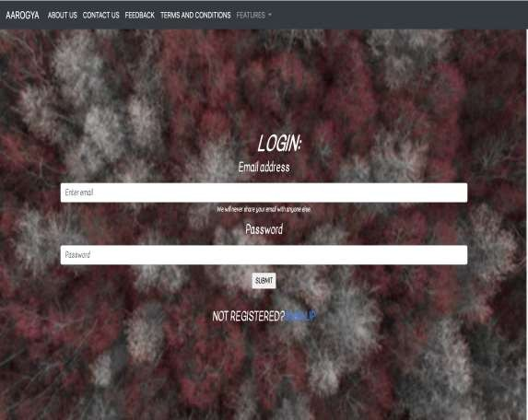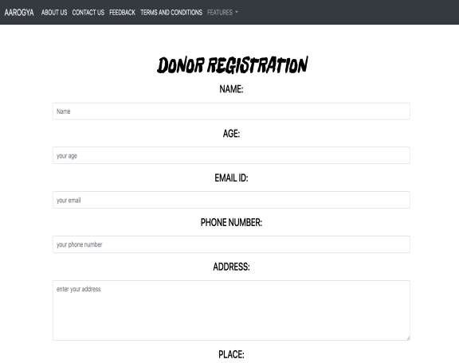

***About Us* Feedback Page**

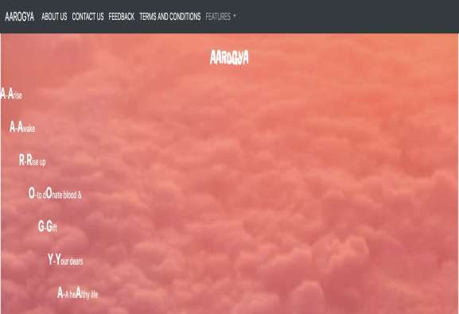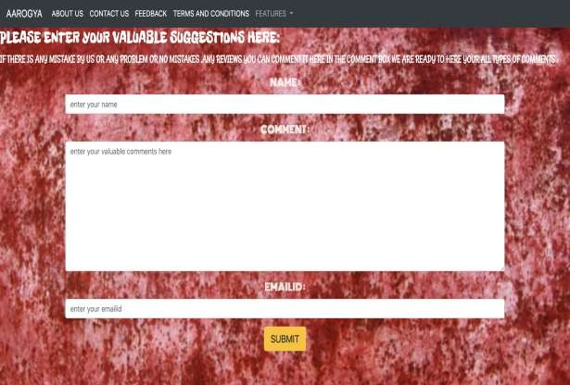

# Code Snippets

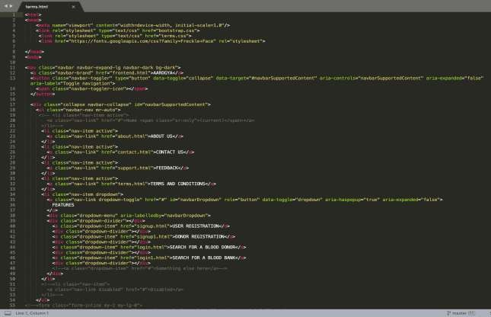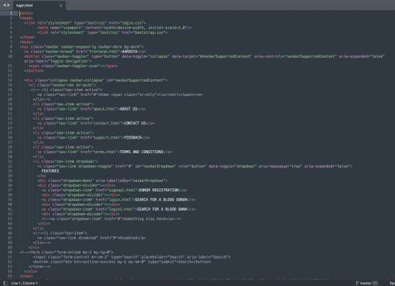

***Deployment Strategy:***

* To deploy a web app to AWS Elastic Beanstalk, you need to do the following in order:
* Create your web app & provide PHP dependencies: This will be your code that will be deployed to AWS

Elastic Beanstalk along with requirements.txt.

* Zip your app: Zip all your source code and dependencies into a single file.
* Upload the zip to S3: The zip file needs to be staged to S3 before deployment
* Create Elastic Beanstalk Application: This will deploy your code and create an application, but you must

create the environment for your application to work.

* Create Elastic Beanstalk Environment: Create the environment & start the application.
* We have created an PHP based application and uploaded into the AWS Elastic Beanstalk.
* Once done, we have used AWS RDS, S3, MYSQL Workbench to create and integrate the databases to the application.

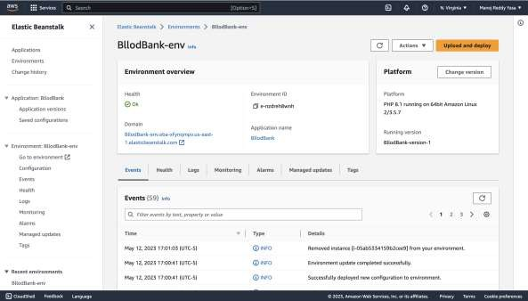

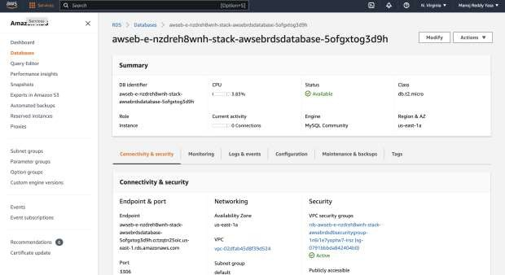

## References & Citations

* + A. Adewumi, N. Budlender and M. Olusanya, "Optimizing the assignment of blood in a blood banking system: Some initial results", 2012 IEEE Congress on Evolutionary Computation CEC 2012,

pp. 10-15, 2012.

* + N. Adarsh, J. Arpitha, M. D. Ali, N. M. Charan and P. G. Mahendrakar, "Effective blood bank management based on RFID in real time systems", International Conference on Embedded Systems ICES 2014, pp. 287-290, 2014.
  + Indirala Vasavi, Jonnadula Jayasree, Ganesana Charishma, S. Kranthi, "Blood and Plasma Donation, Management System with GPS Using MERN Stack", 2022.
  + International Conference on Advancements in Smart, Secure and Intelligent Computing (ASSIC), pp.1-6, 2022.

## CONCLUSION

The implementation of cloud-based platforms specifically targets the challenges encountered in rural settings, where access to essential healthcare services such as blood transfusions may be limited. Through the consolidation of data storage and the utilization of mobile applications, these platforms facilitate easier access to blood donation details, thereby improving communication among donors, recipients, and healthcare institutions.

Collectively, these studies highlight the transformative potential of cloud computing in reshaping blood bank management practices, ultimately advancing the objective of saving lives and enhancing healthcare outcomes across diverse geographical areas.

Thank you!!!