|  |  |
| --- | --- |
| **EX.NO: 1**  **DATE :** | Install the Android SDK and developer tools and build a text project to confirm that those tools are properly installed and configured |

**AIM:**

To install the android SDK and developer tools and build a text project using android environment.

**PROCEDURE:**

Installation of Android studio:

**System requirements:**

To start the Android application development on either of the following operating systems − x Microsoft® Windows® 8/7/Vista/2003 (32 or 64-bit). x Mac® OS X® 10.8.5 or higher, up to 10.9 (Mavericks) x GNOME or KDE desktop

Second point is that all the required tools to develop Android applications are open source and can be downloaded from the Web. Following is the list of software's you will need before you start your Android application programming. x Java JDK5 or later version x Java Runtime Environment (JRE) 6 x Android Studio Step 2 - Setup Android Studio Overview Android Studio is the official IDE for android application development.It works based onIntelliJ IDEA, You can download the latest version of android studio from Android Studio Download,

Step by Step process of installing Android Studio

A file, which is named as android-studio-bundle-135.17407740-windows.exe.So just download and run on windows machine according to android studio wizard guideline.

1.Installation So let's launch Android Studio.exe, Make sure before launch Android Studio, Our Machine should require installed Java JDK.

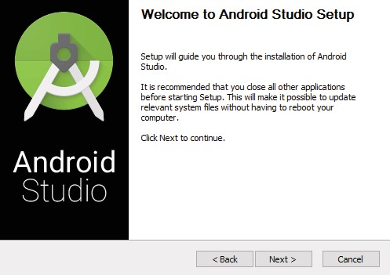

Once we launched Android Studio, it’s time to mention JDK5 path or later version in android studio installer

2. Need to check the components, which are required to create applications, below the image has selected Android Studio, Android SDK, Android Virtual Machine and click Next

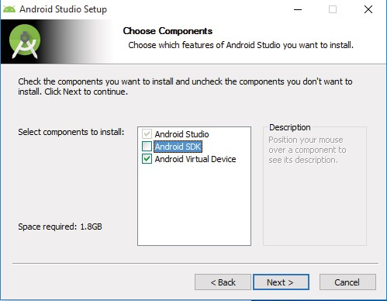

3.In Android SDK Settings Need to specify the location of local machine path for Android SDK and click Next

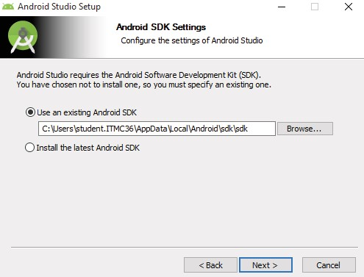

4.In configuration Settings we need to specify the android studio locations of local machine path and click Next.

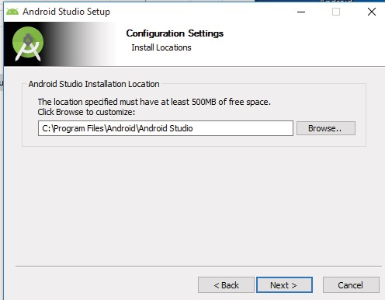

1. After specifying location of android studio we have choose the folder and make the do not create shortcuts checkbox checked and click install

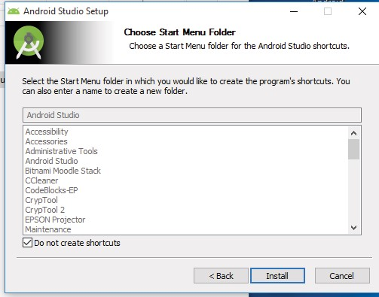

1. At final stage, it would extract SDK packages into our local machine, it would take a while time to finish the task.

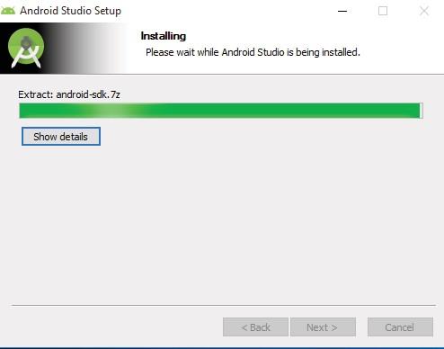

7.After finishing all the above steps successfully the android studio installation is completed.

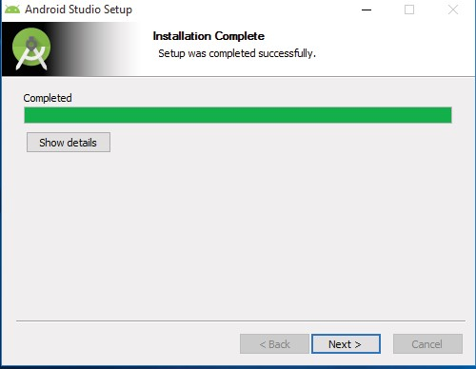

8.After completing the installation click finish.

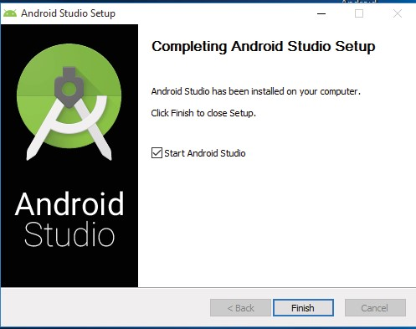

9.A dialog box appears choose the option that do not have a previous version or I do not want to import my settings and click OK

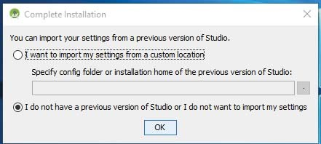

10.The android studio gets opened

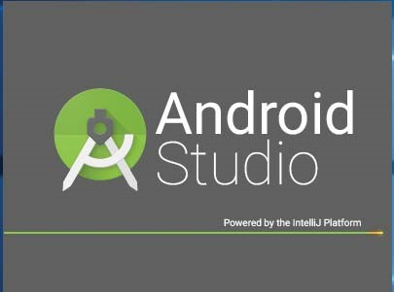

11.In next step click next

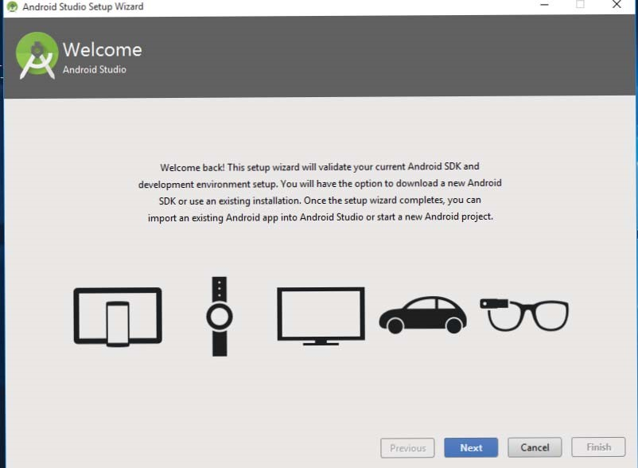

12.In next step choose the type of setup you want for Android Studio and choose Standard type and click next

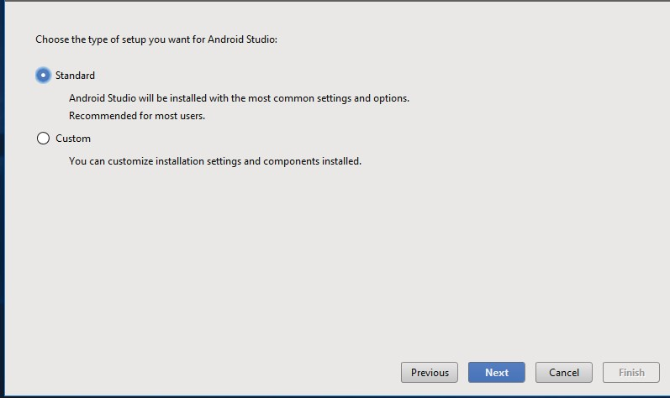

13.In verify settings dialog box click finish

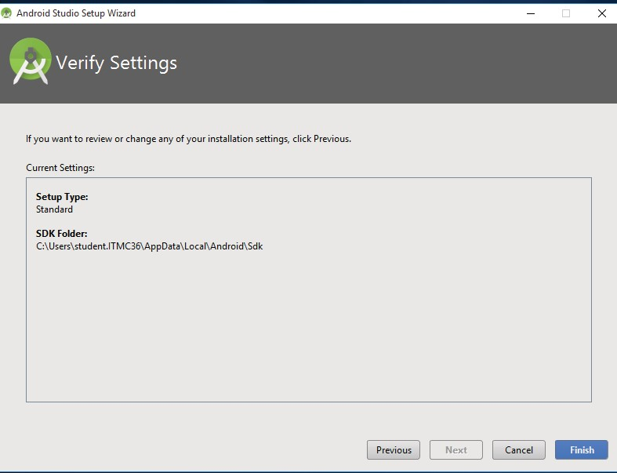

14.We can start your application development by calling start a new android studio project.

1. In a new installation frame should ask Application name, package information

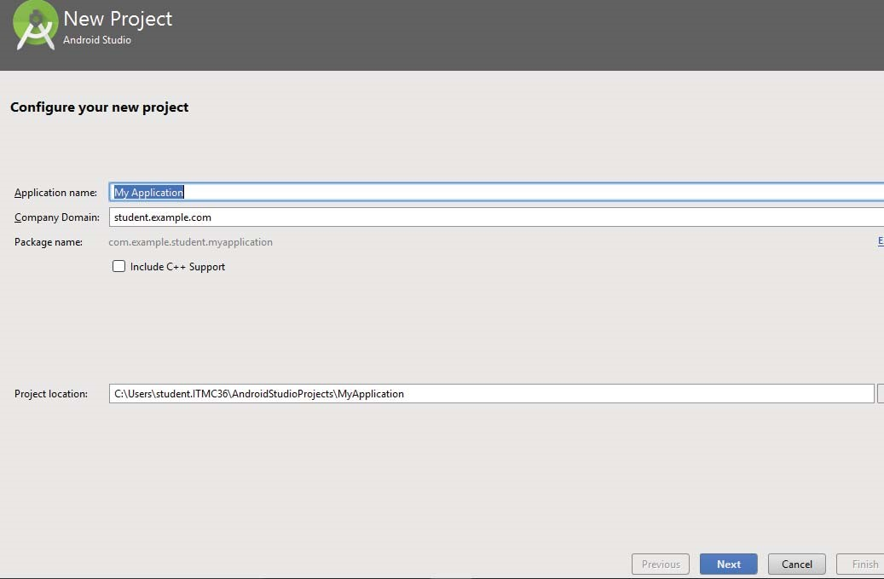

15.After entering application name, specify Minimum SDK, I have declared as API21: Android 5.0(Lollipop).

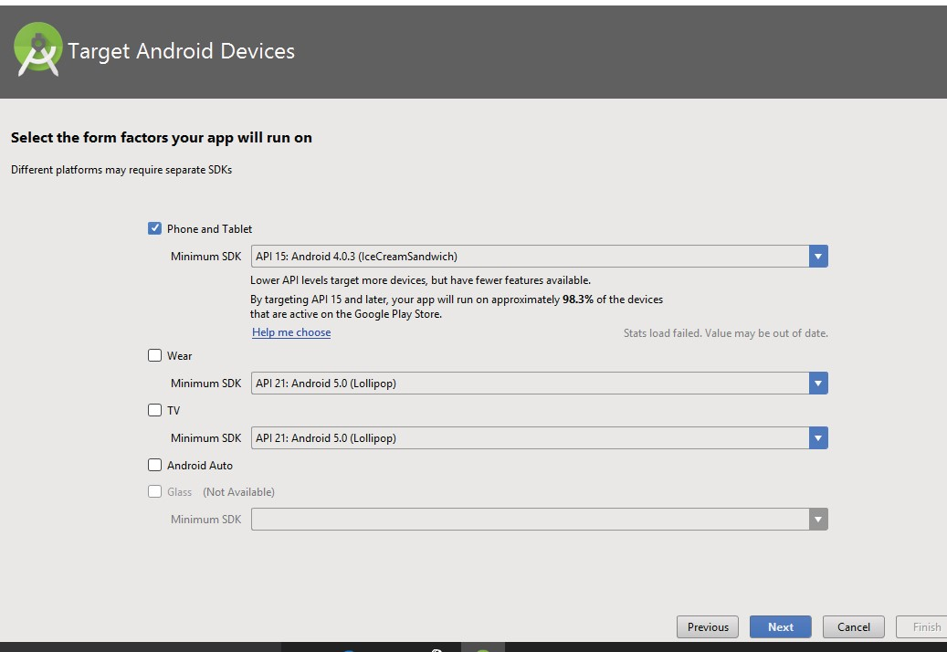

1. The next level of installation should contain selecting the activity to mobile, it specifies the default layout for Applications

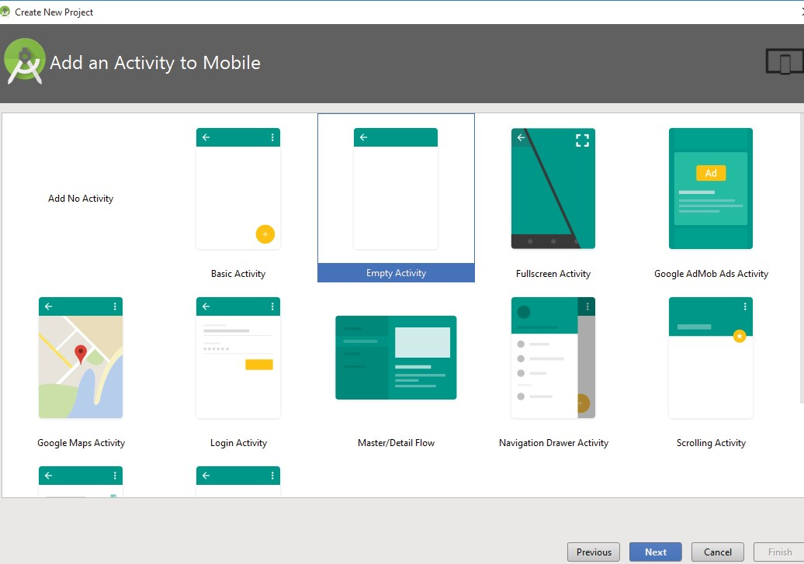

16.After in customize the Activity click finish and if proxy is not set it asks us to setup proxy.

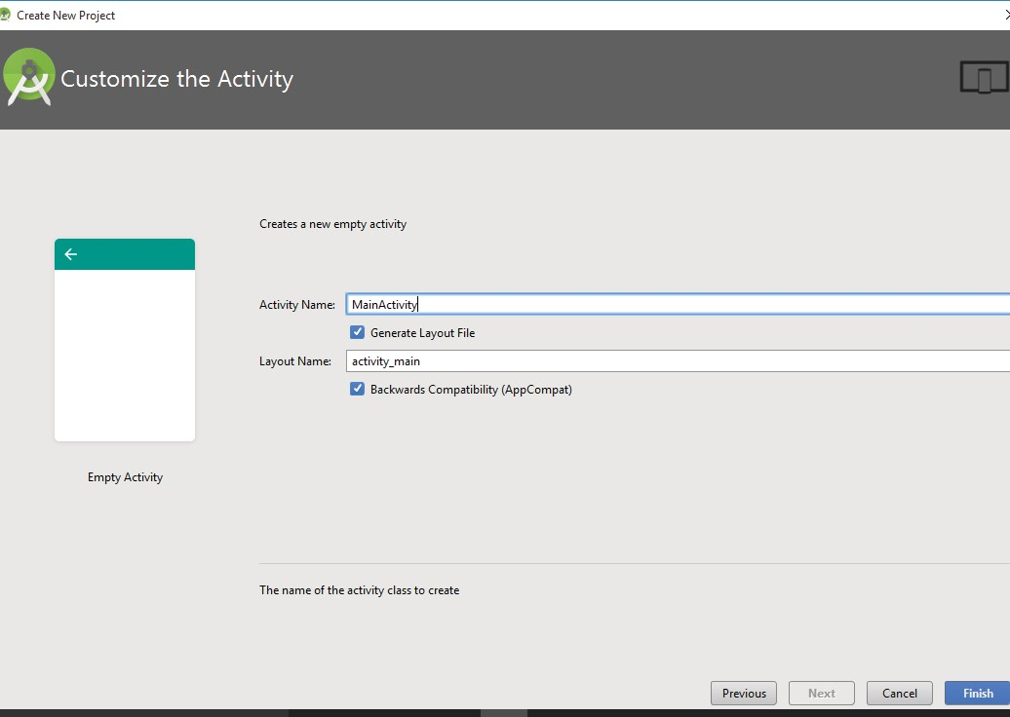

1. In proxy setting setup the proxy hostname and port number.

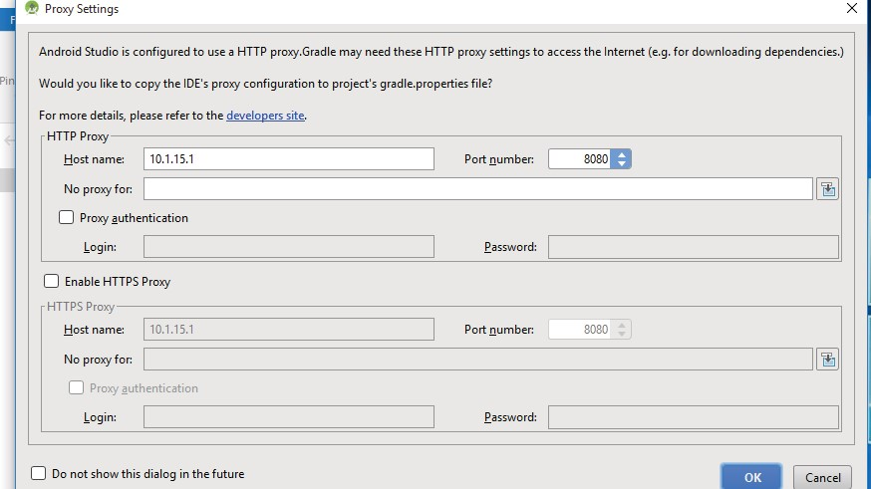

18.The gradle info get loaded.

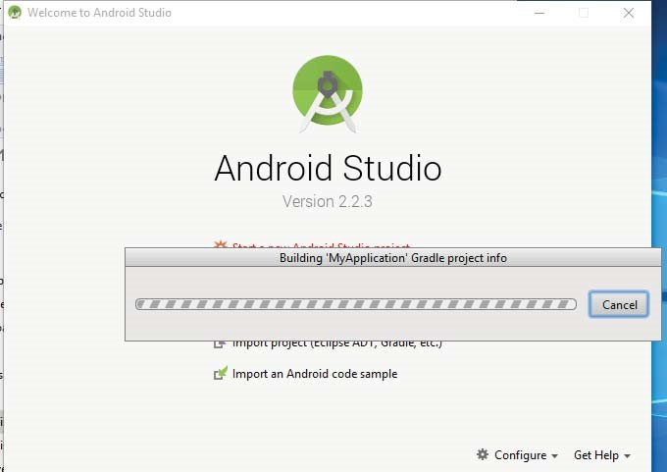

1. Create Android Virtual Device to test your Android applications, you will need a virtual Android device. So before we start writing our code, let us create an Android virtual device. Launch Android AVD Manager Clicking AVD_Manager icon as shown below

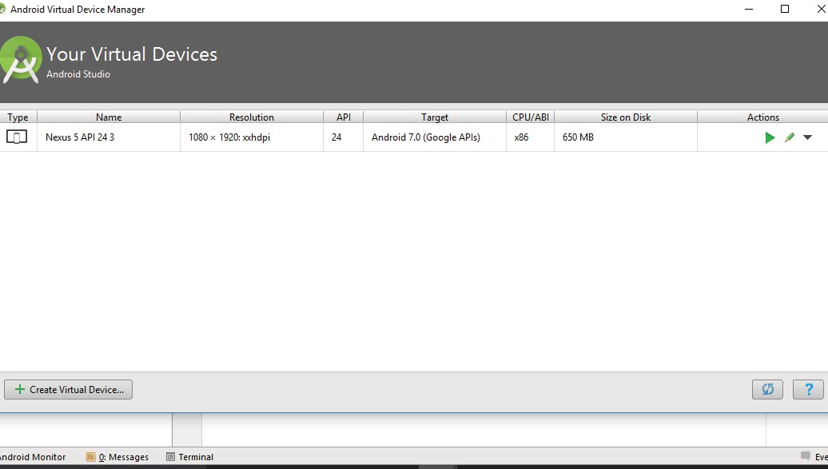

your AVD is created successfully it means your environment is ready for Android application development. If you like, you can close this window using top-right cross button. Better you re-start your machine and once you are done with this last step, you are ready to proceed for your first Android example but before that we will see few more important concepts related to Android Application Development

19.Run the emulator

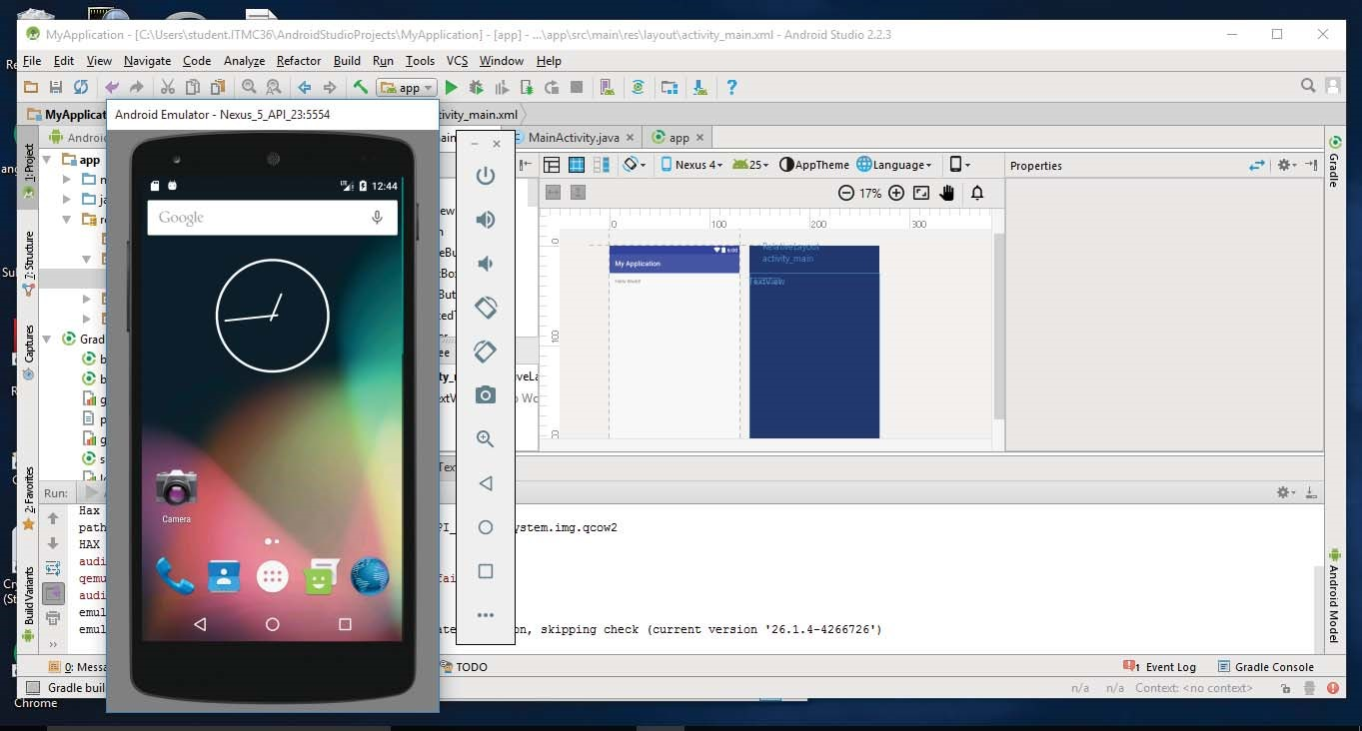

18.Hello world example

Before Writing a Hello world code, you must know about XML tags. To write hello word code, you should redirect to App>res>layout>Activity_main.xml

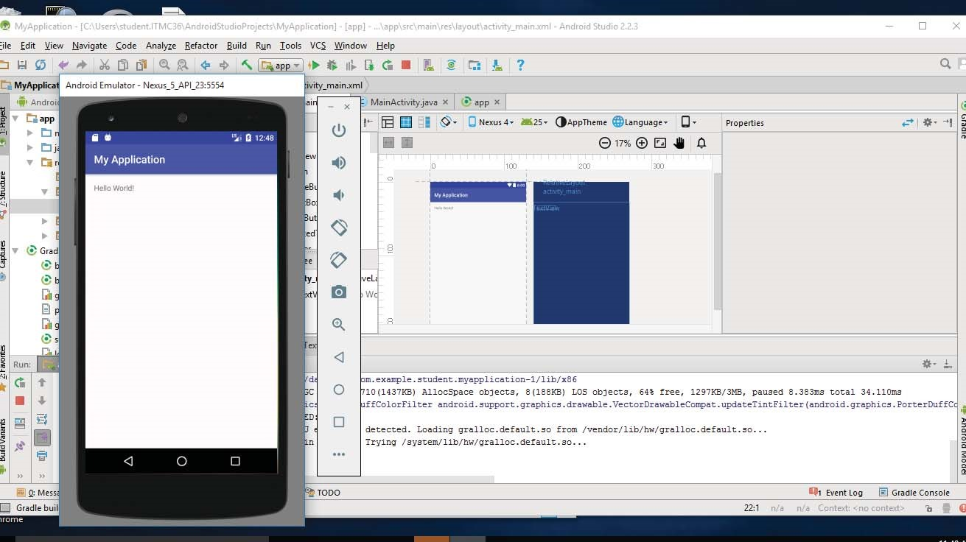

**Program:**

**MainActivity.java**

import android.support.v7.app.AppCompatActivity; import android.os.Bundle;

public class MainActivity extends AppCompatActivity {

@Override

protected void onCreate(Bundle savedInstanceState) { super.onCreate(savedInstanceState); setContentView(R.layout.*activity_main*);

}

}

**activity_main.xml:**

*<?*xml version="1.0" encoding="utf-8"*?>*

<RelativeLayout xmlns:android="http://schemas.android.com/apk/res/android" xmlns:tools="http://schemas.android.com/tools" android:id="@+id/activity_main" android:layout_width="match_parent" android:layout_height="match_parent" android:paddingBottom="@dimen/activity_vertical_margin" android:paddingLeft="@dimen/activity_horizontal_margin" android:paddingRight="@dimen/activity_horizontal_margin" android:paddingTop="@dimen/activity_vertical_margin" tools:context="com.example.senthil.myapplication.MainActivity">

<TextView android:layout_width="wrap_content" android:layout_height="wrap_content" android:text="Hello World!" />

</RelativeLayout>

**Result:**

Thus the Android SDK and developer tools are successfully installed and configured.