WEEK-3

P. Anuradha Nandini
2520030171

STEP 1:
Open the MongoDB Atlas website.

STEP 2:
Sign in to your MongoDB Atlas account.

STEP 3:
Open your existing project/cluster.

STEP 4:
Click:

Database
|
+---- Clusters
|
+---- Browse Collections
STEP 5:
Open the database:

bookflow
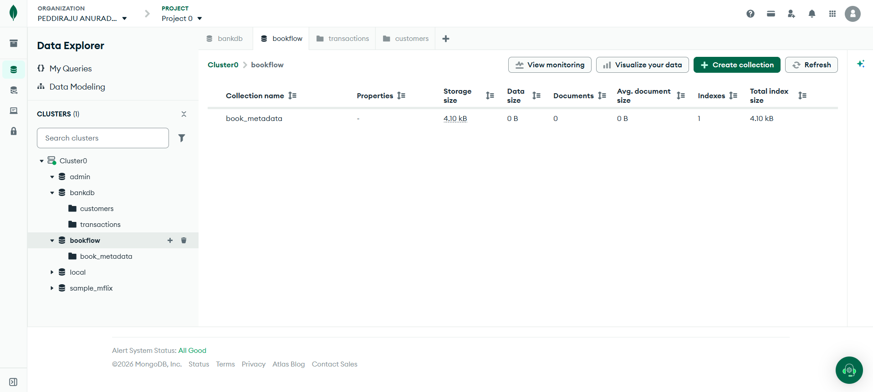

In MongoDB Atlas:

STEP 1:
Open:

bookflow
|
+-- book_metadata

STEP 2:
Click:

Add Data

STEP 3:
Select:

Insert Document

STEP 4:
Insert the following document.
{
"book_id": 101,
"title": "The Martian",
"author": "Andy Weir",
"published_year": 2021,
"category": "Science Fiction",
"format": "Digital PDF",
"file_size": "2.5 MB",
"member_id": 101,
"reviews": [
{
"member_id": 101,
"rating": 5,
"comments": "Excellent science fiction story"
},
{
"member_id": 102,
"rating": 4,
"comments": "Very interesting and informative"
},
{
"member_id": 103,
"rating": 5,
"comments": "Excellent space adventure"
}
]
}
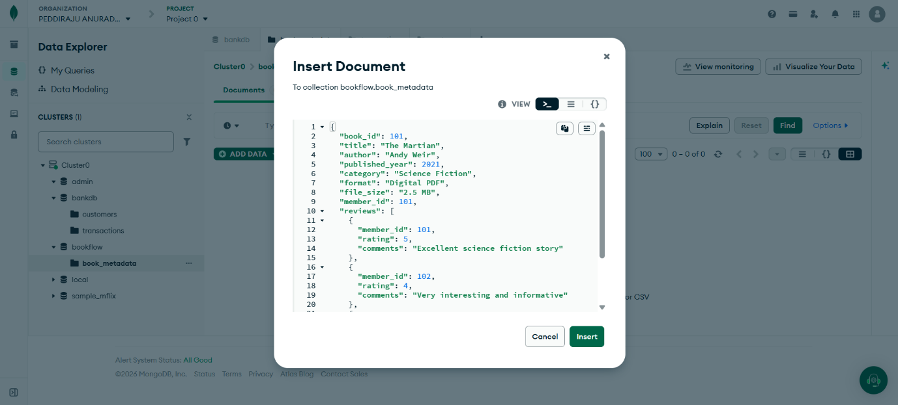
{
"book_id": 102,
"title": "Dune",
"author": "Frank Herbert",
"published_year": 2022,
"category": "Science Fiction",
"format": "Digital EPUB",
"file_size": "3.1 MB",
"member_id": 102,
"reviews": [
{
"member_id": 101,
"rating": 5,
"comments": "Amazing world building"
},
{
"member_id": 104,
"rating": 4,
"comments": "Classic science fiction novel"
},
{
"member_id": 105,
"rating": 5,
"comments": "Excellent characters and story"
}
]
}
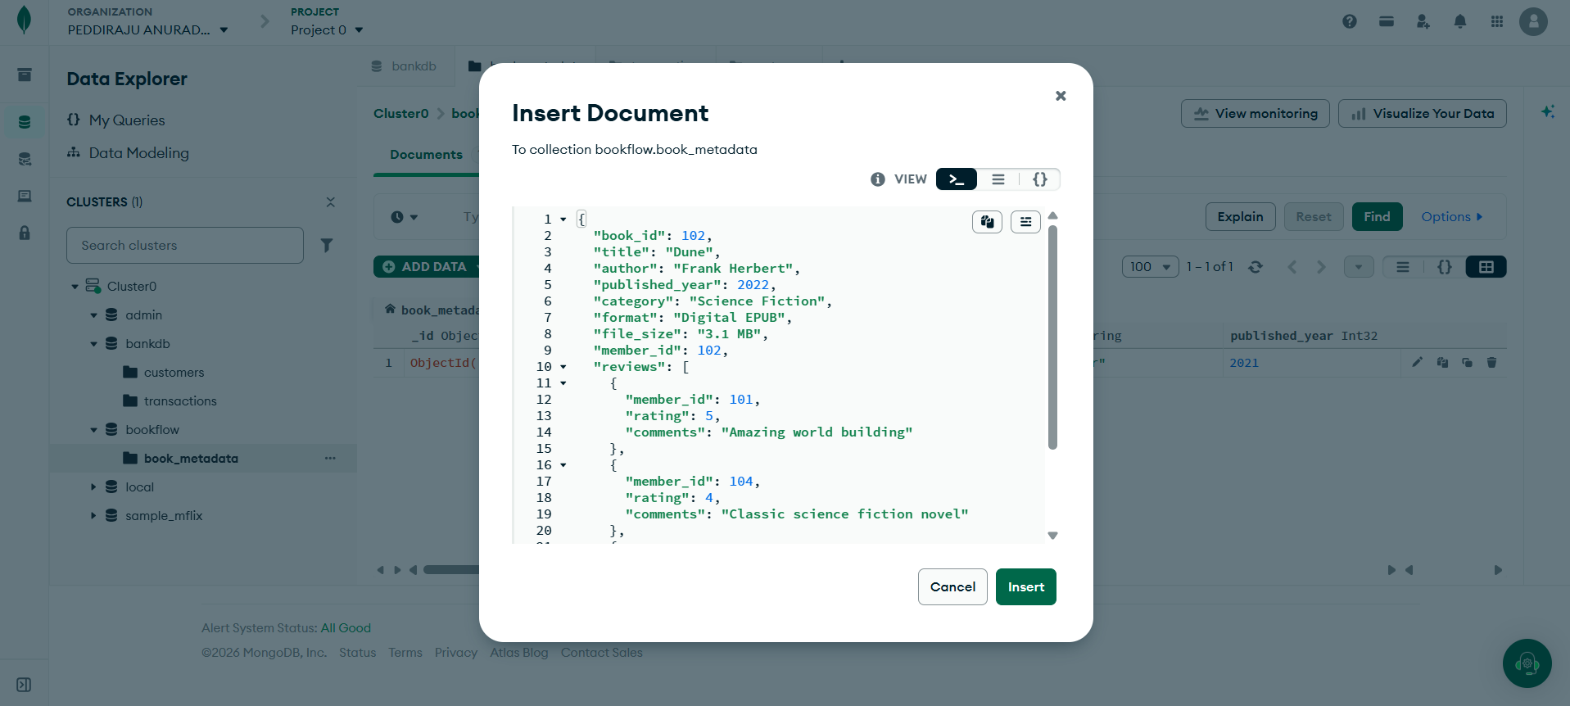
{
"book_id": 103,
"title": "Clean Code",
"author": "Robert C. Martin",
"published_year": 2019,
"category": "Programming",
"format": "Physical",
"dimensions": {
"height": "23 cm",
"width": "18 cm",
"weight": "700 g"
},
"member_id": 103,
"reviews": [
{
"member_id": 101,
"rating": 5,
"comments": "Excellent programming reference"
},
{
"member_id": 106,
"rating": 4,
"comments": "Very useful coding practices"
}
]
}
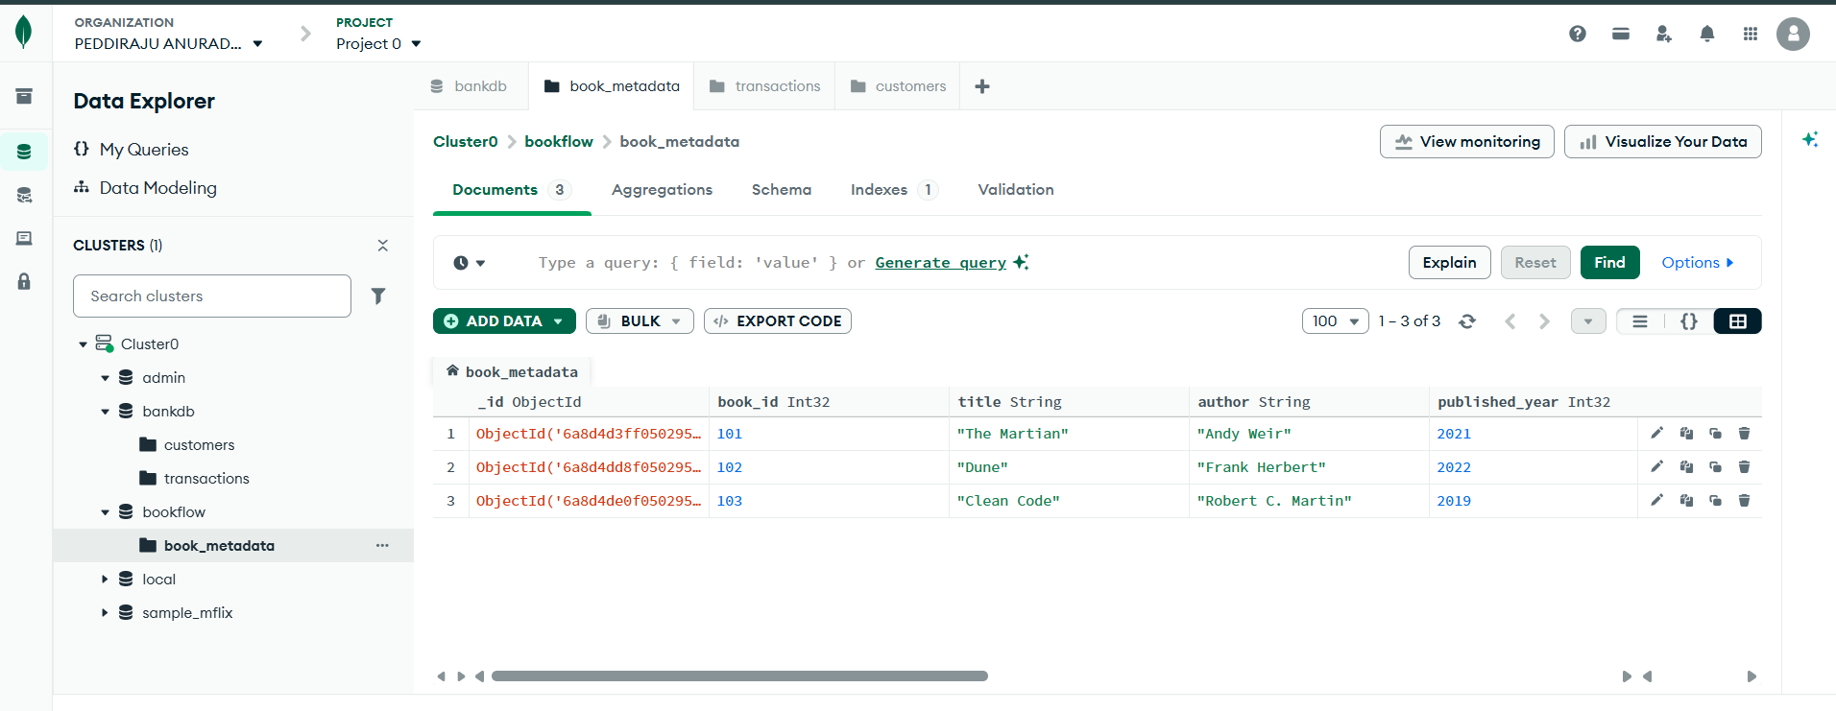
{
"book_id": 104,
"title": "Artificial Intelligence Basics",
"author": "John Smith",
"published_year": 2023,
"category": "Artificial Intelligence",
"format": "Digital PDF",
"file_size": "4.2 MB",
"member_id": 104,
"reviews": [
{
"member_id": 102,
"rating": 4,
"comments": "Good introduction to artificial intelligence"
},
{
"member_id": 105,
"rating": 5,
"comments": "Excellent machine learning explanation"
},
{
"member_id": 106,
"rating": 4,
"comments": "Useful for beginners"
}
]
}
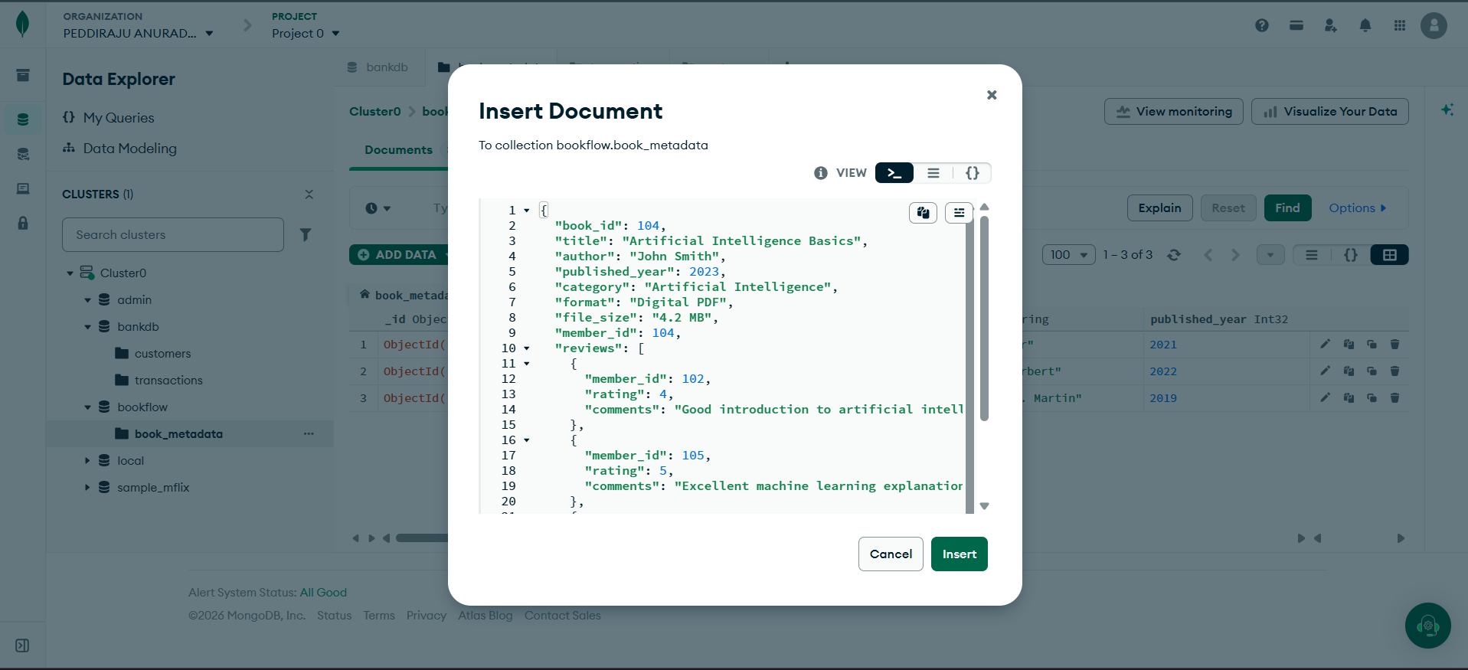
{
"book_id": 105,
"title": "Data Structures",
"author": "Mark Allen",
"published_year": 2024,
"category": "Computer Science",
"format": "Digital PDF",
"file_size": "5.0 MB",
"member_id": 105,
"reviews": [
{
"member_id": 101,
"rating": 5,
"comments": "Excellent data structures book"
},
{
"member_id": 107,
"rating": 3,
"comments": "Good but needs more examples"
}
]
}
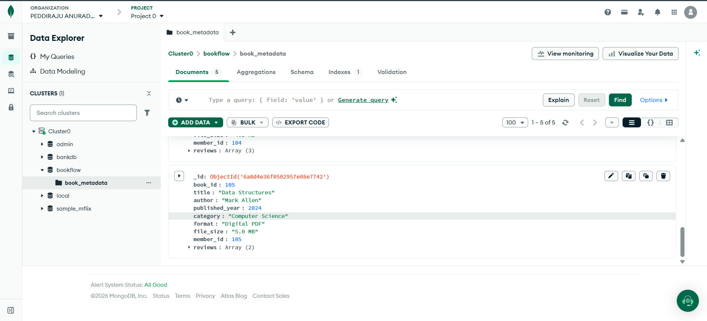
PART 6: COMPARISON OPERATOR
============================================================

OBJECTIVE:

Find books having a rating greater than 4.

MongoDB query:

{
"reviews.rating": {
"$gt": 4
}
}
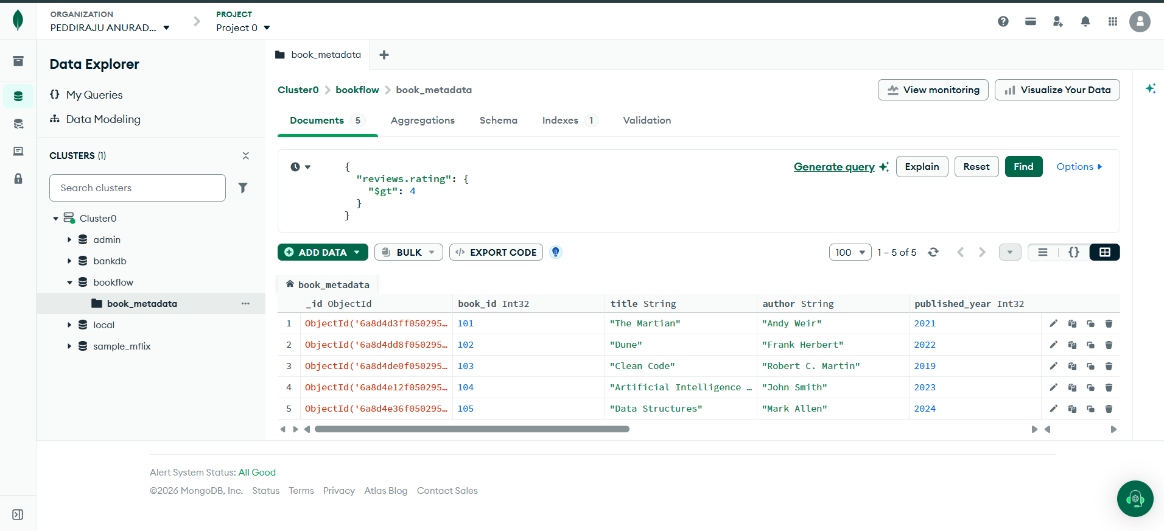

PART 7: USING $IN
============================================================

Find books containing reviews with ratings 4 or 5.

Query:

{
"reviews.rating": {
"$in": [4, 5]
}
}
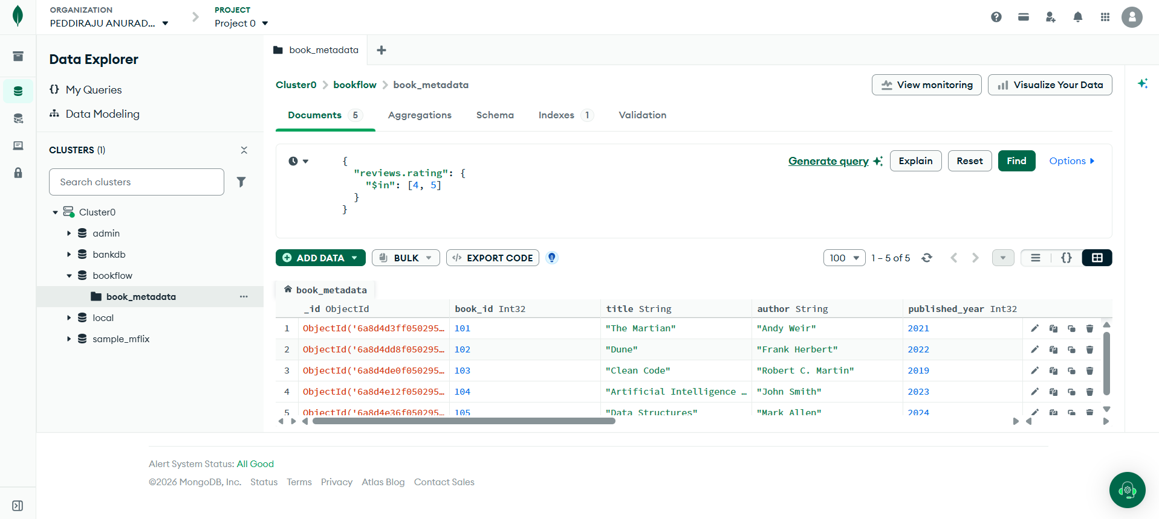

PART 8: REGEX QUERY
============================================================

OBJECTIVE:

Find books where the format contains the word:

Digital

Query:

{
"format": {
"$regex": "Digital",
"$options": "i"
}
}
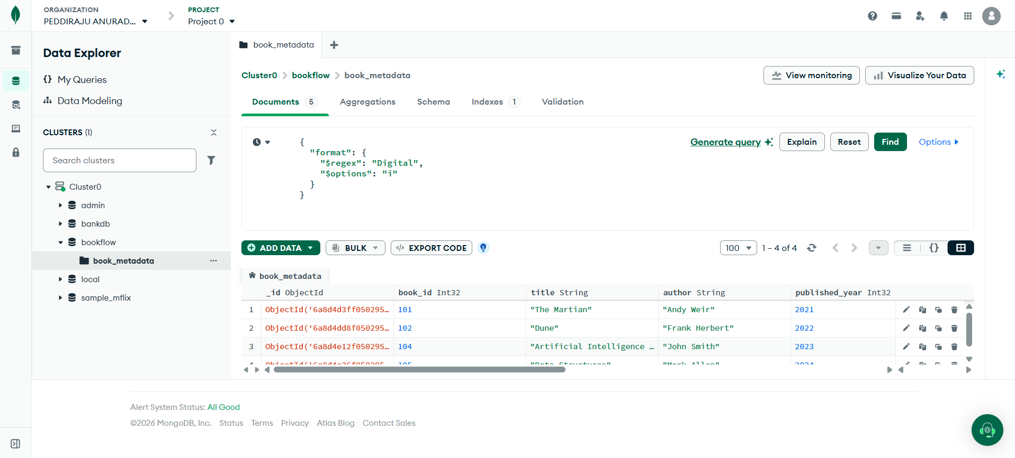
PART 9: AGGREGATION PIPELINE
