**ASSIGNMENT:1**

1. **Hello World Program**: Write a Java program that prints "Hello World!!" to the console.
2. **Compile with Verbose Option**: Compile your Java file using the -verbose option with javac. Check the output.
3. **Inspect Bytecode**: Use the javap tool to examine the bytecode of the compiled .class file. Observe the output.

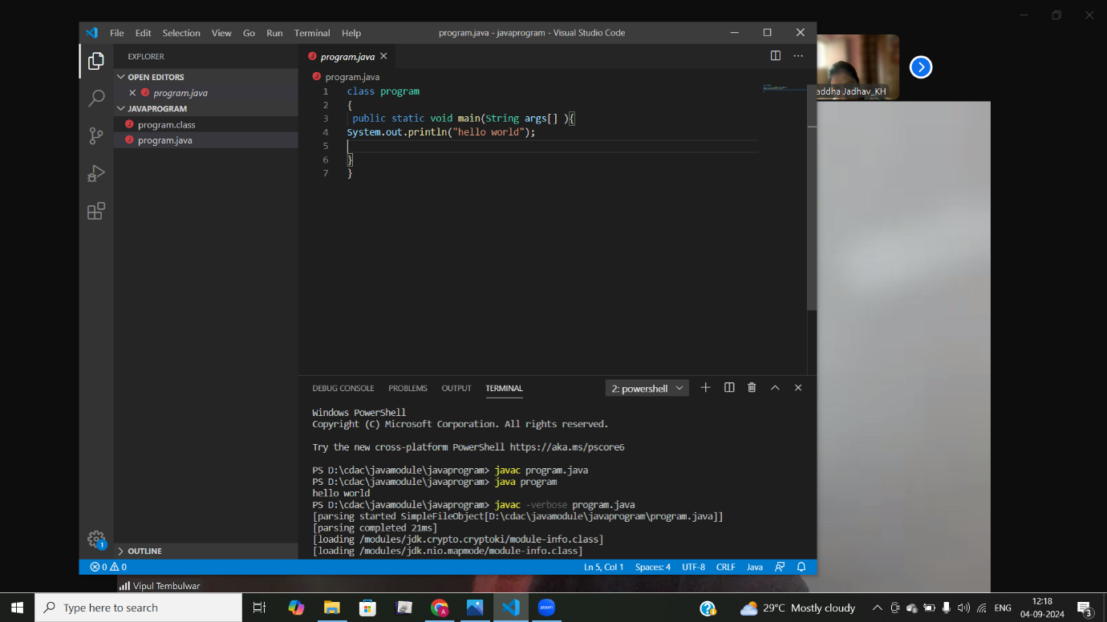

ASSIGNMENT:2

1)Write a program that checks if a given year is a leap year or not using both if-else and switch-case.

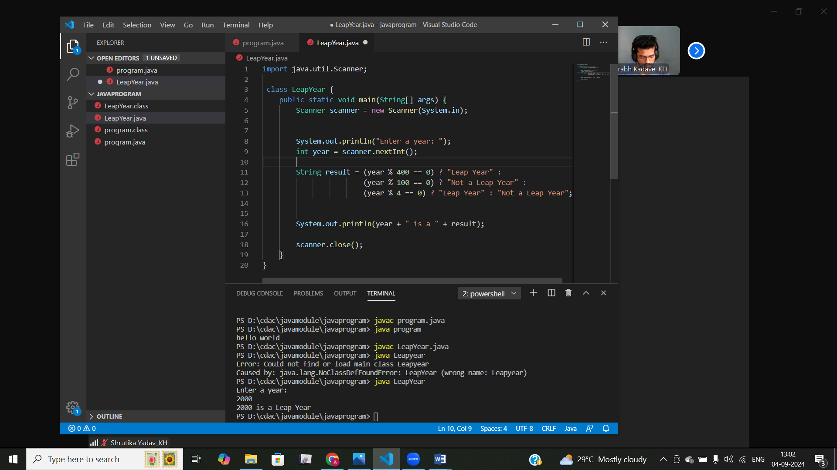

2)Implement a program that calculates the Body Mass Index (BMI) based on height and weight input using if-else to classify the BMI int categories (underweight, normal weight, overweight,etc).

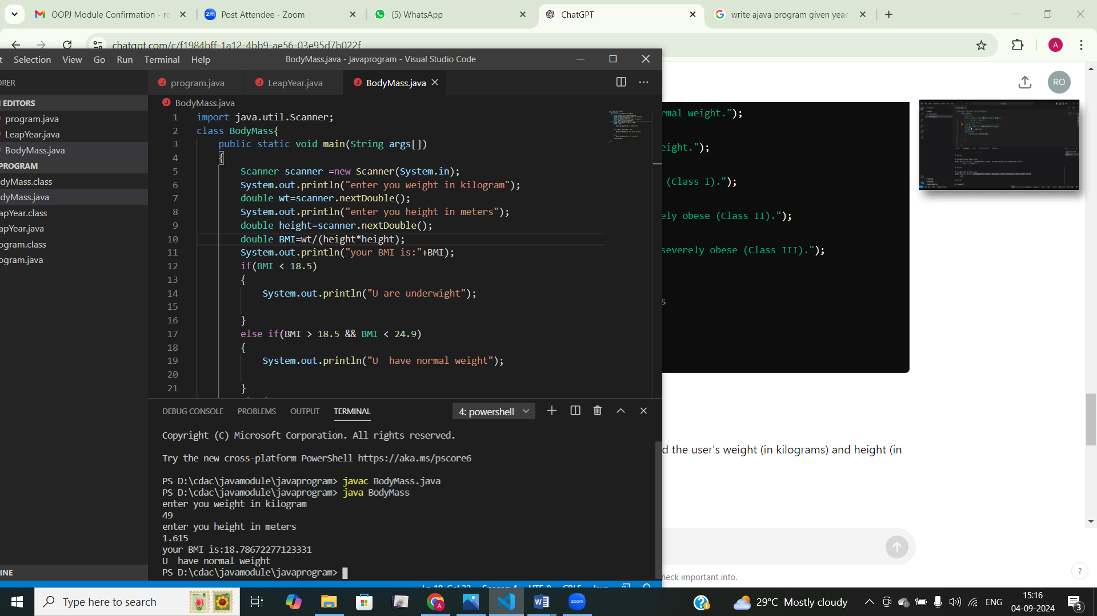

3)Write a program that checks if a person is eligible to vote based on their age.

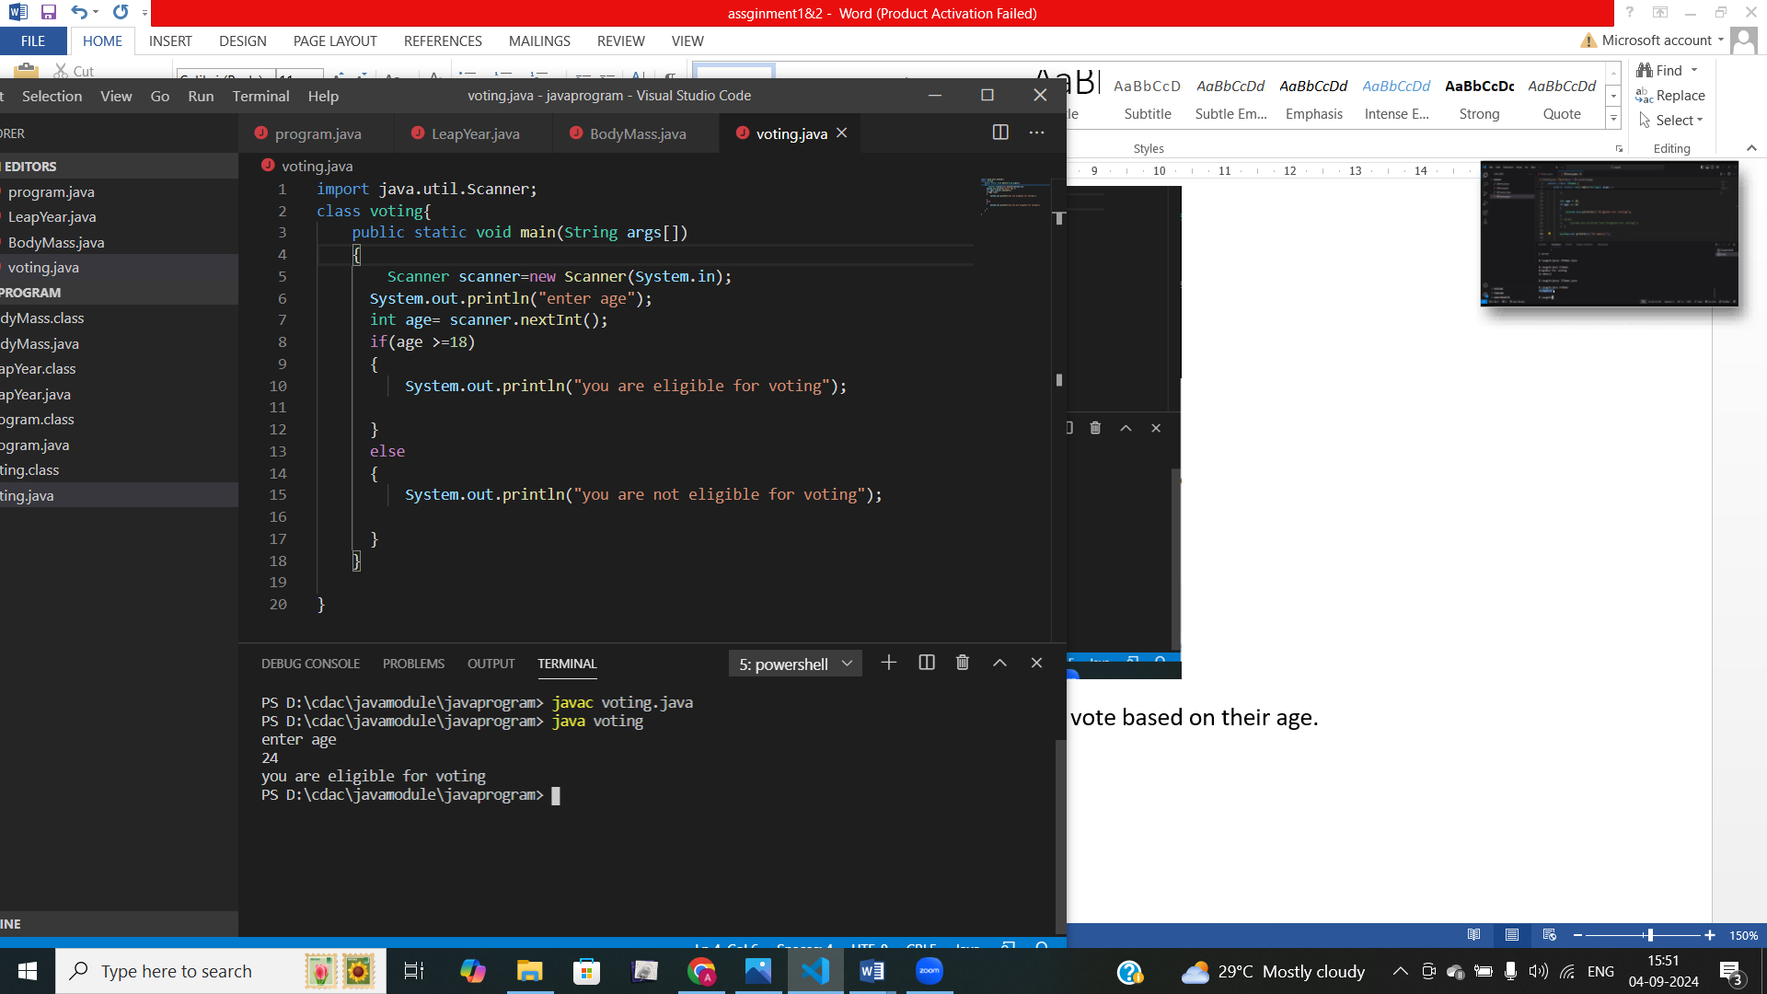

4)Write a program that takes a month (1-12) and prints the corresponding season (Winter, Spring, Summer, Autumn) using a switch case

import java.util.Scanner;

 class season{

    public static void main(String[] args) {

        Scanner scanner = new Scanner(System.in);

        System.out.println("Enter a month (1-12): ");

        int month = scanner.nextInt();

        String season;

        switch (month) {

            case 12:

            case 1:

            case 2:

                season = "Winter";

                break;

            case 3:

            case 4:

            case 5:

                season = "Spring";

                break;

            case 6:

            case 7:

            case 8:

                season = "Summer";

                break;

            case 9:

            case 10:

            case 11:

                season = "Autumn";

                break;

            default:

                season = "Invalid month! Please enter a number between 1 and 12.";

        }

        System.out.println("The season is: " + season);

        scanner.close();

    }

}

5)Write a program that allows the user to select a shape (Circle, Square, Rectangle, Triangle) and then calculates the area based on user-provided dimensions using a switch case

