**Analysis of Factors Influencing the Success of Online Courses on Udemy**

An Academic Essay

By [Your Name]

**Abstract**

The advent of online education platforms has transformed the learning landscape, offering learners worldwide access to a wealth of courses across various domains. However, the success of these courses hinges on several factors that influence their popularity and engagement with the audience. This essay delves into the impact of course features, ratings, pricing, and other relevant factors on the success of online courses on Udemy, a prominent online education platform. By leveraging a comprehensive dataset and visualisations, the analysis unravels the intricate interplay between these factors and their implications for course popularity, subscriber engagement, and overall success. The findings shed light on the characteristics of highly successful courses, pricing strategies, temporal trends, and the role of instructor reputation, providing valuable insights for course creators, instructors, and platform operators to optimise their offerings and cater to the evolving needs of learners in the digital age.

**Introduction**

The rise of online education platforms like Udemy has disrupted traditional learning models, providing learners worldwide with access to a vast array of courses on various topics. However, the success of these courses hinges on several factors that influence their popularity and engagement with the audience. This essay aims to explore the impact of course features, ratings, pricing, and other relevant factors on the success of online courses on Udemy, using the provided dataset and visualisations.

**Relationship between Subscribers and Key Factors**

The number of subscribers serves as a crucial metric for gauging the popularity and success of a course. The analysis reveals a positive correlation between the number of subscribers and the average rating (r=0.053321) and a strong correlation with the number of reviews (r=0.790876). This suggests that courses with higher ratings and more reviews tend to attract a larger subscriber base, as potential learners heavily rely on these indicators to assess the quality and value of a course.

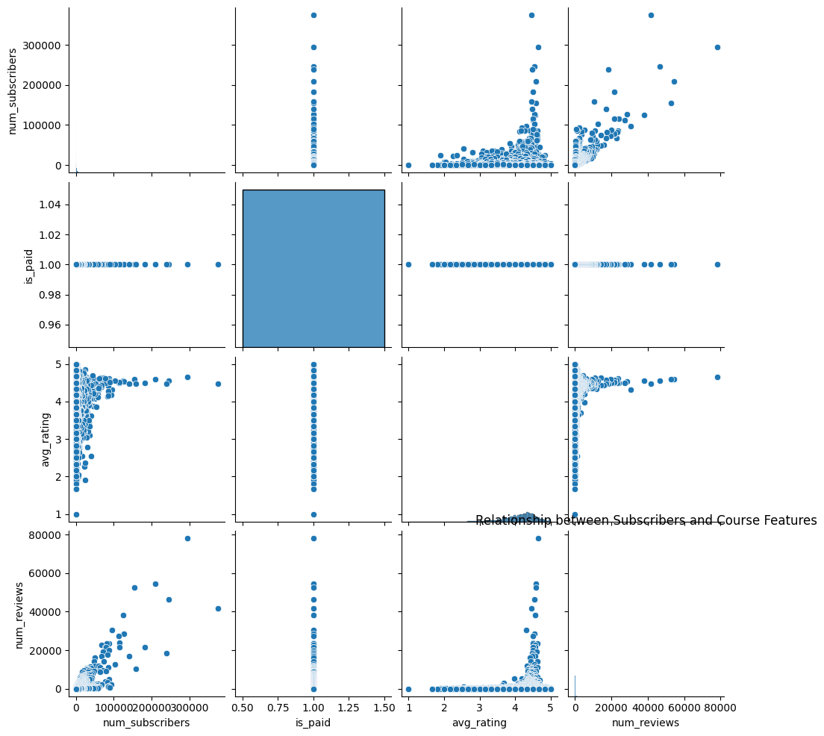

*Figure 1 : Pairplot visually representing the correlation between different factors*

Interestingly, there is no clear correlation between the paid/free status of a course and the number of subscribers. This implies that the willingness to pay for a course may be influenced by other factors, such as the perceived value, instructor reputation, or the specific domain of the course.

**Impact of Course Duration**

The duration of a course, measured by the number of published lectures and practice tests, exhibits a moderate positive correlation with the number of subscribers (r=0.226095 for lectures). However, the number of practice tests has a weak negative correlation (r=-0.027532). This suggests that while a more comprehensive course with more lectures may appeal to learners seeking in-depth knowledge, an excessive number of practice tests may not necessarily contribute to higher popularity.

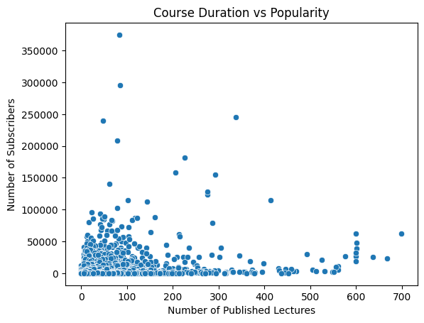

*Figure 2: Scatterplot visually representing the relationship between course duration and popularity*

The distribution of course duration reveals a wide range, with some courses offering a substantial number of lectures and practice tests, catering to learners who value hands-on practice and comprehensive learning experiences.

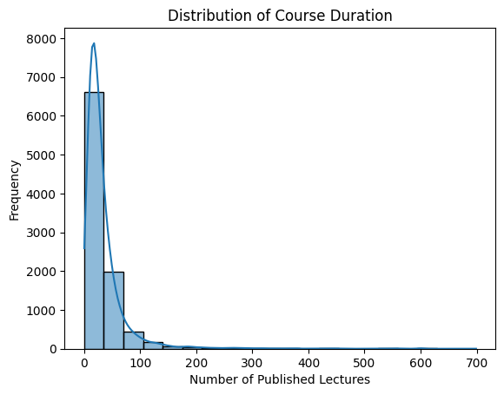

*Figure 3: Additional plot showing the distribution of course duration*

**Pricing Strategies and Subscriber Engagement**

Pricing strategies play a crucial role in determining the success of online courses. The analysis shows a weak negative correlation between the discount price and the number of subscribers (r=-0.020028) and reviews (r=-0.001602). However, there is a moderate positive correlation between the original price and the number of subscribers (r=0.145518) and reviews (r=0.102589).

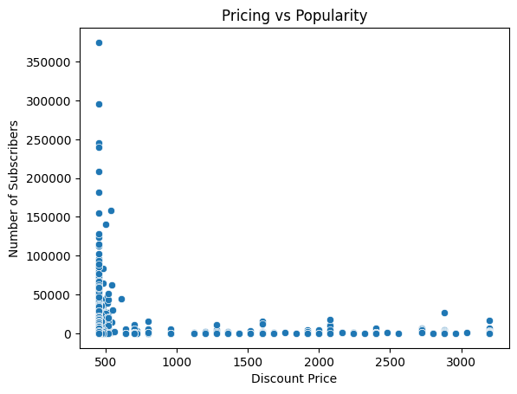

*Figure 4: Scatterplot visually representing the relationship between pricing and popularity*

This counterintuitive finding suggests that courses with higher original prices, even when discounted, tend to attract more subscribers and generate more reviews. This could be attributed to the perception of higher value associated with premium pricing or the tendency of learners to perceive discounted courses as more worthwhile investments.

The distribution of pricing reveals a wide range, with some courses priced significantly higher than others, potentially catering to different segments of learners with varying budgets and expectations.

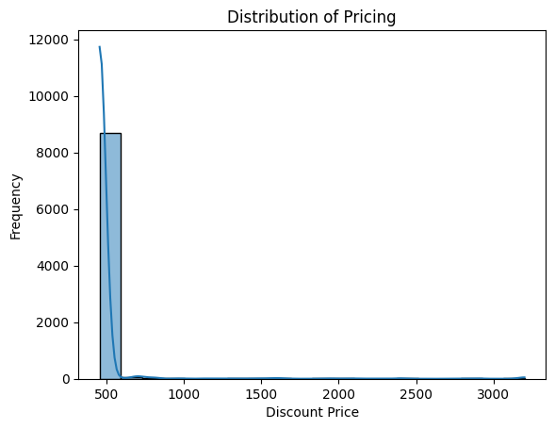

*Figure 5: Additional plot showing the distribution of pricing*

**Temporal Trends and Outliers**

Examining the average number of subscribers over the years reveals interesting temporal trends. The data shows a steady increase in average subscribers from 2010 to 2016, followed by a slight decline in subsequent years. This pattern could be influenced by factors such as the growing popularity of online learning platforms, market saturation, or changes in learner preferences over time.

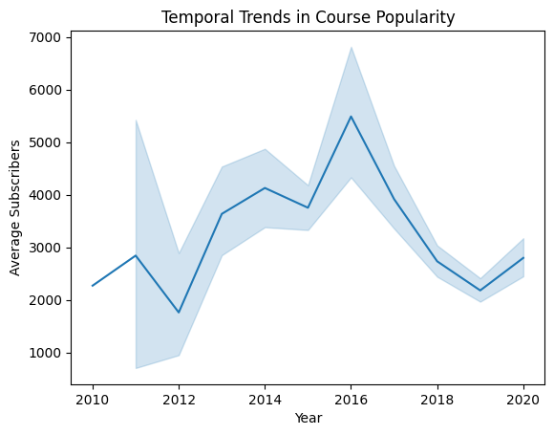

*Figure 6: Line plot visually representing the trend of average subscribers over the years*

Additionally, the number of courses published each year follows a similar upward trend, peaking in 2018 and then declining, potentially due to increased competition or market dynamics.

Analysis of outliers provides valuable insights into the characteristics of exceptionally successful and unsuccessful courses. The top 5 outliers in terms of subscribers are diverse, spanning topics like business, finance, data science, and SQL. These courses seem to leverage instructors' expertise, comprehensive content, and relevance to in-demand skills, attracting a significant subscriber base.

On the contrary, the bottom 5 outliers with the lowest subscriber counts cover niche topics like negotiation, eBay selling, crowdfunding, and betting. The limited appeal of these specialised subjects, combined with factors like low instructor reputation or lack of marketing efforts, could contribute to their relatively low subscriber numbers.

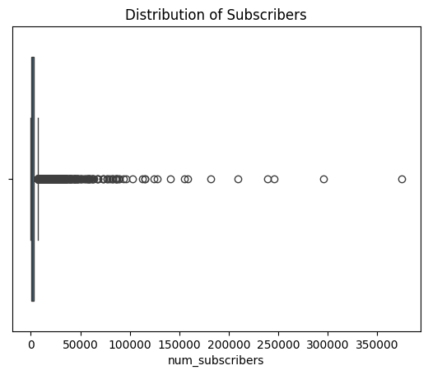

*Figure 7: Boxplot visually representing the distribution of subscribers and identifying outliers*

**Wishlisting and Subscriptions**

The analysis reveals no clear correlation between wishlisting (the act of adding a course to a learner's wishlist) and actual subscriptions. This suggests that while wishlisting may indicate initial interest, it does not necessarily translate into course enrollment or engagement. Other factors, such as pricing, content quality, or learner readiness, likely play a more significant role in converting potential learners into subscribers.

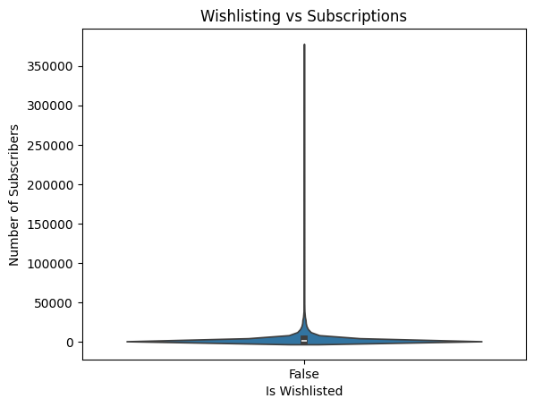

*Figure 8 : Violin plot visually representing the relationship between wishlisting and subscriptions*

**Course Topics and Popularity**

Examining the average subscribers by course topic, based on the title, unveils the popularity of specific domains. Courses related to business, finance, data science, and professional skills like public speaking and project management tend to attract the highest number of subscribers. This aligns with the growing demand for upskilling and acquiring practical knowledge in these fields, driven by evolving job market dynamics and the need for professional development.

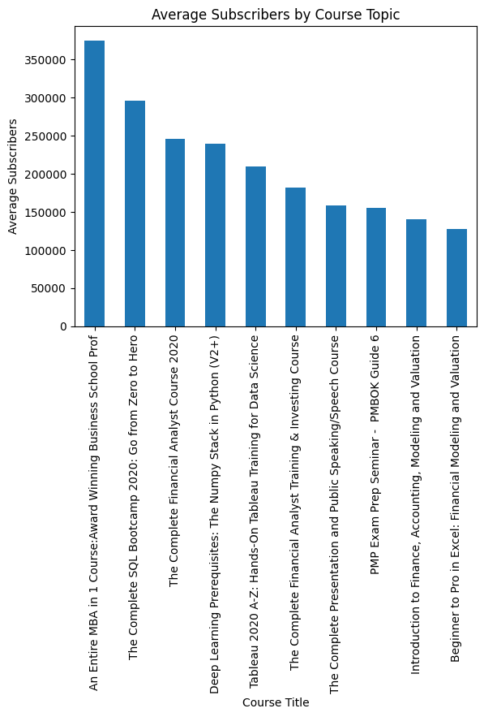

*Figure 9 : Bar plot visually representing the average subscribers by course topic*

**Seasonal Patterns and Marketing Strategies**

The analysis of average subscribers by month reveals a slight uptick during the early months of the year (January to April), potentially coinciding with the start of new academic or professional development cycles. However, the variations are relatively minor, suggesting that course enrollments may not be significantly influenced by seasonal patterns.

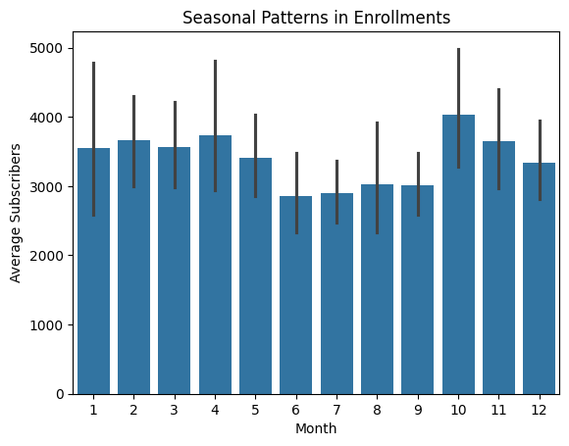

*Figure 10: Bar plot visually representing the average subscribers by month*

Nevertheless, online education platforms could leverage these insights to optimise resource allocation and marketing efforts, targeting learners during periods of heightened interest or aligning promotional campaigns with the beginning of academic or professional cycles.

**Subscriber Behaviour: Paid vs. Free Courses**

Comparing the average number of subscribers for paid and free courses reveals a higher average for paid courses. This finding suggests that learners may perceive paid courses as offering higher value, quality, or exclusivity compared to free alternatives. Additionally, the willingness to invest financially could indicate a stronger commitment to learning and engagement with the course content.

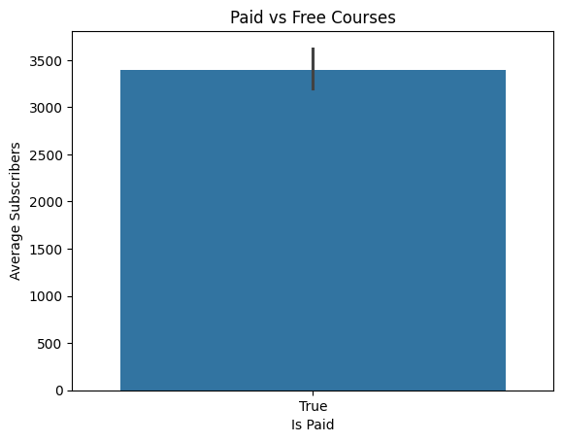

*Figure 11: Bar plot visually representing the average subscribers for paid vs free courses*

However, it is important to note that pricing alone is not the sole determinant of success. Other factors, such as course quality, instructor reputation, and learner preferences, likely play a role in the decision to enrol in paid or free courses.

**Instructor Reputation and Engagement**

The analysis reveals a positive correlation between the instructor's average recent rating and the number of subscribers (r=0.056718) and reviews (r=0.093322). While these correlations are relatively weak, they highlight the importance of instructor reputation and perceived expertise in driving course popularity and learner engagement.

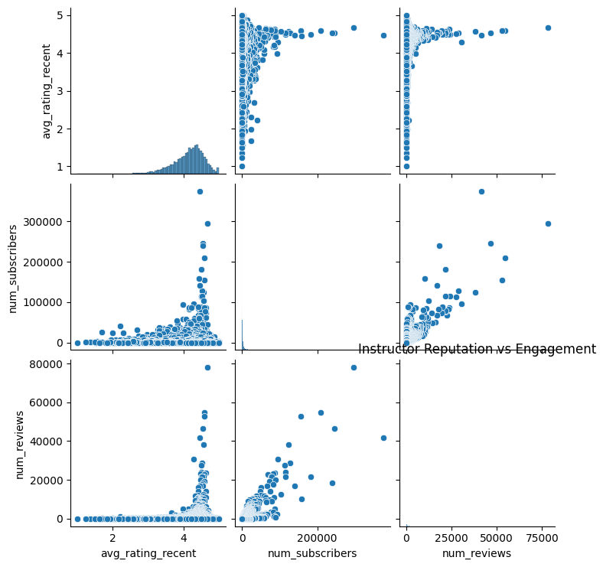

*Figure 12: Pairplot visually representing the correlation between instructor reputation and engagement*

Instructors with consistently high ratings and positive reviews are more likely to attract new subscribers and foster active participation, as learners value the expertise, teaching style, and overall learning experience provided by reputable instructors.

**Conclusion**

The success of online courses on platforms like Udemy is influenced by a multitude of factors, including course features, ratings, pricing strategies, and instructor reputation. While some factors, such as course duration and pricing, exhibit moderate correlations with subscriber numbers and engagement, others, like wishlisting and seasonal patterns, seem to have a less significant impact.

Ultimately, a combination of high-quality content, comprehensive course design, attractive pricing, and a reputable instructor appears to be the recipe for attracting a substantial subscriber base and fostering active learner engagement. Online education platforms should leverage these insights to refine their course offerings, pricing models, and instructor onboarding processes, catering to the evolving needs and preferences of learners in the digital age.

By continuously analysing and understanding the factors influencing course success, platforms like Udemy can enhance the learning experience, drive higher subscriber growth, and solidify their position as leading providers of accessible and effective online education.