GeoViz Analytics

A project report submitted in partial fulfillment of the requirements for the award of the degree of

BACHELOR OF COMPUTER APPLICATION
BY

ANURADHA MOHAN PRAJAPATI
Seat Number: 5862

Under the esteemed guidance of
PROF. KSHITIZ TIWARI

DEPARTMENT OF COMPUTER APPLICATION

MAHATMA EDUCATION SOCIETY’S
PILLAI COLLEGE OF ARTS COMMERCE & SCIENCE (AUTONOMUS)
(Affiliated to University of Mumbai)
NEW PANVEL - 410206, MAHARASHTRA
YEAR 2025-2026

Mahatma Education Society’s
PILLAI COLLEGE OF ARTS, COMMERCE & SCIENCE
(Autonomous), New Panvel
Re-accredited “A” Grade by NAAC (3rd Cycle)

CERTIFICATE

This is to certify that the project entitled “GeoViz Analytics”, is Bonafide work of Miss. Anuradha Mohan Prajapati bearing Seat No: 5862 submitted in partial fulfillment of the requirements for the award of degree of BACHELOR OF COMPUTER APPLICATION from University of Mumbai.

Internal Guide Coordinator

Prof. Kshitiz Tiwari Prof. Shrividhya Nair

College Seal

Date: External Examiner

ACKNOWLEDGEMENT

I would like to express my sincere gratitude to all those who supported me throughout the completion of this project. First and foremost, I extend my heartfelt thanks to my project guide, Prof. Kshitiz Tiwari, for their invaluable guidance, encouragement, and constructive feedback, which greatly contributed to the success of this work.
I am also deeply thankful to our course coordinator, Prof. Shrividhya Nair, for their continuous support and timely assistance, and to our Head of Department, Prof. Dipika Sharma, for their encouragement and for providing the necessary direction that helped me stay focused on my goals.
I am grateful to Department of Computer Application for providing the necessary resources and a conducive environment to carry out this project. My appreciation goes to my classmates and friends for their constant support, insightful discussions, and motivation during challenging times.
Finally, I owe my deepest gratitude to my family for their unwavering encouragement, patience, and belief in me, which inspired me to persevere and complete this project successfully.

Yours faithfully,
Anuradha Prajapati
(S.Y. BCA.)

DECLARATION

I hereby declare that this project report entitled "GeoViz Analytics" submitted by me to University of Mumbai is a record of my original work carried out under the guidance of Prof. Kshitiz Tiwari. This project has not been submitted to any other institution or university for the award of any degree, diploma, or certificate.
I further declare that all sources of information and assistance have been duly acknowledged in the report.

Date: Signature of Student

Place: Name of Student

TABLE OF CONTENTS

Chapter | Title | Page No.
1 | INTRODUCTION | 1
 | 1.1 Introduction | 1
 | 1.2 Define the “Problem” | 1
 | 1.3 Objectives | 2
2 | REVIEW OF LITERATURE | 2
3 | STUDY AREA | 3
 | 3.1 Location and Extent | 3
 | 3.2 General Description of Study Area | 4
4 | MATERIALS & METHODS | 5
 | 4.1 Materials Used | 5
 | 4.2 Software Used | 5
 | 4.3 Data Processing | 6
 | 4.3.1 Digitization | 6
 | 4.4 Research Methodology | 6
 | 4.5 Steps in Analysis (Flowchart) | 7
5 | CODE | 8
 | 5.1 Main Application (app.py) | 8
 | 5.2 Database Manager (db_manager.py) | 10
 | 5.3 Data Loader (data_loader.py) | 11
6 | RESULTS | 12
 | 6.1 The Atlas: Default view (population) (Screenshots) | 12
 | 6.2 The Atlas: Metric Comparison (GDP/Area) (Screenshots) | 12
 | 6.3 The Map Quiz: Game Interface (Screenshots) | 13
 | 6.4 Performance Dashboard: Analytics (Screenshots) | 13
 | 6.5 Performance Dashboard: Attempt History(Screenshots) | 14
 | 6.6 User Profile (Screenshots) | 14
7 | CONCLUSION | 15
 | 7.1 Overall Conclusion | 15
 | 7.2 Future Developments | 15
 | REFERENCES / BIBLIOGRAPHY | 16

ABSTRACT
In the modern digital era, traditional methods of learning geography—such as static maps and rote memorization—often fail to engage students effectively. This disconnect leads to poor retention of critical geospatial knowledge, including country locations, capitals, and demographic statistics. GeoViz Analytics is a Python-based geospatial dashboard designed to bridge this gap by gamifying education through interactive data visualization.
Built using the Streamlit framework, the application integrates Plotly for dynamic mapping and SQLite for performance tracking. The system offers four core functionalities: a Data Explorer (Atlas) for analyzing global demographics, a Map Quiz for testing knowledge, a Performance Dashboard that utilizes data analytics to identify user strengths and weaknesses, and a User Profile section for personalized settings.
By transforming static data into an interactive learning experience, this project demonstrates the practical application of Data Engineering, Interactive Visual Analytics, and State Management in a cohesive web application. The result is a user-friendly platform that not only tests knowledge but actively assists in the learning process through immediate visual feedback and historical performance analysis.

LIST OF FIGURES

Fig 4.1 | System Architecture Diagram | 9
Fig 6.1 | The Atlas: Default View (Population) | 19
Fig 6.2 | The Atlas: Comparison Mode (GDP/Area) | 19
Fig 6.3 | Map Quiz: Game Interface | 20
Fig 6.4 | Performance Dashboard: Analytics Charts | 21
Fig 6.5 | Performance dashboard: attempt history
Fig 6.6 | User Profile

LIST OF TABLES
Table No. | Title of Table | Page No.
Table 2.1 | Comparison of Geospatial Educational Tools | 5
Table 3.1 | Dataset Attributes & Metadata (ISO3, GDP, etc.) | 7

SYMBOLS & ABBREVIATIONS

Abbreviation | Full Form / Description
API | Application Programming Interface
CSS | Cascading Style Sheets
CSV | Comma-Separated Values
DB | Database
DFD | Data Flow Diagram
GDP | Gross Domestic Product
GUI | Graphical User Interface
IDE | Integrated Development Environment
ISO | International Organization for Standardization
KPI | Key Performance Indicator
MVC | Model-View-Controller
SQL | Structured Query Language
UI | User Interface
UX | User Experience

1.1 INTRODUCTION
Geospatial Intelligence (GEOINT) is a rapidly expanding field used in logistics, defense, and business intelligence. However, the foundational skills required to understand this data—basic geography—are often neglected in education. With the advent of Python libraries like Streamlit and Plotly, it is now possible to create "Smart Atlases" that are not just images, but interactive software capable of analyzing user behavior.
This project, GeoViz Analytics, serves as a Python-based geospatial dashboard designed to gamify education. By leveraging interactive technologies and static datasets, the application transforms raw geographical data into an engaging learning experience.

1.2 DEFINE THE “PROBLEM”
Students and enthusiasts often struggle to retain geographical facts (capitals, locations, demographics) because learning materials are passive.
- Lack of Interactivity: Traditional paper maps and PDF atlases are static.
- No Feedback Loop: A student reading an atlas doesn't know if they have retained the information until they fail an exam.
- One-Size-Fits-All: Learning materials do not adapt to the user's specific weak points (e.g., confusing countries in Africa vs. South America).
There is a lack of accessible tools that adapt to the user's learning curve by tracking mistakes and focusing on weak areas using data analytics.

1.3 OBJECTIVES
The primary objectives of this project are:
- To Develop a Geospatial Dashboard: Create a web-based application using Python and Streamlit.
- To Implement Visualization: Use interactive choropleth maps (Plotly) where data such as GDP and Population determine visual output.
- To Gamify Learning: Create a quiz engine that tests users on country locations and capitals.
- To Analyze Performance: Build a persistent tracking system (SQLite) to save user scores and identify weak geographical regions.

2. REVIEW OF LITERATURE
Before developing GeoViz Analytics, a thorough study of existing geospatial educational tools was conducted.
- Google Earth: A 3D representation of the Earth based on satellite imagery.
  - Observation: While visually stunning, it is an exploration tool, not an educational testing platform. It lacks structured quizzes or performance tracking mechanisms.
- Seterra: A popular web-based map quiz game.
  - Observation: It relies on static 2D images and rote memorization. It does not provide "Business Intelligence" style dashboards to analyze performance (e.g., heatmaps of user accuracy).
- Static Kaggle Datasets:
  - Observation: Many data science projects visualize static CSV data, but few integrate them into a real-time, gamified feedback loop that updates a database based on user interaction.
Research Gap: The comparison reveals a gap for a lightweight, data-driven application that combines visual exploration with rigorous testing and analytics. GeoViz Analytics fills this gap.

Table 2.1: Comparison of Geospatial Educational Tools
Feature | GeoViz Analytics | Google Earth | Seterra | Sporcle
Primary Purpose | Gamified Analysis | Visual Exploration | Map Quizzes | General Trivia
Interactive Maps | Yes (Plotly) | Yes (3D Globe) | No (Static Images) | No
Performance Tracking | Yes (Database) | No | Limited | Yes (Basic Score)
Analytics Dashboard | Yes (Heatmaps) | No | No | No
Customizability | High (Open Source) | Low (Proprietary) | None | Low
Cost | Free | Free / Pro | Free / Ads | Free / Ads

3. STUDY AREA

3.1 Location and Extent
Unlike traditional GIS projects focused on a specific city or district, the "Study Area" for GeoViz Analytics is Global.
- Extent: The application covers the entire terrestrial globe, including all continents (Africa, Americas, Asia, Europe, Oceania, and Antarctica).
- Scope: It utilizes the ISO 3166-1 alpha-3 standard (3-letter country codes) to map political boundaries of over 195 sovereign states and territories.

3.2 General Description of Study area
The study area encompasses the political geography of the world. The primary features analyzed within this area include:
- Demographics: Human population distribution across nations.
- Economics: GDP (Gross Domestic Product) distribution.
- Political Boundaries: The spatial definition of countries and their respective capital cities.
- Regional Groupings: The classification of countries into major regions (e.g., Sub-Saharan Africa, Western Europe) for analytical grouping in the dashboard.
Table 3.1: Dataset Attributes & Metadata
Attribute Name | Data Type | Description | Example Value
ISO3 | String (3 Char) | Unique Country Code (Primary Key) | "IND", "USA"
Country | String | Official Name of the Nation | "India", "France"
Region | String | Continental Location | "Asia", "Europe"
Capital | String | Administrative Capital City | "New Delhi", "Paris"
Population | Integer | Total Citizen Count | 1,380,004,385
GDP_Billions | Float | Gross Domestic Product (USD) | 2875.14
Attribute Name | Data Type | Description | Example Value
Area_SqKm | Float | Total Land Area | 3287263.0

4. MATERIALS & METHODS

4.1 Materials used
The development of the project required specific hardware and data resources:
- Hardware: Standard Computing System (Intel Core i3+, 4GB RAM).
- Data Sources:
  - Kaggle World Dataset (CSV): A cleaned static file (countries_cleaned_merged.csv) containing merged indicators for Population, GDP, and Area.
  - Natural Earth Data: Vector geometry used internally by Plotly for rendering map shapes.

4.2 Software Used
The project utilizes a specific open-source technology stack:
- Programming Language: Python 3.10+
- IDE: Visual Studio Code (VS Code)
- Web Framework: Streamlit (for UI/UX)
- Visualization Engine: Plotly Express (for Choropleth Maps)
- Database: SQLite3 (Serverless Relational Database)
- Data Processing: Pandas Library

4.3 Data Processing
Data processing involved cleaning and structuring the CSV inputs to ensure accurate mapping. The raw CSV data contained missing values for "Population" and "Region" which were handled using Python's Pandas library:
- Loading: The pandas.read_csv() function loads the dataset into memory.
- Cleaning: Missing numeric values (NaN) in the 'Population' column are filled with 0 to prevent calculation errors.
- Standardization: Country names are standardized to match the ISO-3 codes required by the plotting engine.

4.3.1 Digitization
In the context of this web-GIS application, digitization refers to the conversion of tabular data into spatial vectors:
- Vector Mapping: The system uses ISO-3 Codes (e.g., "IND", "USA") as the primary key.
- Geometry Linking: These keys are linked to the built-in geometry files within the Plotly library (sourced from Natural Earth).
- Rendering: The software dynamically "digitizes" the map by coloring the vector polygons based on the attribute data (e.g., turning a country polygon Red or Green based on Quiz results).

4.4 Research Methodology
The project followed the Rapid Application Development (RAD) methodology, focusing on quick iterations and user feedback.
- Requirement Gathering: Identified the need for gamified geography tools.
- Data Modeling: Designed the SQLite schema (user_stats table) to track attempts and accuracy.
- Prototype Development: Created the "Atlas" module first to verify map rendering.
- Integration: Connected the Quiz front-end logic with the Database back-end.
- Testing: Performed Black Box testing to ensure the map interactions and score updates functioned correctly.

4.5 Steps in analysis
The analysis logic follows a linear flow from User Interaction to Database Update.
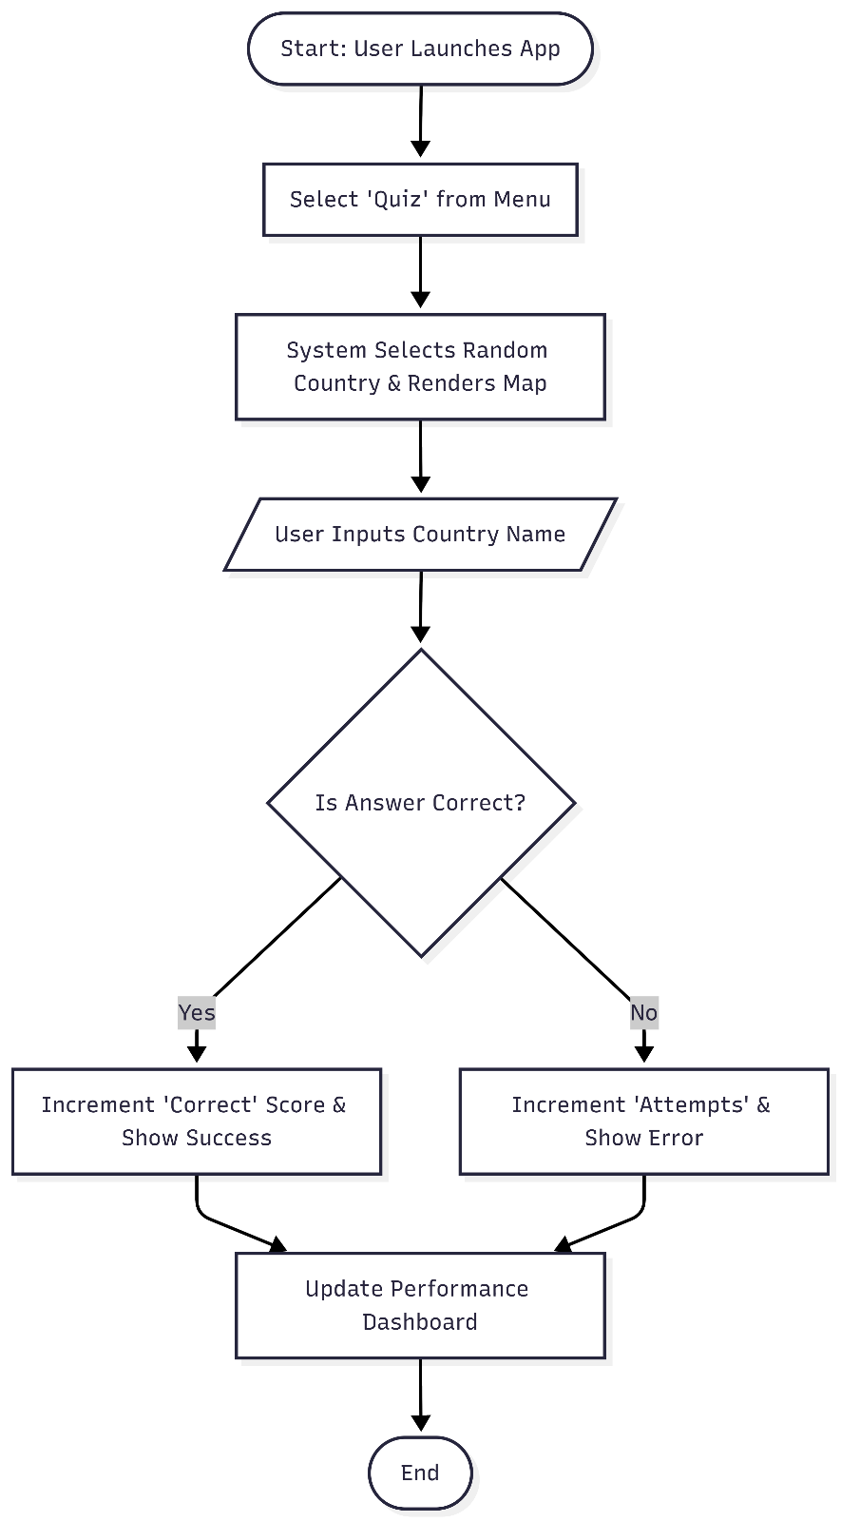
Fig 4.1: System Architecture Diagram

5. CODE

5.1 Main Application (app.py)
import streamlit as st
from streamlit_option_menu import option_menu
import plotly.express as px
import pandas as pd
from data_loader import load_data
from db_manager import init_db, update_user_stats, get_user_stats

st.set_page_config(page_title="GeoViz Analytics", layout="wide")

# Initialize DB and Load Static CSV Data
def local_css(file_name):
with open(file_name) as f:
st.markdown(f"<style>{f.read()}</style>", unsafe_allow_html=True)

local_css("style.css")
init_db()
df = load_data()

# --- SIDEBAR ---
with st.sidebar:
st.title("GeoViz Analytics")
selected = option_menu(
menu_title="Main Menu",
options=["The Atlas", "Map Quiz", "Performance Dashboard", "User Profile"],
icons=["globe", "controller", "bar-chart", "person-circle"],
default_index=0,
)

# --- THE ATLAS ---
if selected == "The Atlas":
st.title("🌍 The Atlas: Data Explorer")
metric = st.selectbox("Select Metric", ["Population", "GDP_Billions", "Area_SqKm"])

fig = px.choropleth(
df, locations="ISO3", color=metric,
hover_name="Country", hover_data=["Capital", "Region"],
color_continuous_scale="Viridis", projection="natural earth"
)
st.plotly_chart(fig, use_container_width=True)

# --- MAP QUIZ ---
elif selected == "Map Quiz":
st.title("🎮 Geography Quiz")
if 'target_country' not in st.session_state:
st.session_state.target_country = df.sample(1).iloc[0]

target = st.session_state.target_country
df['ColorGroup'] = df['ISO3'].apply(lambda x: 'Target' if x == target['ISO3'] else 'Other')
color_map = {'Target': 'red', 'Other': '#eeeeee'}

fig = px.choropleth(
df, locations="ISO3", color="ColorGroup",
color_discrete_map=color_map, projection="natural earth"
)
fig.update_layout(showlegend=False)
st.plotly_chart(fig, use_container_width=True)

with st.form("quiz_form"):
ans = st.text_input("Name the highlighted country:")
submitted = st.form_submit_button("Submit")
if submitted:
if ans.strip().lower() == target['Country'].lower():
st.success("Correct!")
update_user_stats(target['Country'], target['Region'], 1)
else:
st.error(f"Wrong! It was {target['Country']}.")
update_user_stats(target['Country'], target['Region'], 0)
st.form_submit_button("Next", on_click=lambda: st.session_state.pop('target_country'))

# --- DASHBOARD ---
elif selected == "Performance Dashboard":
st.title("📈 User Analytics")
stats = get_user_stats()
if not stats.empty:
stats['Accuracy'] = (stats['correct'] / stats['attempts']) * 100
st.metric("Total Quizzes", stats['attempts'].sum())
st.bar_chart(stats.groupby('region')['Accuracy'].mean())
st.dataframe(stats)
else:
st.info("No data yet.")

# --- USER PROFILE ---
elif selected == "User Profile":
st.title("👤 User Profile")
st.markdown("### User Details")
col1, col2 = st.columns(2)
with col1:
st.text_input("Username", value="Student_01")
with col2:
st.metric("Status", "Active Learner")

5.2 Database Manager (db_manager.py)
import sqlite3
import pandas as pd

DB_NAME = "user_stats.db"

def init_db():
conn = sqlite3.connect(DB_NAME)
c = conn.cursor()
c.execute('''CREATE TABLE IF NOT EXISTS stats (
country TEXT PRIMARY KEY, region TEXT,
attempts INTEGER DEFAULT 0, correct INTEGER DEFAULT 0)''')
conn.commit()
conn.close()

def update_user_stats(country, region, is_correct):
conn = sqlite3.connect(DB_NAME)
c = conn.cursor()
c.execute("SELECT * FROM stats WHERE country = ?", (country,))
data = c.fetchone()
if data:
new_attempts = data[2] + 1
new_correct = data[3] + (1 if is_correct else 0)
c.execute("UPDATE stats SET attempts = ?, correct = ? WHERE country = ?",
(new_attempts, new_correct, country))
else:
c.execute("INSERT INTO stats (country, region, attempts, correct) VALUES (?, ?, 1, ?)",
(country, region, 1 if is_correct else 0))
conn.commit()
conn.close()

def get_user_stats():
conn = sqlite3.connect(DB_NAME)
df = pd.read_sql_query("SELECT * FROM stats", conn)
conn.close()
return df

5.3 Data Loader (data_loader.py)
import pandas as pd
import streamlit as st

@st.cache_data
def load_data():
try:
# Load local CSV instead of API
df = pd.read_csv("countries_cleaned_merged.csv")
df['Population'] = df['Population'].fillna(0)
df['Region'] = df['Region'].fillna('Unknown')
return df
except Exception as e:
st.error(f"Error loading data: {e}")
return pd.DataFrame()

6. RESULTS
The project successfully generated a functional Interactive Dashboard using the CSV dataset. The following outputs were achieved:
6.1 THE ATLAS: DEFAULT VIEW (POPULATION)
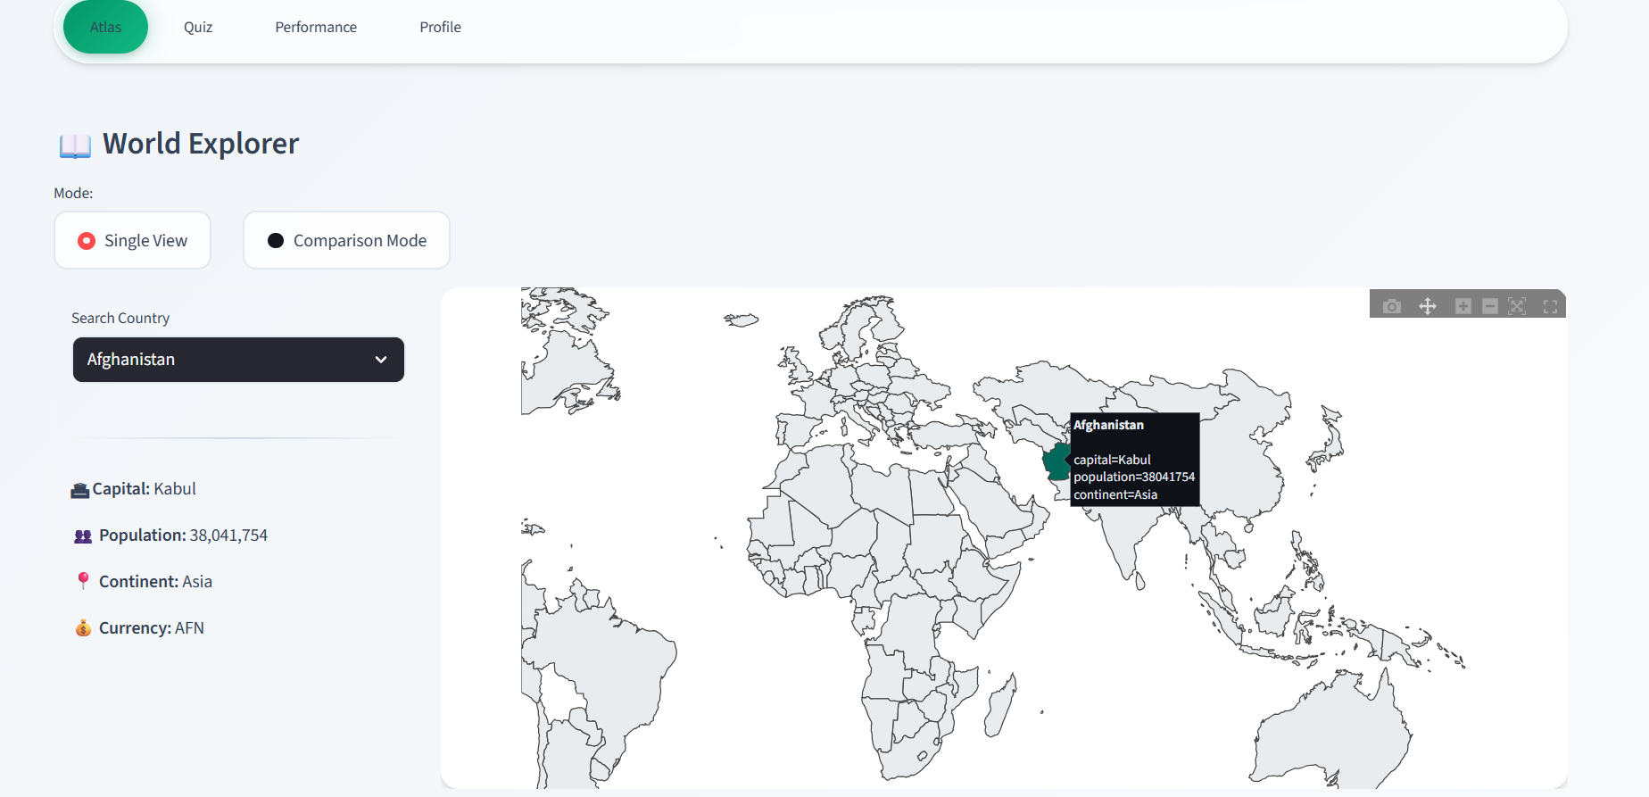
Fig 6.1: The interactive World Map showing global population density.

6.2 THE ATLAS: METRIC COMPARISON (GDP/AREA)

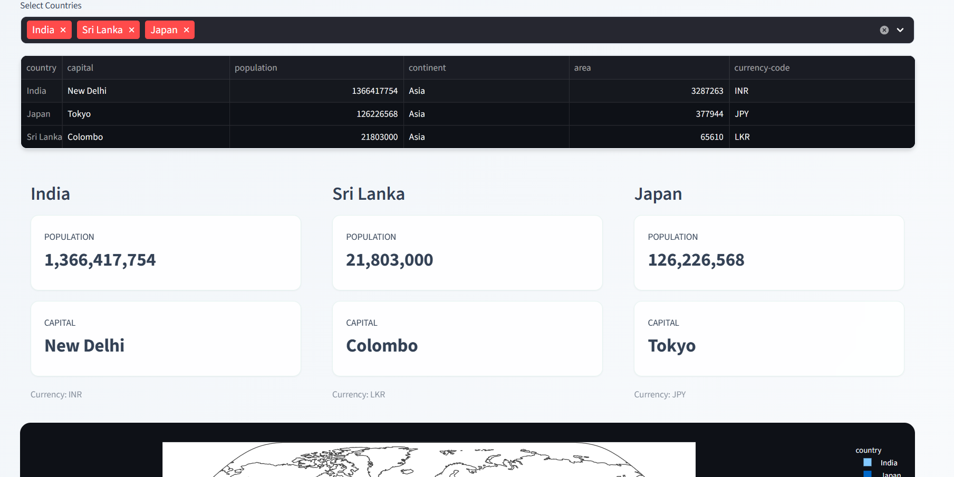
Fig 6.2: The Atlas in Comparison Mode.

6.3 THE MAP QUIZ: GAME INTERFACE

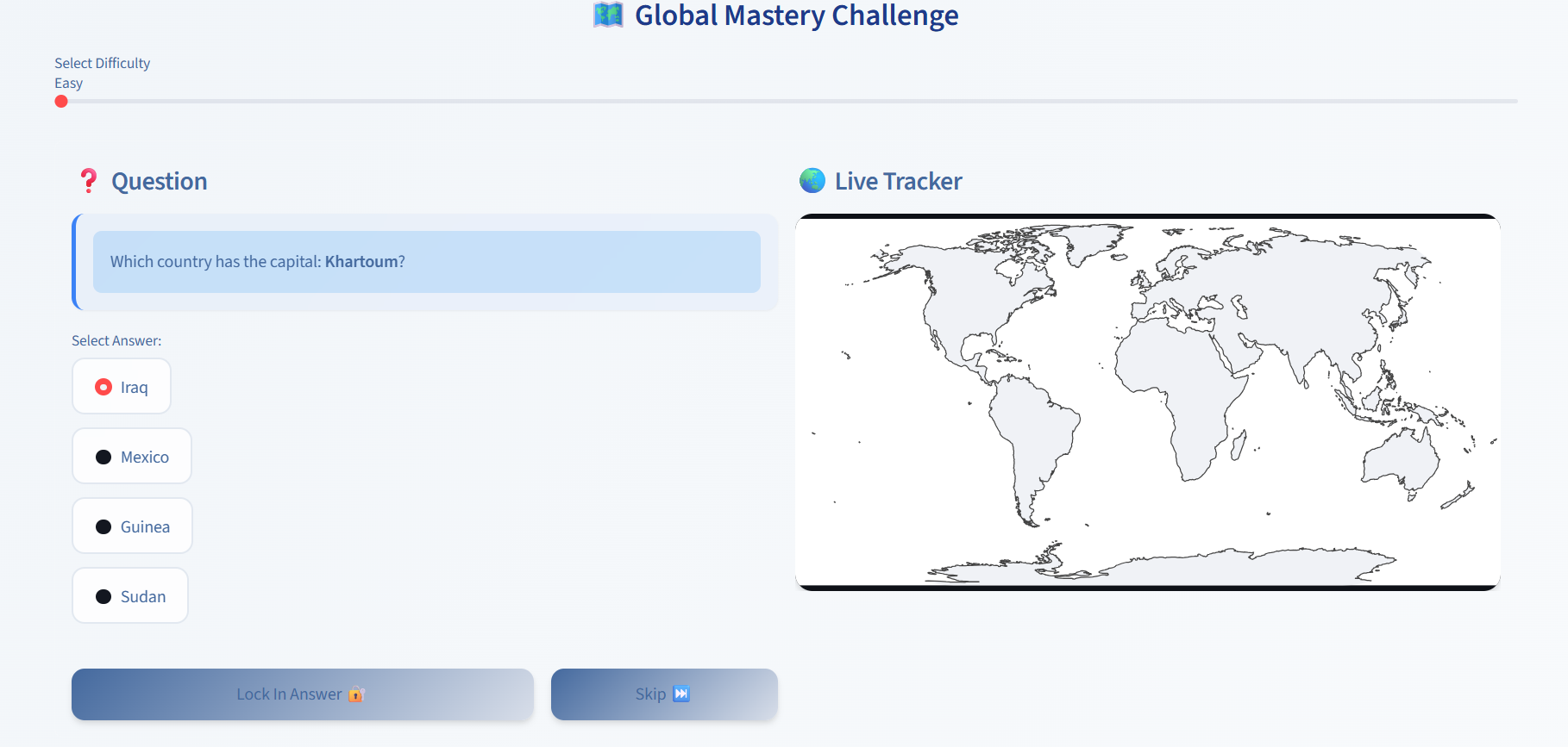
Fig 6.3: The Gamified Quiz Interface.

6.4 PERFORMANCE DASHBOARD: ANALYTICS

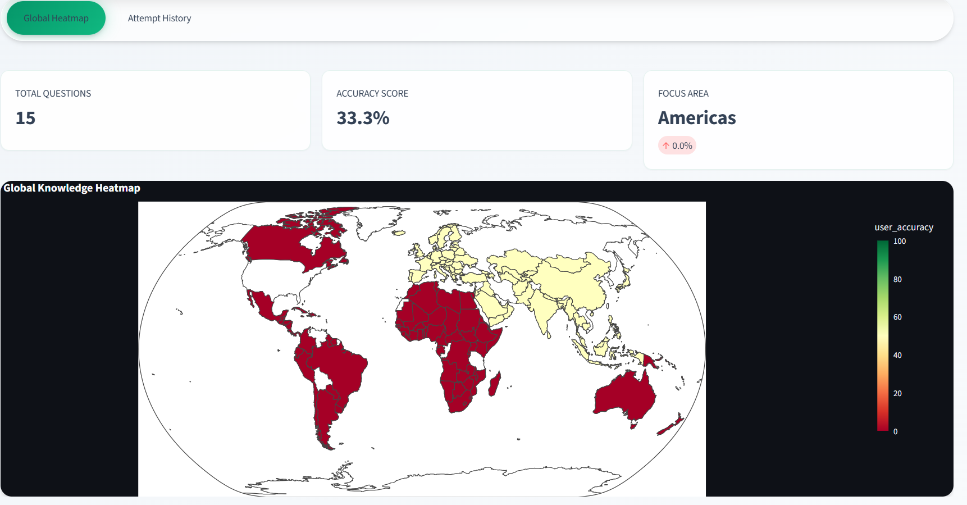
Fig 6.4: Visual Analytics.

6.5 PERFORMANCE DASHBOARD: ATTEMPT HISTORY

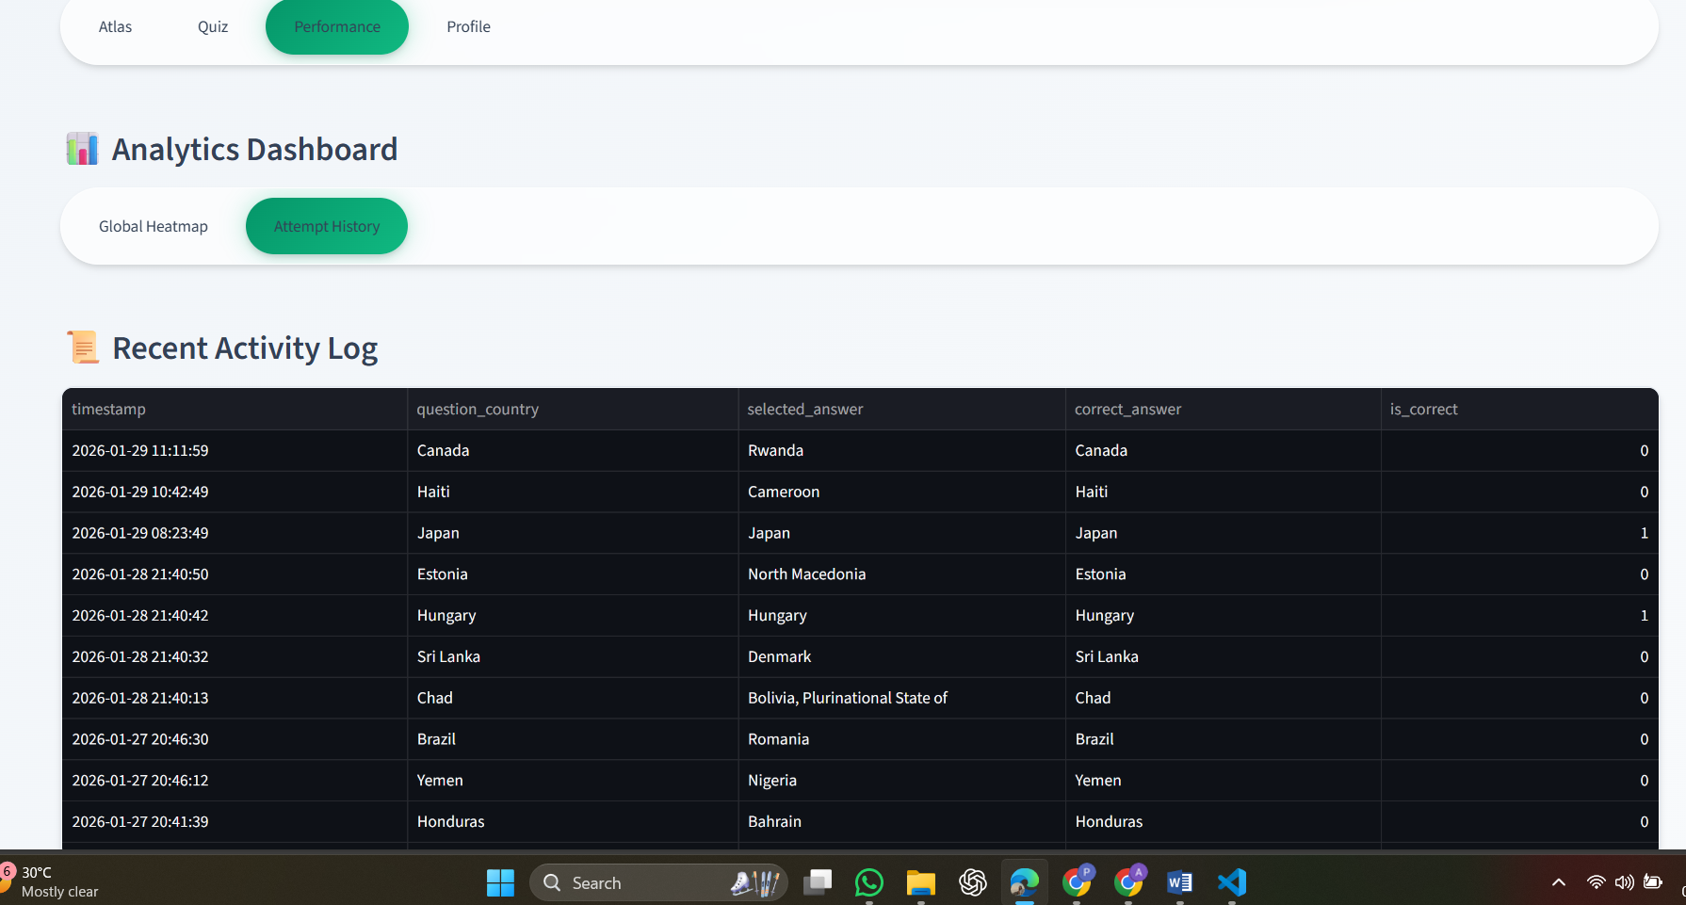
Fig 6.5: Detailed Attempt History.

6.6 USER PROFILE

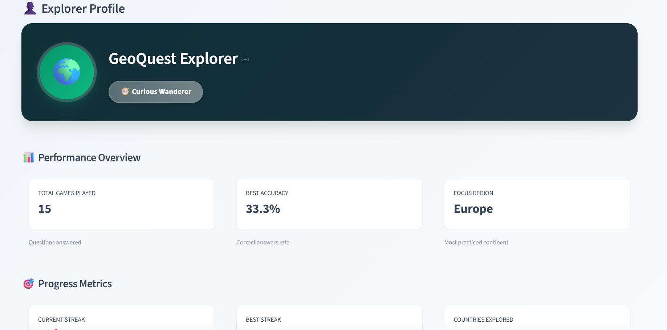
Fig 6.6: User Profile Management.

7. CONCLUSION

7.1 Overall conclusion
GeoViz Analytics has successfully demonstrated the power of Python in the domain of Geospatial Intelligence. The project met all its initial objectives:
- It replaced static learning with interactive exploration.
- It successfully implemented a database-backed feedback loop.
- It proved that complex GIS concepts (Choropleth mapping) can be made accessible via a web browser using standard CSV data sources.
The application serves as a robust prototype for a modern educational tool, proving that gamification is an effective method for teaching geography.

7.2 Future developments
To further enhance the system, the following developments are proposed:
- Live API Integration: Transitioning from the current CSV file to a live REST API (e.g., REST Countries API) to ensure data is always up-to-date.
- Fuzzy String Matching: Implementing algorithms to accept answers with minor spelling mistakes (e.g., accepting "Brazil" for "Brasil").
- Mobile Optimization: Refining the CSS layout to ensure the map renders smoothly on smartphone screens.

REFERENCES / BIBLIOGRAPHY
- Rossum, G., Python Language Reference, version 3.10, Python Software Foundation, 2023.
- McKinney, W., Python for Data Analysis, O'Reilly Media, 2012.
- Streamlit Inc., Streamlit Documentation, Streamlit Inc., 2023.
- Plotly Technologies, Plotly Python Graphing Library, Plotly Inc., 2023.
- Kaggle, World Metrics Dataset (CSV), 2022.
- https://docs.streamlit.io
- https://plotly.com/python/choropleth-maps/

