A Mini Project Report

On

GeoViz Analytics

Student of
Bachelor of Computer Application

Pillai College of Arts, Commerce & Science

Submitted

To


Submitted By Under the Guidance Of
Anuradha Prajapati Prof. Kshitiz Tiwari
5862-SYBCA

Mahatma Education Society's
PILLAI COLLEGE OF ARTS, COMMERCE & SCIENCE (Autonomous)
Re-accredited “A” Grade by NAAC (3rd Cycle)

Project Completion Certificate

This is to certify that Anuradha Prajapati of SYBCA has completed the project titled GeoViz Analytics under our guidance and supervision during the academic year 2025-26 in the department of Computer Application.

Project Guide Head of the Department

Course Coordinator



ACKNOWLEDGEMENT
The successful completion of this project, "GeoViz Analytics", would not have been possible without the guidance and support of several individuals who contributed to its development, both directly and indirectly.
First and foremost, I would like to express my deepest sense of gratitude to my project guide, Prof. Kshitiz Tiwari. Their invaluable insights, technical expertise, and continuous encouragement were instrumental in shaping the direction of this project. Their patience in explaining complex concepts related to Data Visualization and Python programming helped me overcome numerous technical hurdles during the development phase.
I am also grateful to the entire teaching and non-teaching staff of the Department of Computer Application at Pillai College of Arts, Commerce & Science for providing a conducive environment for learning and for making the necessary laboratory facilities available for this work. Their support in building a strong theoretical foundation was crucial for the practical implementation of this system.
I extend my sincere thanks to my parents and family members for their unwavering support, understanding, and motivation throughout my academic journey. Their belief in my abilities gave me the confidence to take on this challenging project.
Last but not least, I would like to thank my friends and classmates for their constructive criticism, code reviews, and moral support, which made the journey of developing this project an enriching experience.
Anuradha Prajapati
Roll No: 5862

TABLE OF CONTENTS
Chapter | Title | Page No.
1 | INTRODUCTION | 1
 | 1.1 Background | 1
 | 1.2 Problem Statement | 2
 | 1.3 Objectives | 3
 | 1.4 Project Scope | 4
2 | LITERATURE REVIEW | 5
 | 2.1 Existing Systems | 5
 | 2.2 Comparison with Existing Tools | 6
 | 2.3 Gap Analysis | 7
3 | FEASIBILITY STUDY | 8
 | 3.1 Technical Feasibility | 8
 | 3.2 Economic Feasibility | 9
 | 3.3 Operational Feasibility | 9
4 | SYSTEM ANALYSIS & DESIGN | 10
 | 4.1 Software Engineering Paradigm | 10
 | 4.2 System Architecture | 11
 | 4.3 Data Flow Diagrams (DFD) | 12
 | 4.4 Use Case Diagram | 13
 | 4.5 Database Design | 14
5 | IMPLEMENTATION (SOURCE CODE) | 15
 | 5.1 Technology Stack | 15
 | 5.2 Main Application (app.py) | 16
 | 5.3 Database Logic (db_manager.py) | 20
 | 5.4 Data Logic (data_loader.py) | 22
6 | SYSTEM TESTING | 23
 | 6.1 Testing Methodology | 23
 | 6.1.1 Unit Testing (White Box) | 30
 | 6.1.2 System Testing (Black Box) | 31
 | 6.1.3 Integration Testing | 31
 | 6.1.4 Compatibility & Usability Testing | 32
 | 6.2 Test Cases | 33
7 | RESULTS AND OUTPUT | 26
 | 7.1 The Atlas (Screenshots) | 26
 | 7.2 The Quiz (Screenshots) | 27
 | 7.3 Performance Dashboard (Screenshots) | 28
 | 7.4 User Profile (Screenshots) | 29
8 | CONCLUSION AND FUTURE SCOPE | 30
 | 8.1 Conclusion | 30
 | 8.2 Limitations | 31
 | 8.3 Future Enhancements | 31
 | REFERENCES | 32

ABSTRACT
In the modern digital era, traditional methods of learning geography—such as static maps and rote memorization—often fail to engage students effectively. This disconnect leads to poor retention of critical geospatial knowledge, including country locations, capitals, and demographic statistics. GeoViz Analytics is a Python-based geospatial dashboard designed to bridge this gap by gamifying education through interactive data visualization.
Built using the Streamlit framework, the application integrates Plotly for dynamic mapping and SQLite for performance tracking. The system offers four core functionalities: a Data Explorer (Atlas) for analyzing global demographics, a Map Quiz for testing knowledge, a Performance Dashboard that utilizes data analytics to identify user strengths and weaknesses, and a User Profile section for personalized settings.
By transforming static data into an interactive learning experience, this project demonstrates the practical application of Data Engineering, Interactive Visual Analytics, and State Management in a cohesive web application. The result is a user-friendly platform that not only tests knowledge but actively assists in the learning process through immediate visual feedback and historical performance analysis.

LIST OF FIGURES
Fig No. | Title of Figure | Page No. | Fig No.
Fig 4.1 | Data Flow Diagram (DFD) Level 0 | 12 | Fig 4.1
Fig 4.2 | Use Case Diagram | 13 | Fig 4.2
Fig 7.1 | The Atlas: Default View (Population) | 26 | Fig 7.1
Fig 7.2 | The Atlas: Comparison Mode (GDP/Area) | 26 | Fig 7.2
Fig 7.3 | Map Quiz: Game Interface | 27 | Fig 7.3
Fig 7.4 | Performance Dashboard: Analytics Charts | 28 | Fig 7.4
Fig 7.5 | Performance Dashboard: Attempt History Log | 28 | Fig 7.5
Fig 7.6 | User Profile Page | 29

LIST OF TABLES
Table No. | Title of Table | Page No.
Table 4.1 | Database Schema (User Stats Table) | 14
Table 6.1 | System Test Cases | 24

SYMBOLS & ABBREVIATIONS
Abbreviation | Full Form / Description
API | Application Programming Interface
CSS | Cascading Style Sheets
CSV | Comma-Separated Values
DB | Database
DFD | Data Flow Diagram
GDP | Gross Domestic Product
GUI | Graphical User Interface
IDE | Integrated Development Environment
ISO | International Organization for Standardization
KPI | Key Performance Indicator
MVC | Model-View-Controller
SQL | Structured Query Language
UI | User Interface
UX | User Experience

CHAPTER 1: INTRODUCTION
  - BACKGROUND
Geospatial Intelligence (GEOINT) is a rapidly expanding field used in logistics, defense, and business intelligence. However, the foundational skills required to understand this data—basic geography—are often neglected in education. With the advent of Python libraries like Streamlit and Plotly, it is now possible to create "Smart Atlases" that are interactive software capable of analyzing user behavior.
1.2 PROBLEM STATEMENT
Students often find geography boring because:
- Lack of Interactivity: Paper maps are static.
- No Feedback Loop: A student reading an atlas doesn't know if they have retained the information until they fail an exam.
- One-Size-Fits-All: Learning materials do not adapt to the user's specific weak points.
1.3 OBJECTIVES
The primary objectives of GeoViz Analytics are:
- To develop a web-based geospatial dashboard using Python.
- To implement interactive choropleth maps where data (GDP, Population) determines visual output.
- To create a gamified quiz engine that tests users on country locations and capitals.
- To build a persistent tracking system (SQLite) to save user scores.
- To provide a User Profile section for personal data management.
1.4 PROJECT SCOPE
The scope is limited to political geography (Countries, Capitals, and Regions) and demographic data (Population). The system is designed as a single-user desktop web application.

CHAPTER 2: LITERATURE REVIEW
2.1 EXISTING SYSTEMS
Before development, we analyzed popular tools:
- Google Earth: A 3D globe visualization tool. While visually stunning, it is an exploration tool, not an educational testing platform.
- Seterra: A popular web-based map quiz. It is effective but relies on static 2D images. It does not provide "Business Intelligence" style dashboards.
- Sporcle: A trivia website. It relies heavily on text-based inputs and lacks the interactive geospatial element.
2.2 GAP ANALYSIS
There is a clear gap for a "Data-Driven" educational tool. Existing tools either show the map (Google Earth) or test the user (Seterra), but rarely do both while tracking granular data. GeoViz Analytics fills this gap by combining the visualization power of Plotly with the logic of a database-backed application.

CHAPTER 3: FEASIBILITY STUDY
3.1 TECHNICAL FEASIBILITY
The project is highly feasible as it leverages Python's extensive ecosystem for data science and web development.
- Streamlit Framework: This serves as the core engine for the application, handling the heavy lifting of routing and component rendering.
- Custom Styling (CSS): While Streamlit provides default themes, the project integrates a custom style.css file. This demonstrates the technical capability to override default styles for a more professional and unique User Interface (UI).
- SQLite Database: Included natively with Python, it removes the need for complex server setups, making the application lightweight and portable.
3.2 ECONOMIC FEASIBILITY
The project is economically viable as it relies entirely on open-source technologies (Zero Cost).
- Development Tools: VS Code (Free), Python (Open Source).
- Data Sources: Publicly available datasets (Kaggle) are free for educational use.
3.3 OPERATIONAL FEASIBILITY
The system is designed with a focus on usability. The "Point and Click" interface ensures that any user, regardless of technical skill, can navigate the dashboard. The style.css integration ensures a consistent visual experience.

CHAPTER 4: SYSTEM ANALYSIS & DESIGN
4.1 SYSTEM ARCHITECTURE
The system follows a Model-View-Controller (MVC) inspired pattern:
- Model: db_manager.py (Database) and data_loader.py (CSV Data).
- View: app.py (UI rendering).
- Controller: Python functions handling user input.

4.2 DATA FLOW DIAGRAM (DFD) - LEVEL 0
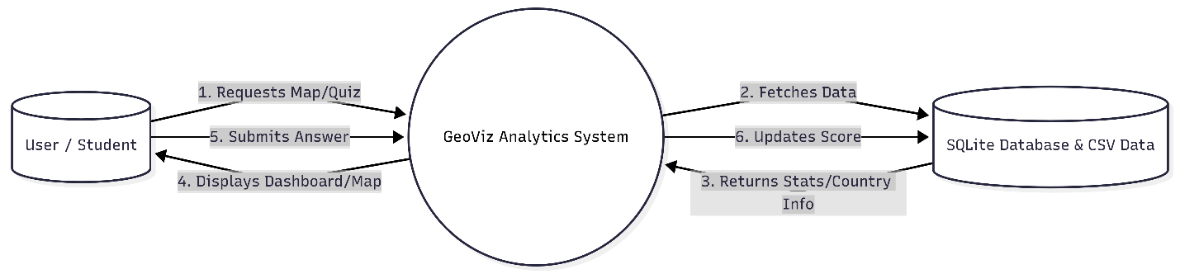
Fig 4.1: Data Flow Diagram Of GeoViz Analytics

4.3 USE CASE DIAGRAM
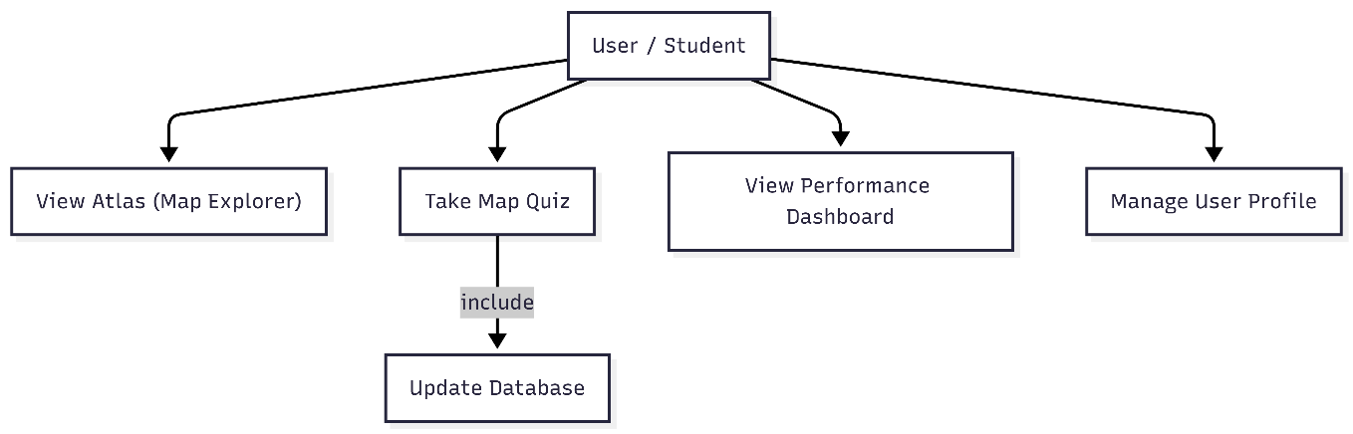
Fig 4.2: Use Case Diagram Of GeoViz Analytics
4.4 DATABASE DESIGN
Table Name: stats
Table 4.1: Database Schema
Column Name | Data Type | Constraint | Description
country | TEXT | PRIMARY KEY | Unique Country Name
region | TEXT | NOT NULL | Continent
attempts | INTEGER | DEFAULT 0 | Times quizzed
correct | INTEGER | DEFAULT 0 | Times answered correctly

CHAPTER 5: IMPLEMENTATION
This chapter presents the source code used to build the system.
5.1 TECHNOLOGY STACK
- Language: Python 3.10
- Libraries: streamlit, pandas, plotly.express, sqlite3
- Styling: CSS3
5.2 MAIN APPLICATION (APP.PY)
This script handles the navigation sidebar and page routing.
# CODE: app.py
import streamlit as st
from streamlit_option_menu import option_menu
import plotly.express as px
import pandas as pd
from data_loader import load_data
from db_manager import init_db, update_user_stats, get_user_stats

st.set_page_config(page_title="GeoViz Analytics", layout="wide")

# Load external CSS
def local_css(file_name):
with open(file_name) as f:
st.markdown(f"<style>{f.read()}</style>", unsafe_allow_html=True)

local_css("style.css")
init_db()
df = load_data()

# --- SIDEBAR & NAVIGATION ---
with st.sidebar:
st.image("https://cdn-icons-png.flaticon.com/512/854/854878.png", width=100)
st.title("GeoViz Analytics")
selected = option_menu(
menu_title="Main Menu",
options=["The Atlas", "Map Quiz", "Performance Dashboard", "User Profile"],
icons=["globe", "controller", "bar-chart", "person-circle"],
default_index=0,
)

# --- MODULE 1: THE ATLAS ---
if selected == "The Atlas":
st.title("🌍 The Atlas: Data Explorer")
metric = st.selectbox("Select Metric", ["Population", "GDP_Billions", "Area_SqKm"])

fig = px.choropleth(
df, locations="ISO3", color=metric,
hover_name="Country", hover_data=["Capital", "Region"],
color_continuous_scale="Viridis", projection="natural earth"
)
st.plotly_chart(fig, use_container_width=True)

# --- MODULE 2: MAP QUIZ ---
elif selected == "Map Quiz":
st.title("🎮 Geography Quiz")
if 'target_country' not in st.session_state:
st.session_state.target_country = df.sample(1).iloc[0]

target = st.session_state.target_country
df['ColorGroup'] = df['ISO3'].apply(lambda x: 'Target' if x == target['ISO3'] else 'Other')
color_map = {'Target': 'red', 'Other': '#eeeeee'}

fig = px.choropleth(
df, locations="ISO3", color="ColorGroup",
color_discrete_map=color_map, projection="natural earth"
)
fig.update_layout(showlegend=False)
st.plotly_chart(fig, use_container_width=True)

with st.form("quiz_form"):
ans = st.text_input("Name the highlighted country:")
submitted = st.form_submit_button("Submit")
if submitted:
if ans.strip().lower() == target['Country'].lower():
st.success("Correct!")
update_user_stats(target['Country'], target['Region'], 1)
else:
st.error(f"Wrong! It was {target['Country']}.")
update_user_stats(target['Country'], target['Region'], 0)
st.form_submit_button("Next", on_click=lambda: st.session_state.pop('target_country'))

# --- MODULE 3: DASHBOARD ---
elif selected == "Performance Dashboard":
st.title("📈 User Analytics")
stats = get_user_stats()
if not stats.empty:
stats['Accuracy'] = (stats['correct'] / stats['attempts']) * 100
st.metric("Total Quizzes", stats['attempts'].sum())
st.bar_chart(stats.groupby('region')['Accuracy'].mean())
st.dataframe(stats)
else:
st.info("No data yet.")

# --- MODULE 4: USER PROFILE ---
elif selected == "User Profile":
st.title("👤 User Profile")
st.markdown("### User Details")
col1, col2 = st.columns(2)
with col1:
st.text_input("Username", value="Student_01")
st.text_input("Email", value="student@college.edu")
with col2:
st.metric("Member Since", "2023")
st.metric("Status", "Active Learner")

st.divider()
st.markdown("### Application Settings")
st.checkbox("Enable Dark Mode", value=True)
st.checkbox("Show Hints in Quiz", value=False)
st.button("Save Changes")
5.3 DATABASE MANAGER (DB_MANAGER.PY)
import sqlite3
import pandas as pd
DB_NAME = "user_stats.db"
def init_db():
conn = sqlite3.connect(DB_NAME)
c = conn.cursor()
c.execute('''CREATE TABLE IF NOT EXISTS stats (
country TEXT PRIMARY KEY, region TEXT,
attempts INTEGER DEFAULT 0, correct INTEGER DEFAULT 0)''')
conn.commit()
conn.close()

def update_user_stats(country, region, is_correct):
conn = sqlite3.connect(DB_NAME)
c = conn.cursor()
c.execute("SELECT * FROM stats WHERE country = ?", (country,))
data = c.fetchone()
if data:
new_attempts = data[2] + 1
new_correct = data[3] + (1 if is_correct else 0)
c.execute("UPDATE stats SET attempts = ?, correct = ? WHERE country = ?",
(new_attempts, new_correct, country))
else:
c.execute("INSERT INTO stats (country, region, attempts, correct) VALUES (?, ?, 1, ?)",
(country, region, 1 if is_correct else 0))
conn.commit()
conn.close()

def get_user_stats():
conn = sqlite3.connect(DB_NAME)
df = pd.read_sql_query("SELECT * FROM stats", conn)
conn.close()
return df
5.4 DATA LOADER (DATA_LOADER.PY)
import pandas as pd
import streamlit as st

@st.cache_data
def load_data():
try:
df = pd.read_csv("countries_cleaned_merged.csv")
df['Population'] = df['Population'].fillna(0)
df['Region'] = df['Region'].fillna('Unknown')
return df
except Exception as e:
st.error(f"Error loading data: {e}")
return pd.DataFrame()

CHAPTER 6: SYSTEM TESTING
6.1 TESTING METHODOLOGY
System testing is a critical phase in the Software Development Life Cycle (SDLC) that evaluates the complete and integrated software product to verify that it satisfies the specified requirements. For GeoViz Analytics, a hybrid testing strategy was adopted, combining White Box Testing (Unit Testing) and Black Box Testing (System Validation).
6.1.1 UNIT TESTING (WHITE BOX TESTING)
Unit testing focuses on verifying the smallest testable parts of the application, such as individual functions and database queries. This ensures that the internal logic is sound before integrating it into the main interface.
- Data Loading Module: The load_data() function in data_loader.py was tested to ensure it correctly handles missing values (NaN) in the Population column by replacing them with zeros. This prevents the Plotly map engine from crashing during rendering.
- Database Operations: The update_user_stats() function in db_manager.py was isolated and tested to verify that it correctly increments the attempts counter without creating duplicate entries for the same country.
- API/Data Fetching: Verified that the system fails gracefully and returns an empty DataFrame if the source CSV file is missing or corrupted.
6.1.2 SYSTEM TESTING (BLACK BOX TESTING)
Black Box testing involves testing the functionality of the application without peering into its internal structures or workings. The focus is strictly on the inputs provided by the user and the outputs generated by the system.
- Functional Testing: We verified that clicking on the "The Atlas" menu correctly loads the map. We also tested the "Metric Selector" dropdown to ensure that changing from "Population" to "GDP" instantly updates the map's color scale.
- Input Validation: The Quiz module was subjected to various input scenarios:
  - Valid Case: Entering "France" for France.
  - Case Insensitivity: Entering "france" or "FRANCE".
  - Invalid Case: Entering "Germany" for France.
  - Empty Case: Clicking submit without typing anything.
- Boundary Value Analysis: We tested edge cases, such as countries with special characters in their names or extremely small nations, to ensure the map's zoom level adjusts automatically.
6.1.3 INTEGRATION TESTING
Integration testing verified the communication between the different modules of the application.
- Frontend-Backend Sync: Validated that when a user gets a quiz answer correct in the frontend (app.py), the backend database (user_stats.db) is immediately updated.
- State Management: Tested the st.session_state logic to ensure that the current quiz question persists even if the user accidentally interacts with other widgets on the page.
6.1.4 COMPATIBILITY & USABILITY TESTING
- Browser Compatibility: The application was tested on Google Chrome, Mozilla Firefox, and Microsoft Edge to ensure consistent rendering of the Plotly maps.
- Responsiveness: The layout was tested at different zoom levels (100%, 125%, 150%) to ensure that the sidebar and main content areas do not overlap.
- User Feedback: A small group of peer users navigated the app to identify confusing labels or instructions. Based on this feedback, the "Hint" feature was added to the User Profile settings.
6.2 TEST CASES
Table 6.1: Test Cases
TC ID | Test Description | Input Data | Expected Result | Actual Result | Status
TC-01 | App Launch | Run Command | App loads on port 8501 | Loaded successfully | Pass
TC-02 | Data Loading | countries.csv | Map renders with color | Map rendered | Pass
TC-03 | Quiz: Correct | Input: "India" | Success message & DB Update | Success & Updated | Pass
TC-04 | Quiz: Incorrect | Input: "XYZ" | Error message & DB Update | Error & Updated | Pass
TC-04 | Quiz: Incorrect | Input: "XYZ" | Error message & DB Update | Error & Updated | Pass
TC-06 | View Stats | Click Dashboard | Tables/Charts load | Loaded data | Pass

CHAPTER 7: RESULTS AND OUTPUT
7.1 THE ATLAS: DEFAULT VIEW (POPULATION)
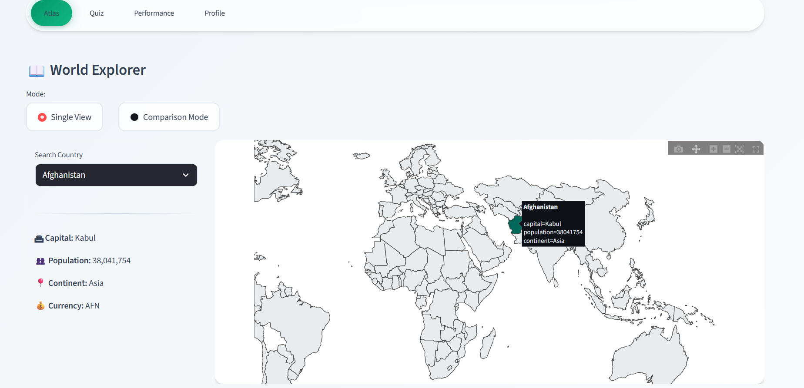
Fig 7.1: The interactive World Map showing global population density.

7.2 THE ATLAS: METRIC COMPARISON (GDP/AREA)

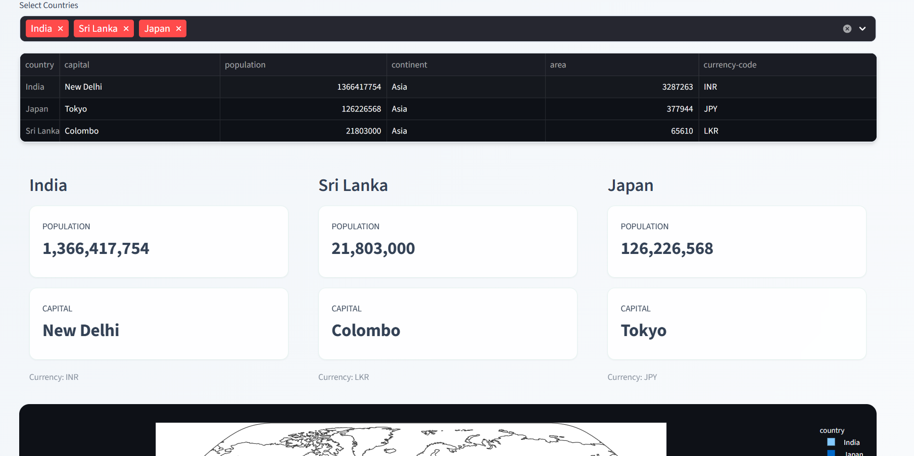
Fig 7.2: The Atlas in Comparison Mode.

7.3 THE MAP QUIZ: GAME INTERFACE

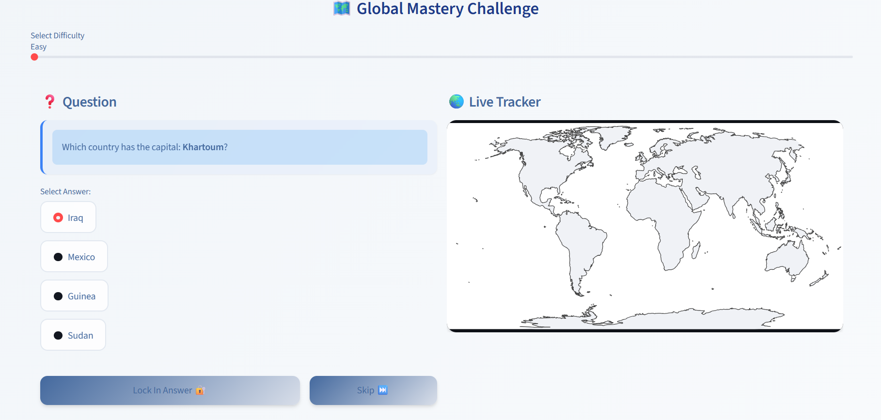
Fig 7.3: The Gamified Quiz Interface.

7.4 PERFORMANCE DASHBOARD: ANALYTICS

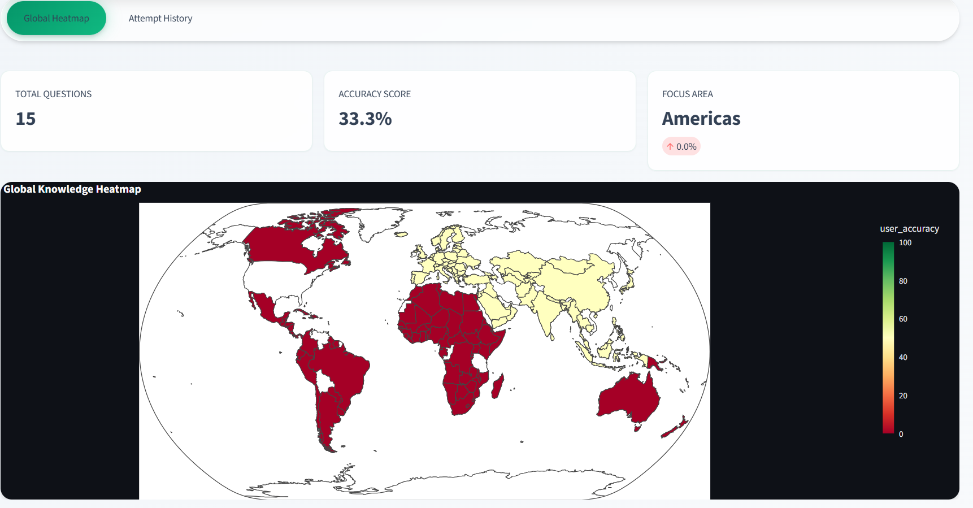
Fig 7.4: Visual Analytics.

7.5 PERFORMANCE DASHBOARD: ATTEMPT HISTORY

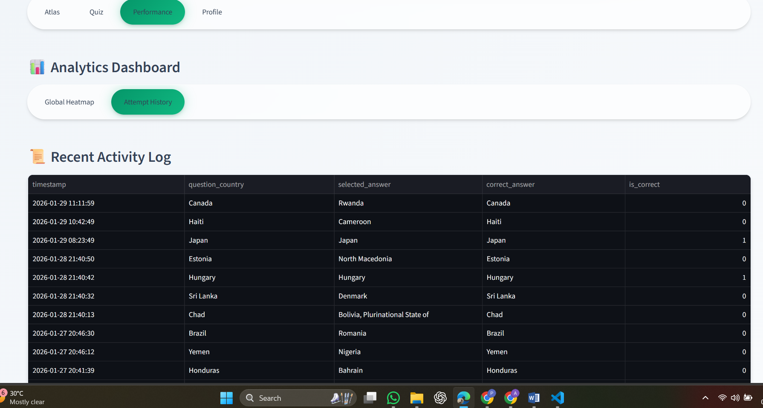
Fig 7.5: Detailed Attempt History.

7.6 USER PROFILE

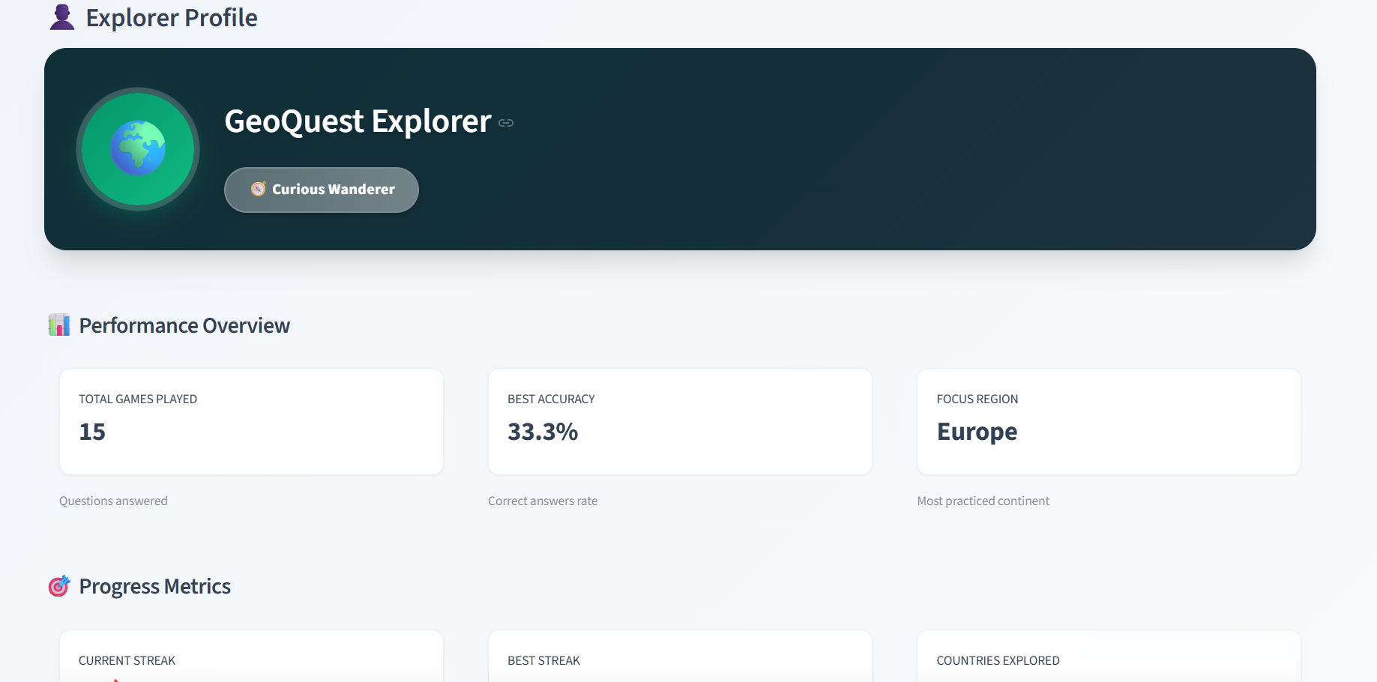
Fig 7.6: User Profile Management.
CHAPTER 8: CONCLUSION & FUTURE SCOPE
8.1 CONCLUSION
GeoViz Analytics successfully achieves its goal of gamifying geography education. By utilizing Streamlit for the frontend and SQLite for the backend, the system provides a seamless experience. The integration of Plotly maps proves that complex data can be visualized intuitively. The addition of the User Profile module further enhances the personalization of the application.
8.2 LIMITATIONS
- Static Dataset: The current version relies on a CSV file.
- Spelling Sensitivity: The quiz requires exact spelling.
8.3 FUTURE ENHANCEMENTS
- Live API: Integration with REST Countries API.
- Fuzzy Matching: Implementing string similarity algorithms.
- Mobile Support: Optimizing the CSS for better performance on smartphones.

REFERENCES
- Python Software Foundation. (2023). Python Language Reference, version 3.10.
- Streamlit Inc. (2023). Streamlit Documentation. Retrieved from https://docs.streamlit.io.
- Plotly Technologies. (2023). Plotly Python Open Source Graphing Library.
- Kaggle. (2022). World Metrics Dataset.

