# French Image Problem Solving

** This was happened due to some of the images does not have language flag in the database.

**1st way: -** I have already downloaded the French and English images, which does not have language flag

This folder is locating at the Ipcom2 Server Folder path -: E:\Anuradha\EnglishImages_ForFrench_Forbidden

As Example: Client is giving the UPC with 12 and 10 digit (**062107090520**) format you have to add 2 digits to the **00062107090520**

When you search, you will get the 2 images as results

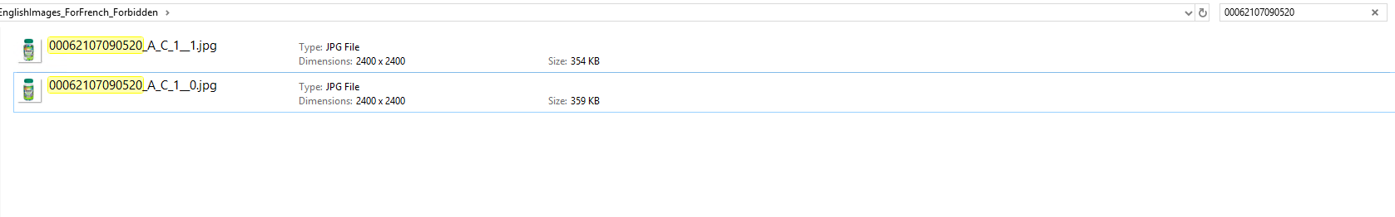

Find out which one is the English image and rename it as the image to the format of the Ipcom1 server image (00062107090520_A_C_1__0 to 00062107090520_A_C_1_.jpg)

90% of the time this works,

**2nd way**

If above folder does not solve the problem you have to download the image from the test server

**Step 1:**  Go to ipecom2 SQL server (Gis_New_Test) Update the **StatusMarketing** field to “0”

**Step 2:** Go to table Identifications update the UPC

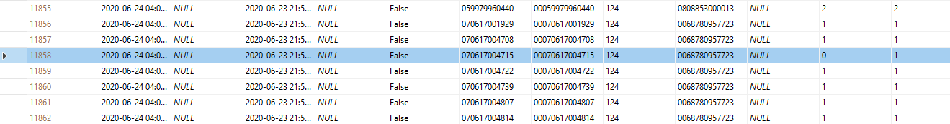

**Step 3:** Open the App on folder path **C:\Anuradha\ClientAppWin in IPCom2**  Run the Windows Client Application

**Step 4:** Click the Image Download Button and

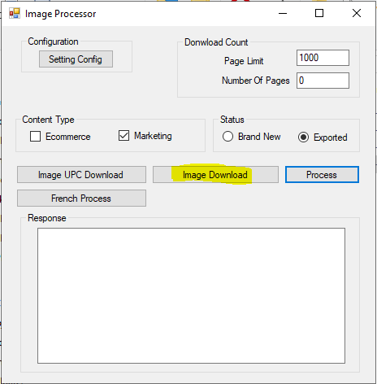

**Step 5:** You Can see the Image Download the in the “**Missing Images folder**”

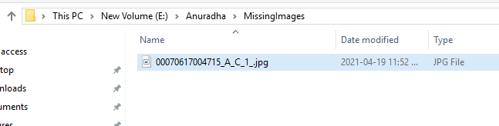

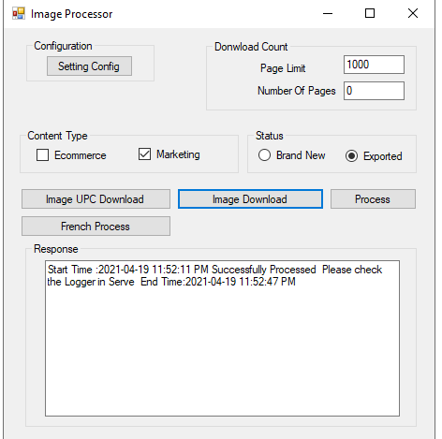

**Step 6:** Copy and Paste the image to the ipcom1 (live server) **E:\Image_Import_Folder\New_Images\GS1**

**\*You cant straight away copy this folder because of its protection level copy to desktop and copy form their**

**Step 7:** Check the image using the Ecom Hub Application