**Step:1**

Click your Maven Project

**Step:2**

Your project will be expanded. Then right click src/main/java

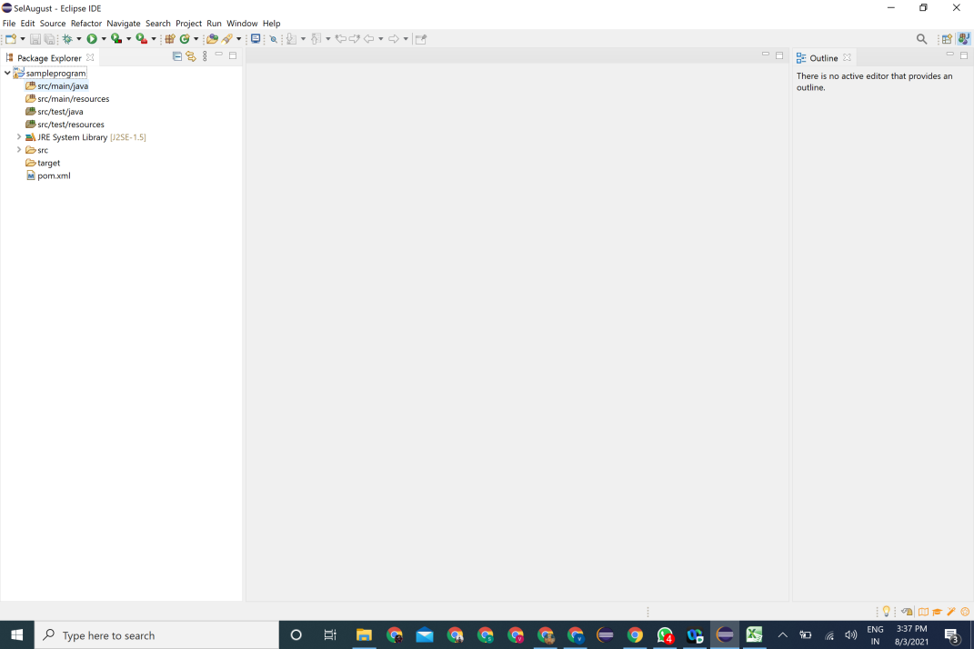

**Step:3**

Then mouse over on New->Package and click

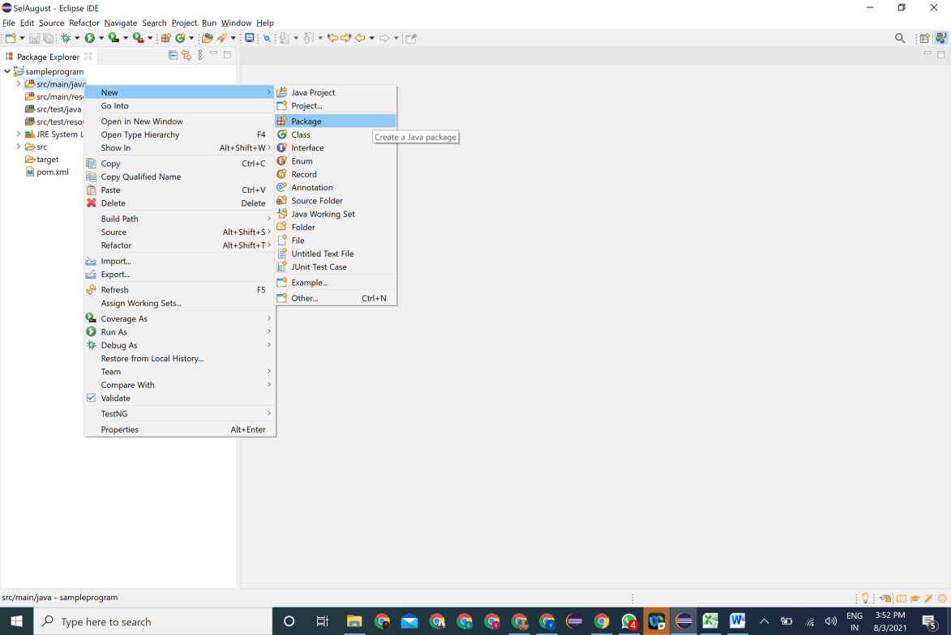

->Give package name (in lowercase) and click finish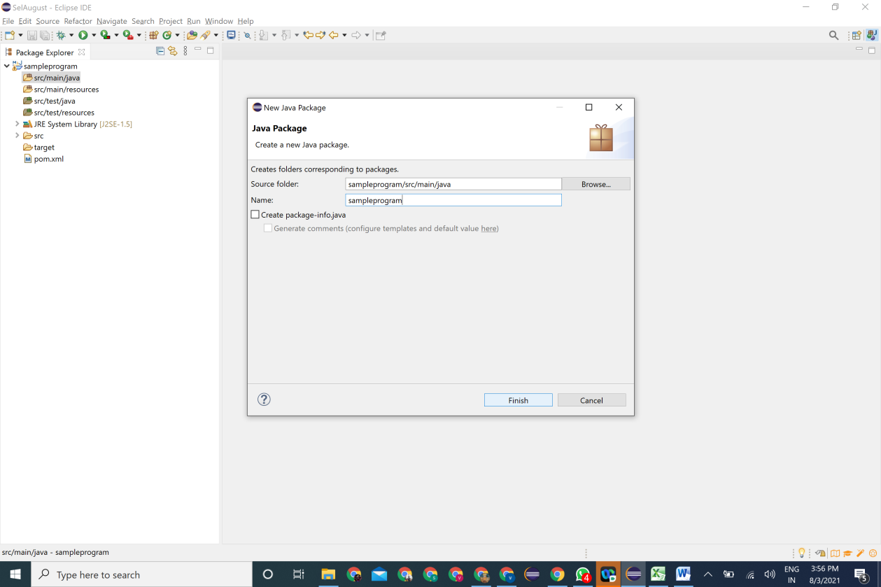

**Step: 5**

Right Click the package and Mouse hover on New->class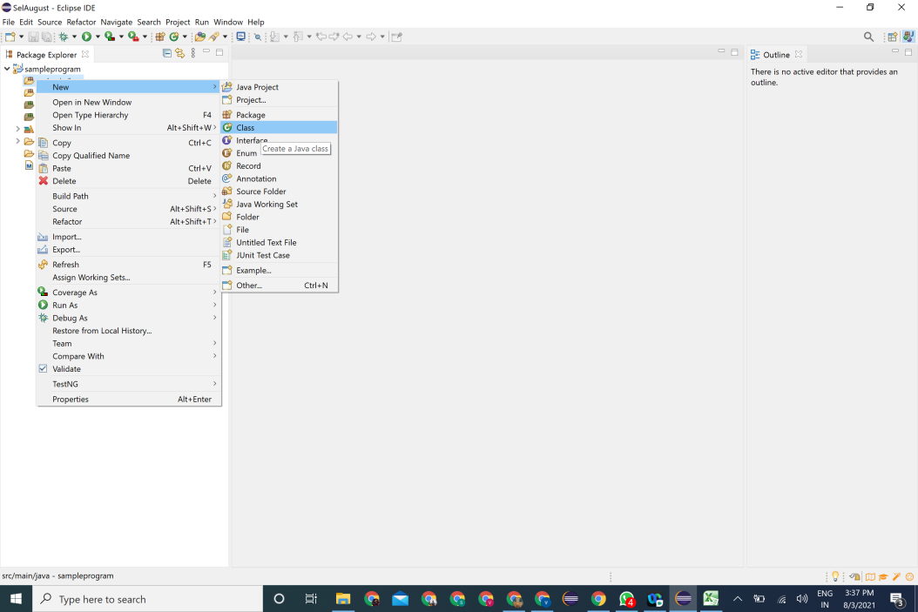

Give name (With first letter Capital) ->click Public Static Void Main(String[] args)->Finish

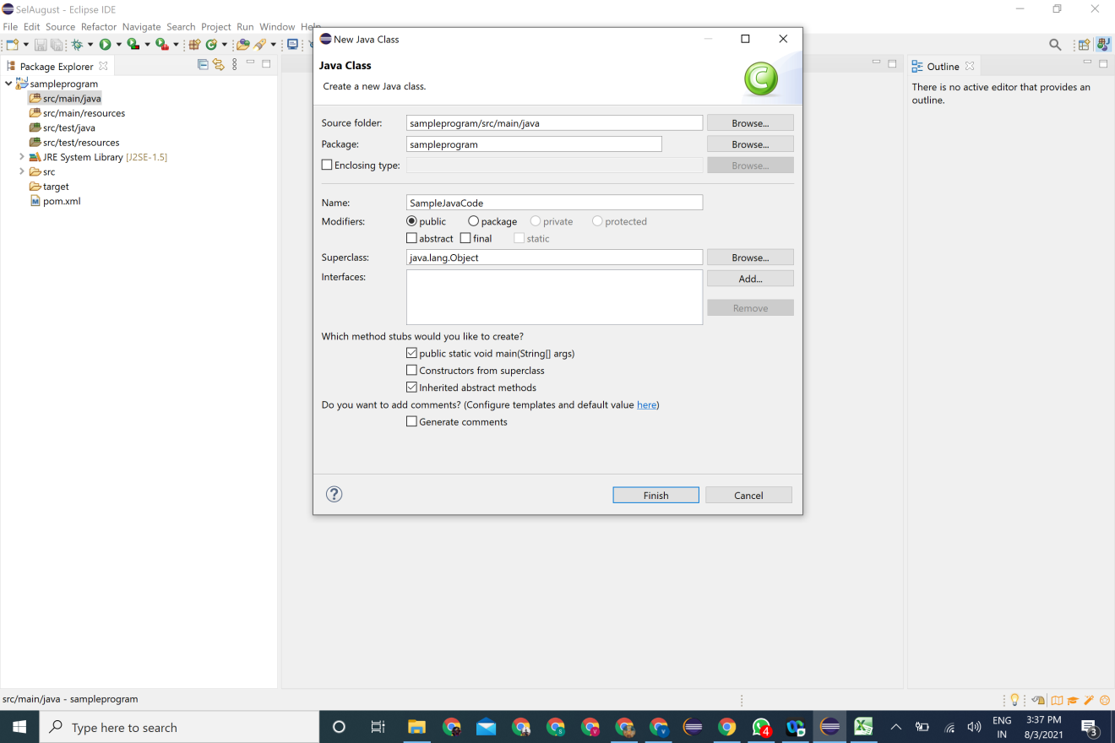

**Step:6**

Copy and Paste the given code under Public Static Void Main(String[] args) System.***out***.println("Happy Learning");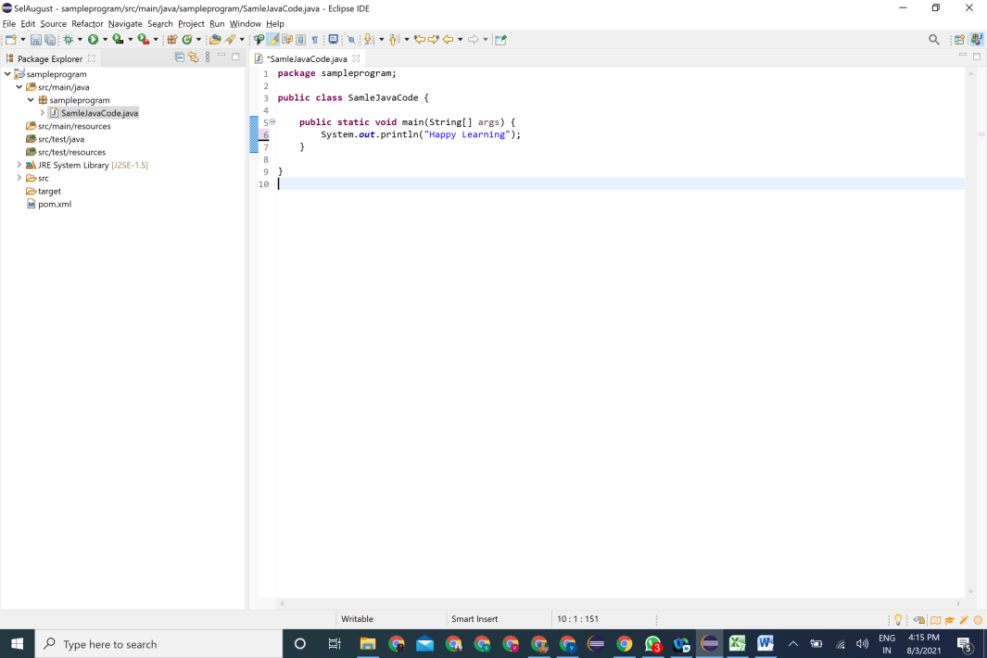

Step:7

Execute the code by Right click 🡪run as-> Java application

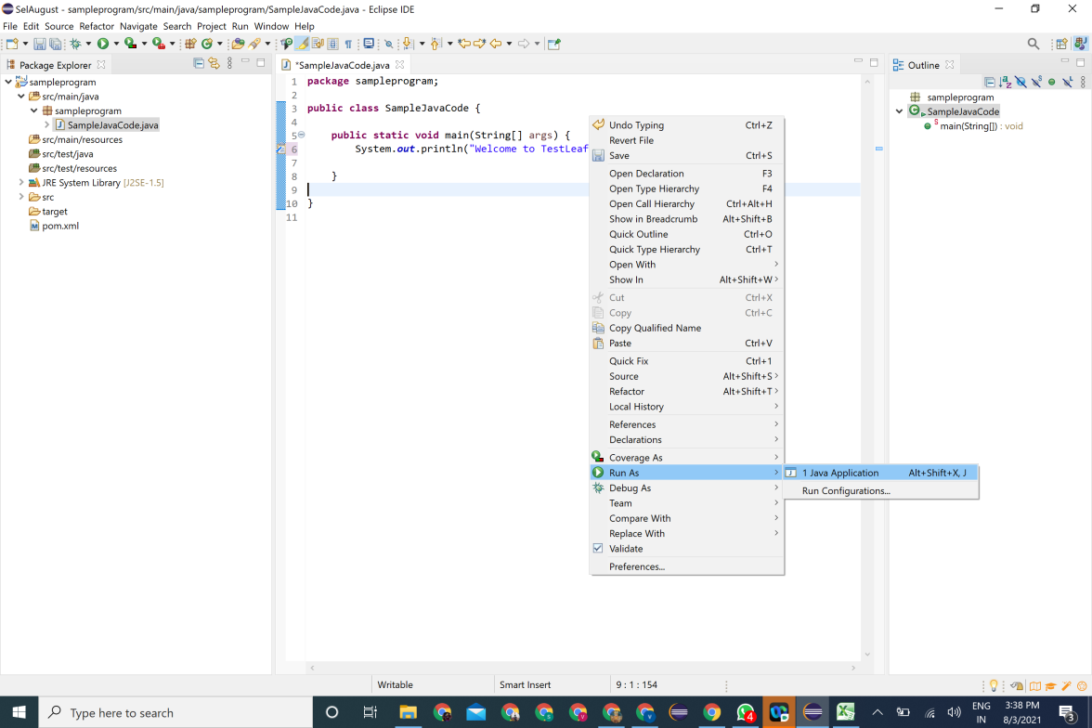

Save the code: Select and ok

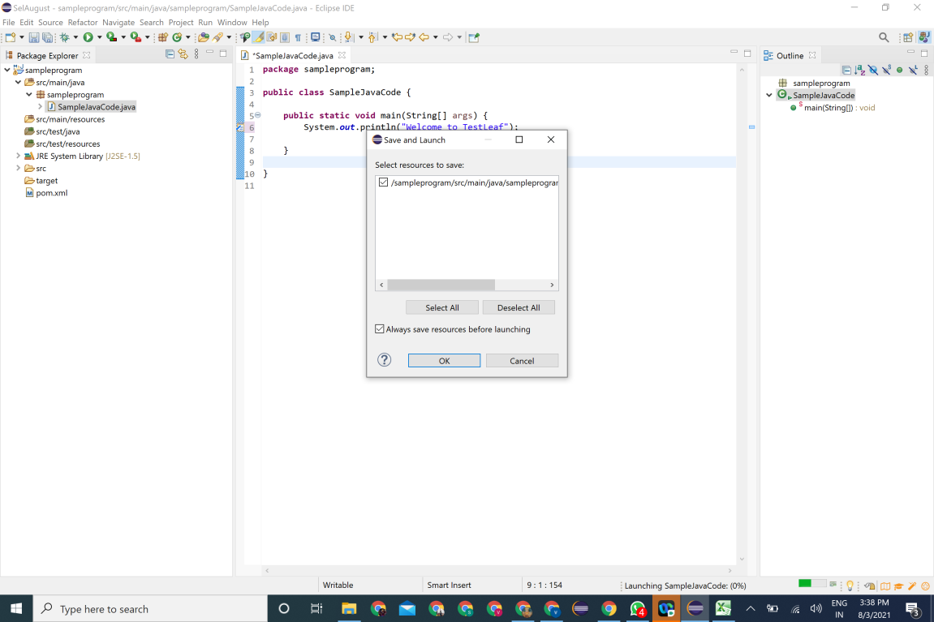

And the console will be having the statement printed

