Price Optimization Using Elasticity Modeling

Author: Anuradha Sawaika

Date: September, 2025

# 1. Executive Summary

This project applies data-driven price optimization techniques to identify the price point that maximizes revenue. Using regression-based elasticity modeling, predicted demand at varying prices was simulated, and the corresponding revenue curve was analyzed. The findings provide actionable insights for strategic pricing decisions.

# 2. Problem Statement

Pricing directly impacts both demand and revenue. Businesses often struggle to find the optimal balance — a price that maximizes revenue without losing significant demand. The goal of this project is to determine the optimal price point using historical sales data and elasticity modeling.

# 3. Dataset Overview

• **Source:** The dataset used in this project is **Competition_Data (Transactional Retail Pricing Dataset)**, sourced from the **Statso Case Study (AmanXai)**.

• **Size:** 100000 rows × 9 columns

• **After preprocessing Size:** 100000 rows × 17 columns

• **Key Variables:**

- *Price –* Product price per unit

*- Item_Quantity –* Units sold

*- Revenue –* Total sales revenue

*- Other derived variables:* Predicted Quantity, Elasticity, Revenue Curve

# 4. Methodology

**1. Elasticity Estimation**

- Regression was applied to estimate price elasticity of demand.  
 - Elasticity formula used:  
 Q = Q0 × (P/P0)^elasticity

**2. Simulation of Price vs Quantity**

- Created a price range across observed values.  
 - Predicted demand calculated using elasticity.

**3. Revenue Curve Analysis**

- Revenue = Price × Predicted Quantity.  
 - Optimal price identified as the point where revenue is maximized.

# 5. Results & Insights

**• Optimal Price:** 310.66

**• Maximum Revenue:** 120,275.58

• At this price point, revenue can be maximized while maintaining a balance in demand.

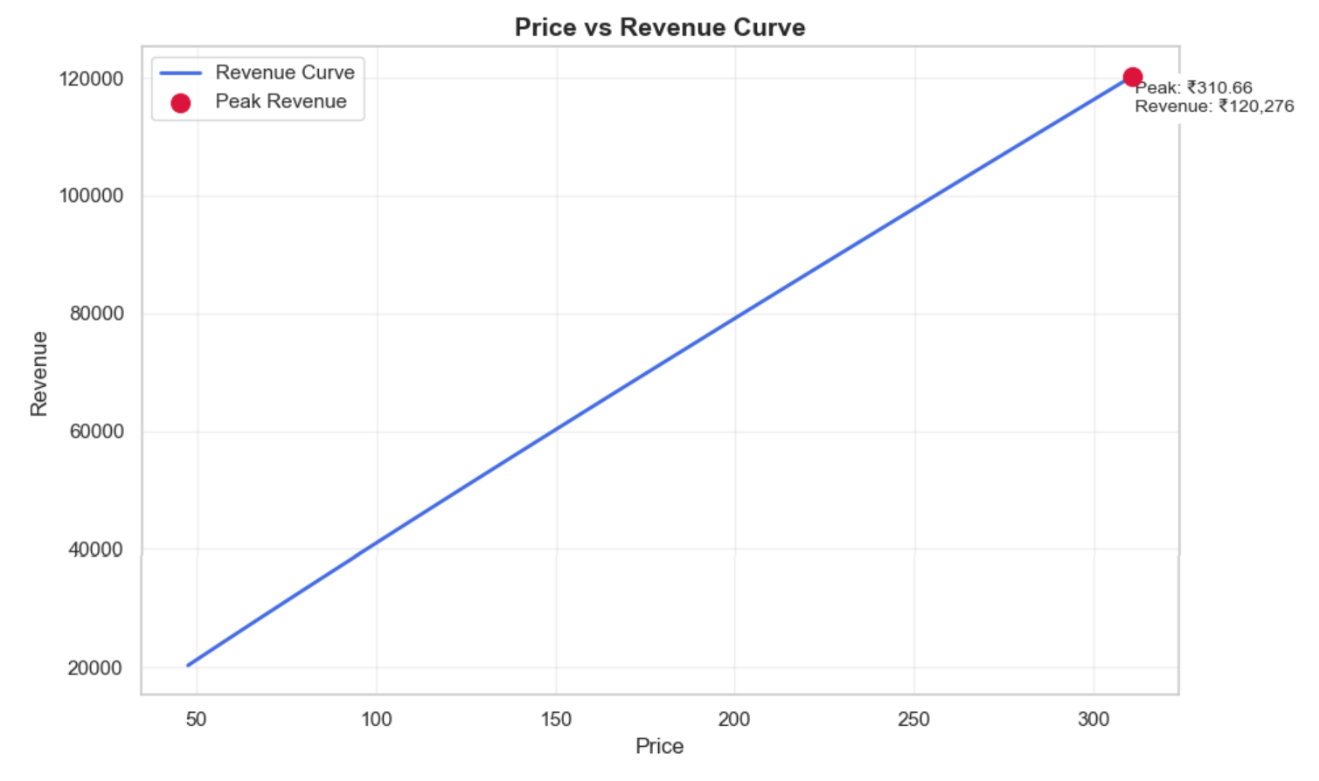

# 6. Business Impact

• This model provides a data-driven framework for price-setting.  
• Helps businesses avoid underpricing or overpricing.  
• Can be extended to multiple product categories for strategic pricing decisions.

# 7. Conclusion

The elasticity-based price optimization approach successfully identified the revenue-maximizing price point. Businesses can use this insight to make more informed pricing decisions and drive profitability.