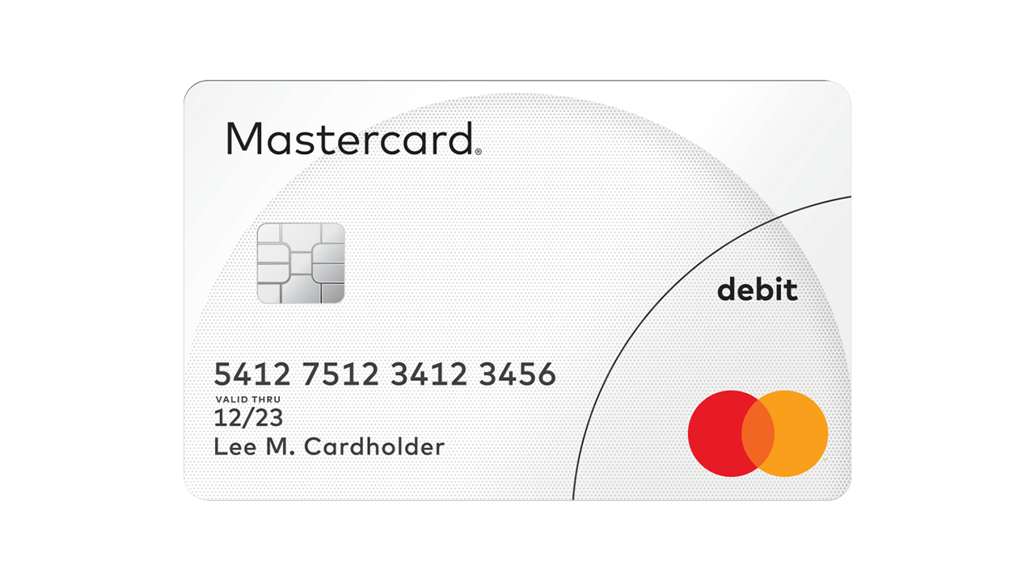

Visa Classic Debit

4000 1234 5678 9876

12/24

c.AR/AS visa