Hinglish Code-Switching Token-Level Language Identification
Using Fine-Tuned XLM-RoBERTa with Loss Function Ablation
College Project Report & Comparative Engineering Analysis
Anurag Basuri / 12306150  Dept. of Computer Science & Engineering  Lovely Professional University  Jalandhar, Punjab, India  anuragbasuri@gmail.com | Ramanjot / 30762  Dept. of Computer Science & Engineering  Lovely Professional University  Jalandhar, Punjab, India  ramanjot.30762@lpu.co.in

Abstract—In many parts of India, people naturally mix Hindi and English in everyday conversations. This mixed language, commonly called Hinglish, shows up everywhere—WhatsApp chats, tweets, Instagram comments, and even customer support messages. Before we can do anything useful with this kind of text (like figuring out the sentiment or translating it), we first need to know which language each word belongs to. This project builds a system that does exactly that: it looks at each word in a Hinglish sentence and labels it as English (EN), Hindi (HI), a Named Entity like a person or brand name (NE), or something else like punctuation (OTHER). We do this by fine-tuning a large pre-trained multilingual model called XLM-RoBERTa on the LinCE benchmark dataset. To find the best training approach, we compared three different loss functions—standard Cross-Entropy, Weighted Cross-Entropy (which gives extra importance to rare categories), and Focal Loss (which focuses on hard-to-classify words). We tested on three separate datasets including 60 hand-written real-world Hinglish sentences. Our best model correctly identifies 98.45% of all tokens, making just 7 mistakes out of 452 words. We also built a complete web application with a FastAPI backend and an interactive dashboard where users can type any Hinglish sentence and instantly see the language breakdown, confidence scores, and code-mixing statistics.
Keywords—Code-Switching, Language Identification, Hinglish, XLM-RoBERTa, Token Classification, Code-Mixing Index, Matrix Language Frame, Focal Loss, Class Imbalance.
I. INTRODUCTION
India is home to over 22 officially recognized languages and hundreds of regional dialects. In cities and towns, millions of people grow up speaking both Hindi and English, and they switch between the two languages all the time—often within the same sentence. For example, someone might text their friend: "Bhai ye app bahut slow chal raha hai, update karna padega." This sentence has Hindi words like "bahut" (very), "chal raha hai" (is running), and "karna padega" (will have to do), mixed in with English words like "app", "slow", and "update".
This kind of language mixing is called code-switching, and the Hindi-English variety is popularly known as Hinglish. It is not broken language—it follows its own natural patterns and is used by educated speakers across India. You can find it in WhatsApp groups, Twitter threads, Instagram comments, YouTube replies, and even in business emails.
Now, here is the problem: most language processing tools (spell checkers, translators, chatbots) are built for one language at a time. They assume every word in a sentence belongs to the same language. When they encounter Hinglish, they get confused. A Hindi word written in English letters looks just like any other English word to a computer. So before we can build any useful application for Hinglish—whether it is sentiment analysis, translation, or search—we first need to solve a basic problem: figure out which language each word belongs to.
This task is called token-level Language Identification (LID). For each word in a sentence, the system assigns one of four labels: EN (English), HI (Hindi), NE (Named Entity, such as a person's name, a city, or a brand), or OTHER (punctuation, numbers, emojis, and similar non-language tokens).
A. Why Is This Hard?
At first glance, labeling words by language sounds easy—just look up each word in a Hindi dictionary and an English dictionary. But in practice, there are several tricky challenges:
1) Same-Spelling Words (Homographs): Some words are spelled exactly the same in both languages but mean completely different things. The word "main" is a common English adjective, but it is also the Hindi pronoun for "I". The word "sale" means a discount event in English, but in Hindi slang it can be a rude term for a person. The only way to tell them apart is by looking at the surrounding words.
2) Unequal Class Sizes: In real Hinglish text, English words appear much more often than named entities. In our training data, English tokens make up about 58% of all words, while Named Entities account for only 7%. If we train the model with a simple loss function, it tends to get really good at English words but does poorly on rare categories like NE.
3) New Names Keep Appearing: People, brands, and places change constantly. Today's popular apps (Zomato, Zepto, Blinkit) or trending names might not exist in the training data at all. The system needs to handle words it has never seen before.
B. What This Project Does
In this project, we set out to accomplish four things:
1) Take a powerful pre-trained multilingual model called XLM-RoBERTa [1] and fine-tune it on the LinCE Hinglish Language Identification benchmark [2] so that it can classify each word in a sentence into EN, HI, NE, or OTHER.
2) Run a careful experiment comparing three different ways of computing the training loss—standard Cross-Entropy, Weighted Cross-Entropy, and Focal Loss—to find out which one works best, especially for the rare Named Entity class.
3) Test every model on three different sets of data: the official LinCE validation set, a separate held-out test set that the model never saw during training, and a custom set of 60 sentences that we wrote by hand to mimic real WhatsApp-style conversations.
4) Build a complete, working web application—a FastAPI backend and an interactive browser-based dashboard—so that anyone can type a Hinglish sentence and see the results immediately, with color-coded language tags, confidence percentages, and code-mixing statistics.
II. BACKGROUND & RELATED WORK
A. What Is Code-Switching?
Code-switching is the technical term for mixing two or more languages in a conversation. Linguists have studied this phenomenon since the 1970s. One of the most well-known theories comes from Carol Myers-Scotton [3], who proposed the Matrix Language Frame (MLF) model. The idea is simple: in a mixed sentence, one language provides the grammar (the "matrix" language), while the other language contributes specific words or phrases (the "embedded" language). In Hinglish, Hindi usually serves as the matrix language—it provides the sentence structure, verb endings, and word order—while English words are inserted for specific concepts.
To measure how much mixing is happening, researchers use something called the Code-Mixing Index (CMI), proposed by Gambäck and Das [4]. It is a simple percentage: out of all the language words in a sentence (ignoring punctuation), what fraction belongs to a non-dominant language? A CMI of 0% means the sentence is purely in one language, while higher values mean more mixing.
B. How Has This Problem Been Solved Before?
The earliest attempts at code-switching detection used hand-built rules—checking words against dictionaries or looking at letter patterns [5]. These systems were brittle and could not handle ambiguous words. Later, researchers used machine learning models like Conditional Random Fields (CRFs) [6], which could look at a word and its neighbors to make better predictions.
A major turning point came with the release of large pre-trained multilingual models. BERT [7], trained on 104 languages, showed that a single model could learn useful representations across languages. XLM-RoBERTa [1] improved on this by training on a much larger dataset (2.5 terabytes of web text from 100 languages) and has become the go-to model for cross-lingual tasks. The LinCE benchmark [2] was specifically created to standardize evaluation of NLP tools on code-switched text.
C. Dealing With Unbalanced Data
When some categories have far fewer examples than others, standard training tends to favor the common ones. Two popular solutions exist. First, Weighted Cross-Entropy [11] multiplies the loss by a weight that is higher for rare classes, essentially telling the model: "Pay extra attention when you get a rare class wrong." Second, Focal Loss [12], originally developed for detecting objects in images, adds a smart twist—it automatically reduces the loss for examples the model already classifies correctly and keeps the loss high for mistakes, focusing training on the hardest cases.
III. GAP ANALYSIS & OUR CONTRIBUTION
Table I shows how our work compares to earlier systems. Most previous studies used older models and did not try different loss functions. None of them built a deployable web application.
TABLE I. HOW OUR WORK DIFFERS FROM PREVIOUS STUDIES
Study | Model Used | Task | Loss Compared? | Web App?
Solorio & Liu [5] | CRF + n-grams | POS Tagging | No | No
Barman et al. [8] | SVM + Dictionary | LID (Hi-En) | No | No
LinCE Benchmark [2] | mBERT | LID + NER | No | No
Prabhu et al. [9] | CNN-BiLSTM | NER (Hi-En) | No | No
Our Project | XLM-RoBERTa | LID (4-class) | Yes (3 losses) | Yes (full)

The key gaps we identified are: (a) no prior study compares how different loss functions affect Named Entity recall in Hinglish LID; (b) models are rarely tested on natural, conversational text outside the original benchmark; and (c) there is no end-to-end system that goes from model to web interface.
IV. HOW THE MODEL WORKS
A. The Base Model: XLM-RoBERTa
XLM-RoBERTa [1] is a large neural network that has been pre-trained on text from 100 different languages. Think of it as a language expert that already understands the basic patterns of Hindi, English, and 98 other languages before we even start training it on our specific task. The model we use (the "base" version) has about 278 million parameters organized into 12 layers, with each layer processing information through 12 attention heads that help the model understand how words relate to each other.
For our task, we add a simple classification layer on top. This layer takes the model's internal understanding of each word (a vector of 768 numbers) and converts it into 4 scores—one for each of our categories (EN, HI, NE, OTHER). The category with the highest score becomes the prediction.
B. Breaking Words Into Pieces (Tokenization)
XLM-RoBERTa does not work with whole words directly. Instead, it uses a technique called SentencePiece Byte-Pair Encoding (BPE) to break words into smaller pieces called subword tokens. It has a vocabulary of about 250,000 such pieces. Common words like "the" or "hai" stay as one piece, but less common words get split. For example, "Flipkart" might become ["_Flip", "kart"].
This creates a practical problem: our labels are for whole words, but the model works with subword pieces. We handle this with a standard approach called first-subword alignment:
1) Only the first piece of each word gets the actual language label. So if "Flipkart" is split into ["_Flip", "kart"], only "_Flip" gets the NE label.
2) All other pieces, plus special tokens that the model uses internally (like start and end markers), are marked with a special value (-100) that tells PyTorch: "ignore these when calculating the loss."
3) When making predictions, we take the label predicted for the first piece and apply it to the whole word. So if the model says "_Flip" is NE, then "Flipkart" is NE.
C. Three Ways to Calculate Training Loss
We tested three different loss functions to see which trains the best model:
1) Standard Cross-Entropy (CE): This is the default and most common loss function. It treats all mistakes equally—getting an English word wrong costs the same as getting a Named Entity wrong. It works well when all classes have roughly equal amounts of data.
2) Weighted Cross-Entropy (WCE): Since Named Entities are rare, we give them a higher weight during training. Specifically, we compute weights based on the inverse square root of each class's frequency. The resulting weights are: EN: 0.572, HI: 0.976, NE: 1.683, OTHER: 1.109. This means a mistake on a Named Entity costs about 3 times more than a mistake on an English word, pushing the model to pay extra attention to names.
3) Focal Loss (gamma=2): This is a smarter version of cross-entropy developed by Lin et al. [12]. Instead of using fixed weights, it dynamically adjusts: when the model is already confident about a word (say, 95% sure it is English), the loss becomes very small. But when the model is unsure (say, only 55% confident), the loss stays large. This naturally focuses training on the hard, ambiguous words at language switch boundaries.
D. Training Setup
Table II shows all the settings we used for training. These were the same for all three experiments.
TABLE II. TRAINING SETTINGS AND THEIR JUSTIFICATIONS
Setting | Value We Used | Why This Value
Base model | xlm-roberta-base | Best multilingual model for code-switching
Optimizer | AdamW (weight decay 0.01) | Prevents overfitting to common patterns
Learning rate | 0.00002 (2e-5) | Standard for fine-tuning transformers
Warmup | 50 steps, then linear decay | Protects pre-trained knowledge early on
Batch size | 32 (train) / 64 (eval) | Fits in GPU memory with FP16
Max length | 128 subword tokens | Enough for typical social media sentences
Precision | FP16 (half precision) | Cuts memory use in half, speeds up training
Epochs | 4 | Enough to converge without overfitting
Model selection | Best Macro F1 on validation | Picks model that works across all classes
GPU | NVIDIA T4, 16 GB VRAM | Free tier on Google Colab
Random seed | 42 | Makes experiments exactly reproducible

E. How Training Works Step by Step
We trained each model using the Hugging Face Transformers library [15], which provides a convenient Trainer class. We wrote a custom subclass called LossTrainer that overrides the loss calculation so we could switch between our three loss functions. Here is what happens during each training run:
Step 1: The dataset is loaded from the Hugging Face Hub (one line of Python code). The tokenizer converts each sentence into subword tokens and creates the label alignment masks. Dynamic batching pads each batch only to the longest sentence in that batch, saving compute.
Step 2: The model processes a batch of 32 sentences. For each token, it produces 4 logits. The loss function compares these to the true labels (ignoring masked positions) and produces a single number representing how wrong the predictions were.
Step 3: The optimizer (AdamW) uses the loss to update the model weights. The learning rate starts at zero, rises linearly to 0.00002 over the first 50 steps (warmup), then decays back toward zero. This warmup prevents big destructive updates at the very start of training.
Step 4: At the end of each epoch (one pass through all training data), the model is evaluated on the validation set. If the Macro F1 score is the best so far, the model weights are saved. After all 4 epochs, the saved best checkpoint is the final model.
Each full training run takes about 8-10 minutes on a single T4 GPU. The saved model checkpoint is roughly 1.1 GB (the model weights) plus about 17 MB for the tokenizer files.
V. DATASET DETAILS
A. Where the Data Comes From
Our main dataset is the LinCE (Linguistic Code-Switching Evaluation) Hindi-English Language Identification benchmark [2]. It consists of real social media posts (primarily from Twitter/X) that have been manually annotated by trained linguists. Each word in every tweet is labeled with its language. The dataset is publicly available on the Hugging Face Datasets Hub and can be loaded with a single Python command. (See: HuggMachas/Lince_benchmark_lid_hineng_train_valid)
B. Simplifying the Labels
The original dataset has 8 different label types, but many of them are very rare (less than 1% of tokens). Having too many rare categories makes training noisy and unreliable. So we simplified them into 4 clear categories (Table III).
TABLE III. HOW WE SIMPLIFIED THE LABELS
Original Label(s) | Our Label | What It Means
lang1 | HI | Hindi word (written in Roman script, like 'bahut')
lang2 | EN | English word (like 'update' or 'slow')
ne | NE | Named entity (person, place, brand, like 'Mumbai')
other | OTHER | Punctuation, numbers, emojis, symbols
unk, fw, mixed, ambiguous | OTHER | Rare tags (under 1% of data), merged into OTHER

C. How We Split the Data
The original LinCE benchmark gives us training and validation splits, but the official test labels are hidden (they are for a public leaderboard). To properly test our models on data they have never seen, we held out 10% of the training data as our own test set. We also created a completely separate hand-written test set of 60 sentences. Table IV shows all our data splits.
TABLE IV. DATA SPLITS AND WHAT EACH ONE IS USED FOR
Split Name | Sentences | Approx. Tokens | What We Use It For
Training Set | 4,340 | ~77,000 | Teaching the model (weight updates happen)
Validation Set | 744 | ~14,575 | Checking progress after each epoch
Held-Out Test | 483 | ~8,500 | Final test on unseen benchmark data
Custom Test | 60 | 452 | Test on realistic WhatsApp-style conversation

D. The Class Imbalance Problem
Table V shows how uneven our training data is. English words make up nearly 58% of all tokens, while Named Entities are only about 7%—almost 9 times less data. This is a big deal because it means a lazy model could ignore Named Entities entirely and still get an overall accuracy above 90%.
TABLE V. HOW MANY TOKENS WE HAVE FOR EACH CATEGORY
Category | Count | Percentage | Examples
EN (English) | 49,459 | 57.9% | app, slow, update, party, Google
HI (Hindi) | 16,983 | 19.9% | bahut, karo, padega, achha, chal
OTHER | 13,135 | 15.4% | , . ! ? @ # 123
NE (Named Entity) | 5,702 | 6.7% | Mumbai, Zomato, Anurag, India

This is exactly why we test Weighted Cross-Entropy and Focal Loss—they help the model pay more attention to the rare Named Entity class during training.
E. Our Custom Test Set: Real Hinglish Conversations
To see how the model performs on everyday language, we hand-wrote 60 Hinglish sentences and labeled every word ourselves. We designed these sentences to include realistic challenges:
- Popular app and brand names: Zomato, Flipkart, Netflix, YouTube, Ola, Swiggy
- Indian cities and places: Mumbai, Delhi, Goa, Shimla, Connaught Place
- Tricky words that exist in both languages: "main" (I/main), "sale" (sale/insult)
- Casual slang and abbreviations: bhai, yaar, chill, scene, tension
- Mix of short messages (4-5 words) and longer sentences (10-12 words)
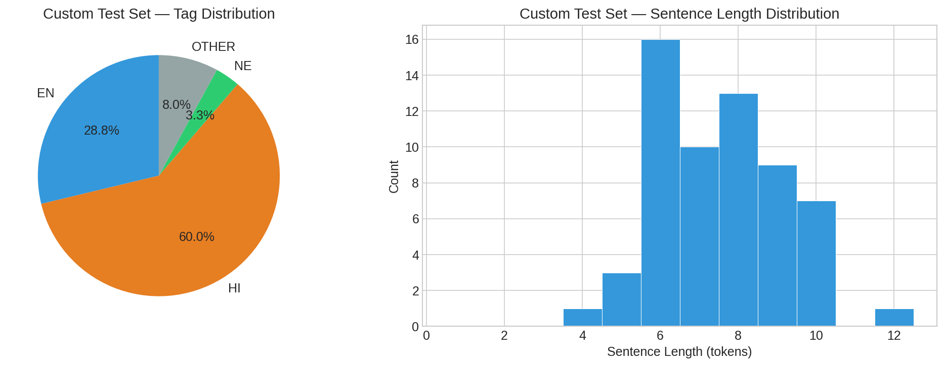
Fig. 1. Custom test set composition: how many tokens of each type and how long the sentences are.
VI. RESULTS & WHAT THEY MEAN
A. Overall Performance
Table VI is the most important table in this report. It shows how each loss function performed on each of our three test sets. The numbers include accuracy (what percentage of tokens were labeled correctly), Macro F1 (an average that treats all four classes equally), and Weighted F1 (an average weighted by class size).
TABLE VI. COMPLETE RESULTS: ALL LOSSES ON ALL TEST SETS
Loss Function | Test Set | Accuracy | Macro F1 | Wtd F1
Cross-Entropy | LinCE Validation | 96.88% | 0.9428 | 0.9689
Cross-Entropy | Held-Out Test | 96.10% | 0.9347 | 0.9610
Cross-Entropy | Custom (60 sent.) | 98.23% | 0.9521 | 0.9825
Weighted CE | LinCE Validation | 96.64% | 0.9400 | 0.9669
Weighted CE | Held-Out Test | 95.96% | 0.9339 | 0.9599
Weighted CE | Custom (60 sent.) | 98.45% | 0.9535 | 0.9847
Focal (gamma=2) | LinCE Validation | 96.86% | 0.9427 | 0.9687
Focal (gamma=2) | Held-Out Test | 96.30% | 0.9373 | 0.9630
Focal (gamma=2) | Custom (60 sent.) | 98.01% | 0.9451 | 0.9805

What do these numbers tell us? Three important things stand out:
First, all three models perform very well—above 95% accuracy everywhere. This confirms that XLM-RoBERTa is an excellent starting point for Hinglish language identification.
Second, Weighted Cross-Entropy wins on real-world conversations. It gets 98.45% accuracy on our custom test—only 7 mistakes out of 452 words. That is the model you would want to use in practice.
Third, Focal Loss gets the best score on the held-out test set (96.30% accuracy, 0.9373 Macro F1), suggesting it generalizes slightly better to unseen benchmark data.
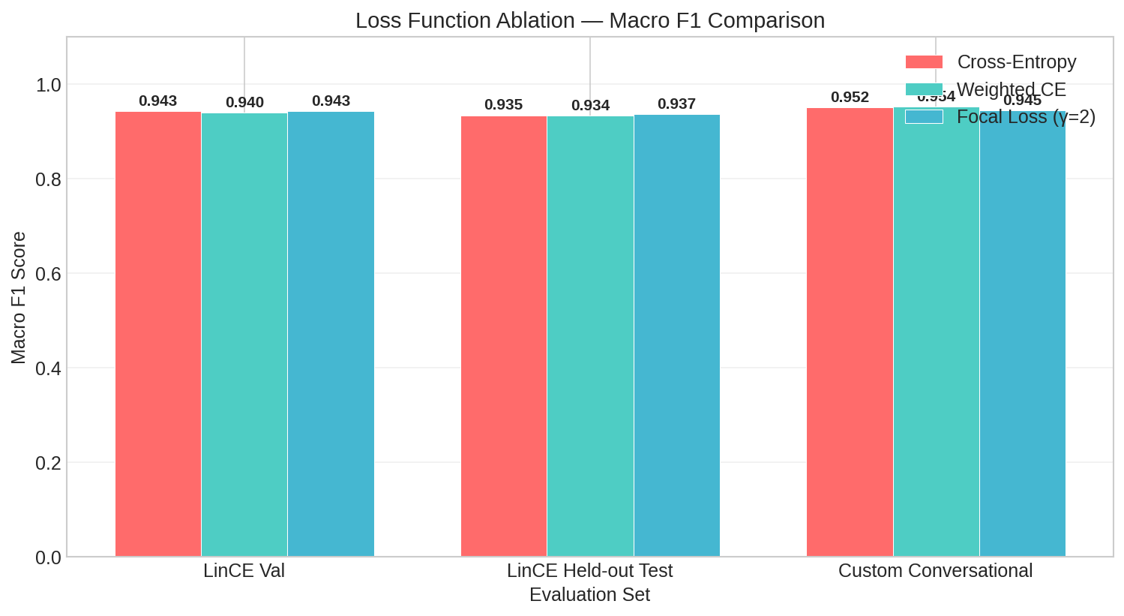
Fig. 2. Visual comparison of Macro F1 scores across all loss functions and test sets.
B. How Each Category Performs
Table VII breaks down the results by category. This is where the difference between loss functions really shows. Pay special attention to the NE (Named Entity) row.
TABLE VII. PER-CLASS PRECISION (P) AND RECALL (R). NOTE THE NE RECALL JUMP WITH WCE.
Category | CE P / R | WCE P / R | FL P / R | WCE Change
EN | 0.98 / 0.98 | 0.99 / 0.97 | 0.98 / 0.98 | −0.9% recall
HI | 0.96 / 0.96 | 0.95 / 0.96 | 0.96 / 0.96 | +0.2% recall
NE | 0.84 / 0.86 | 0.80 / 0.90 | 0.84 / 0.86 | +3.8% recall
OTHER | 0.99 / 0.97 | 0.98 / 0.98 | 0.99 / 0.97 | +0.2% recall

The key finding: Weighted Cross-Entropy boosts Named Entity recall from 86.2% to 90.0%—a gain of 3.8 percentage points. This means the model catches 90 out of every 100 named entities, compared to 86 with standard training. The trade-off is a small drop in precision (from 84.2% to 79.5%), meaning it occasionally labels a regular word as a name. But for most applications, catching more names is more valuable than avoiding false alarms.
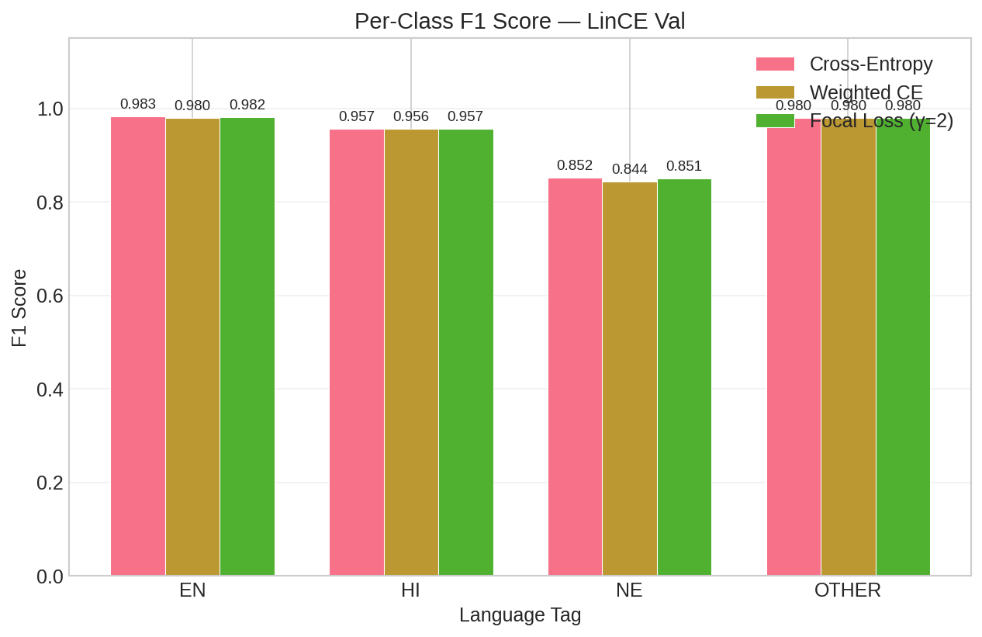
Fig. 3. Per-class F1 scores on the LinCE validation set. EN and OTHER are consistently easy; NE is the challenge.
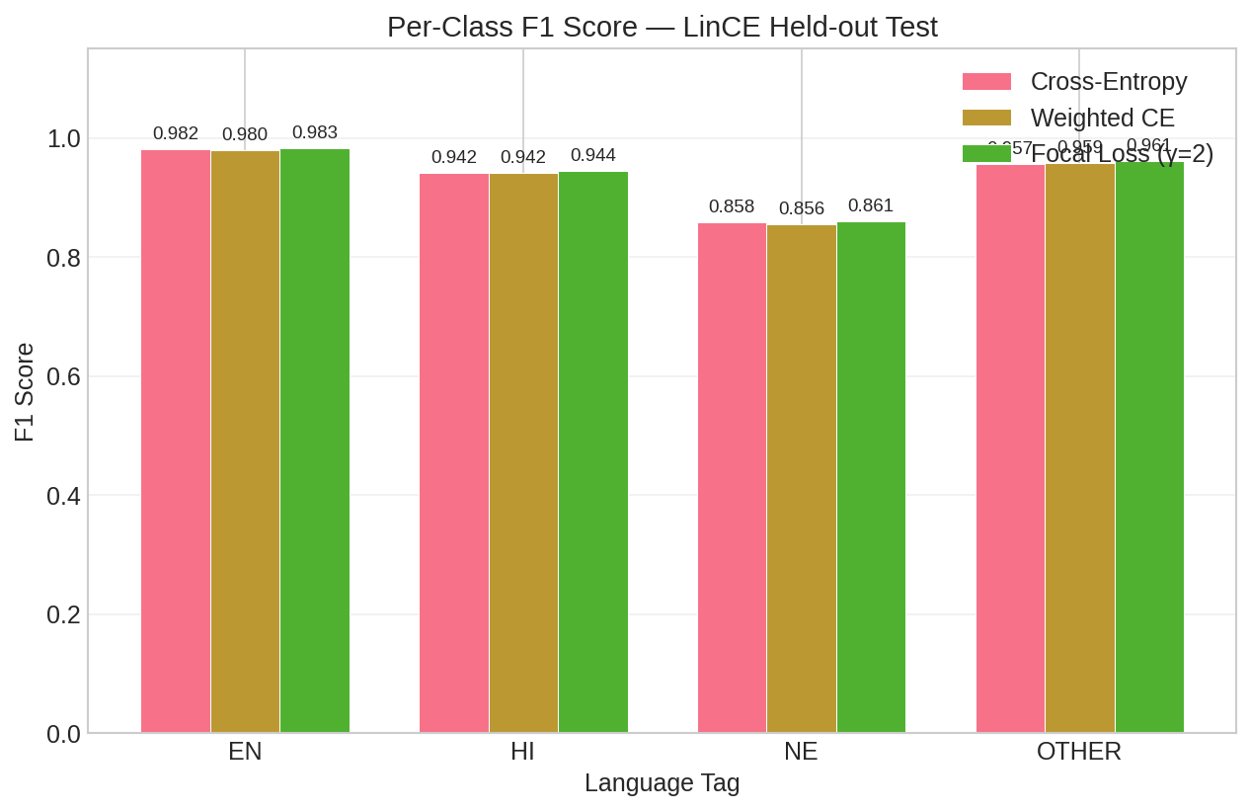
Fig. 4. Per-class F1 on the unseen held-out test set, confirming similar patterns to the validation set.
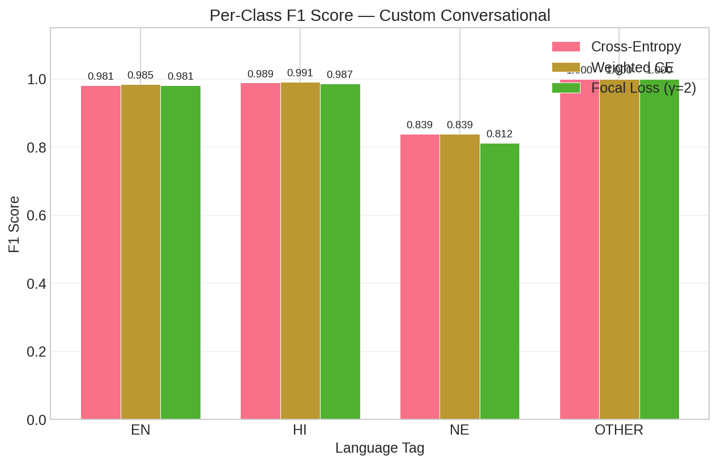
Fig. 5. Per-class F1 on our custom conversational test set, where Weighted CE performs best overall.
C. Where Does the Model Make Mistakes?
Let us look at the confusion matrices for our custom 60-sentence test set. These show exactly which categories get confused with each other (Table VIII).
TABLE VIII. HOW MANY ERRORS EACH MODEL MADE AND WHAT KIND
Model | Total Errors | EN→HI | HI→NE | HI→EN | NE→HI
Cross-Entropy | 8 / 452 | 2 | 2 | 1 | 1
Weighted CE | 7 / 452 | 1 | 2 | 1 | 1
Focal (gamma=2) | 9 / 452 | 2 | 3 | 1 | 1

Some interesting observations: All three models get 100% accuracy on the OTHER class (punctuation, numbers)—those are trivially easy. All errors happen at code-switch boundaries, where the language changes from one word to the next. This makes sense: those are exactly the positions where context is most ambiguous.
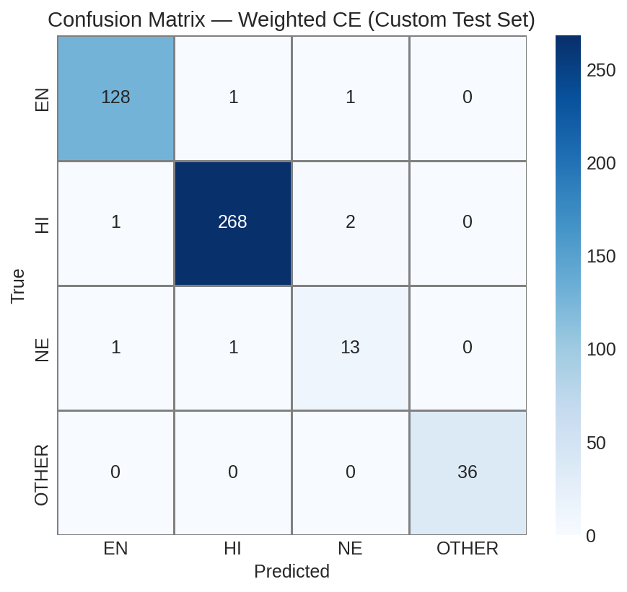
Fig. 6. Confusion matrix for Weighted CE on custom test (best model, 7 errors out of 452 tokens).
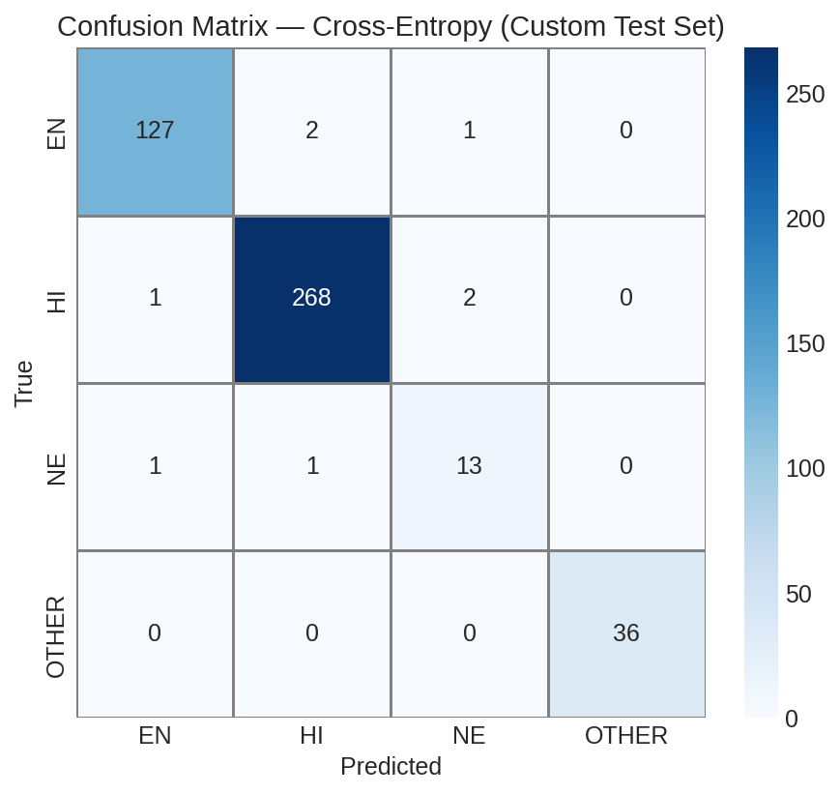
Fig. 7. Confusion matrix for standard Cross-Entropy (8 errors).
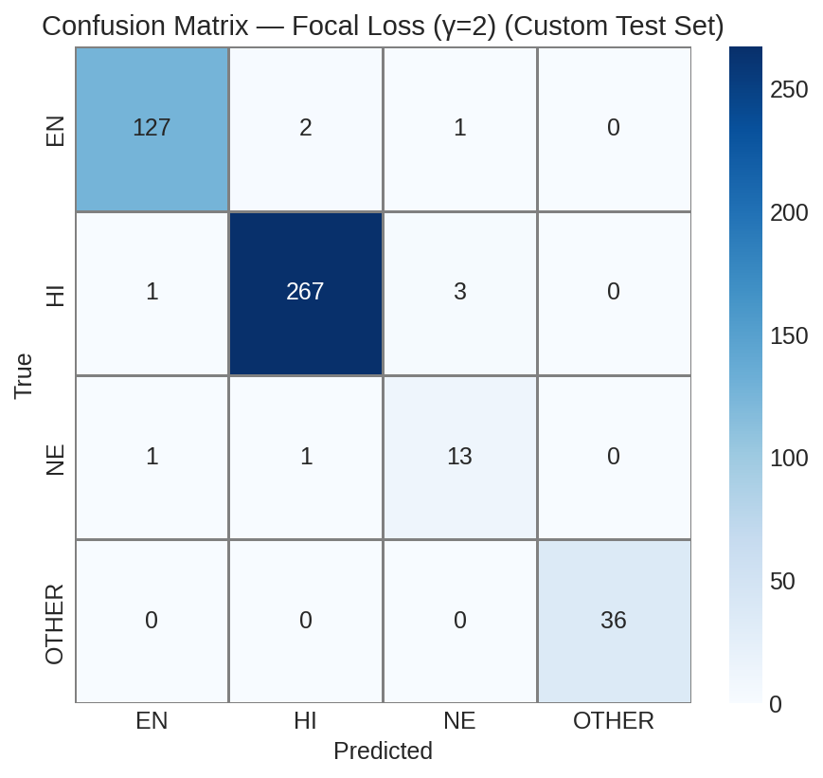
Fig. 8. Confusion matrix for Focal Loss (9 errors).
VII. LOOKING AT SPECIFIC MISTAKES
A. The Most Common Errors
To really understand the model's weaknesses, we looked at each individual mistake. Table IX shows the most instructive error cases.
TABLE IX. DETAILED LOOK AT WHY THE MODEL MADE SPECIFIC MISTAKES
Word | True | Predicted | Why the Model Got Confused
"app" | EN | HI | Surrounded by Hindi words, model assumed it was Hindi too
"subah" | HI | NE | Sounds like a proper name; model lacked dictionary context
"Zomato" | NE | HI | Brand name absent from training data; guessed Hindi from context
"main" | HI | EN | Exists in both Hindi ('I') and English; a classic homograph
"Maps" | NE | EN | Part of "Google Maps"; model saw English word, missed entity

B. The Homograph Problem
The most interesting errors involve words that look the same in both languages. "Main" is the perfect example: it appears in the training data as both a Hindi pronoun ("main check kar raha hun" = "I am checking") and an English adjective ("the main reason"). When the model encounters "main" in a short, ambiguous context, its confidence drops to around 52-58%—it is essentially guessing. This is not really a model failure; it reflects genuine human ambiguity. Even a native speaker might need more context to be sure.
C. The Named Entity Challenge
"Zomato" is a food delivery app that did not appear in the training data. The model sees it surrounded by Hindi words ("Zomato se khana order karo") and guesses it is Hindi. For humans, we know it is a brand name because of world knowledge—but the model only has the sentence context. This is an inherent limitation of any supervised system: it cannot recognize entities it has never seen. Adding a gazetteer (a list of known names) or using character-level features could help in future versions.
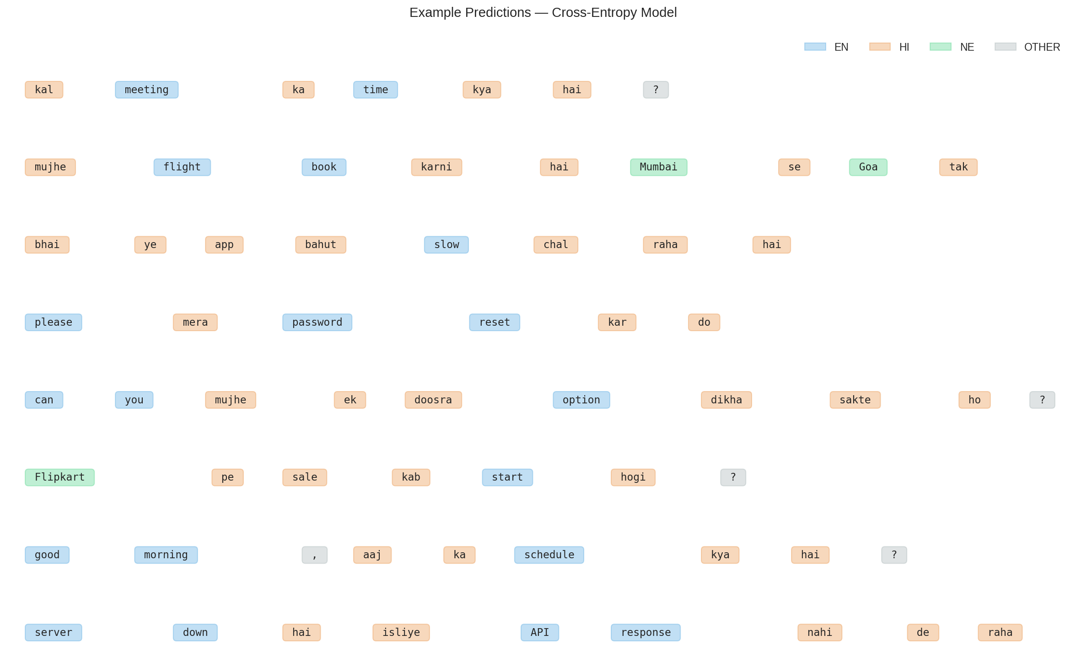
Fig. 9. Sample predictions shown with color-coded tags. Each word is highlighted by its predicted language.
VIII. HOW MUCH MIXING IS HAPPENING?
We computed the Code-Mixing Index (CMI) [4] for every sentence in our custom test set. The formula is simple:
CMI = (N − max_L) / N × 100%
Here N is the total number of language tokens (EN + HI + NE, excluding OTHER), and max_L is the count of whichever language appears most. A monolingual English sentence has CMI = 0%. A sentence with equal Hindi and English has CMI = 50%.
TABLE X. CODE-MIXING INDEX STATISTICS FOR OUR CUSTOM TEST SET
Statistic | Value | What It Tells Us
Average CMI | 29.4% | Our test sentences have a lot of mixing
Median CMI | 31.0% | Half of sentences mix more than this
Standard Dev. | 12.5% | Wide variety from mono to heavily mixed
Range | 0% to 50% | Covers the full spectrum of code-switching

An average CMI of 29.4% means our test sentences are genuinely code-switched—not just sprinkling one or two English words into Hindi. Three sentences were purely monolingual (CMI = 0%), while the most mixed ones reached the theoretical maximum of 50%.
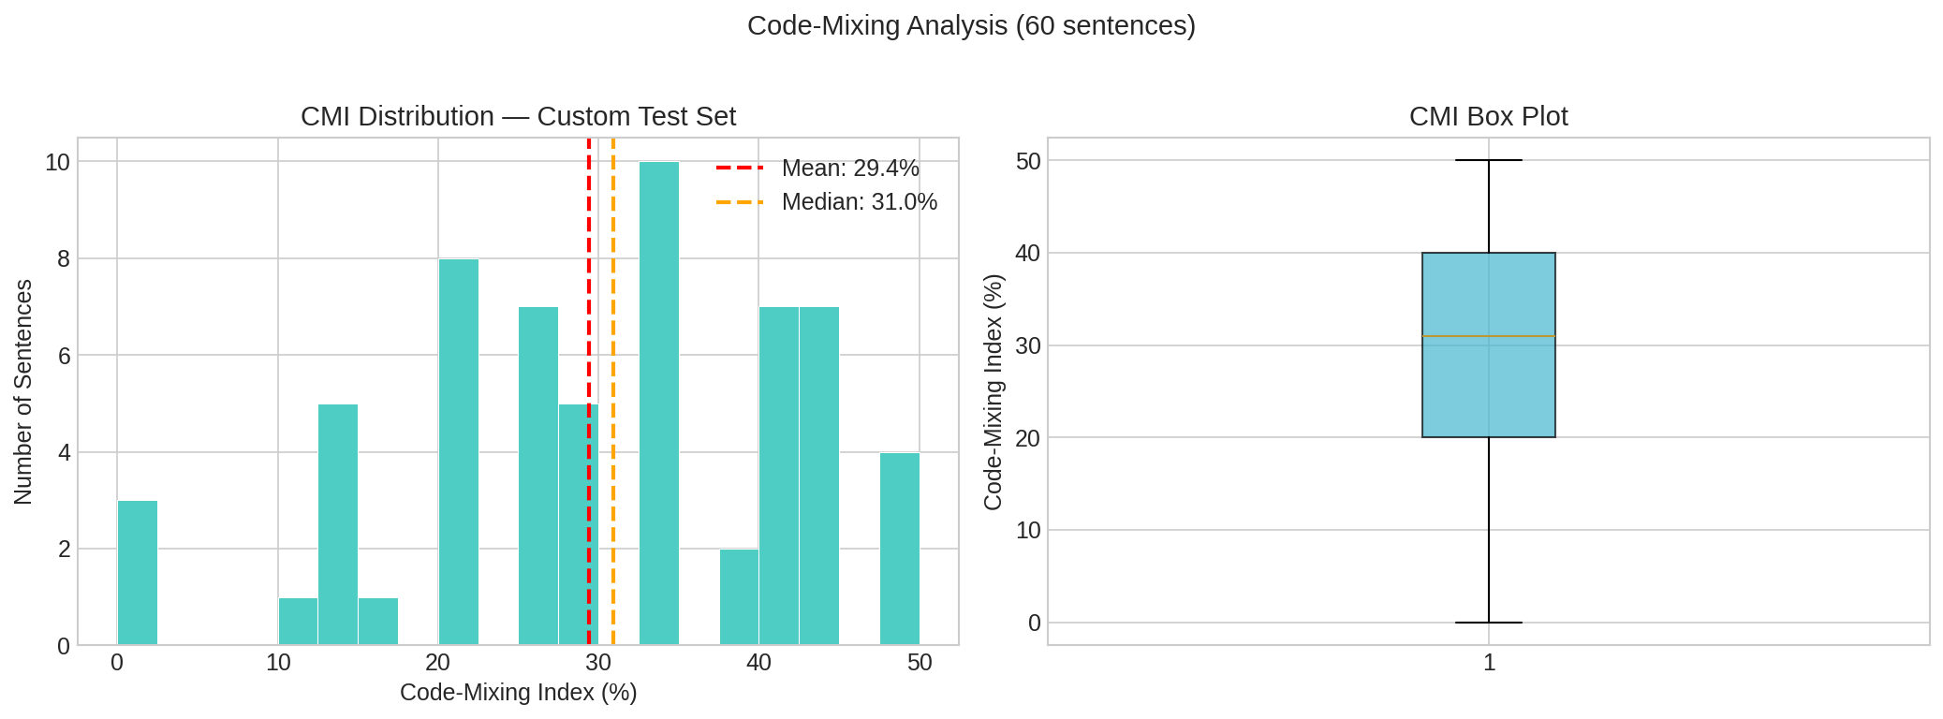
Fig. 10. How the Code-Mixing Index is distributed across our 60 test sentences.
IX. THE WEB APPLICATION WE BUILT
A. Technology Stack
The deployed system uses the following technologies:
- Backend: FastAPI (Python) running on Uvicorn ASGI server
- Deep Learning: PyTorch with Hugging Face Transformers for model inference
- Frontend: Pure HTML, CSS, and JavaScript (no framework dependencies)
- Tokenizer: Same SentencePiece BPE tokenizer used during training
B. What the API Does
Users interact with the system through a REST API. Table XI lists the available endpoints.
TABLE XI. WHAT EACH API ENDPOINT DOES
URL Path | Method | What It Does
/api/predict | POST | Analyze a single sentence: get tags, confidences, CMI, switch points
/api/predict/batch | POST | Analyze multiple sentences at once with aggregate statistics
/api/health | GET | Check if the server and model are running correctly
/api/models | GET | See which trained models are available and their accuracy
/api/examples | GET | Get sample Hinglish sentences for quick testing

C. What Happens If Something Goes Wrong?
One important design decision is the fallback system. If the PyTorch model fails to load (maybe the GPU runs out of memory, or the model files are missing), the server does not crash. Instead, it automatically switches to a simpler rule-based engine that uses:
- Unicode detection: checks whether letters are Latin (likely English) or Devanagari (likely Hindi)
- Word lists: pre-built lists of common Hindi and English words
- Pattern matching: regular expressions to identify punctuation, numbers, URLs, and emojis
This fallback is less accurate than the neural model, but it guarantees that the API always returns a response. The user never sees an error page.
D. The Interactive Dashboard
The web dashboard has two main modes. In Single Sentence Mode, users type a Hinglish sentence and see each word highlighted with its language tag (blue for English, orange for Hindi, green for Named Entity, gray for Other). They also see confidence percentages, switch points (where the language changes), and the Code-Mixing Index. In Batch Mode, users can upload a file with many sentences and get aggregate statistics, including CMI distributions, searchable results tables, and CSV export.
X. LIMITATIONS, CONCLUSION & FUTURE WORK
A. What We Cannot Do Yet
1) No Memory Across Sentences: The model looks at one sentence at a time. It cannot use information from previous messages in a chat to help with the current one.
2) Homographs Remain Hard: Words like "main" and "sale" will always be ambiguous when the surrounding context is too short. A deeper model with sentence-level reasoning might help.
3) New Names Are Always a Problem: Any named entity not seen during training is hard to detect. Adding a character-level model or an external name dictionary could improve this.
4) Model Size: The model is about 1.1 GB, which is too large for mobile phones. A smaller distilled version would be needed for on-device use.
B. What We Achieved
This project shows that with the right model and the right training strategy, we can accurately identify the language of individual words in Hinglish text. Our key findings are:
1) XLM-RoBERTa provides an excellent starting point, achieving above 95% accuracy with all three loss functions. Pre-training on 100 languages gives it a strong foundation.
2) Weighted Cross-Entropy is the best practical choice. It reaches 98.45% accuracy on real conversational text and catches 90% of named entities (up from 86% with standard training).
3) A complete end-to-end system—from model training to web deployment—can be built and demonstrated as a working prototype that anyone can use through a browser.
C. What Could Come Next
In the future, this work could be extended by: adding a CRF layer on top of the transformer to capture sequential patterns between tags; using character-level features to better handle out-of-vocabulary names; creating synthetic training data by programmatically mixing Hindi and English sentences; extending the system to other language pairs like Bangla-English or Tamil-English; and building a lightweight mobile version using model distillation.
REFERENCES
[1] A. Conneau et al., "Unsupervised cross-lingual representation learning at scale," Proc. 58th ACL, pp. 8440-8451, 2020. doi:10.18653/v1/2020.acl-main.747
[2] G. Aguilar, S. Kar, and T. Solorio, "LinCE: A centralized benchmark for linguistic code-switching evaluation," Proc. 12th LREC, pp. 1803-1813, 2020. aclanthology.org/2020.lrec-1.223
[3] C. Myers-Scotton, Duelling Languages: Grammatical Structure in Codeswitching. Oxford University Press, 1993. oup.com/duelling-languages
[4] B. Gamback and A. Das, "On measuring the complexity of code-mixing," Proc. 11th ICON, Goa, India, pp. 1-7, 2014. aclanthology.org/W14-3902
[5] T. Solorio and Y. Liu, "Part-of-speech tagging for English-Spanish code-switched text," Proc. EMNLP, pp. 1051-1060, 2008. aclanthology.org/D08-1110
[6] T. Solorio et al., "Overview for the first shared task on language identification in code-switched data," Proc. First Workshop on Computational Approaches to Code Switching, pp. 62-72, 2014. aclanthology.org/W14-3907
[7] J. Devlin, M.-W. Chang, K. Lee, and K. Toutanova, "BERT: Pre-training of deep bidirectional transformers for language understanding," Proc. NAACL-HLT, pp. 4171-4186, 2019. doi:10.18653/v1/N19-1423
[8] U. Barman, A. Das, J. Wagner, and J. Foster, "Code mixing: A challenge for language identification in the language of social media," Proc. First Workshop on Computational Approaches to Code Switching, pp. 13-23, 2014. aclanthology.org/W14-3902
[9] M. R. Prabhu, A. Khandelwal, S. Gupta, and P. Bhattacharyya, "Named entity recognition for Hindi-English code-mixed social media text," Proc. 7th Named Entities Workshop (NEWS), pp. 27-35, 2018. aclanthology.org/W18-2404
[10] S. Srivastava and A. Singh, "Understanding sentiment in Hindi-English code-mixed tweets via multilingual transformers," arXiv preprint arXiv:2104.09848, 2021. arxiv.org/abs/2104.09848
[11] S. H. Khan et al., "Cost-sensitive learning of deep feature representations from imbalanced data," IEEE Trans. NNLS, vol. 29, no. 8, pp. 3573-3587, 2018. doi:10.1109/TNNLS.2017.2732482
[12] T.-Y. Lin, P. Goyal, R. Girshick, K. He, and P. Dollar, "Focal loss for dense object detection," IEEE Trans. PAMI, vol. 42, no. 2, pp. 318-327, 2020. doi:10.1109/TPAMI.2018.2858826
[13] A. Vaswani et al., "Attention is all you need," Advances in NeurIPS, pp. 5998-6008, 2017. arxiv.org/abs/1706.03762
[14] Y. Liu et al., "RoBERTa: A robustly optimized BERT pretraining approach," arXiv preprint arXiv:1907.11692, 2019. arxiv.org/abs/1907.11692
[15] T. Wolf et al., "Transformers: State-of-the-art natural language processing," Proc. EMNLP: System Demonstrations, pp. 38-45, 2020. doi:10.18653/v1/2020.emnlp-demos.6
APPENDIX A: LINKS TO ALL SOFTWARE AND DATA
- LinCE Hinglish LID Dataset: huggingface.co/datasets/HuggMachas/Lince_benchmark_lid_hineng_train_valid
- XLM-RoBERTa-base Model: huggingface.co/xlm-roberta-base
- Hugging Face Transformers: github.com/huggingface/transformers
- PyTorch: pytorch.org
- FastAPI: fastapi.tiangolo.com
- scikit-learn: scikit-learn.org
APPENDIX B: WHAT IS IN EACH MODEL CHECKPOINT
After training finishes, each experiment produces a folder with the files listed in Table XII. These folders are stored at runs/ce/best/, runs/weighted/best/, and runs/focal/best/.
TABLE XII. FILES SAVED FOR EACH TRAINED MODEL
File Name | Size | What It Contains
model.safetensors | ~1.1 GB | The trained model weights (all 278M parameters)
tokenizer.json | ~17 MB | The vocabulary the model uses to split words
config.json | ~918 B | Model architecture details (layers, heads, etc.)
training_args.bin | ~5.2 KB | A record of all training settings used

