Stock Price Validation *vis-à-vis* Benford’s Law: The Adani Enterprises Limited Case

Anurag Dutta 1, Liton Chandra Voumik 2*, John Harshith 3, Lakshmanan Kumarasankaralingam 4 and Grzegorz Zimon 5

1 Department of Computer Science, Government College of Engineering and Textile Technology, Serampore, Calcutta 712201, India, Email- anuragdutta.research@gmail.com; ORCID: 0000-0002-5787-3860

2 Department of Economics, Noakhali Science and Technology University, Noakhali, Bangladesh 3814; Email- litonvoumik@gmail.com; ORCID: 0000-0002-9612-7350

3 Department of Computer Science, Vellore Institute of Technology, Vellore Campus, Tamil Nadu 632014, India; Email- johnharshith@icloud.com; ORCID: 0000-0003-2448-6386

4 Department of Mathematics, Kuwait American School of Education, Salmiya 22062, Kuwait; Email- coprime65@gmail.com; ORCID: 0000-0002-1426-204X

5 Department of Management, Rzeszow University of Technology, Poland; gzimon@prz.edu.pl

|  |
| --- |
| **Citation:** Lastname, F.; Lastname, F.; Last-name, F. Title. *Journal Name.* **2023**, x, x. https://doi.org/10.3390/xxxxx  Received: date  Accepted: date  Published: date  Publisher’s Note: MDPI stays neutral with regard to jurisdictional claims in published maps and institutional affiliations.    **Copyright:** © 2023 by the authors. Submitted for possible open-access publication under the terms and conditions of the Creative Commons Attribution (CC BY) license (http://creativecommons.org/licenses/by/4.0/). |

**\*** Correspondence: litonvoumik@gmail.com

**Abstract:** Data is generated every second in the current world of technological advancements. In fact, today’s world is sustained on data, be it Google or Meta; everyone needs data for survival. Numerous instances are there where data is morphed to cipher essential information. Recently, in 2023, controversies have been revolving around Adani Enterprises Limited and the Hindenburg Research. This article will dive deep into the scenario by validating the "Adani" Stock Price Data. We made use of the well-known Benford’s Law to do the same. To support the results, we have cross-validated the result using similar statistics, like Zipf’s Law, and others. The Validation would be evidence to judge the controversy. Apart from these, Benford's Law has several proximities, such as conformal range, which gives a closer look at whether the data put forward by the respective organizations have been morphed or not, and even if so, the level to which it is so done. Instead, we would be determining the accuracy of the Adani Stocks' Pricing , which would give us conclusion on the controversy between the Adani Group and Hindenburg Research. Validation was subjected to the Opening (Price when the Market Opened), Closing (Price at which the Market Closed), as well as the Highest (Highest Price of the Day) Price of Stocks within the time frame of 8 years between 2016 to 2023. Further, it is to be carefully noted by the readers of this article that the conclusion drawn in this article is unbiased and is wholly based on Statistical Analysis and Factual Figures put forward by the Adani Enterprise Group.

**Keywords:** Benford’s Law; Stock Price; ChaosNet; Adani Enterprises Limited; Data Validation

1. Introduction

Fraud (Muller et al. 2014) is a term that refers to practices, procedures, or systems that do not comply with the regulations that have been put in place for the benefit of the planet's young. Since the first scam occurred around 300 BC, everything has stayed the same. Days moved, civilization developed (Koepke and Baten2005), colonization (Annus 2012) took place, and the economy (Varian 1987) soared and crashed, but humanity's (Ryan and Deci 2001) most excellent fundamental drive stayed the very same. Even though con artists are cunning, nature's rules cannot be changed. The challenge, however, seems to be that tyrannies can do this, as Russia did in 2008, and upright unquantifiable, impressive bureaucratic ( Dahlstrom and Lapuente 2022) obstacles that reasonably believe and reach the conclusion that every unbiased and feasible supervision is an insurmountable problem of an interloper, or, as it happened in Ukraine in 2004, both parties of a dispute can paddock their cadre of spectators affirming or disputing the validity of the other's findings.

Benford's law ( Cai et al.2020) also has the potential to provide us with reliable collection points about the majority of frauds that occur in our daily lives, including vote rigging, GDP forgery, fraud with credit cards, revenue tax fraud and a number of bank frauds and frauds related to money laundering (Salehi et al. 2023; Mousavi et al. 2022)

The first digit law, sometimes called the law of aberrant numerals or Benford's law, is a logarithmic (Dehaene et al. 2008) probability distribution model for the first digits of a randomized, extensive, and varied collection. The first non-zero numeral on a number's far left, such as 8 for 81297, 9 for 99, and 0 for 0.007895, is considered the number's first significant digit. The suggested Benford's law states that in a delimited collection, the chances of a specific digit occurring as the initial figure reduce logarithmically as the digit's value increases from 1 to 9. In the table underneath, the predicted probabilities are shown. Any data that is natural in sense, must follow the tabularized probabilities mentioned in the Table 1. Since Stock Price Data are not any contradiction to the domains, it is obvious that they must follow the Benford’s Distributional Probabilities.

**Table 1.** Numbers' likelihood of occurring according to Benford's law. In nature, the general Distribution of Numbers is supposed to follow this likelihood table if not tampered with in most cases.

|  |  |
| --- | --- |
| **Digit** | **Probability** |
| 1 | 0.301029 |
| 2 | 0.176091 |
| 3 | 0.124938 |
| 4 | 0.096910 |
| 5 | 0.079181 |
| 6 | 0.066946 |
| 7 | 0.057991 |
| 8 | 0.051152 |
| 9 | 0.045757 |

Benford's method was first applied in the investigative research and fraudulent detection fields by Mark J. Nigrini (2012). His assessment covered a wide range of cutting-edge theoretical studies on Benford's law and the complex judicial procedures surrounding fraud judgments. In his book Investigative Analytics by Wiley Publications, Mark J. Nigrini explains how to use tests like Benford's rule to find biases, errors, and fraud in financial and electoral data. The Wall Street Journal and the national media praised him, and he published numerous studies on Benford's law.

According to Arno Berger and Theodore P. Hill's research report (Berger and Hill 2020) on the randomness of Benford's law, this rule should only be applied to a limited number of unique datasets to produce accurate and convincing results; otherwise, it has more drawbacks than advantages.

The study paper by Hill, Theodore (1995) attempted to describe the various applications of Benford's law in areas such as computer design, computational analysis, and the detection of fraudulent activity in financial information.

Jan H. P. Eloff's investigation (2022) of Innocent Mbona focused on developing a solution to counteract malicious social media bots. The study showed that, whereas an equivalent choice on a malevolent bot collection broke Benford's law, the characteristic choice nearly matched it on a typical sentient dataset. According to this study, Benford's law area's recognized alternatives are consistent and, consequently, the same as the data produced by PCA and the Randomized Forest technique on a comparable dataset.

The studies of Aleksandar Toi & Jernej Vii emphasize the application of Benford's law to cooperative scientific networks (2021). The report offered a unique way to evaluate the advancement of the research organization. The report delves deeply into the discrepancies between many varied research topics in Slovenia.

In the 2015–2016 fiscal year, the Adani group, an Indian multinational, generated around $12 billion in sales. Ahmedabad, Gujarat, India, is home to the company's headquarters. Adani is a prominent global infrastructure operator with a diversified portfolio of operations, including coal mining (Dove et al. 1990), coal trading, docks, electricity production (Cropper 2021), multi-model logistics (Zhao 2022), renewable energy (Armaroli and Balzani 2011), gas transmission (Wang 2022), and distribution. The Adani has long been renowned for its capacity for expansion and national-building vision. Indian billionaire businessman Gautam Shantilal Adani is the chairman and founder of the Adani Group, a global corporation engaged in port operations and economic growth in India. According to reports, Adani is friendly with Indian Prime Minister Narendra Modi and the Bharatiya Janata Party, which is in power. Since his companies have been awarded numerous infrastructure, energy, and other agreements in the country and abroad since Modi became India's prime minister, this has given rise to accusations of cronyism. Recently, there have been controversies around Adani Enterprises Limited. Adani, as well as his family's wealth, had fallen by over 50% to approximately $50.2 billion since around March 2023 after unsubstantiated allegations of stock manipulation & fraud by activist organization Hindenburg Research in January 2023, pushing them down to the 24th spot on the "Forbes Real Time Billionaires list ."According to the research, the conglomerate is heavily indebted and has "precarious financial footing," which led to a 3-7% decline in the value of the assets of 7 Adani publicly traded subsidiaries. The research was made public before the follow-on IPO of Adani Businesses, which began trading on Friday, January 27, 2023. The scheduling of the report's release, according to the CFO of The Adani Group, was a "brazen, mala fide aim" to harm the transaction. On February 1, 2023, Adani Enterprises canceled its first capital raising. According to The Adani Group, the Hindenburg Research study was a malicious amalgamation of inaccurate preferential information and stagnant knowledge. The Adani Group also evaluated the legal requirements under US and Indian laws for rehabilitative and coercive action against Hindenburg Research. According to Alison Frankel, it is improbable that the Adani Group will file a lawsuit against Hindenburg in the United States considering financial statement is often viewed as protected by the first amendment by American free speech rules by American courts. The Adani Group responded to accusations made by Hindenburg Research in a 413-page report. We have gathered data on the Adani Stock Price, subjected to Opening, Closing, and Highest price of the day. In this article, we would dig deep into the scenario and would try to validate the data. Section 2 covers in detail the Adani Controversy. In Section 3, we will be discussing Benford’s Law and a few more related statistics. Section 4 aims towards validating the Stock Price, and in Section 5, we would conclude the findings we have reached as an evaluation of the Stock Data.

2.“. *Hum Adani ke hain kaun”* – The Indian Chaos

Rahul Gandhi, the commander of the Congress, claimed that "the real miracle" began in 2014, following the BJP's victory in Delhi. He decided to make these combustible claims against PM Narendra Modi on February 7 inside the Lok Sabha, alleging him of unfairly endorsing business magnate Gautam Adani just at the nation's expense. Rahul held up images of the PM meeting Adani aboard the latter's private aircraft to support the lengthy list of claims. A Congress spokesman tweeted that "deMOcracy was cremated in the Lok Sabha" when Speaker Om Birla subsequently deleted 18 comments Rahul uttered criticizing Modi & Adani after the blistering criticism of the PM was widely shared on social media. The following day, in his response, Prime Minister (Langford 2006) deftly redirected the discussion to criticism of himself, citing the "trust of 1.4 billion Indians" as a "protective shell that no untruth could break." He responded to Rahul's criticism by referring to the Congress as a party "drowning in arrogance and misery" and was determined to perceive everything negatively. However, the 87-minute address by the Prime omitted any reference to Adani, the figure at the epicenter of the controversy. The industrialist's meteoric ascent, especially in the last ten years, has frequently sparked accusations of cronyism from the opposing party, which notes that the industrialist's net wealth has increased by even more than 200% since Modi became Prime Minister. A large portion of this can be attributed to Modi's pro-business policy initiatives, initially as the chief minister of Gujarat and later as the prime minister, which led to Adani having won various federal bids and infrastructure improvements in the country's harbors, airfields, roadways, commuter trains, fossil fuel extraction, and renewable technology. Adani was able to submit bids and secure contracts for six airports in 2018 thanks to a contentious decision made by the Modi government, which ignored warning signs raised by the department of budget and management and NITI Aayog and refused to make the expertise a requirement. Adani seemed to have no prior expertise running runways, yet the choice made his company overnight one of the largest private travel agencies in the nation. According to the records, the PPP branch of NITI Aayog was concerned that the bidder might lack technical knowledge and endanger the enterprise. Nevertheless, a substantial number of administrators had previously resolved to remove the requirement for formal training. According to a bureaucrat who was present for the negotiations, "there was a strong argument that it will expand the competition." Along with Adani, other bidders included GMR Group, Zurich Airport, Cochin International Airport, and Changi Airport. The Department of Economic Affairs (DEA) made reasons in favor of capping the number of airports that corporate entities might own at two apiece, particularly given that the airports up for bid required significant upfront investment. However, many infrastructure improvement players had a negative net worth in 2018 while the conversations took place. Congress officials had already raised concerns at the time; however, the Senior officials claim that choices were made with the assurances of ease of conducting business for the big players in consideration. Rahul claimed that the entire India-Israel military partnership project had been given to Adani on a silver platter, with all intergovernmental industrial agreements flowing to the firm, regarding the Adani Group's entry into the military sector. Furthermore, this is taking place despite the Adanis' complete lack of prior engagement with the industry. However, military observers say the accusations are merely a "political slugfest." Regarding formal training, they assert that no private Indian company could satisfy those competency standards in a market previously monopolized by the governmental sector. They can join forces with a foreign organization to gather experience as a group, preparing themselves for the pre-qualification process. A defense lawyer states, "In this case, the only dispute concerns whether any pre-qualification rules were loosened for the Adanis." In addition to the missiles deal with the Indian government-owned aerospace and defense electronics manufacturer Bharat Electronics Limited (BEL), Adani and its partner Israeli companies also won the drone, radar, and communications agreements. An important MoD official mentions the Tata Group's foray into the aviation industry. The Tata family has never even produced airplanes, but thanks to a partnership with Airbus, they now make C295 aircraft carriers in India. L&T has also been included in the nuclear submarine development. They also needed to gain significant experience. The official continues, "The only factor that counts is the company's financial and technical capacity to fulfill the agreement.

The Hindenburg assessment has even been referred to as an onslaught on Delhi itself by Adani in response to the most recent events. However, despite demonstrations and sloganeering, both chambers of parliament repeatedly adjourned, failing to persuade the resistance. Mahua Moitra, a member of the Trinamool Congress, blasted the administration for supporting Adani in an impassioned speech in the Legislative Assembly, stating, "The pride of Country resides in the resilience of its organizational institutions, not in the wealth of one guy." She continued, "Don't let him tarnish your tenure in office with the stench of crony capitalism," gesturing to the finance seats. Our nation's reputation is at risk, so please urgently order a rigorous, comprehensive, and detailed investigation through all problems. A joint parliamentary inquiry into the Adani Group under the supervision of the Supreme Court is what the Congress plus 16 other opposition groups are demanding. Congress Prez Mallikarjun Kharge emphasized that only a JPC or an SC-monitored inquiry under the CJI could reveal the truth about the LIC and PSU banks 'forced' investments in businesses that have been alleged of financial crime and jeopardizing the complex cash reserves of millions of Indians. Several Lok Sabha members have moved a similar notice to discuss the matter in the lower chamber. At the same time, officials inside the Rajya Sabha likewise filed a notification under Rule 267. Assuring MPs "not to make unsupported claims," LS Speaker Birla rejected the proposals, and VP and head of the Rajya Sabha Jagdeep Dhankhar dismissed the resolutions as "not in order." The Minority, however, is determined. The opposition keeps up its onslaught on various fronts. The Congress has been questioning the government, "*Hum Adani ke hain kaun*? (Who are we to Adani?)" in a pun on a famous rom-com headline from the nineties. A sequel to this has been three questions posed to PM Modi every day on the subject since February 5. Additionally, Congress members have been demonstrating in front of LIC and SBI offices and branches all over India. Both A-list public sector entities have a stake in the Adani business through stock holdings and loans, though both claim their commitments are far less than 1% of their building support. The UPA administration was ensnared in 2011 amid fraud claims in distributing telecommunications licenses, coal licenses, and infrastructure improvements. The Minority believes the Adani scandal may be a replay of that incident. In the lead-up to the 2019 elections, Rahul made allegations of bribery in purchasing Rafale fighter aircraft, marking the last time the BJP was the focus of such an attack. That gained little traction then, and going after Modi directly was eventually considered ineffective.

3. Data and Methodologies

In this section, the skeletal framework behind this research is presented – the data and the methodologies.

3.1 Data

The data circumscribes around the Stock Price Information of the Adani Group. The data have been made public by the Adani Group, but, since controversies are revolving around them, a secure source of data is made available for the readers of this article at, https://github.com/Anurag-Dutta/Adani. The data might seem to be randomly scattered, but since the Basic Definition of Benford’s Law is concerned with any data that is natural in sense, the Adani Stock Price data must follow the Natural Statistics or obey the laws that are valid for Laws defined as such.

3.2 Benford’ Law

The revelation of Benford's law dates back to the 1800s, as Canadian-American astronomer Simon Newcomb (1881) noticed that the earliest sheets in his log book, particularly those commencing with "1," were in much worse condition than the later ones. This discovery gave him a thought impulse, which eventually became a theory. The likelihood of a single number being the first digit, according to a law put forward by Newcomb, is equal to log(λ + 1) - log(λ).

A physicist named Frank Benford later saw this occurrence again in the early 1900s. He tested the formulations at the time on many datasets and, to his astonishment, found that almost all of them exhibited an association with the concept. Nearly 20,000 samples were used altogether by Benford for his study, which was a massive amount to handle at the moment. Benford was eventually given credit for this, though. In a nutshell, Benford's law asserts that a diversity of procedures or metrics that give rise to numbers such as investment returns, a community of major cities, addresses of places, revenues of firms, and altitudes of turrets and houses define trends in the digits that could otherwise appear paradoxical where lesser data points are much more prevalent than bigger ones. Benford's law mathematical formulation is

|  |  |
| --- | --- |
| $$π\left(δ\right)=\log_{10}\left(δ+1\right)-\log_{10}\left(δ\right)=\log_{10}\left(1 + \frac{1}{δ}\right)$$ | *…(i)* |

where,

π(δ) = Probability of Occurrence of the digit δ as the first digit ∋∀ 1 ≤ δ ≤ 9

The graph for Benford’s law (First digit) is

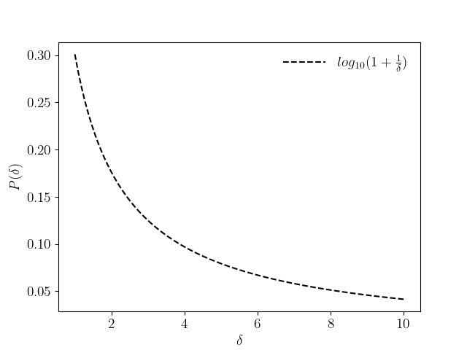

**Figure 1.** Benford's law graphic, with the initial numbers on the *x*-axis and their associated likelihood on the *y*-axis. P(δ) was constrained on the y-axes in the figure above, while δ was restrained on the x-axes. The following ogive has been developed from the points in Table 1.

The formulation mentioned above works only for the occurrence of digit δ as the 1st digit only, though another formulation has been generated that tells us about the probability of occurrence of digit δ as the ζ'th digit. The phrase is written as follows:

|  |  |
| --- | --- |
| $$π(δ) = \sum_{κ = {10}^{ζ-2}}^{{10}^{ζ-1}-1}{\log_{10}\left(1+\frac{1}{10κ+δ}\right)}$$ | *…(ii)* |

π(δ) = Probability of Occurrence of the digit δ as the ζ’th digit ∋∀ 0≤δ≤9 ∀ ζ>1

Generally speaking, Benford's law is as follows:

|  |  |
| --- | --- |
| $$π(δ)=\left\{\begin{aligned}\log_{10}\left(1 + \frac{1}{δ}\right) ∋∀ 1≤δ≤9 and ζ=1 \\ \sum_{κ = {10}^{ζ-2}}^{{10}^{ζ-1}-1}{\log_{10}\left(1+\frac{1}{10κ+δ}\right) ∋∀ 0≤δ≤9}and ζ>1\end{aligned}\right.$$ | *…(iii)* |

Hal Varian, an analyst, proposed using Benford's law to monitor for deception in the socio-economic statistics (Oakes and Rossi 2003) h good reason. After all, its range of operation was so broad. Benford's law has applications in many different fields, including the following:

1. By examining inconsistencies in the election (Moore and Colley 2022) dataset, it is utilized to identify fraud.
2. It is used to research pricing digits.
3. It is utilized to validate genetic data (Waples 2023).
4. It is used to check scientific works for errors (Salemi and Canola 2002).

3.3 Zipf’s Law

Although Zipf’s Law is widely used in linguistics, still it’s definition can be extended to statistical analysis as follows. If a set of information is arranged in ascending order, frequency times rank will perpetually remain an invariant.

Mathematically,

|  |  |
| --- | --- |
| $$f_{r}×r=k$$ | *…(iv)* |

where,

$f_{r}$ = Frequency of data with rank $r$.

$r$ = Rank.

$k$ = Constant.

The probability of occurrence of a digit as the first digit as $r$ would be,

|  |  |
| --- | --- |
| $$π\left(r\right)=\frac{f_{r}}{\sum{f_{r}}}$$ | *…(v)* |

Zipf’s Law was historically studied by Kingsley Zipf, an American linguist as well as philologist who investigated statistical instances, hypothesized in 1935 that certain phrases are used infrequently while others are frequently. For Zipf's law, we frequently use a log-log graph, in which the measurement range over the $y$-axis is determined by the log of the frequency range, and the distribution for the $x$-axis is defined by the log of the rank. A log-log graph can be utilized to display the graph's edges with more clarity and completeness. If we plug in logarithms on both sides of the equation (iv), we get

|  |  |
| --- | --- |
| $$\log{f_{r}}+\log{r}=k^{'}$$ | *…(vi)* |

where, $k^{'}$ is another constant. Figure 2 demonstrates the Zipfian Distribution plot.

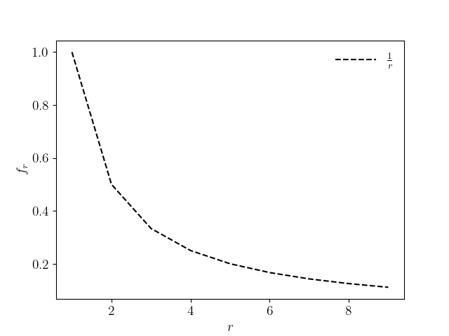

**Figure 2.** Zipfian Distribution for $k=1$ with frequencies along the $y$ axes, and ranks along the $x$ axis.

3.4 A Unified Approach by Dutta, et.al.

Dutta, and Roy Choudhury in their work, “A Unified Approach to Fraudulent Detection” (Dutta et al. 2022) developed a methodology based on the Benford and Zipf Law to detect fraudulences in Data.

According to the research, suppose we have a data set, $D$. The probability of occurrence of digit, $µ$ as a First Digit of a data point would be,

|  |  |
| --- | --- |
| $$π\left(n=µ\right)=9.741×{10}^{-7}µ^{8}-0.4×{10}^{-4}µ^{7}+0.8×{10}^{-3}µ^{6}-0.009µ^{5}+0.062µ^{4}-0.262µ^{3}+0.704µ^{2}-1.142µ+1$$ | *…(vii)* |

The graph for “A Unified Approach by Dutta , et.al.” (First digit) would be,

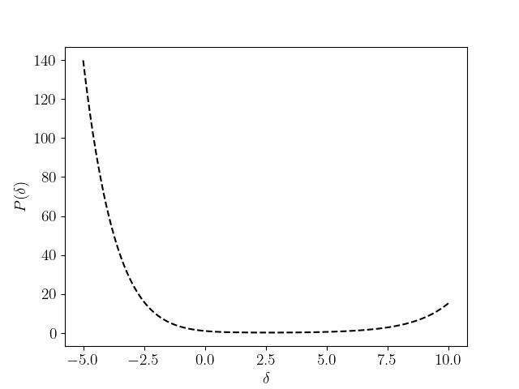

**Figure 3.** The Graphical interpretation of the “Unified Approach by Dutta et.al.”, with probability of occurrence of any digit along the $y$ axes, and the digits along the axes.

4. A Scientific Mitigation

This section will conclude the controversies following some well-fledged scientific paradigms, especially Benford's Law. We have collected the Adani Enterprise Stock Value between 2016 and 2023. To apply Benford's Law in any dataset, we must perform some tests to confirm whether the collection is fit. We have performed three tests on the collection, namely

1. *Mean Absolute Deviation Test*: Mean of the direct deviates from the origin. Suppose we have a dataset, $\left\{x_{1}, x_{2}, x_{3}, x_{4}, ..., x_{n}\right\}$. Its Mean Absolute Deviation (Yitzaki and Lambert 2011) is

|  |  |
| --- | --- |
|  | *…(viii)* |

For a collection to be suitable for implementing Benford's law, one must pass the Mean Absolute Deviation criterion within a particular band. Table 2. Shows the conformity range (Campbell-Meiklejohn 2012) from a Paper by Mark. J. Nigrini

**Table 2.** First-digit conformity range.

|  |  |
| --- | --- |
| **Conformity Range** | **First Digits** |
| Close Conformity | 0.000 - 0.006 |
| Acceptable Conformity | 0.006 - 0.012 |
| Marginal Conformity | 0.012 - 0.015 |
| Non-conformity | Above 0.015 |

1. *Mantissa Arc Test*: We may identify the centroid for a specific group of mantissas evenly dispersed around a unit circle using this experiment. The pivot point, or the average vector, is the vector that results if the mantissa of integers is spread evenly over the unit circle (0, 0).
2. $χ^{2}$*Test*: If a discrepancy between conceptual stats and the actual data, it can be determined using Pearson's Chi-Squared test [27], a fitting experiment. Assuming that the null hypothesis is true as n approaches infinity, the $χ^{2}$ dispersion is as follows:

|  |  |
| --- | --- |
| $$Z^{2}=\sum_{i=1}^{k}{\frac{{\left(z_{i}-m_{i}\right)}^{2}}{m_{i}}}= \sum_{i=1}^{k}{\left(\frac{{z_{i}}^{2}}{m_{i}}-n\right)}$$ | *…(ix)* |

$m_{i}= np_{i}$ $∀ i∈N_{n }$ where $p_{i}$ is the probabilities given by the null hypothesis and $\sum_{i∈N_{n}}{p_{i}=1}$. If the pixels on the scatter diagram are roughly identical to zero, the "Difference" graph, or scatter plot, representing the distinction between Artificial likelihood and the likelihood by our suggested equation, substantially corresponds to the collection's authenticity. We may assess the dataset's fairness depending on this scatter graph by determining whether or not it detracts from following our suggested formula. The mean absolute deviation analysis is the most reliable procedure to determine whether the data fit Benford's law. Chi-Square and Mantissa Arc tests are employed for additional conformance if the MAD test yields a score of "moderate conformity" but rather "non-conformity."

4.1. The Adani Stock Price Opening Value

The rate for which a commodity is initially dealt over an exchange there at the start of a trading day is known as the Starting Price. Table 3 shows a few instances of the Stock Opening Price between 2016 and 2023.

**Table 3.** Stock Opening Price for Adani Enterprises Limited. The following segments have been scrapped from the whole dataset to make demonstrating it easier.

|  |  |
| --- | --- |
| **Date** | **Stock Opening Price (USD)** |
| 01-01-2016 | 45.553741 |
| 04-01-2016 | 48.768658 |
| 05-01-2016 | 46.670792 |
| 06-01-2016 | 47.951309 |
| 07-01-2016 | 46.262115 |
| 08-01-2016 | 44.6819 |
| 11-01-2016 | 44.136997 |
| 12-01-2016 | 44.872616 |
| 13-01-2016 | 44.572922 |
| 14-01-2016 | 43.019951 |
| … | … |
| 16-01-2023 | 3720 |
| 17-01-2023 | 3620 |
| 18-01-2023 | 3648 |
| 19-01-2023 | 3470 |
| 20-01-2023 | 3450 |
| 23-01-2023 | 3443.050049 |
| 24-01-2023 | 3447.449951 |
| 25-01-2023 | 3422 |
| 27-01-2023 | 3335 |
| 30-01-2023 | 2850 |

The complete dataset is made available at <https://github.com/Anurag-Dutta/Adani/blob/main/open.csv>. Firstly, we have considered the first digit of the Opening Stock Price Column entries. Table 4. shows the digit-wise frequency of the same.

**Table 4.** Digit–wise frequency for 1st Digit place for the Stock Opening Price.

|  |  |
| --- | --- |
| **Digit** | **Frequency** |
| 1 | 712 |
| 2 | 213 |
| 3 | 269 |
| 4 | 180 |
| 5 | 64 |
| 6 | 80 |
| 7 | 108 |
| 8 | 92 |
| 9 | 32 |

Adding up all the entries of the Frequency Column, we get,

$$\sum_{i=1}^{9}{f_{i}}=1750$$

Then, using the equation

$$P\left(i\right)=\frac{f_{i}}{\sum_{i=1}^{9}{f_{i}}}=\frac{f_{i}}{1750}$$

We estimated the artificial likelihood or, more accurately, the realistic likelihood and contrasted it to the mathematical likelihood by Benford’s Law. The theoretical probabilities have been demonstrated in Table 1. Figure 2 contrasts the same.

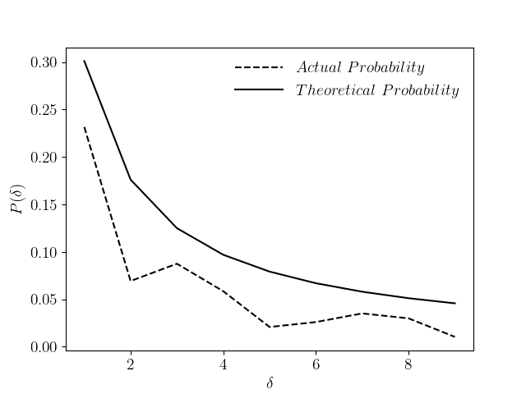

**Figure 4.** The contrast between Actual and Theoretical Probabilities taking into consideration, Opening Price of the Adani Stock Price subjected to the Benford’s Law.

The mean squared error,

$$\sum_{i=1}^{9}{{\left(y_{i}-\hat{y_{i}}\right)}^{2}}$$

turns out to be **0.026420815**, which is in the acceptable range.

To validate the acceptability of the result, we subjected the same data to the Zipfian Distribution, The Contrast between Actual and Theoretical Probabilty in that case is as,

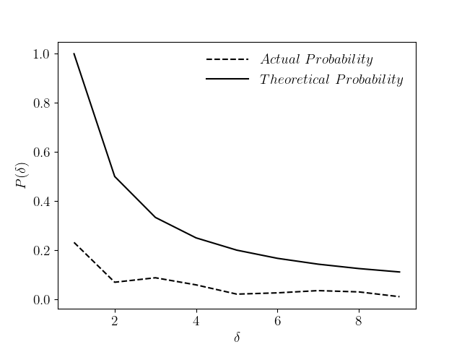

**Figure 5.** The contrast between Actual and Theoretical Probabilities taking into consideration, Opening Price of the Adani Stock Price subjected to Zipfian Distribution.

Here, the mean squared error, turns out to be **0.1062038719237965** (< 0.5), which is in the acceptable range for Zipfian Distribution.

And finally, using the “Unified Approach by Dutta et.al” method, the contrast was

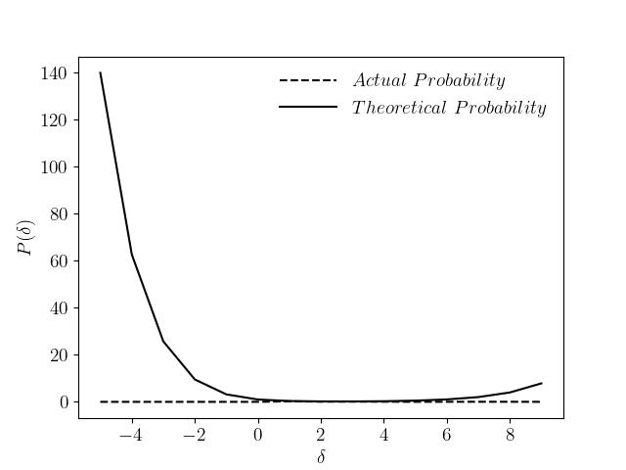

**Figure 6.** The contrast between Actual and Theoretical Probabilities taking into consideration, Opening Price of the Adani Stock Price for the Lagrange Interpolation based method – “Unified Approach by Dutta et.al.”

Here, the mean squared error in the range [0, 9][1], turns out to be **0.05056085856554** (< 0.1), which is in the acceptable range.

4.2. The Adani Stock Price Closing Value

The final transaction price of security well before the exchange formally shuts for regular trading is known as the closing price or cash value. Table 5 shows a few instances of the Stock Closing Price between 2016 and 2023.

**Table 5.** Stock Closing Price for Adani Enterprises Limited.

|  |  |
| --- | --- |
| **Date** | **Stock Closing Price (USD)** |
| 01-01-2016 | 44.872616 |
| 04-01-2016 | 45.907928 |
| 05-01-2016 | 45.880684 |
| 06-01-2016 | 46.480076 |
| 07-01-2016 | 42.502296 |
| 08-01-2016 | 43.946285 |
| 11-01-2016 | 42.992706 |
| 12-01-2016 | 43.319649 |
| 13-01-2016 | 42.066376 |
| 14-01-2016 | 42.148109 |
| … | … |
| 16-01-2023 | 3600 |
| 17-01-2023 | 3560.199951 |
| 18-01-2023 | 3527.100098 |
| 19-01-2023 | 3426.699951 |
| 20-01-2023 | 3440.949951 |
| 23-01-2023 | 3412.550049 |
| 24-01-2023 | 3430 |
| 25-01-2023 | 3315 |
| 27-01-2023 | 2712 |
| 30-01-2023 | 2665 |

The complete dataset is made available at <https://github.com/Anurag-Dutta/Adani/blob/main/close.csv>. Firstly, we have considered the first digit of the Closing Stock Price Column entries. Table 6. shows the digit-wise frequency of the same.

**Table 6.** Digit–wise frequency for 1st Digit place for the Stock Closing Price.

|  |  |
| --- | --- |
| **Digit** | **Frequency** |
| 1 | 718 |
| 2 | 207 |
| 3 | 301 |
| 4 | 152 |
| 5 | 66 |
| 6 | 83 |
| 7 | 113 |
| 8 | 94 |
| 9 | 17 |

Adding up all the entries of the Frequency Column, we get,

$$\sum_{i=1}^{9}{f_{i}}=1750$$

Then, using the equation

$$P\left(i\right)=\frac{f_{i}}{\sum_{i=1}^{9}{f_{i}}}=\frac{f_{i}}{1750}$$

We estimated the artificial likelihood or, more accurately, the realistic likelihood and contrasted it to the mathematical likelihood by Benford’s Law. The theoretical probabilities have been demonstrated in Table 1. Figure 3 contrasts the same.

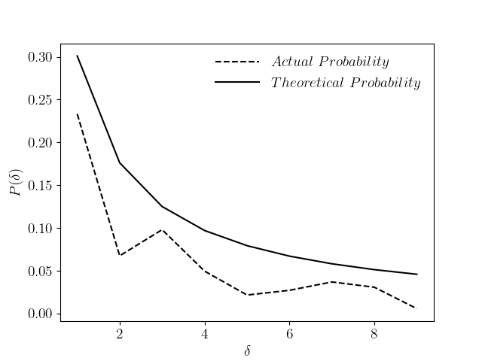

**Figure 7.** The contrast between Actual and Theoretical Probabilities taking into consideration, Closing Price of the Adani Stock Price subjected to Benford’s Law.

The mean squared error,

$$\sum_{i=1}^{9}{{\left(y_{i}-\hat{y_{i}}\right)}^{2}}$$

turns out to be **0.026861614**, which is in the acceptable range.

To validate the acceptability of the result, we subjected the same data to the Zipfian Distribution, The Contrast between Actual and Theoretical Probabilty in that case is as,

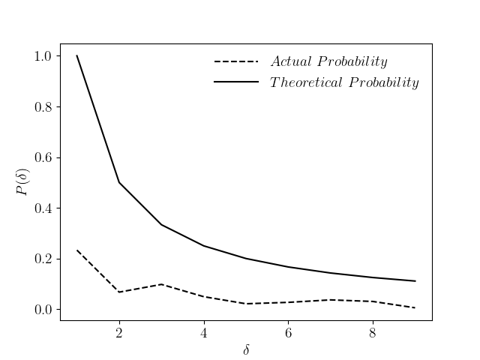

**Figure 8.** The contrast between Actual and Theoretical Probabilities taking into consideration, Closing Price of the Adani Stock Price subjected to Zipfian Distribution.

Here, the mean squared error, turns out to be **0.10595704217394913** (< 0.5), which is in the acceptable range for Zipfian Distribution.

And finally, using the “Unified Approach by Dutta et.al” method, the contrast was

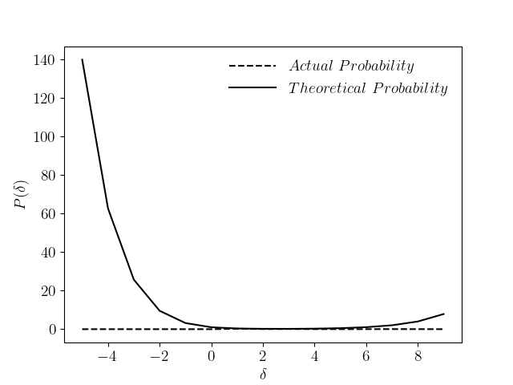

**Figure 9.** The contrast between Actual and Theoretical Probabilities taking into consideration, Closing Price of the Adani Stock Price for the Lagrange Interpolation based method – “Unified Approach by Dutta et.al.”

Here, the mean squared error in the range [0, 9], turns out to be **0.05015615616515** (< 0.1), which is in the acceptable range.

4.3. The Adani Stock Price Highest Value

Table 7 shows a few instances of the Stock's Highest Price between 2016 – 2023.

**Table 7.** Stock Highest Price for Adani Enterprises Limited.

|  |  |
| --- | --- |
| **Date** | **Stock Highest Price (USD)** |
| 01-01-2016 | 49.422543 |
| 04-01-2016 | 50.158157 |
| 05-01-2016 | 48.823151 |
| 06-01-2016 | 48.468964 |
| 07-01-2016 | 46.262115 |
| 08-01-2016 | 45.226803 |
| 11-01-2016 | 45.717213 |
| 12-01-2016 | 45.635475 |
| 13-01-2016 | 46.643543 |
| 14-01-2016 | 44.136997 |
| … | … |
| 16-01-2023 | 3739.949951 |
| 17-01-2023 | 3649.600098 |
| 18-01-2023 | 3648 |
| 19-01-2023 | 3537.699951 |
| 20-01-2023 | 3477.350098 |
| 23-01-2023 | 3460 |
| 24-01-2023 | 3508 |
| 25-01-2023 | 3428 |
| 27-01-2023 | 3346.5 |
| 30-01-2023 | 3037.550049 |

The complete dataset is made available at <https://github.com/Anurag-Dutta/Adani/blob/main/high.csv>. Firstly, we have considered the first digit of the Highest Stock Price Column entries. Table 8. shows the digit-wise frequency of the same.

**Table 8.** Digit–wise frequency for 1st Digit place for the Stock Highest Price.

|  |  |
| --- | --- |
| **Digit** | **Frequency** |
| 1 | 708 |
| 2 | 211 |
| 3 | 244 |
| 4 | 207 |
| 5 | 67 |
| 6 | 76 |
| 7 | 94 |
| 8 | 94 |
| 9 | 49 |

Adding up all the entries of the Frequency Column, we get,

$$\sum_{i=1}^{9}{f_{i}}=1750$$

Then, using the equation

$$P\left(i\right)=\frac{f_{i}}{\sum_{i=1}^{9}{f_{i}}}=\frac{f_{i}}{1750}$$

We estimated the artificial likelihood or, more accurately, the realistic likelihood and contrasted it to the mathematical likelihood by Benford's Law. The theoretical probabilities have been demonstrated in Table 1. Figure 4 contrasts the same.

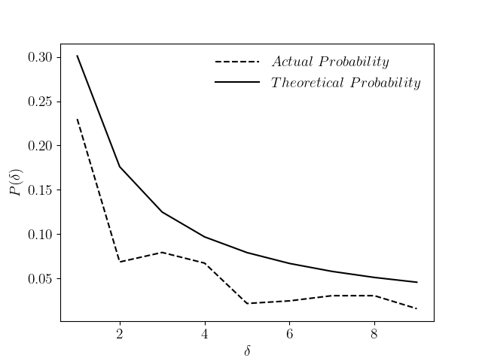

**Figure 10.** The contrast between Actual and Theoretical Probabilities taking into consideration, Highest Price of the Adani Stock Price subjected to Benford’s Law.

The mean squared error,

$$\sum_{i=1}^{9}{{\left(y_{i}-\hat{y_{i}}\right)}^{2}}$$

turns out to be **0.02672328**, which is in the acceptable range.

To validate the acceptability of the result, we subjected the same data to the Zipfian Distribution, The Contrast between Actual and Theoretical Probabilty in that case is as,

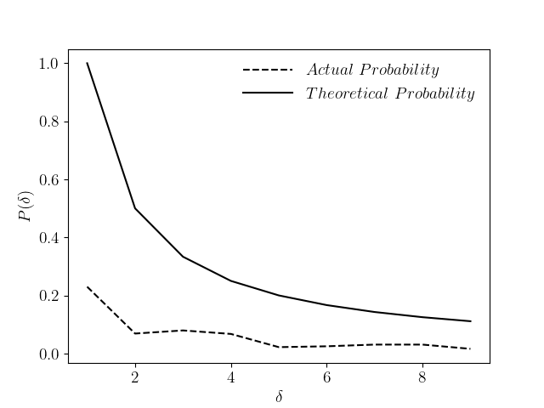

**Figure 11.** The contrast between Actual and Theoretical Probabilities taking into consideration, Highest Price of the Adani Stock Price subjected to Zipfian Distribution.

Here, the mean squared error, turns out to be **0.10661003032585675** (< 0.5), which is in the acceptable range for Zipfian Distribution.

And finally, using the “Unified Approach by Dutta et.al” method, the contrast was

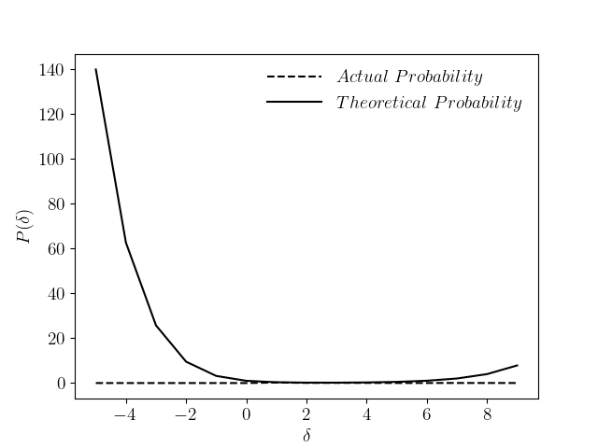

**Figure 12.** The contrast between Actual and Theoretical Probabilities taking into consideration, Highest Price of the Adani Stock Price for the Lagrange Interpolation based method – “Unified Approach by Dutta et.al.”

Here, the mean squared error in the range [0, 9], turns out to be **0.05041551565647** (< 0.1), which is in the acceptable range.

5. Conclusion

The Adani Stock Price deviates from Benford Law but is within acceptable ranges. For the Opening, Closing, and Highest price in 2016 - 2023, the collection followed the Law of Anomalous Numbers. Though it isn't justified to conclude the Adani Controversy drawing attenuation from the Stock Price data, there hasn't been any data morphing (Cash 1974; Karnow 1994) on the Adani Stock Price Data, as per its accordion with Benford's Law. The authors would like to clarify that the results of the article have nothing to do with the resolution of the entire controversy around the Adani Case. The only objective in work is the Validation of the Stock Price as put forward by the Adani Group. Further, this technique of Fraudulent detection could also be introduced to inquire about possible fallacies in any Data.

The authors encourage future works on the case to reach a more concrete conclusion using other measures that could be futuristic enough to rule out the jeopardize. Statistical laws like Weber's, etc., could also be drawn into the frame as a scope of future works.

References

1. M. J. Müller, B. Landsberg, and J. Ried, “Fraud in science: a plea for a new culture in research,” *European Journal of Clinical Nutrition*, vol. 68, no. 4, pp. 411–415, Apr. 2014, doi: https://doi.org/10.1038/ejcn.2014.17.
2. N. Koepke and J. Baten, “The biological standard of living in Europe during the last two millennia,” *European Review of Economic History*, vol. 9, no. 1, pp. 61–95, Apr. 2005, doi: https://doi.org/10.1017/s1361491604001388.
3. E. Annus, “The Problem of Soviet Colonialism in the Baltics,” *Journal of Baltic Studies*, vol. 43, no. 1, pp. 21–45, Mar. 2012, doi: https://doi.org/10.1080/01629778.2011.628551.
4. H. R. Varian, “Microeconomics,” *The New Palgrave Dictionary of Economics*, pp. 1–5, 1987, doi: https://doi.org/10.1057/978-1-349-95121-5_1212-1.
5. R. M. Ryan and E. L. Deci, “On Happiness and Human potentials: a Review of Research on Hedonic and Eudaimonic well-being,” *Annual review of psychology*, vol. 52, no. 1, pp. 141–66, 2001, doi: https://doi.org/10.1146/annurev.psych.52.1.141.
6. C. Dahlström and V. Lapuente, “Comparative Bureaucratic Politics,” *Annual Review of Political Science*, vol. 25, no. 1, Feb. 2022, doi: https://doi.org/10.1146/annurev-polisci-051120-102543.
7. Z. Cai, M. Faust, A. J. Hildebrand, J. Li, and Y. Zhang, “The Surprising Accuracy of Benford’s Law in Mathematics,” *The American Mathematical Monthly*, vol. 127, no. 3, pp. 217–237, Feb. 2020, doi: https://doi.org/10.1080/00029890.2020.1690387.
8. S. Dehaene, V. Izard, E. Spelke, and P. Pica, “Log or Linear? Distinct Intuitions of the Number Scale in Western and Amazonian Indigene Cultures,” *Science*, vol. 320, no. 5880, pp. 1217–1220, May 2008, doi: https://doi.org/10.1126/science.1156540.
9. M. J. Nigrini, *Benford's law: applications for forensic accounting, auditing, and fraud detection*. Hoboken, New Jersey: Wiley, 2012.
10. A. Berger and T. P. Hill, “The mathematics of Benford’s law: a primer,” *Statistical Methods & Applications*, Jun. 2020, doi: https://doi.org/10.1007/s10260-020-00532-8.
11. T. P. Hill, “A Statistical Derivation of the Significant-Digit Law,” *Statistical Science*, vol. 10, no. 4, pp. 354–363, Nov. 1995, doi: https://doi.org/10.1214/ss/1177009869.
12. I. Mbona and J. H. P. Eloff, “Feature selection using Benford’s law to support detection of malicious social media bots,” *Information Sciences*, vol. 582, pp. 369–381, Jan. 2022, doi: https://doi.org/10.1016/j.ins.2021.09.038.
13. A. Tošić and J. Vičič, “Use of Benford’s law on academic publishing networks,” *Journal of Informetrics*, vol. 15, no. 3, p. 101163, Aug. 2021, doi: https://doi.org/10.1016/j.joi.2021.101163.
14. D. Dove, W. Daniels, and D. Parrish, “Importance of Indigenous VAM Fungi for the Reclamation of Coal Refuse Piles,” *Journal American Society of Mining and Reclamation*, vol. 1990, no. 1, pp. 463–468, 1990, doi: https://doi.org/10.21000/jasmr90010463.
15. M. Cropper et al., “The mortality impacts of current and planned coal-fired power plants in India,” *Proceedings of the National Academy of Sciences*, vol. 118, no. 5, Jan. 2021, doi: https://doi.org/10.1073/pnas.2017936118.
16. ‌J. Zhao, “Logistic Forecast Analysis of Sichuan Province on the Basis of Multi-model Combination,” *BCP Business & Management*, vol. 34, pp. 684–696, Dec. 2022, doi: https://doi.org/10.54691/bcpbm.v34i.3083.
17. N. Armaroli and V. Balzani, “Towards an electricity-powered world,” *Energy & Environmental Science*, vol. 4, no. 9, p. 3193, 2011, doi: https://doi.org/10.1039/c1ee01249e.
18. X. Wang et al., “Simulation Analysis of External Damage and Repair of the Gas Transmission Pipeline,” *Advances in Materials Science and Engineering*, vol. 2022, pp. 1–9, Aug. 2022, doi: https://doi.org/10.1155/2022/3978649.
19. P. Langford, “Prime Ministers and Parliaments: The Long View, Walpole to Blair,” *Parliamentary History*, vol. 25, no. 3, pp. 382–394, 2006, doi: https://doi.org/10.1353/pah.2006.0045.
20. S. Newcomb, “Note on the Frequency of Use of the Different Digits in Natural Numbers,” *American Journal of Mathematics*, vol. 4, no. 1/4, p. 39, 1981, doi: https://doi.org/10.2307/2369148.
21. J. Michael. Oakes and P. H. Rossi, “The measurement of SES in health research: current practice and steps toward a new approach,” *Social Science & Medicine*, vol. 56, no. 4, pp. 769–784, Feb. 2003, doi: https://doi.org/10.1016/s0277-9536(02)00073-4.
22. M. Moore and T. Colley, “Two International Propaganda Models: Comparing RT and CGTN’s 2020 US Election Coverage,” *Journalism Practice*, pp. 1–23, Jun. 2022, doi: https://doi.org/10.1080/17512786.2022.2086157.
23. R. S. Waples, “Guidelines for genetic data analysis,” *J. Cetacean Res. Manage*., vol. 18, no. 1, pp. 33–80, Jan. 2023, doi: https://doi.org/10.47536/jcrm.v18i1.421.
24. C. Salemi, M. T. Canola, and E. K. Eck, “Hand Washing and Physicians: How to Get Them Together,” *Infection Control & Hospital Epidemiology*, vol. 23, no. 1, pp. 32–35, Jan. 2002, doi: https://doi.org/10.1086/501965.
25. S. Yitzhaki and P. J. Lambert, “The Relationship between the Gini and the Mean Absolute Deviation,” *SSRN Electronic Journal*, 2011, doi: https://doi.org/10.2139/ssrn.1945705.
26. D. K. Campbell-Meiklejohn et al., “Structure of orbitofrontal cortex predicts social influence,” *Current Biology*, vol. 22, no. 4, pp. R123–R124, Feb. 2012, doi: https://doi.org/10.1016/j.cub.2012.01.012.
27. W. Cash, “Parameter estimation in astronomy through application of the likelihood ratio,” *The Astrophysical Journal*, vol. 228, p. 939, Mar. 1979, doi: https://doi.org/10.1086/156922.
28. ‌C. E. A. Karnow, “Data Morphing: Ownership, Copyright and Creation,” *Leonardo*, vol. 27, no. 2, p. 117, 1994, doi: <https://doi.org/10.2307/1575978>.
29. [Salehi, M.](https://www.emerald.com/insight/search?q=Mahdi%20Salehi), [Ali Mohammed Al-Msafir, H.](https://www.emerald.com/insight/search?q=Hasanain%20Ali%20Mohammed%20Al-Msafir), [Homayoun, S.](https://www.emerald.com/insight/search?q=Saeid%20Homayoun) and [Zimon, G.](https://www.emerald.com/insight/search?q=Grzegorz%20Zimon) (2023), "The effect of social and intellectual capital on fraud and money laundering in Iraq", [*Journal of Money Laundering Control*](https://www.emerald.com/insight/publication/issn/1368-5201), Vol. 26 No. 2, pp. 227-252. <https://doi.org/10.1108/JMLC-12-2021-0142>
30. Mousavi, M.; Zimon, G.; Salehi, M.; Stępnicka, N. The Effect of Corporate Governance Structure on Fraud and Money Laundering. Risks **2022**, 10, 176. https://doi.org/10.3390/risks10090176
31. Dutta, Anurag, Manan Roy Choudhury, and Arnab Kumar De. 2022. A Unified Approach to Fraudulent Detection. International Journal of Applied Engineering Research 17: 110.

1. Since the First Digit of any number can not be other than 0, 1, 2, ..9.