**Results after Hyperparameter Tuning**

***ChaosNet + Decision Tree***

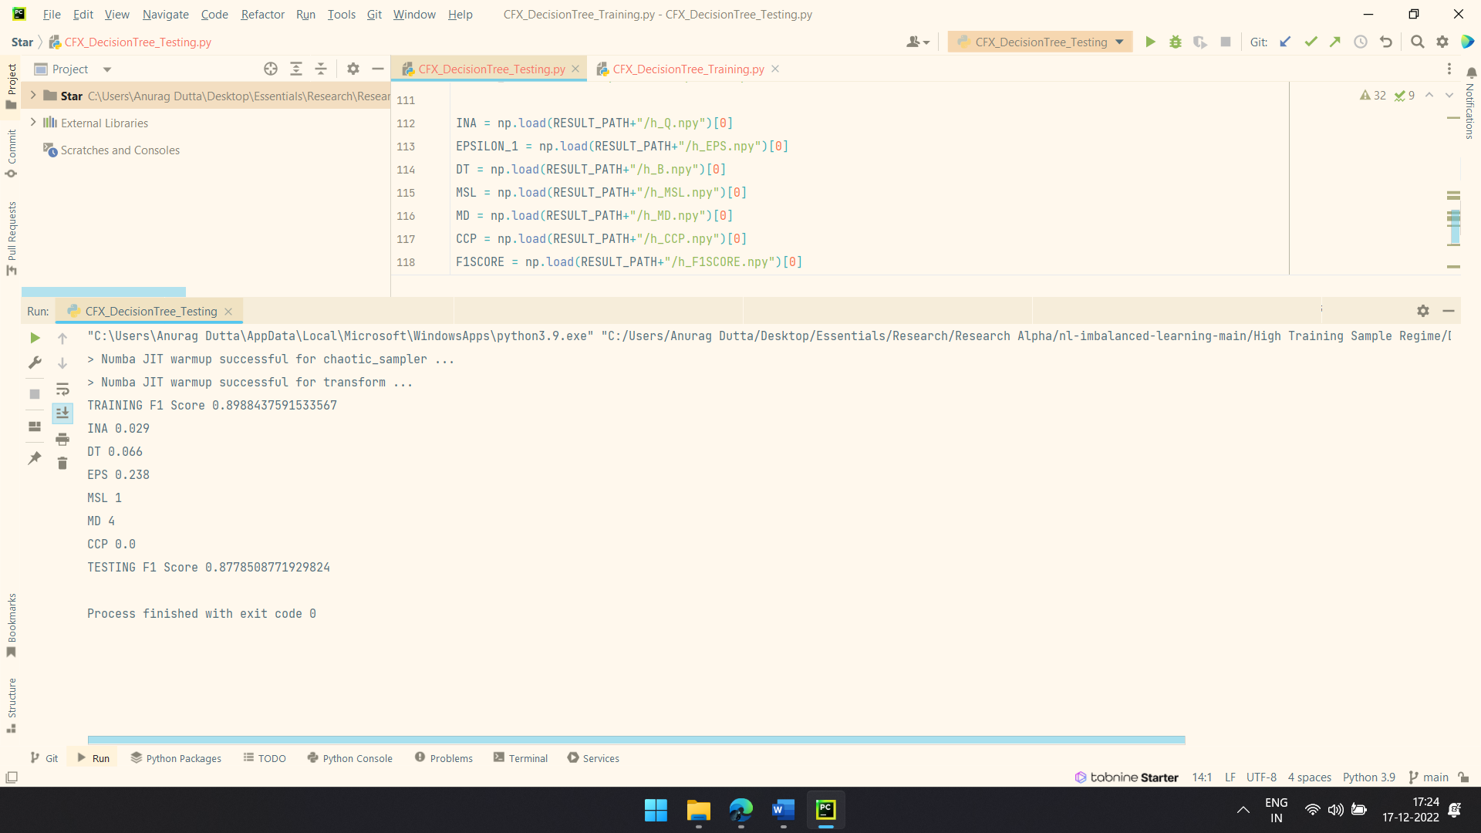

INITIAL_NEURAL_ACTIVITY = [0.029]

DISCRIMINATION_THRESHOLD = [0.066]

EPSILON = [0.238]

|  |
| --- |
| TRAINING F1 Score 0.8988437591533567  TESTING F1 Score 0.8778508771929824 |

***ChaosNet + AdaBoost***

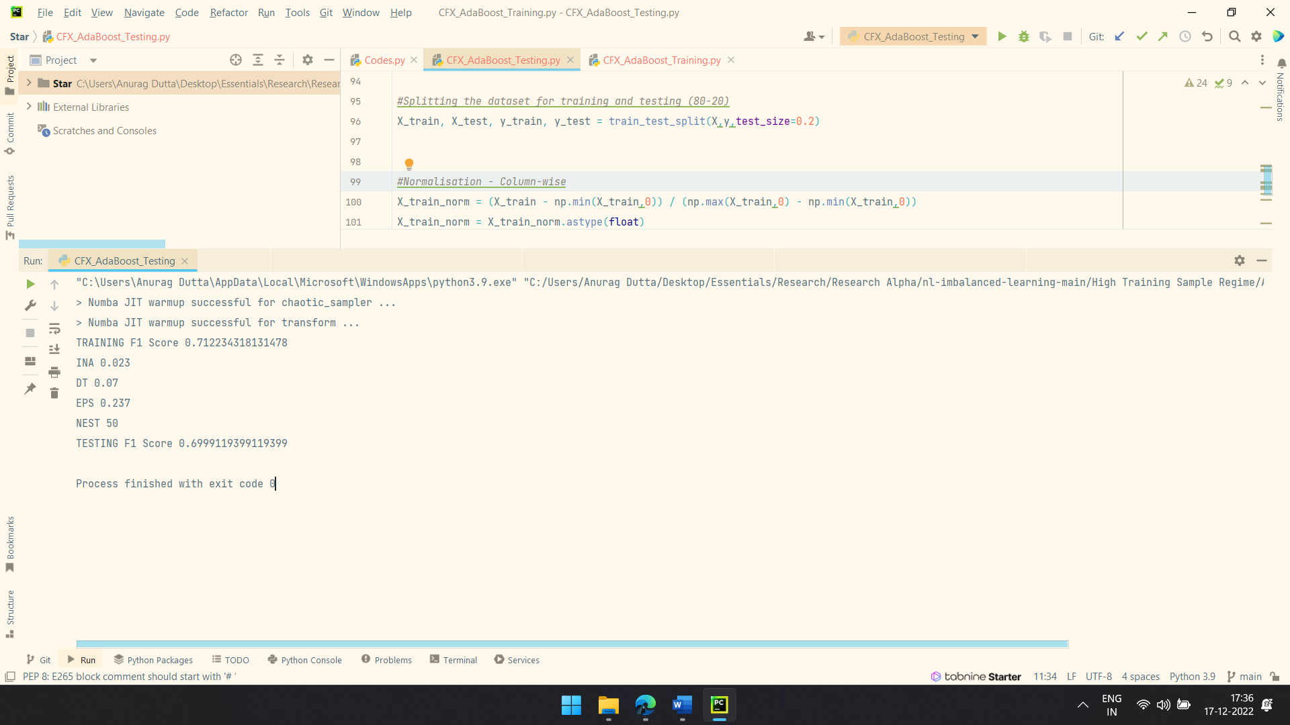

INITIAL_NEURAL_ACTIVITY = [0.023]

DISCRIMINATION_THRESHOLD = [0.070]

EPSILON = [0.237]

|  |
| --- |
| TRAINING F1 Score 0.712234318131478  TESTING F1 Score 0.6999119399119399 |

***ChaosNet Standalone***

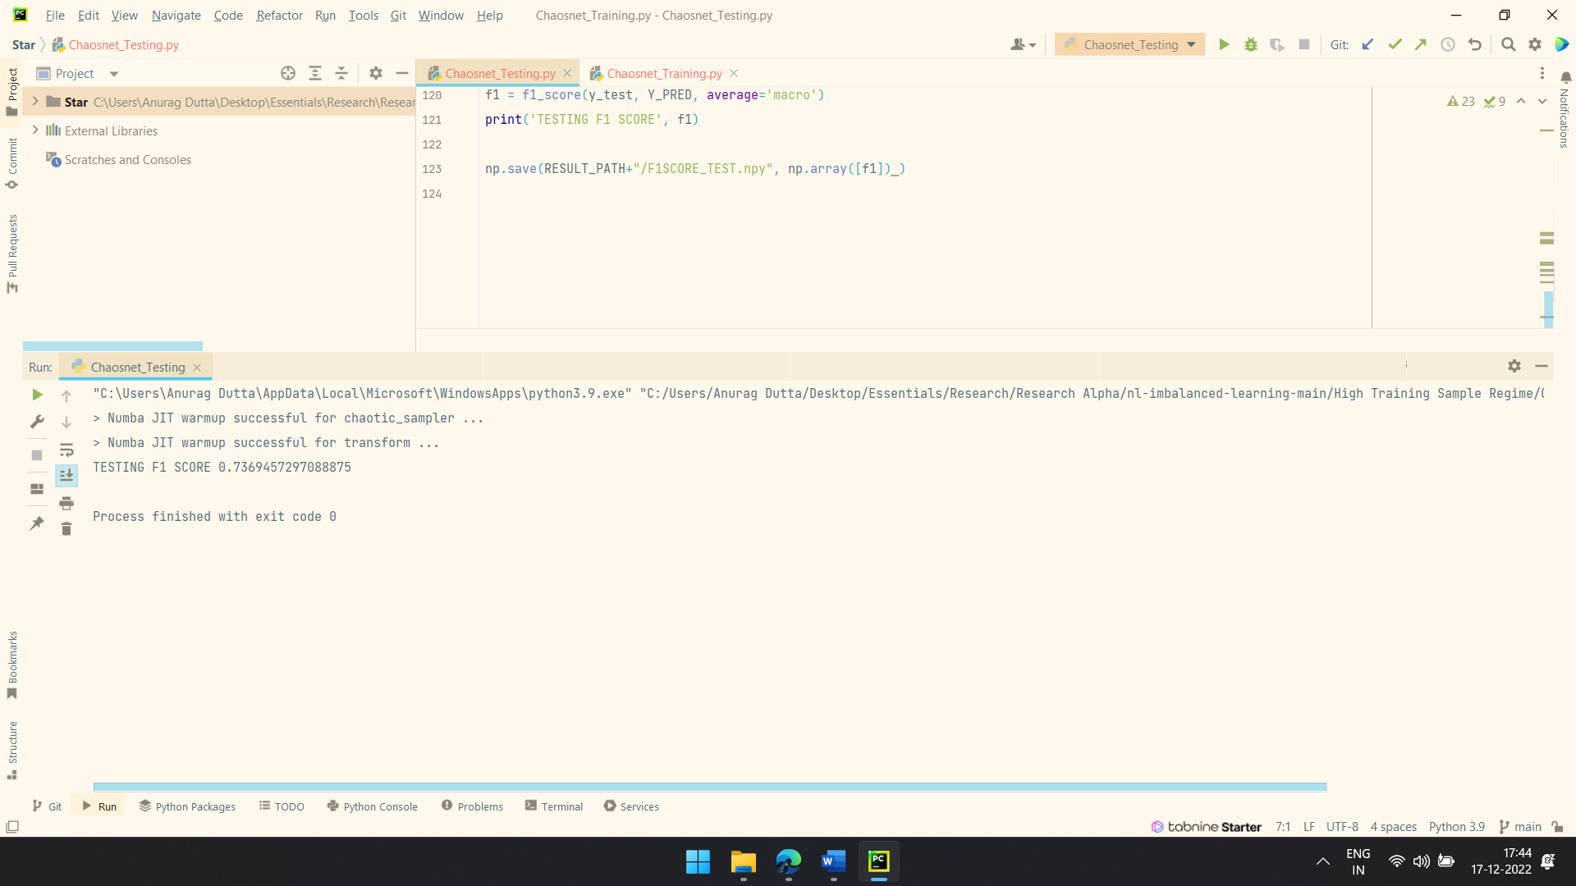

INITIAL_NEURAL_ACTIVITY = [0.03]

DISCRIMINATION_THRESHOLD = [0.07]

EPSILON = [0.226]

|  |
| --- |
| TRAINING F1 Score 0.7778545471767979  TESTING F1 SCORE 0.7369457297088875 |

***ChaosNet + Gaussian Naïve Bayes***

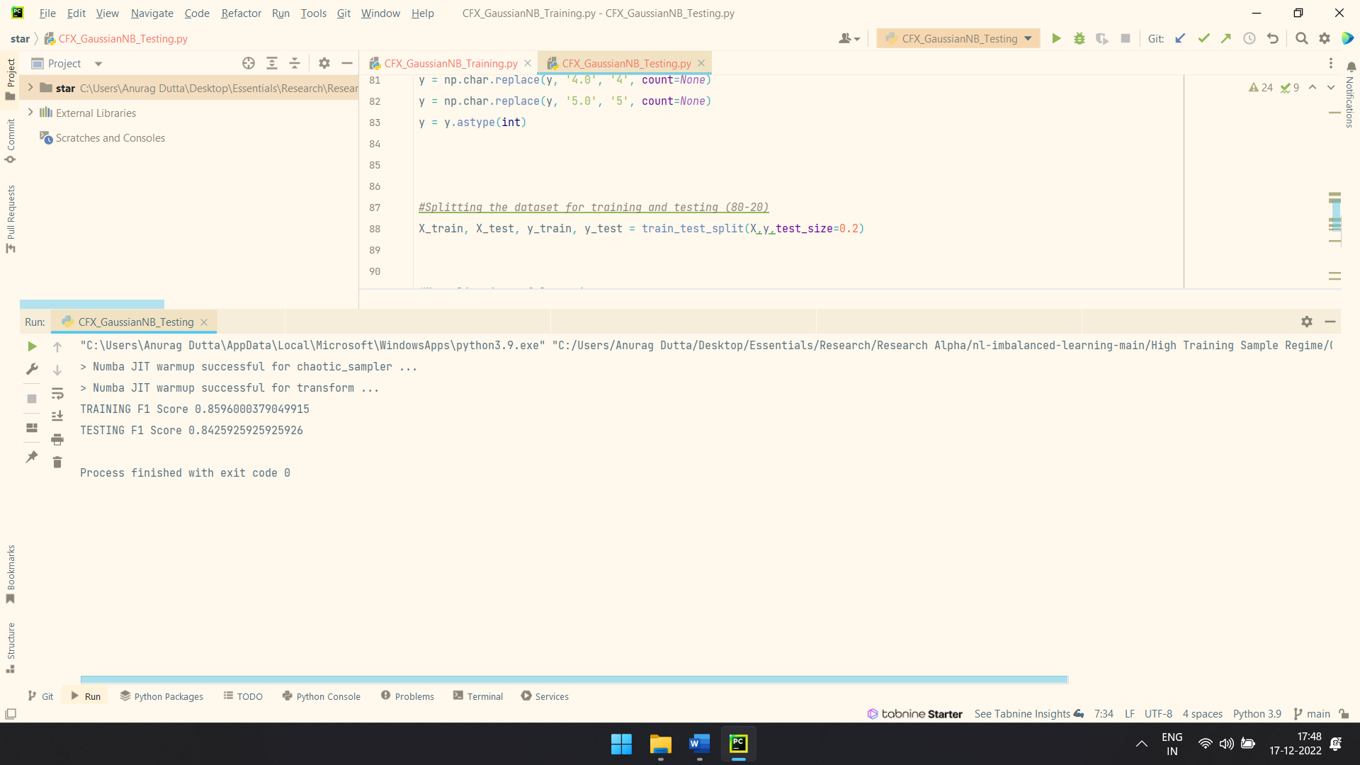

INITIAL_NEURAL_ACTIVITY = [0.03]

DISCRIMINATION_THRESHOLD = [0.07]

EPSILON = [0.228]

|  |
| --- |
| TRAINING F1 Score 0.8596000379049915  TESTING F1 Score 0.8425925925925926 |

***ChaosNet + k – Nearest Neighbors***

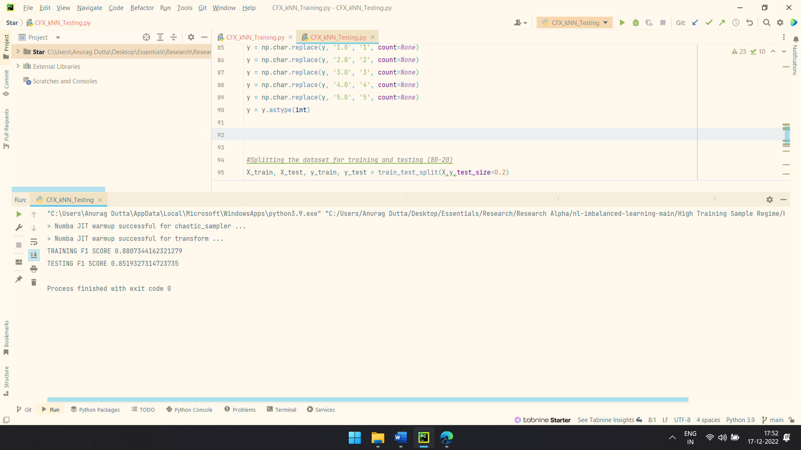

INITIAL_NEURAL_ACTIVITY = [0.029]

DISCRIMINATION_THRESHOLD = [0.070]

EPSILON = [0.213]

|  |
| --- |
| TRAINING F1 SCORE 0.8807344162321279  TESTING F1 SCORE 0.8519327314723735 |

***ChaosNet + Random Forest***

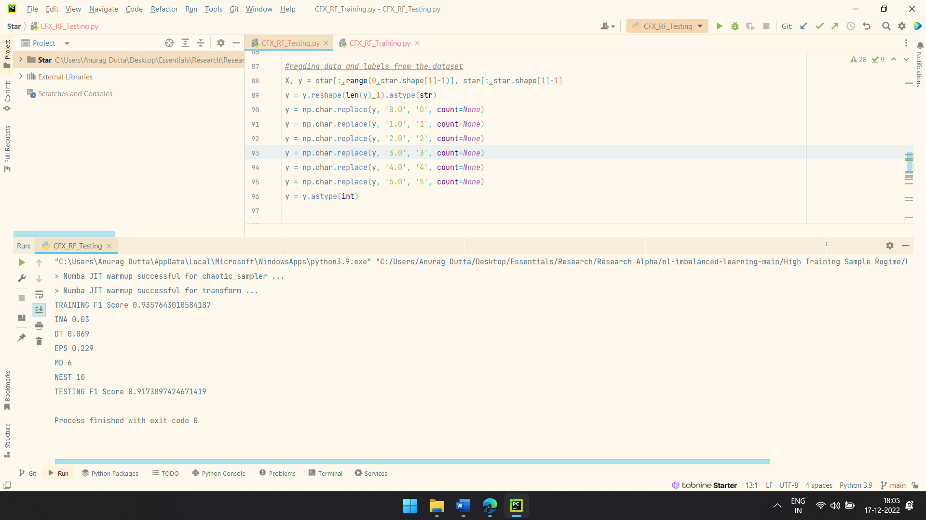

INITIAL_NEURAL_ACTIVITY = [0.030]

DISCRIMINATION_THRESHOLD = [0.069]

EPSILON = [0.229]

|  |
| --- |
| TRAINING F1 Score 0.9357643010584187  TESTING F1 Score 0.9173897424671419 |

***ChaosNet + Support Vector Machine***

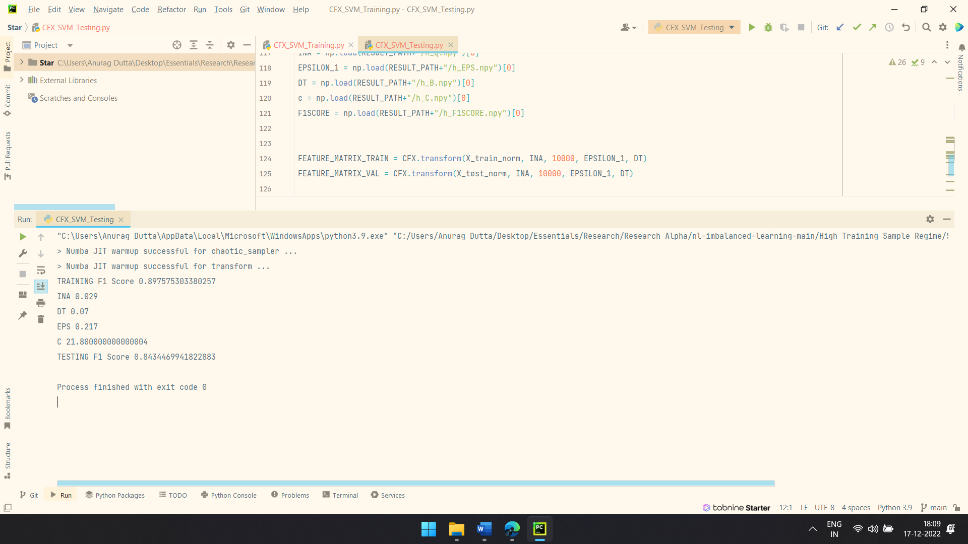

INITIAL_NEURAL_ACTIVITY = [0.029]

DISCRIMINATION_THRESHOLD = [0.066]

EPSILON = [0.217]

|  |
| --- |
| TRAINING F1 Score 0.897575303380257  TESTING F1 Score 0.8434469941822883 |