**Chaotic Maps in 1 - Dimension**

1. **Logistic Map**

Logistic maps are quadratic polynomial maps, which are often cited as typical examples of how complex and chaotic behavior can occur from very simple nonlinear dynamic equations. Increase. Mathematically, a logistic map is written as

$$x_{k+1}=rx_{k}\left(1-x_{k}\right)$$

where,

$x_{k}$ represents the $k'th$ term in the Recurrence

$r$ represents the rate of change

This rate of change can be of two types

* Reproduction: $x_{k+1}≥x_{k}∀k≥0$
* Starvation: $x_{k+1}<x_{k}∀k≥0$

In usual cases, we are ought to take $r$ in the range $\left[0, 4\right]$, which surely indicates that the $x_{k}$ will remain bounded between $\left[0, 1\right]$, else we are supposed to get negative population instances.

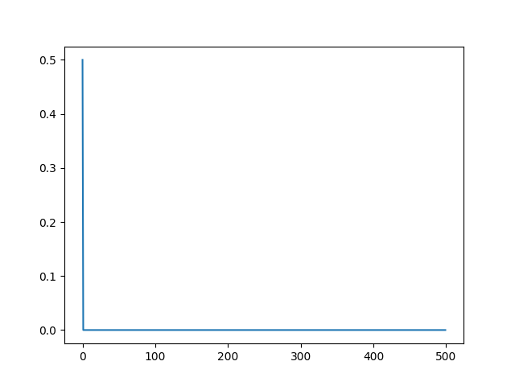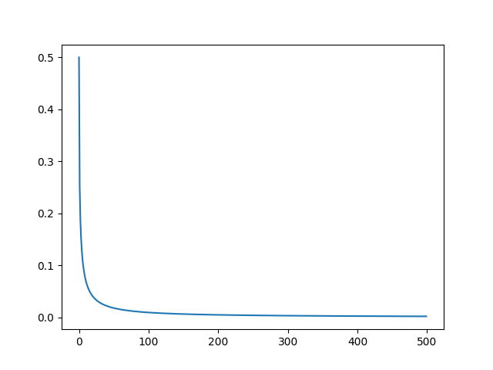

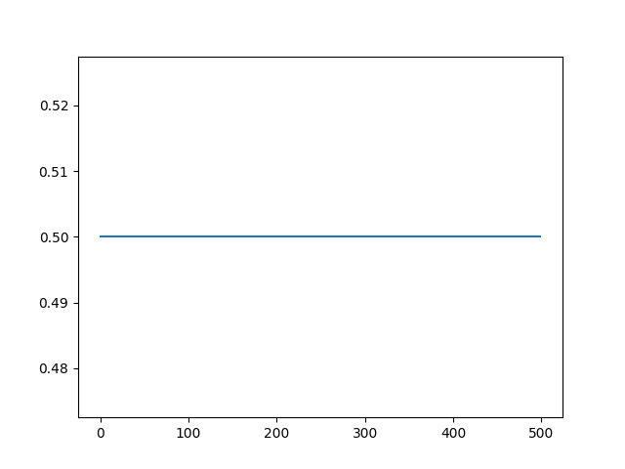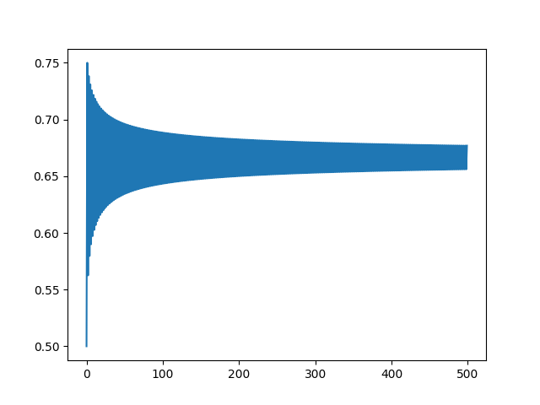

**Fig. 1.** Graphical Plot of the Logistic Map for $r=0, 1, 2, 3$ respectively, in row major manner

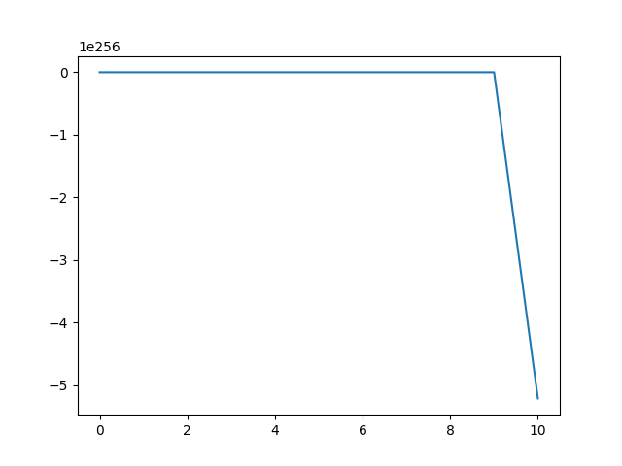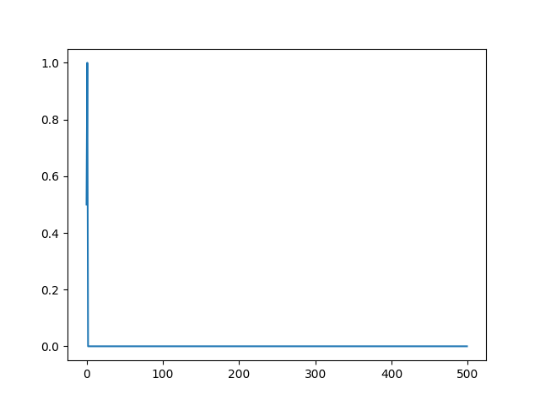

**Fig. 2.** Graphical Plot of the Logistic Map for $r=4, 5$ respectively, in row major manner

The bifurcation diagram[1] will be

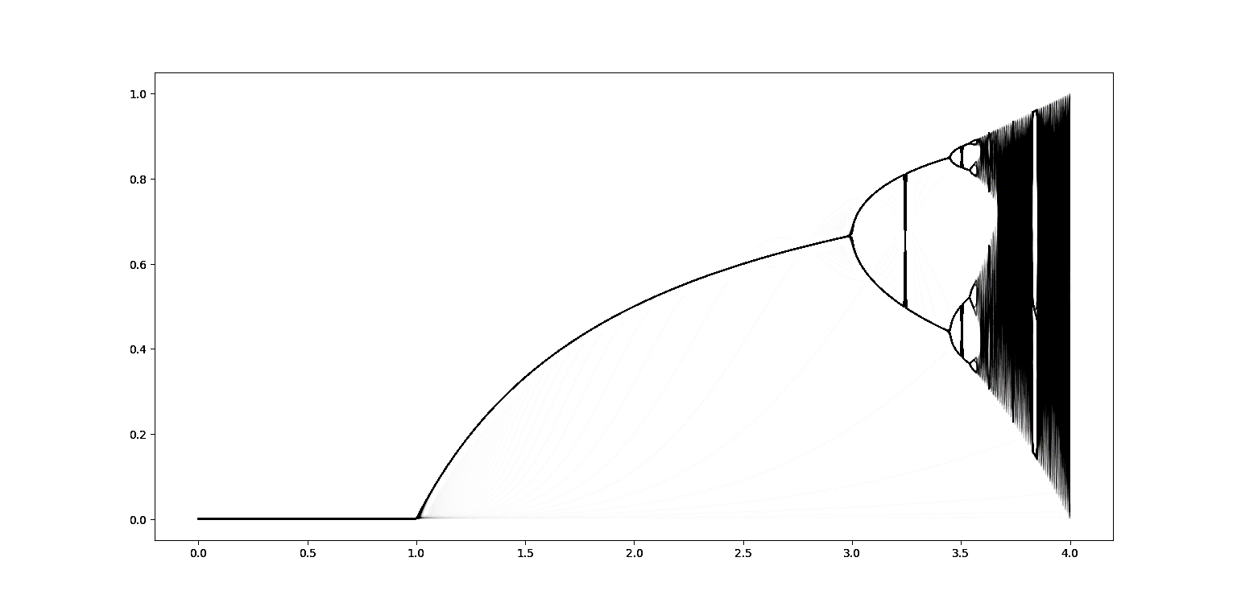

**Fig. 3.** Bifurcation Plot of the Logistic Map

1. **Gauss Map**

Gauss Map is a non-linear iteration mapping of real numbers to the real number interval given by the Gaussian function.

$$x_{k+1}=e^{-α{\left(x_{k}\right)}^{2}}+β$$

where,

$α, β$ are real valued parameters

In usual cases, we are ought to take $β$ in the range $\left[-1, 1\right]$

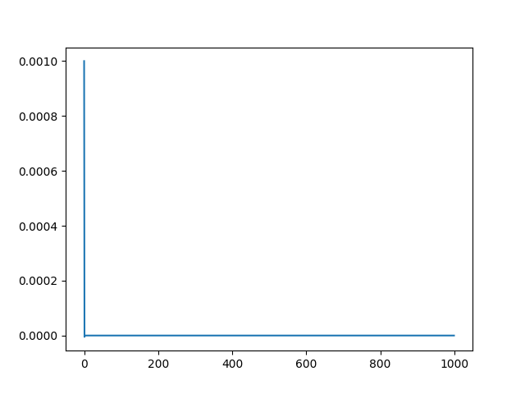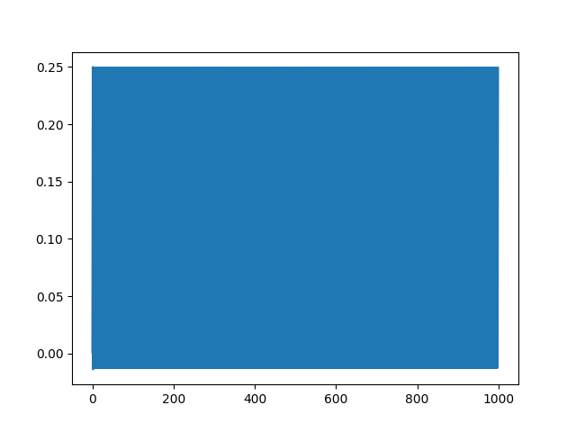

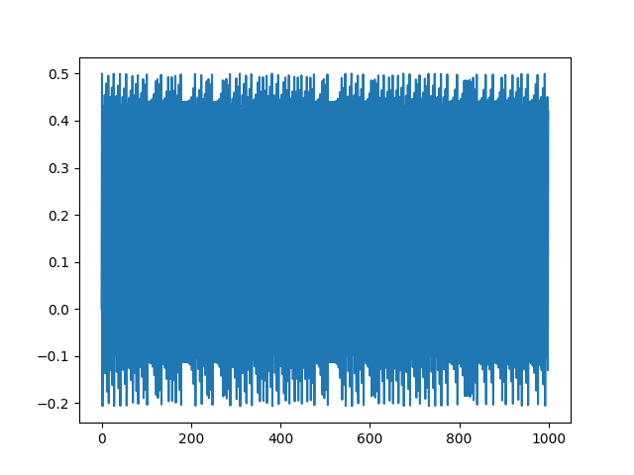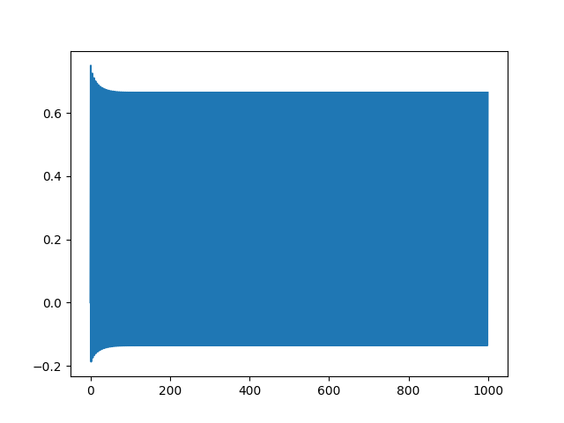

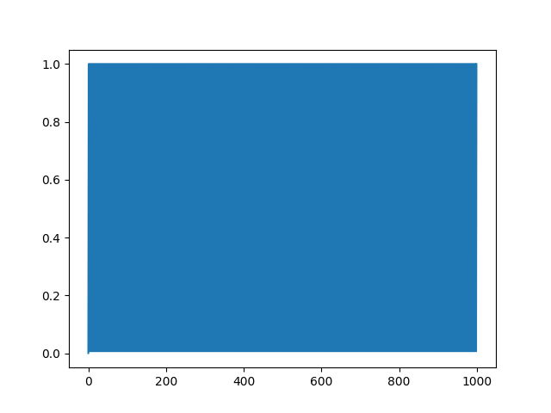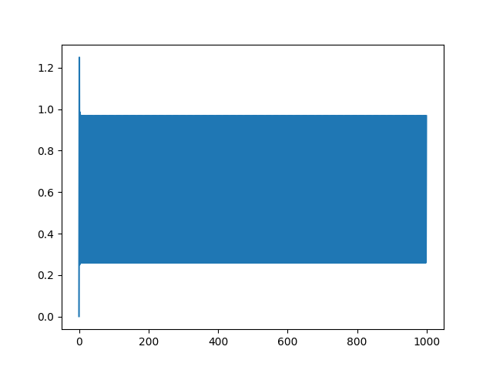

**Fig. 4.** Graphical Plot of the Gauss Map for $β=-1, -0.75, -0.50, -0.25, 0, 0.25$ and $α=4.9$ respectively, in row major manner

The bifurcation diagram will be

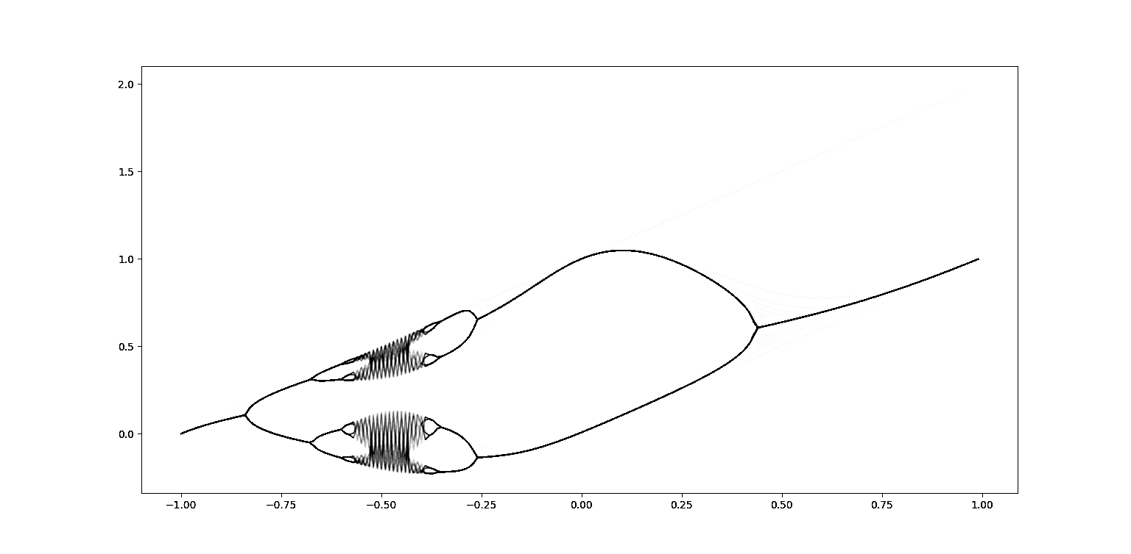

**Fig. 5.** Bifurcation Plot of the Gauss Map with $α=4.90$

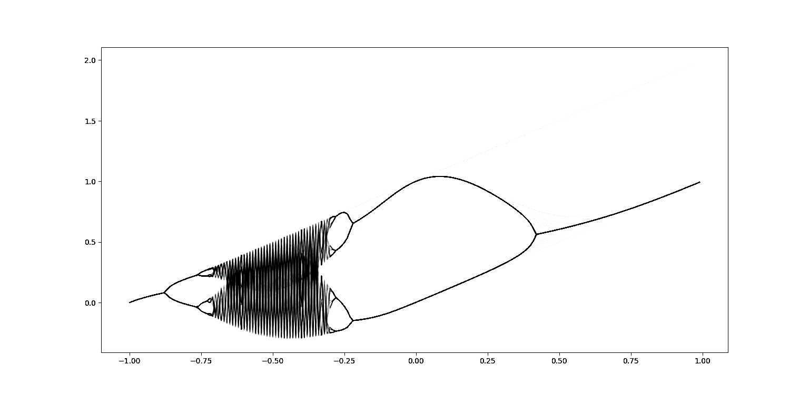

**Fig. 6.** Bifurcation Plot of the Gauss Map with $α=6.20$

1. **Circle Map**

A family of pie charts is a function (or endomorphism) of a circle relative to itself. It is mathematically easier to think of a point on a circle as a point on a solid line that is modulo $2π$ should be interpreted and represents the angle at which the point is in the circle. Even if the modulo is obtained with a value other than $2π$, the result represents an angle, but normalized so that the entire range is $\left[0, 2π\right]$ can be expressed. With this in mind, the family of circle maps is given as follows

$$θ_{k+1}=θ_{k}+Ω+\frac{K}{2π}\sin\left(2πθ_{k}\right)$$

where,

$K, Ω$ are real valued parameters

In usual cases, we are ought to take $K$ in the range $\left[0, 4π\right]$

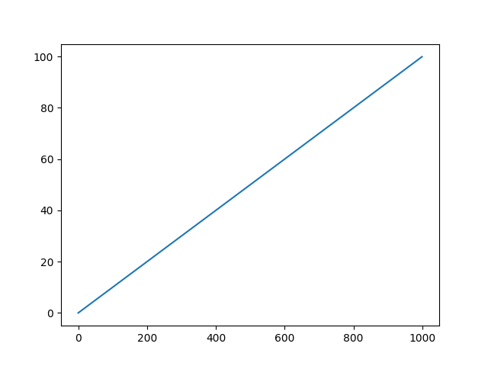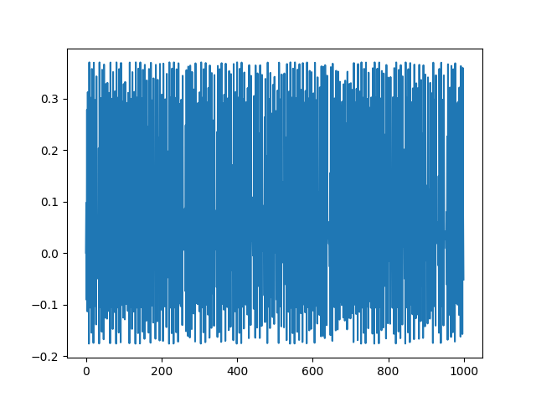

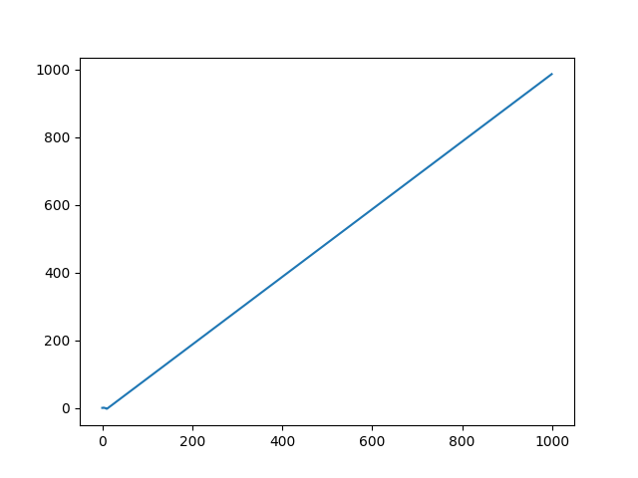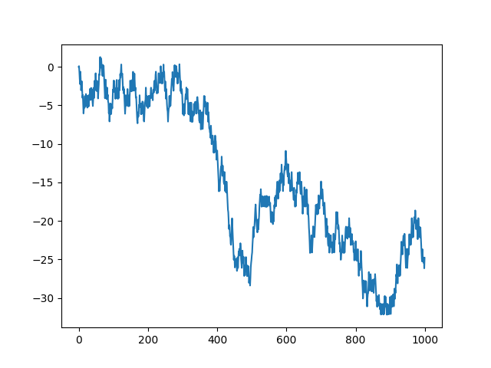

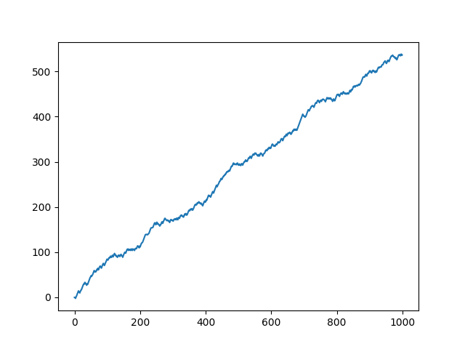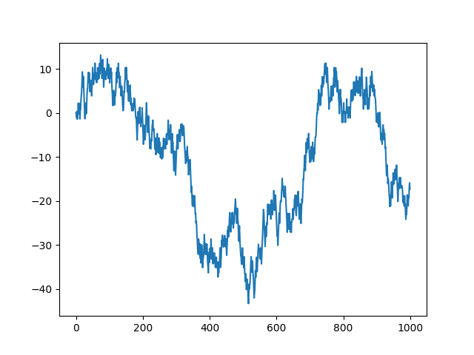

**Fig. 7.** Graphical Plot of the Gauss Map for $K=0, π, 2π, 3π, 4π, 5π$ and $ω=0.1$ respectively, in row major manner

The bifurcation diagram will be

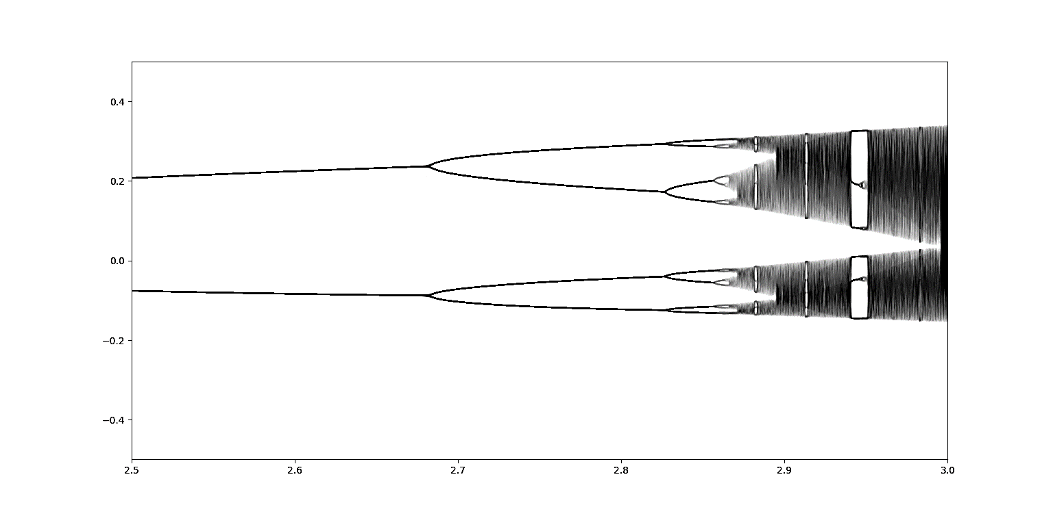

**Fig. 8.** Bifurcation Plot of the Circular Map with $ω=0.1$

1. It denotes the stable state values