Predict Transaction Fraud using ChaosNet: An Exemplification from the Plastic Money Transactions

Anurag Dutta1[](https://orcid.org/0000-0002-5787-3860), Liton Chandra Voumik2*[](https://orcid.org/0000-0002-9612-7350), Lakshmanan Kumarasankaralingam 3[](https://orcid.org/0000-0002-1426-204X), and Athilingam Ramamoorthy4[](https://orcid.org/0000-0001-8430-4594)

1 Undergraduate, Department of Computer Science, Government College of Engineering and Textile Technology, Serampore, Calcutta, India, Email- [anuragdutta.research@gmail.com](mailto:anuragdutta.research@gmail.com); ORCID: 0000-0002-5787-3860

2 Assistant Professor, Department of Economics, Noakhali Science and Technology University, Noakhali, Bangladesh-3814; Email- [litonvoumik@gmail.com](mailto:litonvoumik@gmail.com); ORCID: 0000-0002-9612-7350

3 Professor, Department of Mathematics, Kuwait American School of Education, Salmiya 22062, Kuwait; Email- [coprime65@gmail.com](mailto:coprime65@gmail.com); ORCID: 0000-0002-1426-204X

4 Assistant Professor, Department of Mathematics, Velammal Engineering College, Anna University, Chennai, Tamil Nadu, India; Email- [ramzenithmaths@gmail.com](mailto:ramzenithmaths@gmail.com); ORCID: 0000-0001-8430-4594

|  |
| --- |
| **Citation:** Lastname, F.; Lastname, F.; Last-name, F. Title. *J. Risk Financial Manag.* **2021**, *14*, x. https://doi.org/10.3390/xxxxx  Received: date  Accepted: date  Published: date  Publisher’s Note: MDPI stays neutral with regard to jurisdictional claims in published maps and institutional affiliations.    **Copyright:** © 2020 by the authors. Submitted for possible open access publication under the terms and conditions of the Creative Commons Attribution (CC BY) license (http://creativecommons.org/licenses/by/4.0/). |

**\*** Correspondence: [litonvoumik@gmail.com](mailto:litonvoumik@gmail.com)

**Abstract:** Online transactions are in high demand right now, possibly due to their efficiency and ease of being used. It is a form of digital commercial transactions in which customers buy commodities or services through the World Wide Web. Payment systems can be managed to complete using a variety of devices, such as desktops and laptops, smartphones, etc. To pay for web - based products or services, customers could use credit and debit cards or even digital wallets. This research seeks to identify falsehoods and probable fraudulence in Credit Card based transactional processes. This investigation seeks to determine outright lies and potential fraud in Credit Card, also termed as Plastic Money based transactions. ChaosNet, an Intelligent Artificial Neural Network built with Generalized Luroth Series spatial information, now has this capability. Chaos has been clearly and accurately unearthed in the central nervous system at several temporal and spatial scales. Chaos is present across several synthesized synaptic simulation models, such as the Hindmarsh-Rose model, and turbulent exploding is observed in some brain neurons. Although Chaos is present throughout many Artificial Neural Networks such as Recursively Generating Neural Network models, no ANN exists for classification tasks that is entirely composed of chaoticity. ChaosNet employs the topographic syntagmatic property of Chaotic GLS neurons to solve categorization problems with cutting-edge effectiveness on a data reservoir with a relatively low training sample quantity. By assembling a specific quantity of training information, this synthesized Neural Networking Model can undertake categorization activities. ChaosNet uses some of the best network attributes confined to neurons in the human brain, which deduce from specific neurons' powerful Chaotic interaction, to resolve complex multiclass classification on par with some or stronger than conventional Artificial Neural Networks. It has been demonstrated that it requires far fewer training sets.

**Keywords:** Credit Card; Blockchain; ChaosNet; GLS Neurons; Artificial Neural Network

1. Introduction

It is now possible to learn using techniques like Machine Learning as well as Statistical Learning. Because of the advancement of Artificial SuperIntelligence. [1] It have gained prominence as several major topics, with implementations in almost every field of human exertion. Speech Application [2], Machine Vision [3], Information Security [4], and Biological Prognosis [5] are a few examples. Human memory and knowledge embedding procedures are just not directly linked to these methodologies, even after getting inspired by the neural impulses. The learning procedures of these Artificial Neuronal Networks [6] attempting to change weights and biases are based on optimization techniques and the minimization of loss as well as error operations. As a significantly bigger pool of new data is nourished into the framework, ANNs are presently using a substantial percentage of subjecting parameters for the model [7] that are corrected through some ad - hoc basis technique for precise estimation. These neuronal changes are principally based on evidence and complete absence or are supported by little theoretical underpinning. Furthermore, these procedures require a large amount of training information in order to precisely anticipate or characterize the dispersion of the class labels.

Although ANNs have already accomplished considerable success, whenever it happens to come to tasks such as interpreting natural languages [8] they lack behind. Scientists are concentrating on developing biomimetic methodologies and configurations in hopes of tapping into the notable learning abilities of our brain while also improving its comprehensibility. This is carried out within the framework of memory consolidation and acquiring knowledge. Among the most fascinating characteristics of the central nervous system is its ability to demonstrate "Chaos" - the circumstance in which evident due to non - linear frameworks exemplifying complicated unforeseen and stochastic nature. The chaotic interactions of electroencephalography (EEG) transmissions [9] are well known. The responsiveness of a nervous synapses to minor changes in intrinsic functioning attributes aids in generating the most effective reaction to different impacts. This characterization is similar to the kinetic attributes of stochastic processes. Furthermore, it is clear that now the brain is continually swapping among states instead of going back to homeostasis following an ephemeral. As a result, based on the operational specifications of the neural connections, it is theorized that the central nervous system can exhibit a wide range of behaviors, such as resonance in orbits, an insufficient essence of turbulent dynamics, and a large and powerful essence of uncertainties. Cerebral channels, that are mainly composed of trillions of synapses, are erratic, but so are the complexities of individual neuronal synapses at both the subcellular as well as cellular stages. The ability of these nerve cells to form instinctive reflex trains is just what enables the central nervous system to emit and process information. Nerve impulses are managed to produce once numerous ions pass throughout the peripheral nerve membrane and impair the potential difference across it. Huxley and Hodgkin suggested an interactive dynamic system prototype capable of producing precise electrical impulses to bridge the ion excerpts and the axonal outer layer for information exchange [11]. It was later proposed to use its standardized counterparts, such as the Hindmarsh-Rose [12] as well as the Fitzhugh prototype [13][14]. All of these modeling techniques exhibit stochastic nature.

Recurrent networks of neurons [15][16] are one of the kinds of artificial neural networks that demonstrates stochastic dynamics; nevertheless, much further as we are conscious, every one of the suggested frameworks subjected to classification techniques so far anyway show uncertainty at the specifics of neuronal individuality. Other turbulent neurotransmitter frameworks, on the other hand, have been postulated as a theoretical demonstration for memory consolidation within our central nervous system.

The Aihara prototype [17] constitutes one of these modeling techniques, and it has been implemented to cognitive performance in the chaotic trajectories’ [18] of the constituent networks.  To illustrate the procedure of rote memorization scents, Freeman, Kuzma, and collaborators created chaotic simulation models inspired by the sensory pathway of the mammals [19 - 21]. Tsuda and colleagues have also investigated chaos in neural networks. Kaneko investigated the dynamic characteristics of globally paired chaotic maps, hypothesizing that these networks will be capable of handling biological information.

ChaosNet is an artificially constructed network of neurons composed of unidimensional chaotic spatial neurons from the Generalized Luröth Series (GLS) [22]. To accomplish supervised classification, this network must acquire knowledge from a comparatively tiny assortment of training scenarios. ChaosNet was created to take advantage of some of the best features of biological neural networks. It has been evidenced that it can accomplish complicated supervised classification on par with or stronger than long - established neural nets when using considerably fewer data for training.

ChaosNet, which was actually inspired by biological synapses, employs a neurological syntax for gaining knowledge that is comparable towards the "sudden increase rate" of turbulent neuron activation. Furthermore, the infrastructure can have a layered architecture that incorporates information as it travels to profound, elevated amounts of the system. The GLS, or Generalized Luröth Series, is a piece - wise linear sequential unidimensional chaotic map that symbolizes the synapse that we propose. Tent maps, Binary maps, and their skewed relatives are examples of GLS. ChaosNet employs the following types of GLS neurons:

$$T_{Skew-Binary}(x)=\left\{\begin{matrix}\frac{x}{b} & 0≤x<b \\ \frac{\left(x-b\right)}{\left(1-b\right)} & b≤x<1\end{matrix}\right.$$

and

$$T_{Skew-Tent}(x)=\left\{\begin{matrix}\frac{x}{b} & 0≤x<b \\ \frac{\left(1-x\right)}{\left(1-b\right)} & b≤x<1\end{matrix}\right.$$

$b$ denotes the “Generating Markov Partition” (Skew Parameter)

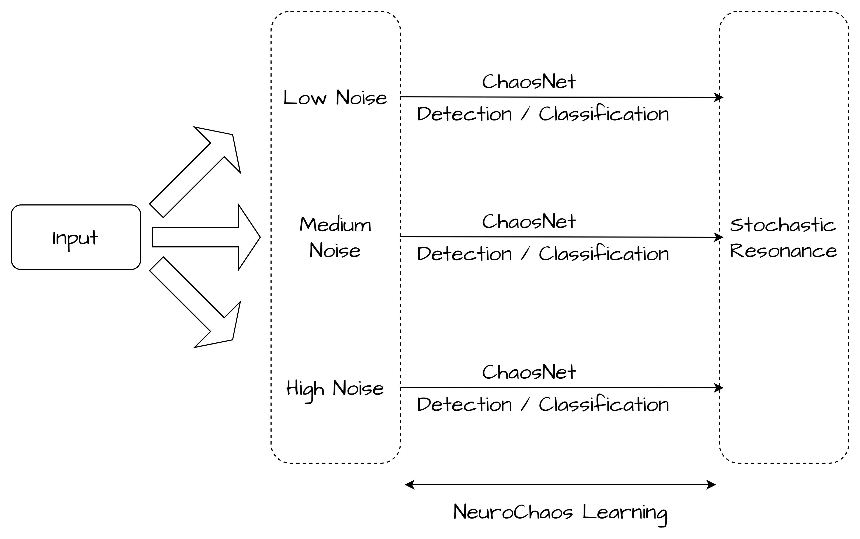

**Figure 1.** Neurochaos Learning [23].

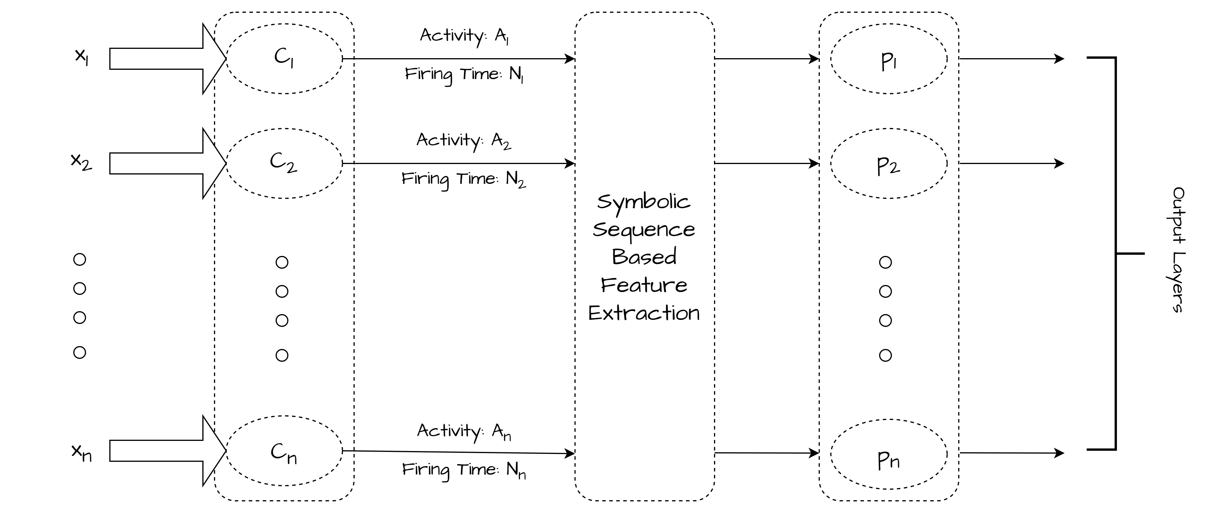

**Figure 2.** The architecture of ChaosNet [24] Luroth neural networks for purposes relating to classification. 𝐶1, 𝐶2, . . . , 𝐶𝑛 are the unit dimensional Generalized Luroth Series’ neurons. Each neuron initially exhibits 𝑞 units of normalized neuronal activity. The input to the network, or the normalized collection of stimuli, is denoted by the ${\left\{x_{i}\right\}}_{i=1}^{n}$. When a Generalized Luroth Series’ neuron 𝐶𝑖's chaotic activity value 𝐴𝑖(𝑡), starting from initial neural activity (𝑞), reaches the 𝜀 -neighborhood of stimulus, it stops firing chaotically. This neuron has a “firing time” of 𝑁𝑖 ms. 𝐴𝑖(𝑡) contains topological transitivity symbolic sequence feature 𝑝𝑖. This feature is extracted from 𝐴𝑖(𝑡) of the 𝐶𝑖's GLS-neuron.

A credit card is a method of payment authorized to account holders that lets them make purchases from a seller for products or services premised on the cardholder's accumulated liabilities in exchange for an agreement to compensate the credit card company for the amounts plus some other agreed fees. The card provider, which is normally a financial institution or credit confederation, opens a rapidly rotating account and subsidies the cardholder a credit limit so that the account holder can take funds for reimbursement to a vendor or as a cash payment. A normal credit card differs from a charge card in that the amount must be paid off completely each pay period. Credit cards, on the other hand, allow individuals to accumulate a prolonging balance of borrowed funds, pertaining to interest charges. A credit card is also distinguished from a charge card by the fact that a credit card usually entails a 3rd party organization that reimburses the seller and is compensated by the purchaser, whilst a charge card essentially delegates reimbursement by the purchaser until a later point in time. A credit card is also distinct from a debit card, that is capable of being utilized as monetary system by the card's holder. Debit cards, digital money, electronic wallet, cryptographic currencies, pay-by-hand, fund transfer, and consider purchasing now, give later are all alternative solutions to credit card payments. There have been 7.753 billion credit cards in the entire globe as of June 2018. In 2020, there have been 1.09 billion credit cards being used in the United States.

Credit card fraud refers to any type of fraud perpetrated with a credit card. The goal could be to acquire products or services or perhaps to transfer funds towards another account operated by a *convicted felon*. Credit card fraud can indeed be authorized, when a legitimate consumer practices payment towards another account governed by a criminal, or unsanctioned, whereby the account owner doesn't give authorization for the compensation to progress but the same is carried out by a 3rd person. This article makes use of the proposed ChaosNet Model to presage the Credit Card Fraudulency as subjected to transactional data gathered from a confidential source. The data have been made public, but the source is made *anonymous* to prevent any potential controversies around the well reputed source (*anonymous*).

2. Plastic Money – Credit Card

A Credit Card is a narrow rectangular piece made from plastic or metal authorized by a financial institution or economic services provider that enables account holders to borrow to purchase products and services from vendors who accept cards. Credit cards require cardholders to repay the borrowed funds and any relevant interest, in addition to any additionally agreed-upon expenses, by the date of invoice or over time. In addition to the typical Line Of Credit, the lender of the credit card might very well authorize account holders to a specific Line Of Credit (LOC), which allows them to obtain funds through the use of cash withdrawals, which can be obtained through cashiers, or ATMs. When compared to exchanges that obtain the primary credit line, such cash advances usually come with distinct terms, like a shorter time frame and greater interest rates. Financial institutions typically set borrowing constraints depending on an individual’s credit score. The vast majority of companies allow customers to make purchase decisions using credit and debit cards, which persist among the majority of prevalent payment methods for purchasing goods and services that consumers use today. Credit cards generally have a higher overall percentage rate than those other types of consumer debts. Interest payments on any underpaid account balance billed to the magnetic stripe are imposed around one month after one purchase has been made unless immediately preceding underpaid balances from a preceding period were conducted forward, where in case no waiting period is conferred for additional charges. Credit card companies are required by law to provide a grace time limit of no less than 21 days before participation on items purchased starts to accumulate. Therefore, whenever possible, going to have to pay off account balance even before time limit ends is advisable. Knowing regardless of whether ones issuing bank incurs interest regularly or monthly also is crucial because the erstwhile results in higher interest and fees for as a while as the rebalancing is unpaid. Following is the exemplar imagery of a credit card.

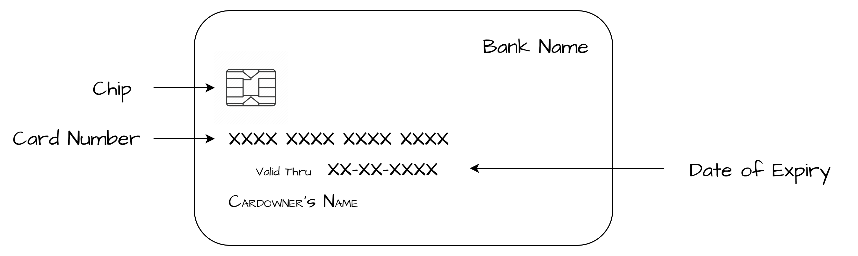

**Figure 3.** The frontal view of a Plastic Money

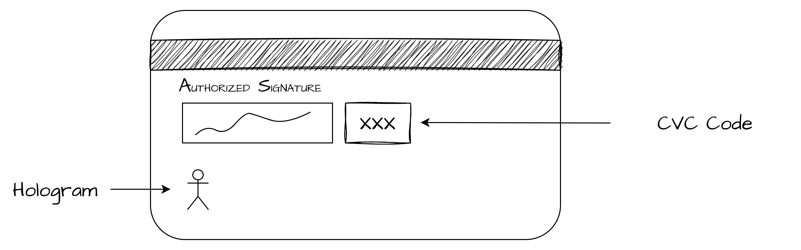

**Figure 4.** The back view of a Plastic Money

3. Dataset Description

We have collected a set of data points subjected to Transaction from a anonymous source. The genuinely of the dataset have been cross validated by the authors, but for avoidance of any unnecessary controversies. The dataset description have been laid underneath.

* distance_from_home: The transaction's location's proximity from residence.
* distance_from_last_transaction: The separation from the preceding transfer of funds.
* ratio_to_median_purchase_price: Ratio of Transactional Acquired Price to the Average Retail Price.
* repeat_retailer: Is the transfer of funds initiated from the identical merchant?
* used_chip: Is the transaction chip-based? (Credit Card)
* used_pin_number: Is the transaction completed using a PIN?
* online_order: Is this a purchase made online?
* fraud: Label

The dataset has been made available online at <https://github.com/Anurag-Dutta/Ethereum/blob/19b35453da25b40bb22556c1070cfb79fbb52b2f/Eth_Pub_19122022.csv>

4. ChaosFeatureEXtractor + ML Classifiers

Using ChaosNet Standalone, the performance is okay, but we can do better if we make use of a better ML Classifier in conjunction with the Chaos Feature Extractor. [39]

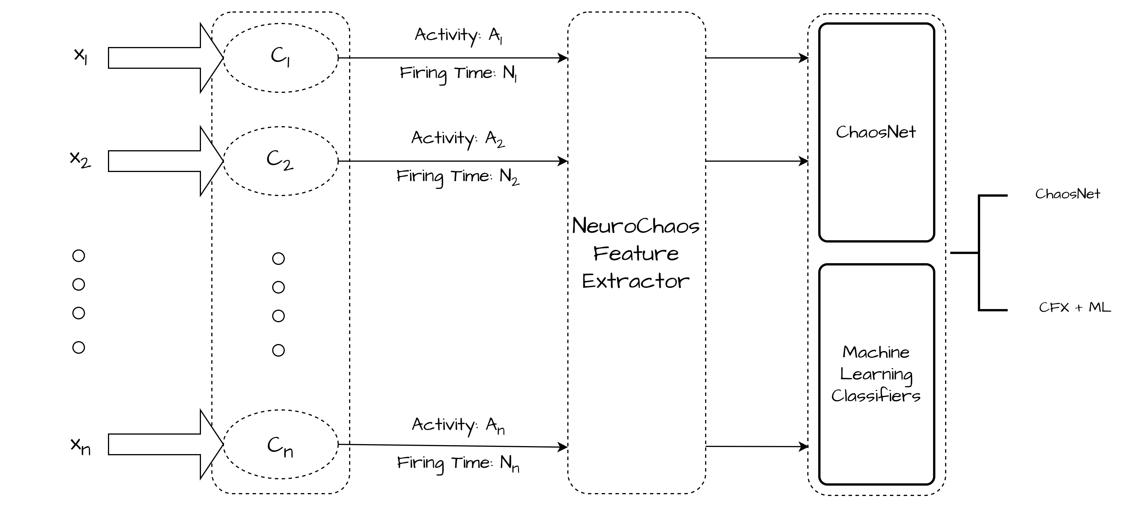

**Figure 3.** Architecture proposing Conjunction of the Chaos Feature Extractor with standard ML Classifiers. The three actions involved include Feature transformation, feature extraction from Neurochaos, and classification are the first two steps. ChaosNet or any other ML classifier could be selected as the chosen classifier.

ChaosNet uses 3 hyperparameters

INA - Initial Neural Activity

EPSILON_1 - Noise Intensity

DT - Discrimination Threshold

The memory of this Single Internal Neuron is corresponding to the Initial Neural Activity. As individual Machine Learning Classifiers, we have used AdaBoost, and kNN (k Nearest Neighbors). Also, we have made use of ChaosNet Standalone.

The respective values of the hyperparameters for the same were tuned to

INITIAL_NEURAL_ACTIVITY = [0.38]

DISCRIMINATION_THRESHOLD = [0.06]

EPSILON = [0.29]

for Standalone ChaosNet.

INITIAL_NEURAL_ACTIVITY = [0.36]

DISCRIMINATION_THRESHOLD = [0.06]

EPSILON = [0.29]

for ChaosNet Feature Extractor conjugated with AdaBoost.

In 1995, Yoav Freund and Robert Schapire created AdaBoost, a statistical classification meta-algorithm. For their efforts, they received the 2003 Gödel Prize. Combining it with a variety of other learning approaches can improve its performance. The findings of the other learning algorithms, or "weak learners," are combined to produce a weighted sum representing the boosted classifier's final outcomes. Although AdaBoost can be applied to a wide range of classes or limited intervals on the real line, it is most employed for binary classification. AdaBoost is adaptive in the sense that it modifies succeeding weak learners in favor of examples that were incorrectly identified by earlier classifiers. In some cases, it may be less prone to overfitting than other learning methods. It can be shown that the final model converges to a strong learner even if each individual learner's performance is just marginally better than random guessing.

INITIAL_NEURAL_ACTIVITY = [0.039]

DISCRIMINATION_THRESHOLD = [0.070]

EPSILON = [0.023]

for ChaosNet Feature Extractor conjugated with k Nearest Neighbors.

One of the simplest supervised learning-based nonparametric machine learning algorithms is k-Nearest Neighbor. Assuming that new cases and data are similar to existing cases, classifying new cases into categories most similar to existing ones, storing all relevant data, and putting fresh data into categories based on similarity. Therefore, it is simple to categorize new data into relevant categories using the K-NN method. Although K-NN algorithms can be applied to classification and regression problems, they are most frequently utilized for classification issues. In other words, no presumptions regarding the underlying data are made. It is also known as a delayed learning algorithm since it saves the dataset and modifies it during classification rather than instantly learning from the training set. The k-NN algorithm only keeps the training phase dataset and classifies fresh data into categories that are like the new data as it comes in.

In order to evaluate performance, we used the macro F1-score. The F1 score can be conceived of as a harmonic mean of precision and recall, where 1 is the highest and 0 being the worst. Precision and recall are both equally important in determining the F1 score; "macro" compute the measurements for each label and derives their unweighted mean. Label imbalance is not considered in this. The confusion matrix is used to calculate this measure. Mathematically,

$$Macro F1 Score =\frac{{F1 Score}_{Class 1}+{F1 Score}_{Class 2}+...+{F1 Score}_{Class n}}{n}$$

$$Macro F1 Score =\frac{1}{n}\left(\sum_{i=1}^{n}{{F1 Score}_{Class i}}\right)$$

where,

$${F1 Score}_{Class i}=\left(\frac{2×{Precision}_{Class i}×{Recall}_{Class i}}{{Precision}_{Class i}+{Recall}_{Class i}}\right)$$

$${Precision}_{Class i}=\left(\frac{{True Positive}_{Class i}}{{True Positive}_{Class i}+{False Postive}_{Class i}}\right)$$

$${Recall}_{Class i}=\left(\frac{{True Positive}_{Class i}}{{True Positive}_{Class i}+{False Negative}_{Class i}}\right)$$

|  |  |
| --- | --- |
| Algorithm | Macro F1 Score (Training) |
| ChaosNet Standalone | 0.5802753655203908 |
| Chaos Feature Extractor + AdaBoost | 0.8125910159305623 |
| Chaos Feature Extractor + kNN | 0.7937217353400664 |

|  |  |
| --- | --- |
| Algorithm | Macro F1 Score (Testing) |
| ChaosNet Standalone | 0.5752543039000217 |
| Chaos Feature Extractor + AdaBoost | 0.6649360740269832 |
| Chaos Feature Extractor + kNN | 0.7888128840520701 |

5. Conclusion

In the field of machine learning, making decisions when unusual events are present is a difficult task. This is because unusual occurrences have few data examples, and the issue is ultimately one of imbalanced learning. In this work, we have taken use of Neurochaos Learning (NL) architectures' usage of ChaosFEX (CFX) feature modification for imbalanced learning. Since, Cryptocurrencies are in it’s very nascent stage currently, and due to their masking nature, finding data involving transaction in the Ethereum is quite difficult, and not much can be obtained from that. Like, even if we manage to snoop into the transaction details, the details won’t be necessarily sufficient to fulfil the requirements of the classical ML Classifier Algorithms. In this work, we have tried to make use of ChaosNet along with it’s indigenous Feature Extractor to try out the prediction of possible fraud in the Ethereum Transaction. We made use of the Standalone ChaosNet, that gave us a F1 Score of 0.58 for Training, and 0.57 for Testing, which isn’t a good hold. Further, we have made use of the ChaosNet Feature Extractor assisted with Adaptive Boosting to get a F1 Score of 0.81 for Training, and 0.66 for Testing. Finally, we made use of the ChaosNet Feature Extractor assisted with k – Nearest Neighbors to get a F1 Score of 0.79 for Training, and 0.78 for Testing, which is the maximum we can get of it. So, we can conclude of by saying that the ChaosNet Feature Extractor assisted with k – Nearest Neighbors is the best for Predicting Possible Fraudulences in the Ethereum Transaction Dataset. Notably, the F1 Scores used here, are the Macro F1 Score.

Data, code, and supporting materials are publicly available via <https://github.com/Anurag-Dutta/Ethereum> publicly available.

Future Scopes of Research includes the Chaos Feature Extractor being adjunct with several other ML Algorithms that would give a Major F1 Score greater than 0.78.

**References**

1. Lauriola, A. Lavelli, and F. Aiolli, “An introduction to Deep Learning in Natural Language Processing: Models, techniques, and tools,” Neurocomputing, Jul. 2021, doi: 10.1016/j.neucom.2021.05.103.
2. R. M. Gray, “A History of Realtime Digital Speech on Packet Networks: Part II of Linear Predictive Coding and the Internet Protocol,” Foundations and Trends® in Signal Processing, vol. 3, no. 4, pp. 203–303, 2009, doi: 10.1561/2000000036.
3. L. Jiao et al., “A Survey of Deep Learning-Based Object Detection,” IEEE Access, vol. 7, pp. 128837–128868, 2019, doi: 10.1109/access.2019.2939201.
4. M. Kianpour, S. J. Kowalski, and H. Øverby, “Systematically Understanding Cybersecurity Economics: A Survey,” Sustainability, vol. 13, no. 24, p. 13677, Dec. 2021, doi: 10.3390/su132413677.
5. K. Arun Bhavsar, J. Singla, Y. D. Al-Otaibi, O.-Y. Song, Y. Bin Zikriya, and A. Kashif Bashir, “Medical Diagnosis Using Machine Learning: A Statistical Review,” Computers, Materials & Continua, vol. 67, no. 1, pp. 107–125, 2021, doi: 10.32604/cmc.2021.014604.
6. L. V. Jospin, H. Laga, F. Boussaid, W. Buntine, and M. Bennamoun, “Hands-On Bayesian Neural Networks—A Tutorial for Deep Learning Users,” IEEE Computational Intelligence Magazine, vol. 17, no. 2, pp. 29–48, May 2022, doi: 10.1109/mci.2022.3155327.
7. L. Yang and A. Shami, “On hyperparameter optimization of machine learning algorithms: Theory and practice,” Neurocomputing, vol. 415, pp. 295–316, Nov. 2020, doi: 10.1016/j.neucom.2020.07.061.
8. Turchin and L. F. Florez Builes, “Using Natural Language Processing to Measure and Improve Quality of Diabetes Care: A Systematic Review,” Journal of Diabetes Science and Technology, vol. 15, no. 3, pp. 553–560, May 2021, doi: 10.1177/19322968211000831.
9. J. Montoya-Martínez, J. Vanthornhout, A. Bertrand, and T. Francart, “Effect of number and placement of EEG electrodes on measurement of neural tracking of speech,” Oct. 2019, doi: 10.1101/800979.
10. B.-W. Shen et al., “Is Weather Chaotic? Coexisting Chaotic and Non-chaotic Attractors Within Lorenz Models,” 13th Chaotic Modelling and Simulation International Conference, pp. 805–825, 2021, doi: 10.1007/978-3-030-70795-8_57.
11. L. Hodgkin and A. F. Huxley, “A quantitative description of membrane current and its application to conduction and excitation in nerve,” The Journal of Physiology, vol. 117, no. 4, pp. 500–544, Aug. 1952, doi: 10.1113/jphysiol.1952.sp004764.
12. “A model of neuronal bursting using three coupled first order differential equations,” Proceedings of the Royal Society of London. Series B. Biological Sciences, vol. 221, no. 1222, pp. 87–102, Mar. 1984, doi: 10.1098/rspb.1984.0024.
13. R. FitzHugh, “Impulses and Physiological States in Theoretical Models of Nerve Membrane,” Biophysical Journal, vol. 1, no. 6, pp. 445–466, Jul. 1961, doi: 10.1016/S0006-3495(61)86902-6.
14. J. Nagumo, S. Arimoto, and S. Yoshizawa, “An Active Pulse Transmission Line Simulating Nerve Axon,” Proceedings of the IRE, vol. 50, no. 10, pp. 2061–2070, Oct. 1962, doi: 10.1109/JRPROC.1962.288235.
15. D. A. Moses et al., “Neuroprosthesis for Decoding Speech in a Paralyzed Person with Anarthria,” New England Journal of Medicine, vol. 385, no. 3, pp. 217–227, Jul. 2021, doi: 10.1056/nejmoa2027540.
16. H. Hewamalage, C. Bergmeir, and K. Bandara, “Recurrent Neural Networks for Time Series Forecasting: Current status and future directions,” International Journal of Forecasting, vol. 37, no. 1, pp. 388–427, Jan. 2021, doi: 10.1016/j.ijforecast.2020.06.008.
17. K. Aihara, T. Takabe, and M. Toyoda, “Chaotic neural networks,” Physics Letters A, vol. 144, no. 6–7, pp. 333–340, Mar. 1990, doi: 10.1016/0375-9601(90)90136-c.
18. N. Crook and T. olde Scheper, “Special edition of BioSystems: Information processing in cells and tissues,” Biosystems, vol. 94, no. 1–2, p. 1, Oct. 2008, doi: 10.1016/j.biosystems.2008.06.001.
19. G. Meurant, Mass Action in the Nervous System. Elsevier, 2012.
20. H.-J. Chang and W. J. Freeman, “Parameter optimization in models of the olfactory neural system,” Neural Networks, vol. 9, no. 1, pp. 1–14, Jan. 1996, doi: 10.1016/0893-6080(95)00093-3.
21. R. Kozma and W. J. Freeman, “A possible mechanism for intermittent oscillations in the KIII model of dynamic memories - the case study of olfaction,” IJCNN’99. International Joint Conference on Neural Networks. Proceedings (Cat. No.99CH36339), doi: 10.1109/ijcnn.1999.831455.
22. N. B. Harikrishnan and N. Nagaraj, “A Novel Chaos Theory Inspired Neuronal Architecture,” 2019 Global Conference for Advancement in Technology (GCAT), Oct. 2019, doi: 10.1109/gcat47503.2019.8978360.
23. N. B. Harikrishnan and N. Nagaraj, “When Noise meets Chaos: Stochastic Resonance in Neurochaos Learning,” Neural Networks, vol. 143, pp. 425–435, Nov. 2021, doi: 10.1016/j.neunet.2021.06.025.
24. H. N. Balakrishnan, A. Kathpalia, S. Saha, and N. Nagaraj, “ChaosNet: A chaos based artificial neural network architecture for classification,” Chaos: An Interdisciplinary Journal of Nonlinear Science, vol. 29, no. 11, p. 113125, Nov. 2019, doi: 10.1063/1.5120831.