Report

Point Procesing Techniques

**Anurag Dutta** **(R.N: 11000220025)** *Department of Computer Science and Engineering,*  
Government College of Engineering and Textile Technology, Serampore[1anuragdutta@gmail.com](mailto:1anuragdutta@gmail.com)

*Abstract–The process of employing a computing device to run an analysis on digital photographs is known as "Digital image Processing". Digital Image Processing has significant benefits over analogue image processing as a subfield or area of digital signal processing. It permits the application of a considerably wider variety of techniques to the input information and can prevent issues like the accumulating distortion and noise throughout processing. Digital image processing can be described as a multidimensional system because images might exist in 2 components.* *Point processing is the process of enhancing any area of a picture that just depends on its current grayscale. This report emphasizes on Point Processing Techniques, that are commonly taken into use in Digital Image Processing.*

# Introduction

The term "Digital Image Processing" refers to the use of a computing device [1] to process digital images [2]. In order to achieve an improved image or to uncover some critical info, we can also state that it is the usage of computational models [3]. The necessary procedures that are significantly involved in image processing are:-

1. Using Image Capturing Technologies to acquire the Image
2. Examining and editing the photograph
3. Output, the outcome of which may be a modified image or a statement based on the analysis of that imagery

The amplitude [4] of at each given set of coordinates is referred to as the intensity of that illustration at that location. An image is characterised as a two-dimensional feature, , within which and are spatial coordinates. We refer to it as a digital image when 's , , as well as amplitude values are all bounded.

In other respects, a two-dimensional array [5] that is specifically organized in rows and columns can be used to define a visual. A digital image is made up of an infinite [6] number of discrete components, each of which has a unique value at a unique place. These components are also known as pixels, image elements, and picture elements. The most frequent usage of a pixel is to indicate a component of a digital photo.

We do have following syntax to represent photos since, as we all understand, photographs are expressed in rows and columns

Grayscale gamut and dispersion can frequently be changed using point operations. Point operations work by mapping each pixel onto a different picture using a predetermined transformation technique.

where,

is the Output Imagery

is the Input Imagery

is the Transformation Operator

The usage of a neighborhoods size is the most basic image enhancing technique. A point operation is what it is. In this instance, the point operation procedure can indeed be condensed as follows since the output raster ('') depends solely on the input cell ('')

where,

denotes the gray level of Input and Output Pixels.

is the Transformation Operator

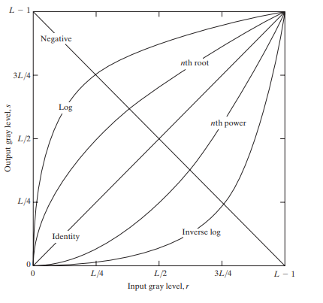

1. For certain contexts, various transformation functions are effective.

This Report focuses on proposing a review on the Various Point Processing Techniques [7] that are taken into use. Section 2 holds a review on all of the commonly used PPTs. Section 3 puts forward the implementation of specific PPTs in Python. Section 4 cocnludes the Report.

# Point Processing Techniques

As mentioned above in Section 1, Point Processing is a set of rules that defines transformations in imagery data. Here, we would consider a few of them.

## Linear Point Processing Technique

Linear transformations include identity transformation and negative transformation. Mathematically,

where,

is the Largest Gray Level in an Imagery

denotes the gray level of Input and Output Pixels.

is the Transformation Operator

Figure 2 shows a surficial image of the Moon. Figure 3 imitates it’s negative image.

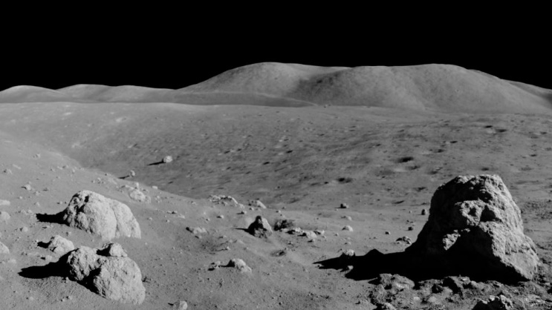

1. Moon Surface Imgery. The Linear Transformation for the Imagery would remain unaltered.

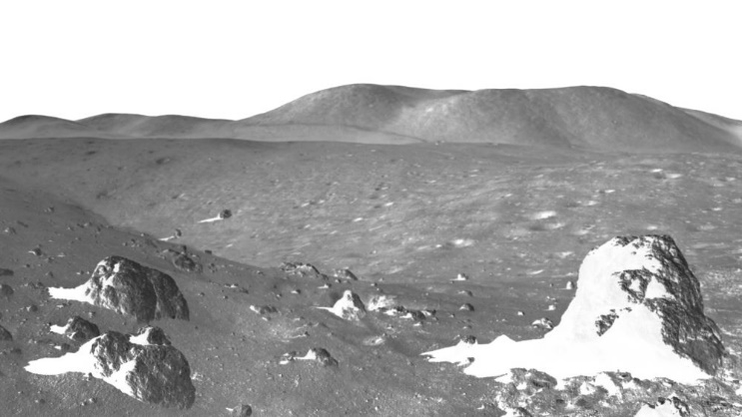

1. Negative Transformation of the Moon Surface Imagery

## Logarithmic Point Processing Technique

The low intensity values are transformed into greater intensity values through the log transformation. It converts a small range of dark grey levels into one that is significantly wider. In general, dark photos benefit from the log transformation the most. Logarithmic Point Processing includes General Logarithmic Transformation, and the Inverse Logarithmic Transformation. The log transform's opponent is the inverse log transform. It converts a small range of intense grey tones into a considerably larger range. The darker-level values are compressed while the lighter-level values are expanded via the inverse log transform. Mathematically,

where,

is the Constant

denotes the gray level of Input and Output Pixels.

is the Transformation Operator

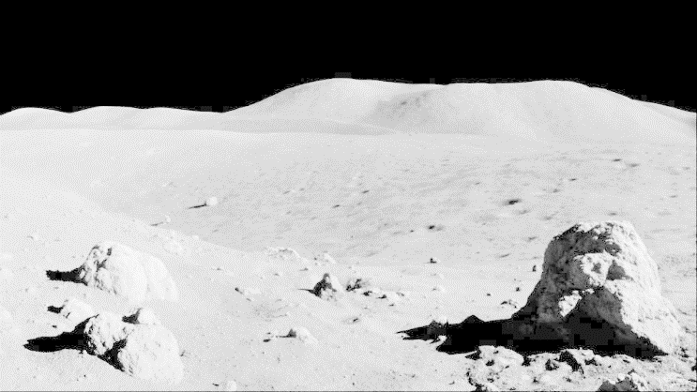

1. General Logarithmic Transformation of the Moon Surface Imagery

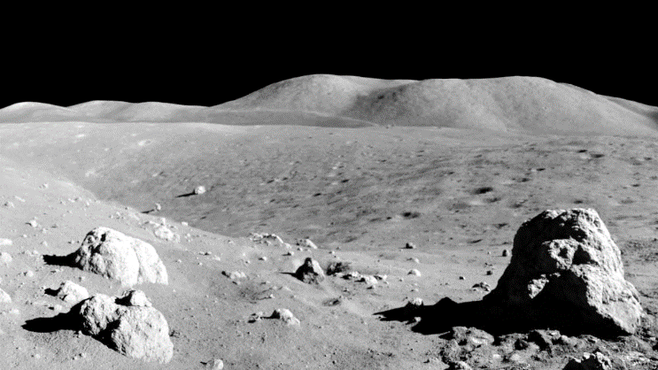

1. Inverse Logarithmic Transformation of the Moon Surface Imagery

## Gamma Transformation

A frequent grayscale non-linear transformation is the gamma transform, often known as the exponential transform or power transform. Based on the value of , the gamma alteration can favorably improve the contrast of either the dark or the light region. Figure 6 shows a contrast amongst different valued Transformations. Mathematically,

where,

is the Constant

is the Gamma Coefficient

denotes the gray level of Input and Output Pixels.

is the Transformation Operator

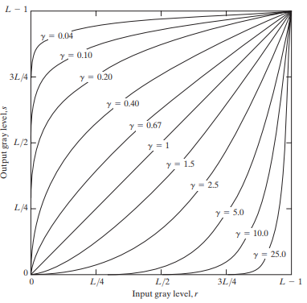

1. Comparative Plot with potentially varying values of apropos Gamma Transformation

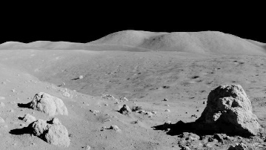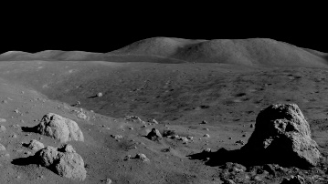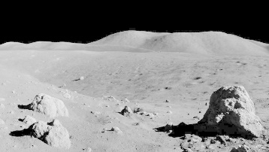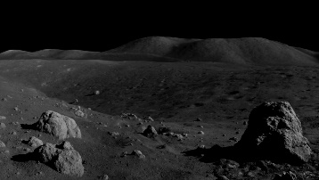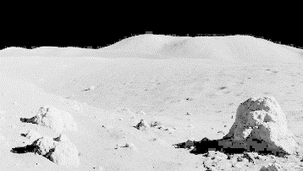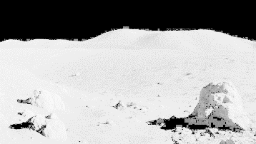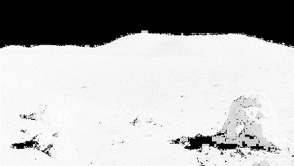

1. Gamma Transformation of the Moon Surface Imagery with respect to the values mentioned in Fig. 6

# Implementation

In this section, we would put forward the implementation of the Point Processing Techniques discussed in Section 2. Given below a snippet of the code in Python to implement the PPTs.

import cv2

import numpy as np

def function(parameters):

...

...

return cv2.LUT(parameters)

img = cv2.imread('moon_original.jpg')

modified_img = function(...)

cv2.imshow('Original image', img)

cv2.imshow('Modified image', modified_img)

cv2.waitKey(0)

cv2.destroyAllWindows()

The Codes, Data, and Supplementary Materials are made available at <https://github.com/Anurag-Dutta/PPT_DIP>

# Conclusion

Point Processing Techniques are quite useful in Digital Image Processing due to their ability to undertake severe changes in the images that promise greater information gain.

Gaining knowledge from a random variable as determined by a random variable observation is defined as taking value as,

where,

is the Prior Distribution with respect to Kullback–Leibler divergence

is the Posterior Distribution with respect to Kullback–Leibler divergence

Higher the value of , better is the knowledge gain from the Imagery Data.

Many Interplanetary missions are now possible due to Digital Image Processing. One of the best applications of Point Processing Techniques is the same.

##### References

1. W. S. Boyle and G. E. Smith, “Charge Coupled Semiconductor Devices,” *Bell System Technical Journal*, vol. 49, no. 4, pp. 587–593, Apr. 1970, doi: <https://doi.org/10.1002/j.1538-7305.1970.tb01790.x>.
2. E. R. Fossum and D. B. Hondongwa, “A Review of the Pinned Photodiode for CCD and CMOS Image Sensors,” *IEEE Journal of the Electron Devices Society*, vol. 2, no. 3, pp. 33–43, May 2014, doi: <https://doi.org/10.1109/jeds.2014.2306412>.
3. “Computational framework decomposes and annotates single-cell and spatial omics,” *Nature Biotechnology*, Feb. 2023, doi: <https://doi.org/10.1038/s41587-023-01658-2>.
4. T. Aidukas, P. C. Konda, A. R. Harvey, M. J. Padgett, and P.-A. Moreau, “Phase and amplitude imaging with quantum correlations through Fourier Ptychography,” *Scientific Reports*, vol. 9, no. 1, Jul. 2019, doi: <https://doi.org/10.1038/s41598-019-46273-x>.
5. T. Hawkins, “Cauchy and the spectral theory of matrices,” *Historia Mathematica*, vol. 2, no. 1, pp. 1–29, Feb. 1975, doi: <https://doi.org/10.1016/0315-0860(75)90032-4>.
6. ‌ D. M. Jesseph, “Leibniz on the Foundations of the Calculus: The Question of the Reality of Infinitesimal Magnitudes,” *Perspectives on Science*, vol. 6, no. 1–2, pp. 6–40, 1998, doi: <https://doi.org/10.1162/posc_a_00543>.
7. E. N. Brown, R. E. Kass, and P. P. Mitra, “Multiple neural spike train data analysis: state-of-the-art and future challenges,” *Nature Neuroscience*, vol. 7, no. 5, pp. 456–461, Apr. 2004, doi: <https://doi.org/10.1038/nn1228>.