**Electrostatics**

**Anurag Dutta**

**December 6, 2021**

E – Mail: [1anuragdutta@gmail.com](mailto:1anuragdutta@gmail.com)

**1 Electric Charge**

Electric Charge is that property of a body due to which it interacts with other charges. There are three types of charges:-

* Positive Charges
* Negative Charges
* Neutral Charges

S. I. unit of electric charge is ‘ $C$’ – Coulomb.

**2 Coulomb’s Law**

Force between two charges $q_{1}$ and $q_{2}$ is $F = \frac{1}{4πε_{0}}\frac{q_{1}q_{2}}{r^{2}}$, with $r$ being the distance between them.

**3 Electric Field**

It is the net force per unit positive charge

$$\vec{E }= \frac{\vec{F}}{q}$$

the S. I. unit of Electric Field is $N/C$.

Electric Field due to

1. A point charge $(q)$

$$E = \frac{kq}{r^{2}}$$

The plot of the Electric field ($\vec{E}$) versus radial distance ($r$) is given below.

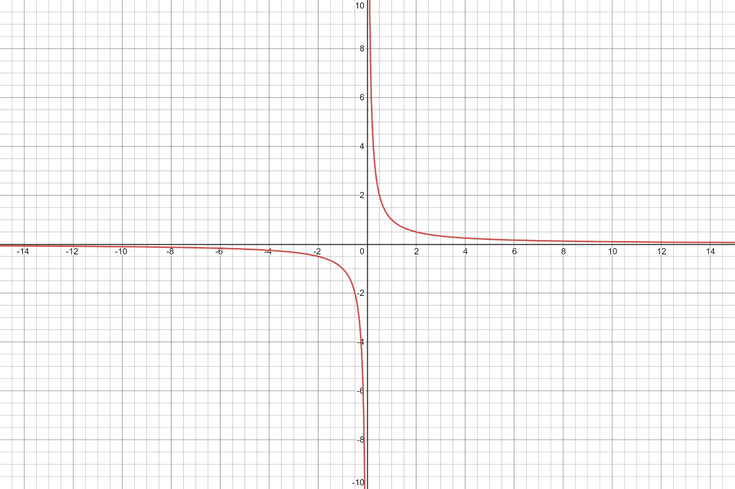

2. A linear charged rod of charge $(q)$ and length ($l$) at a distance $d$ from the end of the rod.



$$E = \frac{kq}{l}(\frac{1}{d}-\frac{1}{d+l})$$

The plot of the Electric field ($\vec{E}$) versus radial distance ($r$) is given below.



3. A charged conducting sphere of charge $(q)$ and radius $(R)$

$$E = \left\{\begin{aligned}\frac{kq}{r^{2}}, for points outside the sphere, that is r>R. \\ \frac{kq}{R^{2}}, for points on the surface of the sphere, that is r = R. \\ 0, for points inside the sphere, that is r<R.\end{aligned}\right.$$