**Light**

January 27, 2022

Email: [1anuragdutta@gmail.com](mailto:1anuragdutta@gmail.com)

**1 Definition**

It is a form of energy that enables us to the see the beautiful world around us.

Scientifically, light (or visible light) is an electromagnetic radiation that falls in the electromagnetic spectrum, which can be perceived by Human Eye. Generally, when we are talking ‘bout light, we mean visible light. The Visible light comprises of Electromagnetic Spectrum within the wavelength range 400 nm to 750 nm.

**2 Properties**

Some of the important properties of light are:

* Light travels in a straight line (Rectilinear Propagation).
* Speed of Light is one of the highest known speeds - , basically, the speed of light varies from medium to medium. The reference is taken as vacuum, in which its speed attains maxima.
* Light shows important phenomenon like
  + Reflection
  + Refraction
  + Diffraction
  + Interference
  + Polarization

Reflection, Refraction stands for the particle nature of light, while Diffraction, Interference, and Polarization stands for wave nature of light.

NOTE: Particle Theory of Light was proposed by the famous physicist and mathematician, Sir Isaac Newton.

NOTE: Wave Theory of Light was proposed by the Dutch physicist Christiaan Huygens.

**3 Reflection of Light**

When a ray of light approaches a smooth polished surface and the light ray bounces back, it is called the reflection of light.

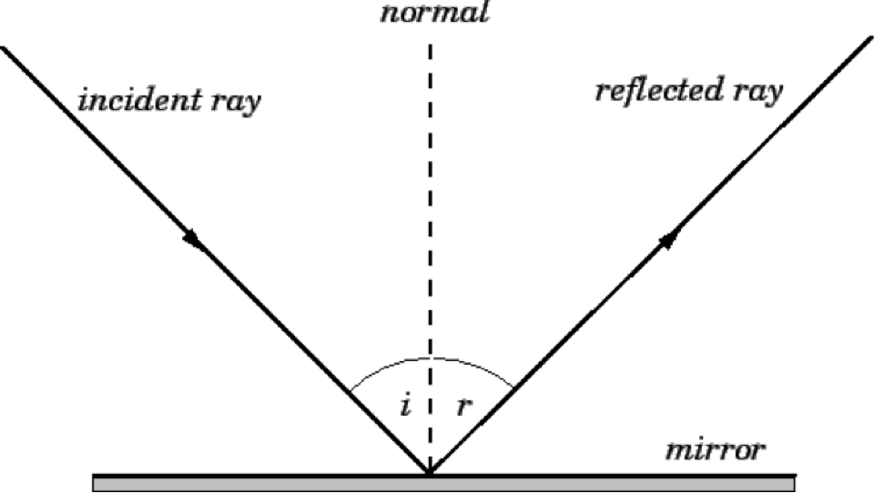

**Fig 1.** Reflection of Light

The basic laws of reflections are:

* Angle of incidence is equal to the Angle of reflection.

Mathematically,

* Incident Ray, Reflected Ray, and the Normal, all three lies on a same plane.

Mathematically,

So, we can say the three vectors, , and are coplanar.

Reflections can be of two types on the basis of the surface on which the incident ray is incident on.

* Regular Reflection

If the ray of light is incident on a smooth surface (e.g., Mirror, Water, etc.), such a reflection can be termed as Regular Reflection.

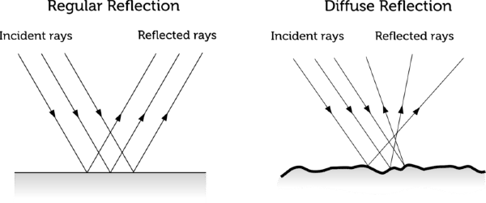

**Fig 2.** Regular Reflection

* Diffuse Reflection or Irregular Reflection:

If the ray of light is incident on a rough surface (e.g., Wall, Ground, etc.), such a reflection can be termed as Irregular or Diffuse Reflection.



**Fig 3.** Irregular Reflection

**3.1 Reflection from Plane Surface**

Before diving deep into the topic, we will first try to get a complete know – how on objects.

Objects can be of two types:

* Point Object: These are the objects that are relatively (sometimes infinitely) smaller in size.
* Extended Object: These are the objects that are relatively larger in size.

Q. Where will the image be formed?

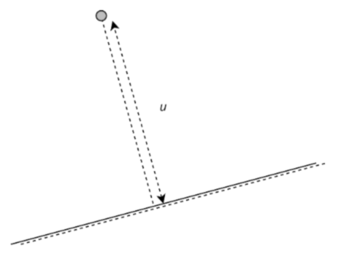

Solution:

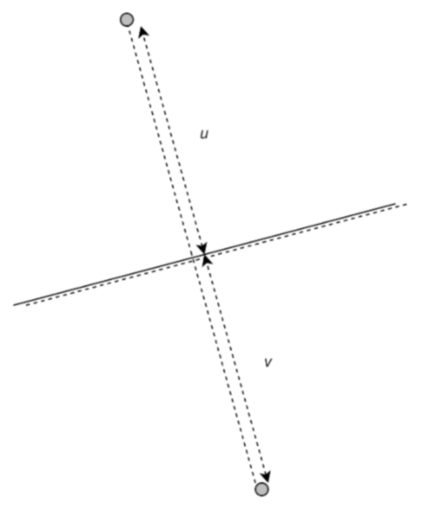

u = v

Q. Where will the image be formed?



Solution:

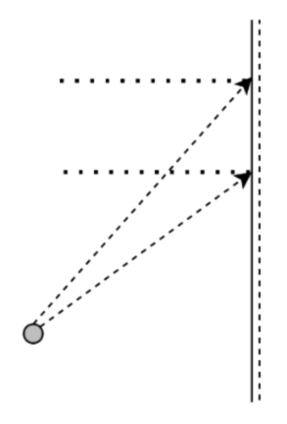

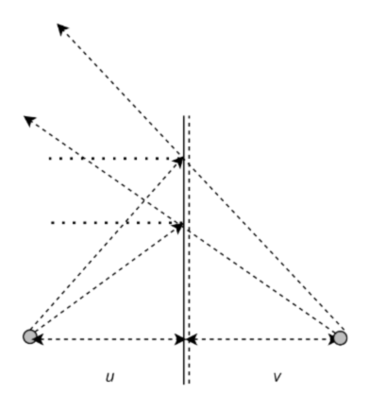

u = v

Q. Where will the image be formed?

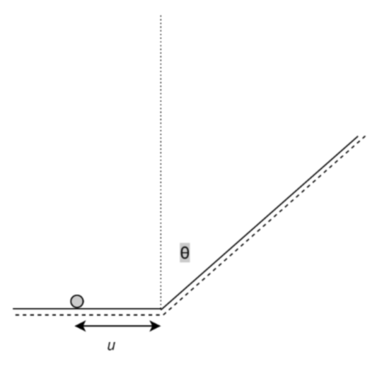

Solution:

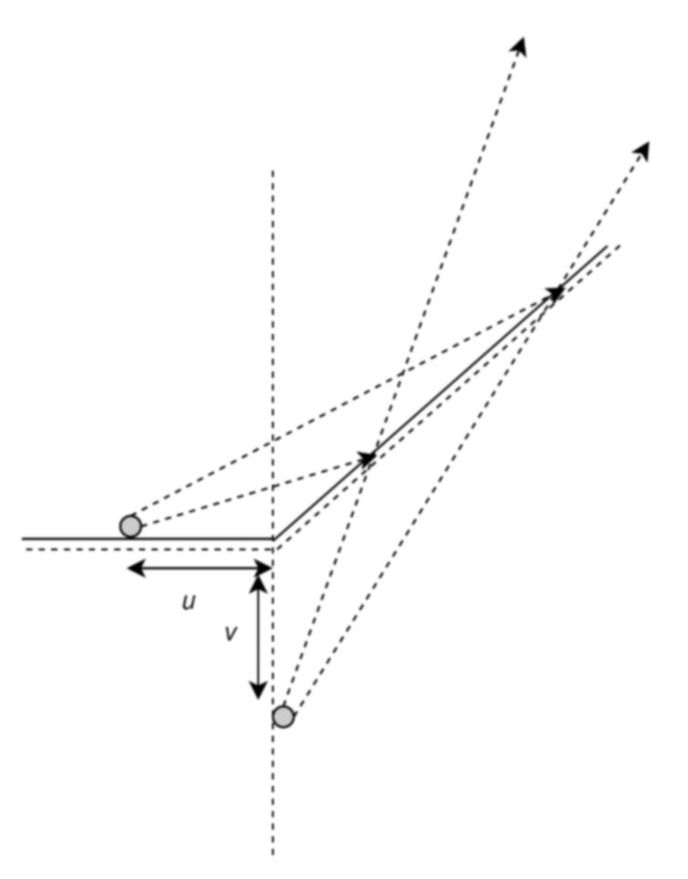

u = v

Images can be of two types:

* Real Image: Those images that can be casted on a screen. Real Images will always be inverted
* Virtual Image: Those images that cannot be casted on a screen. Virtual Images will always be erect.

The images formed by a Plane Mirror is always virtual.

Reflections are basically shown by smooth surfaces and one the most important example of those kind of surfaces are the mirrors. Mirrors can be of two types

* Plane Mirror
* Curved Mirror or Spherical Mirror

In the section 3.1, the mirrors mentioned were completely plane.

**3.2 Reflection from Curved Surface**

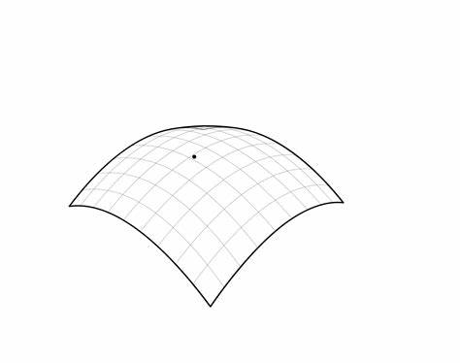

**Fig 4.** Curved Surface

Whenever, we deal with curved surface, we have spherical mirrors in our mind and we know, a curved surface have two sides, one is the convex side, while the other is the concave side.

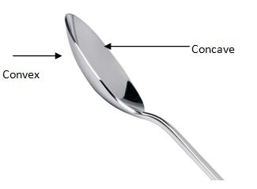

**Fig 5.** Concave and Convex

Before going deep into the reflection by spherical surface, we would like to discuss some of the well-known terms.

* Pole : Mid-Point of Spherical Mirror.
* Centre of Curvature : Centre of the sphere of which the mirror is a part.
* Radius of Curvature : Radius of the sphere of which the mirror forms a part.
* Principal Axis: Line passing through the pole and the Center of Curvature.
* Principal Focus : A narrow parallel beam of light parallel to the principal axis if converges or appears to diverge from a point on the Principal Axis, such a point is known as focus (or better Principal Focus).
* Focal Length : The distance between the pole and the focus.

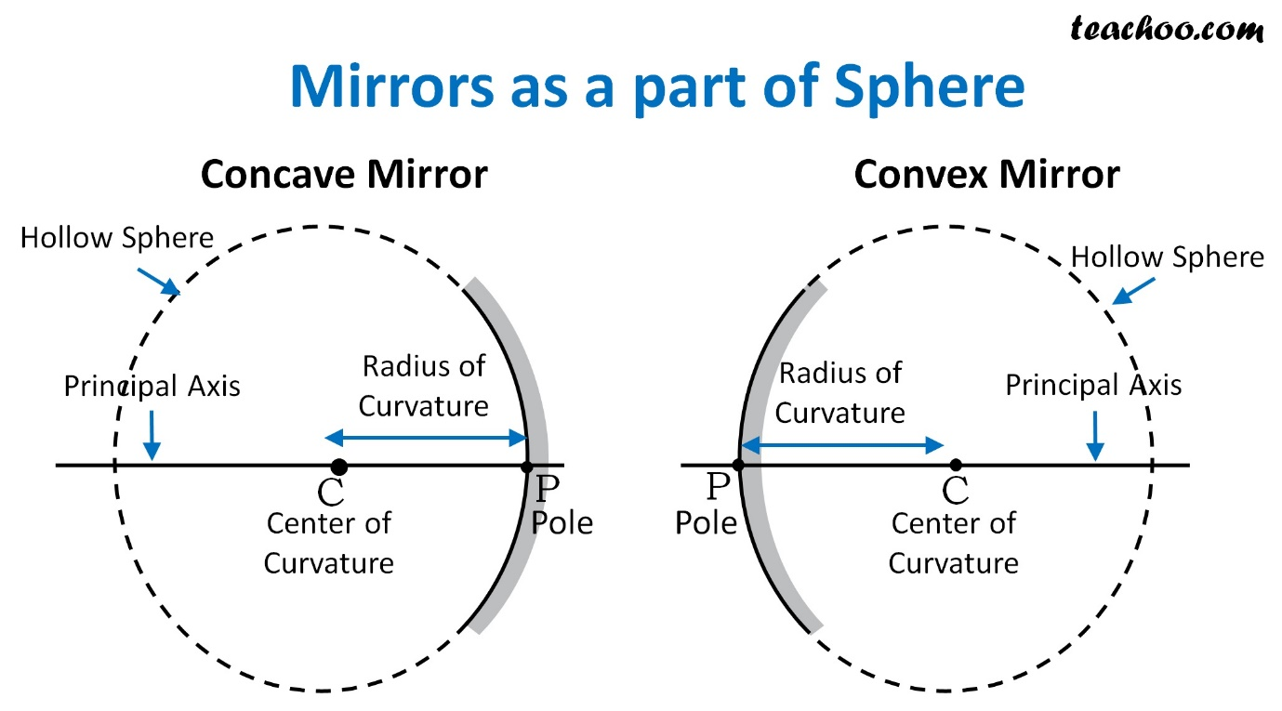

**Fig 6.** Concave and Convex Mirror

**4 Refraction of Light**

Refraction is the change in direction of a light ray (treated in terms of wave) on passing from one medium to another.

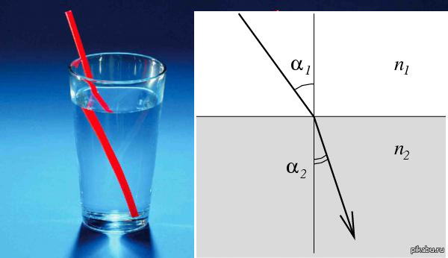



Normal

Refracted Ray

Incident Ray

Medium 2

Medium 1

**Fig 7.** Refraction of Light

The basic laws of refractions are:

* Incident Ray, Refracted Ray, and the Normal, all three lies on a same plane.

Mathematically,

* For the given pair of media, the ratio of the sine of the angle of incidence to the sine of angle refraction is always constant.

Mathematically,

Or,

This constant is nothing but the relative refractive index of the medium 2 with respect to medium 1, i.e., .

We can witness refraction though any set of two medium, the only requisite being, the change in refractive index should be considerably high.

In case of refraction, when a ray of light moves from a less dense medium to a more denser medium, the ray bends towards the normal.

In case of refraction, when a ray of light moves from a more denser medium to a less denser medium, the ray bends away from the normal.

**4.1 Refraction from Plane Surface**

As you might have studied till now, that in reflection from plane surface, we used plane mirrors in particular, Similarly, in the case of Refraction, in place surface, we use Glass Slab in general,

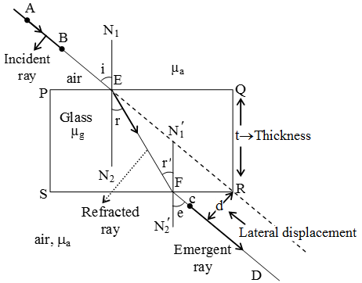

**Fig 8.** Refraction of Light in a Glass Slab

**4.2 Refraction from Curved Surface**



**Fig 9.** Curved Surface

There are Curved Surfaces, that shows refraction, when a ray of light passes through them, such pieces of curved surfaces are termed as lens.

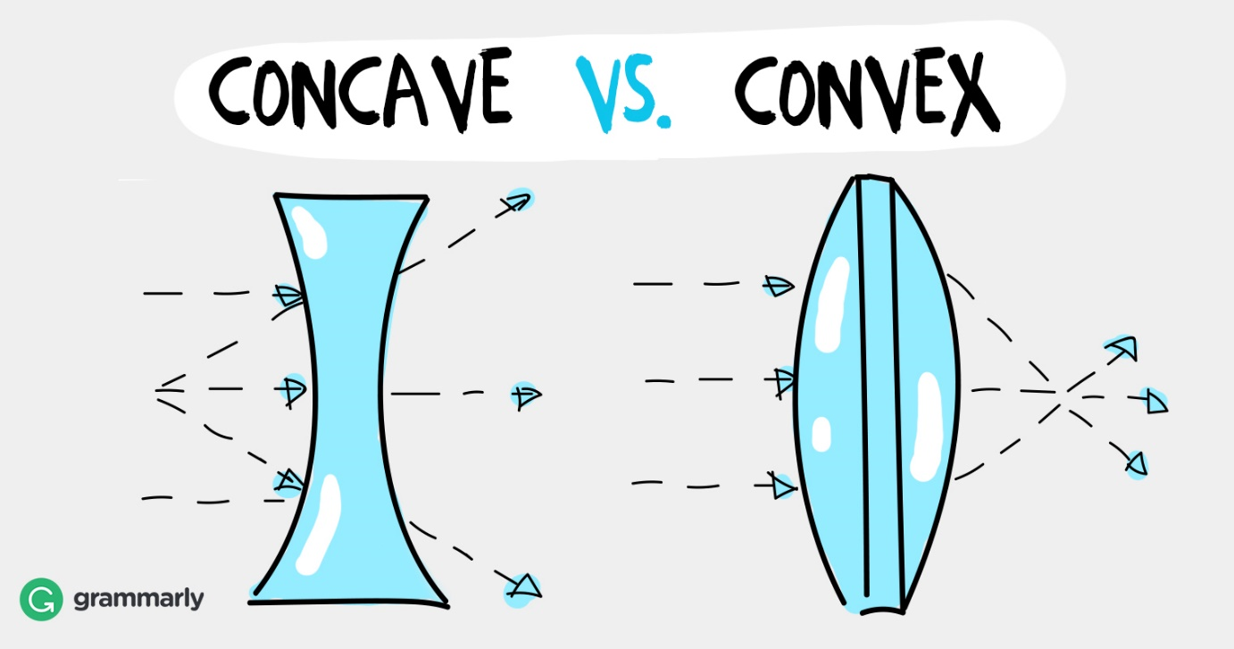



**Fig 9.** Concave and Convex Lens

NOTE: Concave Mirror Converging Mirror, Convex Mirror Diverging Mirror.

Concave Lens Diverging Lens, Convex Lens Converging Lens.

**4.3 Prism**

An optical prism is a transparent optical element with flat, polished surfaces that are designed to refract light.

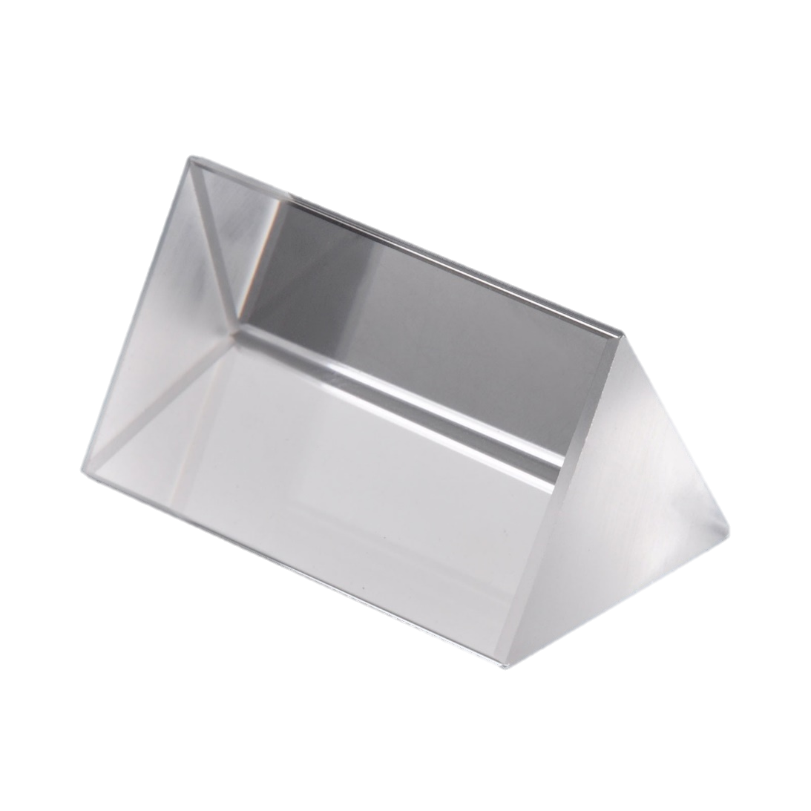

**Fig 10.** Prism

Now, we will look into the refraction of light accompanied by a prism.

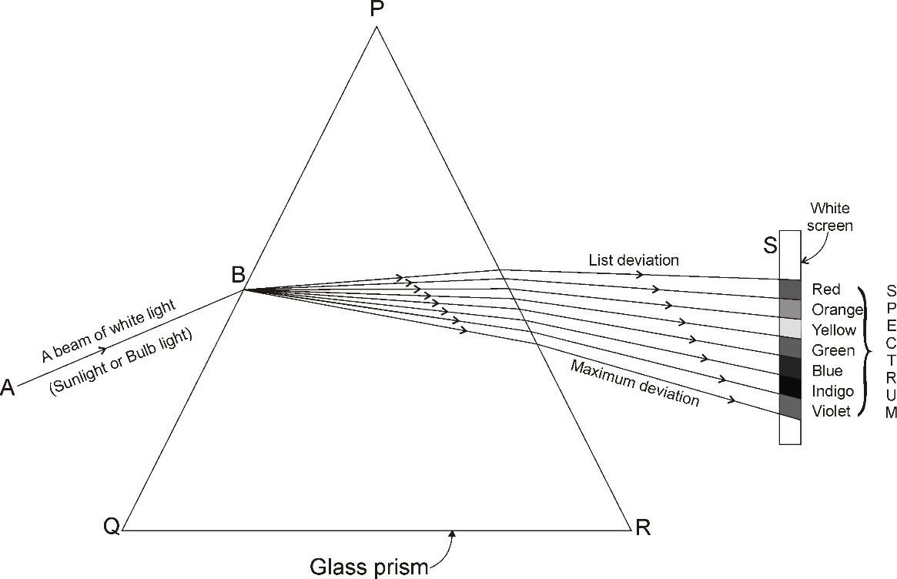

**Fig 11.** Breaking of White light into 7 colors, **V**iolet, **I**ndigo, **B**lue, **G**reen, **Y**ellow, **O**range, **R**ed.

These dispersed seven colors can be recomposed by another prism kept in inverted manner to the first prism.

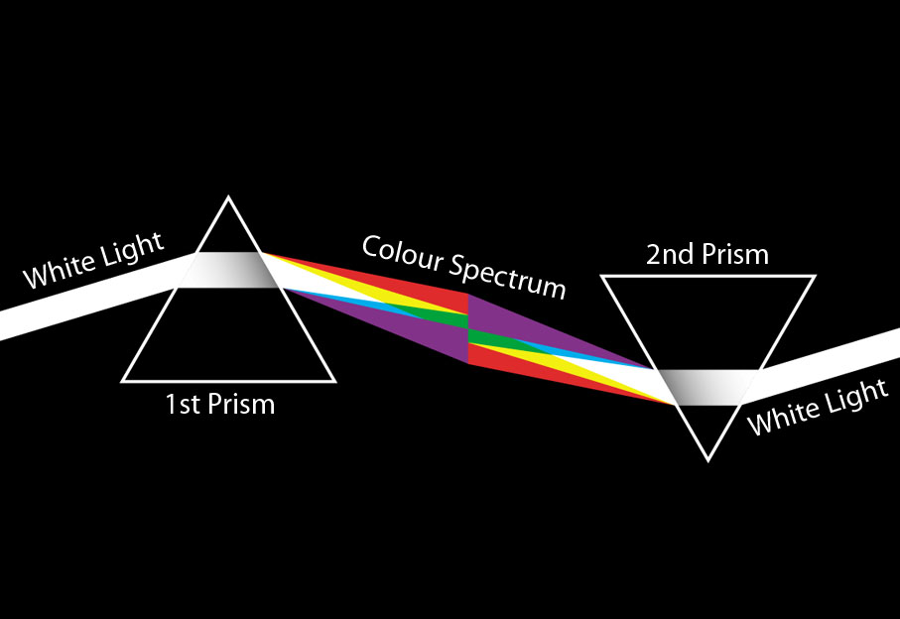

**Fig 12.** Recombination.

One Similar phenomenon is observed in the sky just after the rains, in sunny weather, in which the white light of the Sun is broken into 7 colors of the spectrum, such a phenomenon is called Rainbow. In rainbow formation, the water droplets suspended in the sky / atmosphere acts as a prism.

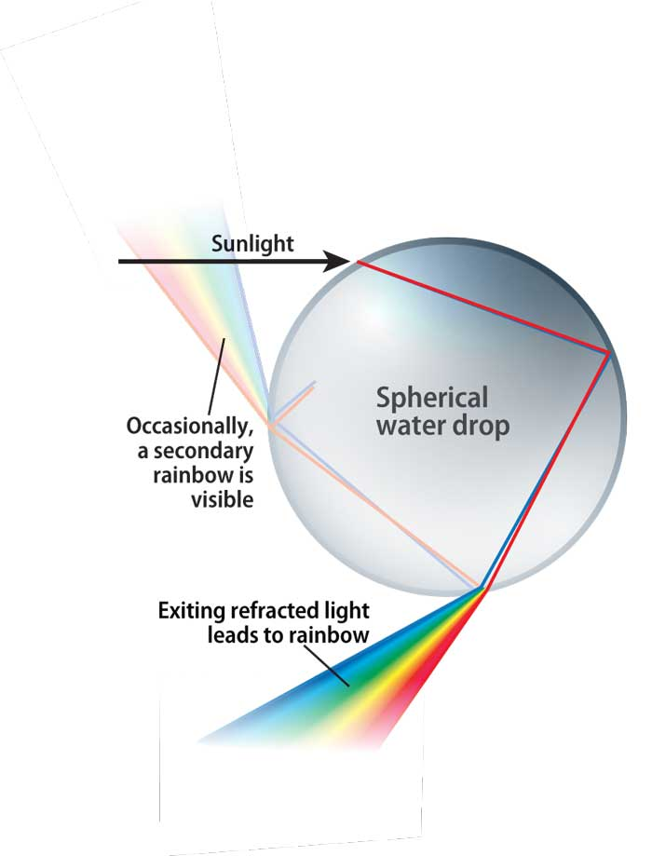

**Fig 13.** Formation of Rainbow in the Sky by Water Drops.