**Optics**

**Anurag Dutta**

E-Mail: [1anuragdutta@gmail.com](mailto:1anuragdutta@gmail.com)

**1 Introduction**

**1.1 Light**

It is a source of energy that enables us to see the world around us. It is an Electromagnetic wave with wavelength ranging between 400 nm – 750 nm. Light travels in a straight line

Speed of light in vacuum $(c)$ $=3×{10}^{8}\frac{m}{s}$

**1.2 Optics**

It is a branch of physics which deals with nature, production and propagation of light.

There are two branches of optics

* Ray Optics: Treats light as a particle.
* Wave Optics: Treats light as a wave.

**1.3 Ray – Optics**

Ray Optics deals with

* Reflection
* Refraction

**1.4 Wave – Optics**

Wave Optics deals with

* Diffraction
* Interference
* Polarization

**2 Reflection**

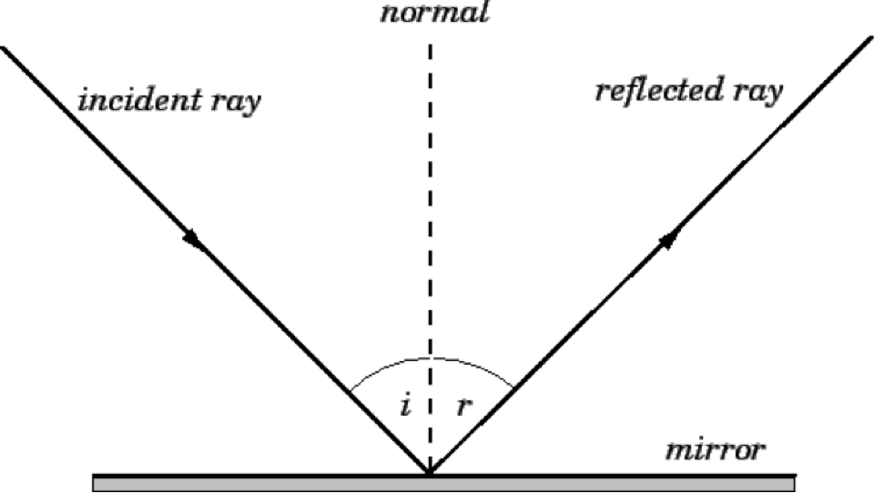

The basic laws of reflections are:

* Angle of incidence is equal to the Angle of reflection. Mathematically,
$$∠i=∠r$$

* Incident Ray, Reflected Ray and the Normal all three lies in a same plane. Mathematically,

*Dot Product*



$$\hat{r}=\hat{i}-2\left(\hat{i}.\hat{n}\right)\hat{n}$$

So, we can say the three vectors, $\hat{r}$, $\hat{i}$ and $\hat{n}$ are coplanar.

**2.1 Reflection from Plane Surface**

Before diving deep into the topic, we will first try to get a complete know – how on objects.

Objects can be of two types:

* Point Object
* Extended Object

Q. Where will the image be formed?

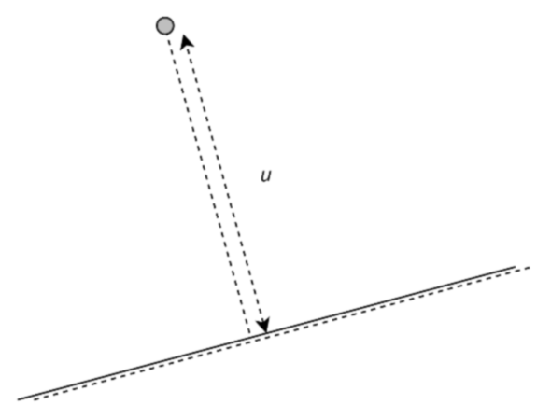

Solution:

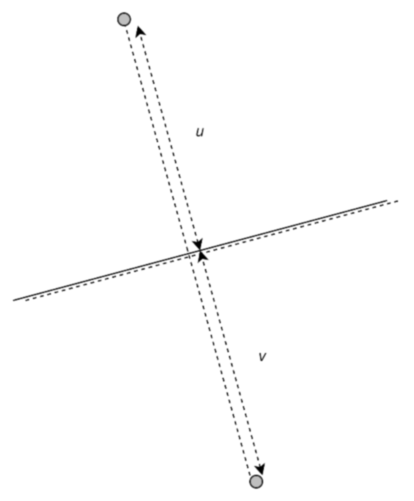

u = v

Q. Where will the image be formed?



Solution:

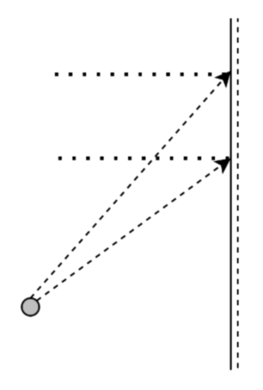

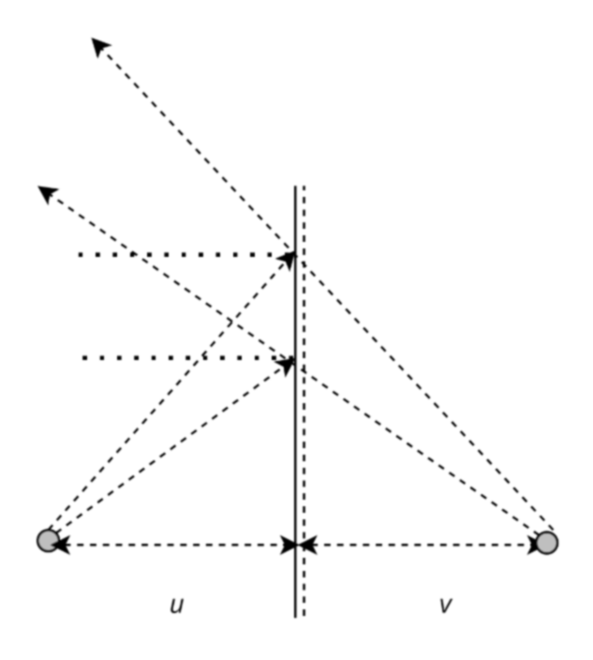

u = v

Q. Where will the image be formed?

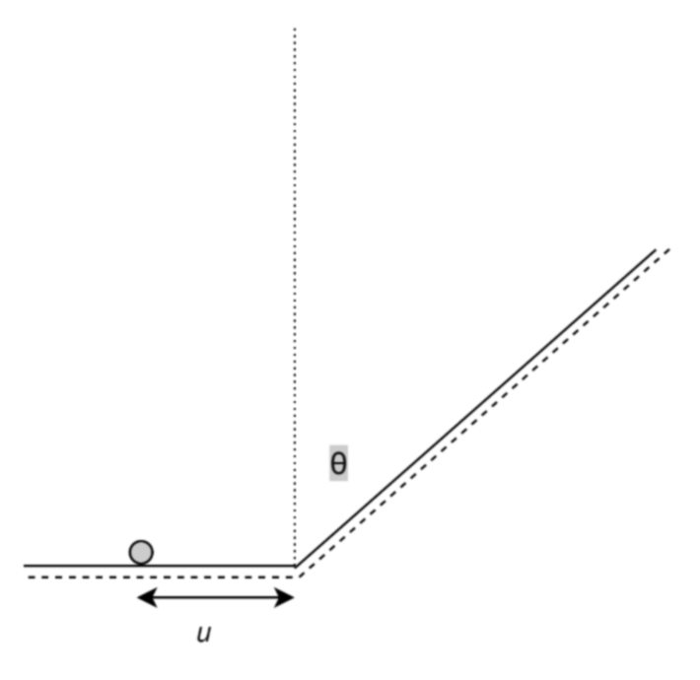



Solution:

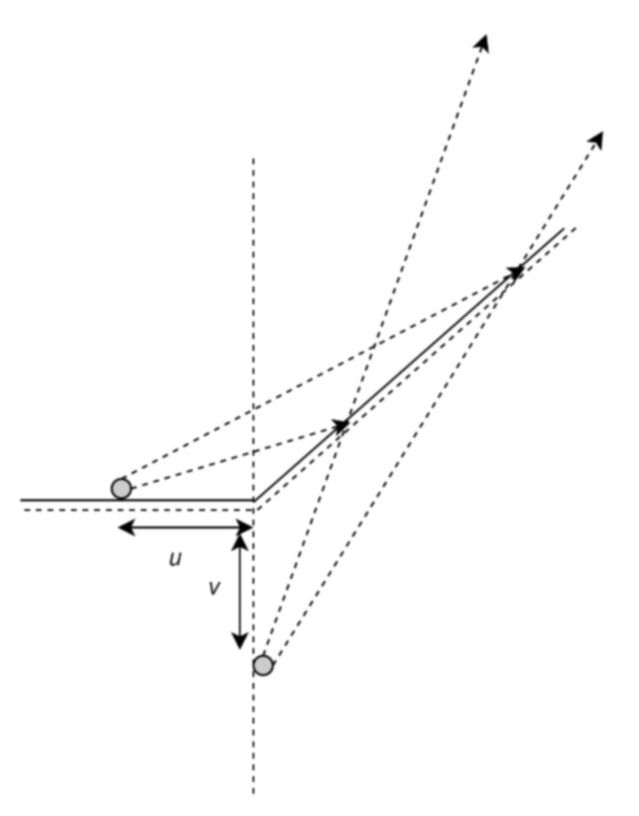

u = v

**2.2 Reflection from Curved Surface**

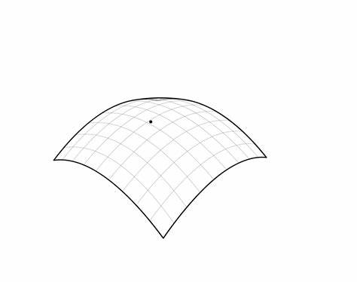

Whenever, we deal with curved surface, we have spherical mirrors in our mind and we know, a curved surface have two sides, one is the convex side, while the other is the concave side.

Before going deep into the spherical mirror, we would like to discuss some of the well-known terms.

* Pole $(P)$: Mid-Point of Spherical Mirror.
* Centre of Curvature $(C)$: Centre of the sphere of which the mirror is a part.
* Radius of Curvature $(R)$: Radius of the sphere of which the mirror forms a part.
* Principal Axis: Line passing through the pole and the Center of Curvature.
* Principal Focus $(F)$: A narrow parallel beam of light parallel to the principal axis if converges or appears to diverge from a point on the Principal Axis, such a point is known as focus (or better Principal Focus).
* Focal Length $(f)$: The distance between the pole and the focus.

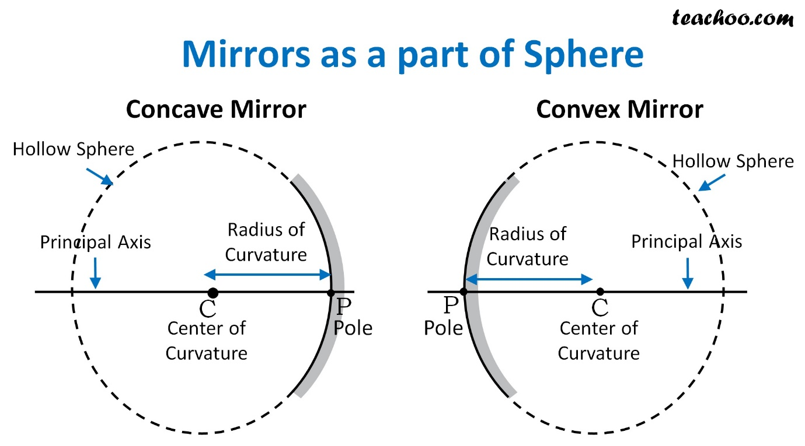

The Cartesian Sign Convention (Modified) states that*,*

*“The distances in the direction of the movement of the light will be considered as positive, while those in the direction opposite to it will be considered negative.”*

and

*“If the object / image is placed in the positive side of the y – axis, the height of the object / image will be considered $+$ ve, else it would be considered – ve”*

Q. Prove that $f=R/2$.

Solution:

**2.2.1 Mirror Equation**

$$\frac{1}{v}+\frac{1}{u}=\frac{1}{f}$$

$$⇒\frac{u+v}{vu}=\frac{1}{f}$$

$$⇒vu=uf+vf$$

where,

$v=$ Image Distance

$u=$ Object Distance

$f=$ Focal Length

Magnification $\left(μ\right)=\left(\frac{{Height}_{IMAGE}}{{Height}_{OBJECT}}\right) -\left(\frac{v}{u}\right)=-\left(\frac{vu}{u^{2}}\right)=-\left(\frac{uf+vf}{u^{2}}\right)=-\left(\frac{f}{u}\right)-\left(\frac{v}{u}\right)\left(\frac{f}{u}\right)$

$$⇒μ=-\left(\frac{f}{u}\right)-\left(\frac{v}{u}\right)\left(\frac{f}{u}\right)$$

$$⇒μ=-\left(\frac{f}{u}\right)+μ\left(\frac{f}{u}\right), as-\left(\frac{v}{u}\right)=μ$$

$$⇒μ-μ\left(\frac{f}{u}\right)=-\left(\frac{f}{u}\right)$$

$$⇒μ\left(1-\frac{f}{u}\right)=-\left(\frac{f}{u}\right)$$

$$⇒μ\left(\frac{f}{u}-\frac{u}{u}\right)=\left(\frac{f}{u}\right)$$

$$⇒μ\left(f-u\right)=\left(f\right)$$

$$⇒μ=\left(f/{\left(f-u\right)}\right)$$

**3 Refraction**

