**Water**

February 01, 2022

Email: [1anuragdutta@gmail.com](mailto:1anuragdutta@gmail.com)

**1 Definition**

Water is an inorganic chemical substance that quenches our thirst. It comprises of 3 atoms, 2 of them being the hydrogen molecule, and the remaining one being Oxygen molecule. The Chemical Formula of Water is $H_{2}O.$

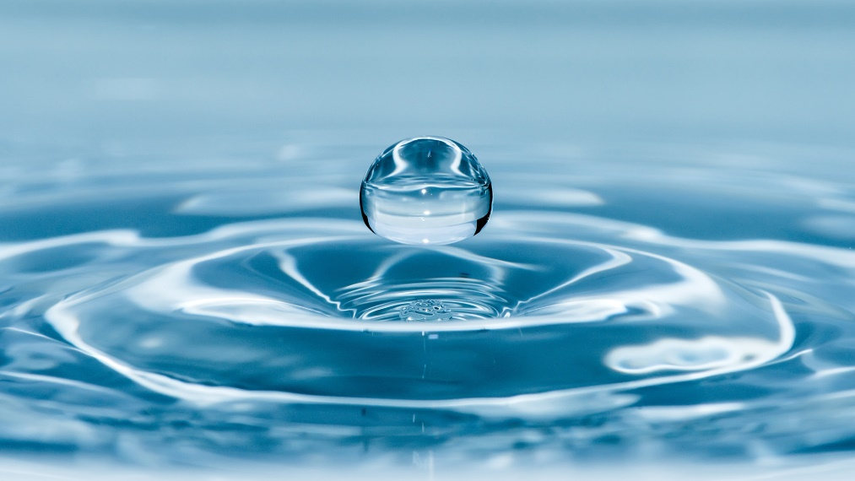

**Fig 1.** Water

The Chemical Structure of one molecule of water is

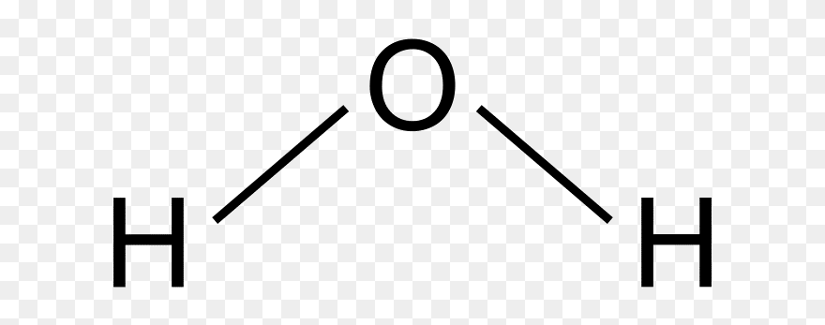

**Fig 2.** Water Molecule 2 – D Chemical Structure.

Water Constitutes nearly 71% of the earth’s surface. Now, in this 71%, 97.4% of water is inedible, remaining 2.6% is edible, and is obtained from River, Underground Water, Glaciers, Ponds, clean water bodies.

Some of the basic uses of water are:

* Drinking
* Cooking
* Bathing
* Washing
* Watering Plants

**2 States of Water**

There are 3 states in which water is available:

* Solid (Ice): This is the state of water that occurs at $0℃$ (or 273.15 K) and 1 atm pressure[1]. Water in found in thus form in the glaciers, ice – caps, polar regions, etc.

NOTE: Liquid $CO_{2}$ is known as Dry – ice, which is used as refrigerant as well as a coolant.

* Liquid (Water): This is the state of water that is found at normal / room temperature $25℃$ (or 298.15 K) and 1 atm pressure. Water is found in this form in lakes, rivers, water bodies, rain, etc.
* Gas (Water Vapor): This is the state of water that is found at boiling temperature $100℃$ (or 373.15 K) and 1 atm pressure. Water is found in this form in the water bodies near to an active volcano, clouds, etc.

All these forms are interchangeable.

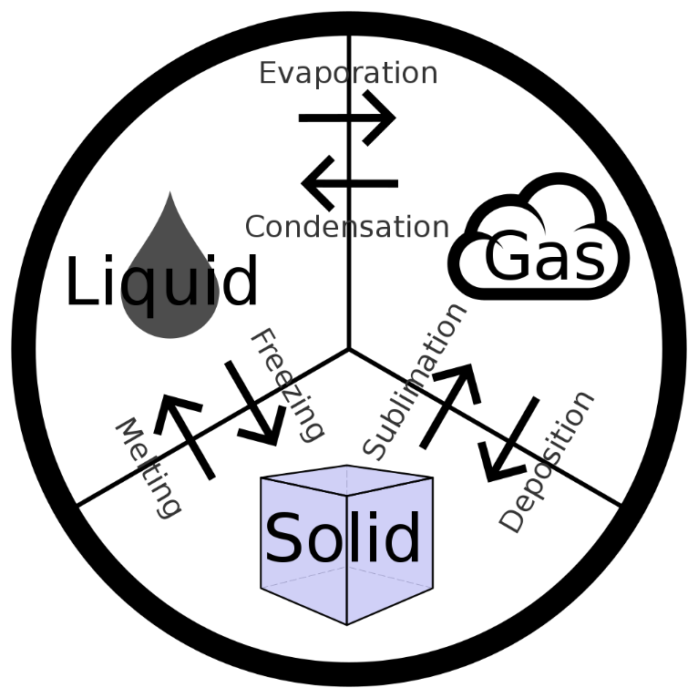

**Fig 3.** The interchangeability of States of Water.

**3 Phase Transition**

This is the process in which the various states of water are made interchangeable amongst them.

When there is a pressure of 1 atmosphere, or 1 atm, water (in liquid state) will freeze at $0℃$, boil at 100 $℃$. So $0℃$ is known as the freezing point of water at 1 atm pressure, and 100 $℃$ is known as the boiling point of water at 1 atm pressure.

Now, when water reaches these temperatures, say $0℃$ or 100 $℃$, the water is still at liquid phase in each cases.

To get to the solid phase at $0℃$, it will have to give away a certain amount of heat to the surroundings, which we specifically refer as Latent Heat of fusion $L_{f}$.

To get to the gaseous phase at $100℃$, it will have to take away a certain amount of heat from the surroundings, which we specifically refer as Latent Heat of vaporization $L_{v}$.

These data can be easily represented on a chart with thermodynamical essence, specially coined as phase diagram. The phase diagram of Water is as follows.

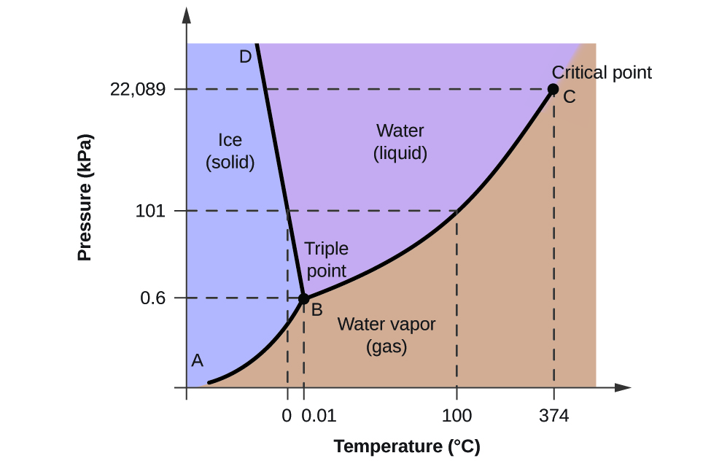

**Fig 4.** Phase Diagram of Water.

**4 Physical Properties of Water**

Some of the important physical properties of water are:

* Colorless
* Odorless
* Transparent
* Tasteless

**5 Chemical Properties of Water**

Some of the chemical properties of water are:

* It is a polar[2] molecule.

In a water molecule, the hydrogen atoms form a 104.5° angle, known as dihedral angle with the oxygen atom.

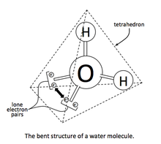

**Fig 5.** Water Molecule 3 – D Chemical Structure.

* It shows Hydrogen Bonding[3].

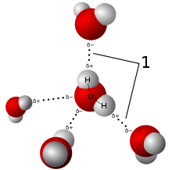



**Fig 6.** Water Molecules showing Hydrogen Bonds.

* It shows self-ionization[4].

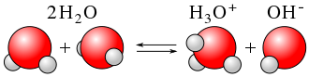

**Fig 7.** Water Molecules showing Self – Ionization.

* It shows electrical conductivity.

**6 Water Cycle (or Hydrological Cycle)**

The water cycle (known scientifically as the hydrologic cycle) refers to the continuous exchange of water within the hydrosphere, between the atmosphere, soil water, surface water, groundwater, and plants.

The steps involved in the process of Water Cycle are:

* Evaporation from oceans and other water bodies into the air and transpiration from land plants and animals into the air.
* Precipitation, from water vapor condensing from the air and falling to the earth or ocean.
* Runoff from the land usually reaching the sea.

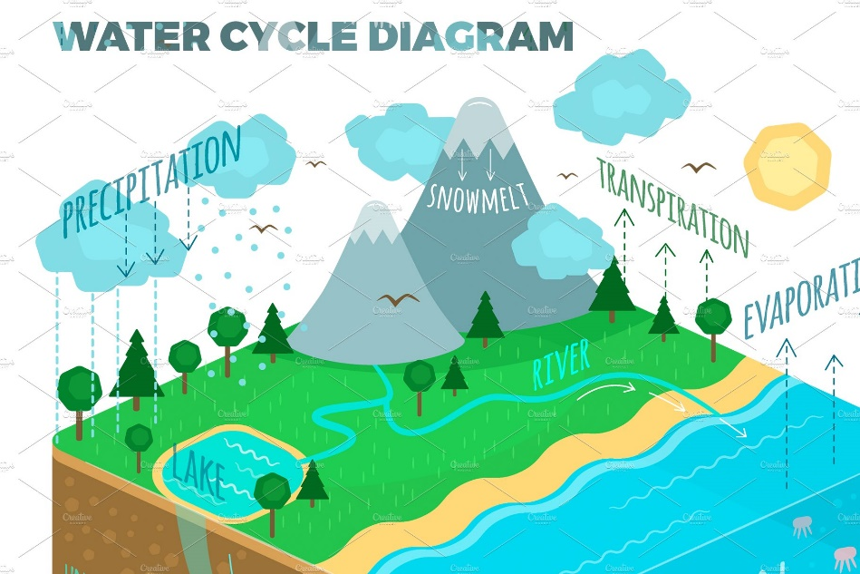

**Fig 8.** Water Cycle

The main importance of water cycle are:

* It maintains the earth’s weather.
* It makes water available in earth.

**7 Distribution of Water**

In our country India, there are a variety of soils, and each soil is accompanied with their own standards of holding water, that may result in uneven distribution of water throughout our nation. Like in the deserted region of Rajasthan, there is sandy soil, with low water retaining capacity, and hence lower water level. In the green vivid regions of West Bengal and nearby states, there is a plenty of clayey soil, with better water retaining capacity, and hence higher water level. Likewise, there are different kinds of soil in various states, that results in variation in water table layer.

1. Pressure is a physical quantity that is defined by the ratio of the amount of force applied on a substance and the surface area on which the force is applied.
2. A state or a condition of an atom or a molecule having positive and also negative charges.
3. Hydrogen – Bonding is an electrostatic force of attraction between Hydrogen and some more electronegative elements, like Fluorine, Oxygen, Nitrogen, Chlorine, Bromine.
4. It is the process in which two water molecules, $H_{2}O$ deprotonates to 1 hydronium ion, ${H_{3}O}^{+}$ and 1 hydroxide ion, .