Voyager’s Guide

Plot

Suppose you are on holidays and you plan a trip to an unknown place and to your surprise there are a total of ‘n’ number of tourist spots surrounding that place. Now, you will be eager to visit all the places. On the same time, you will also try to do so in the shortest distance. So, what will you do? Don’t worry! Voyager’s Guide is here to help you.

Test Case

Suppose you are at California with your mates. Now you got to know that California has a total of 5 major attractions,

* Golden Gate Bridge (1,1)
* Griffith Park (5,7)
* San Diego Zoo (1,3)
* Glacier Point (4,9)
* Santa Monica Pier (8,9)

Now, you want to visit all these places at the shortest distance possible.

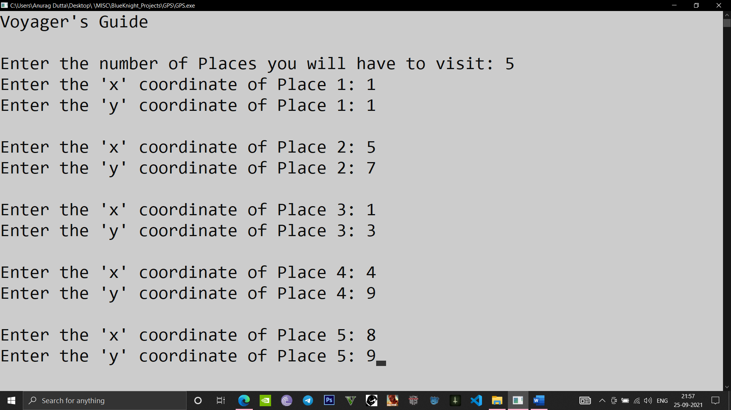

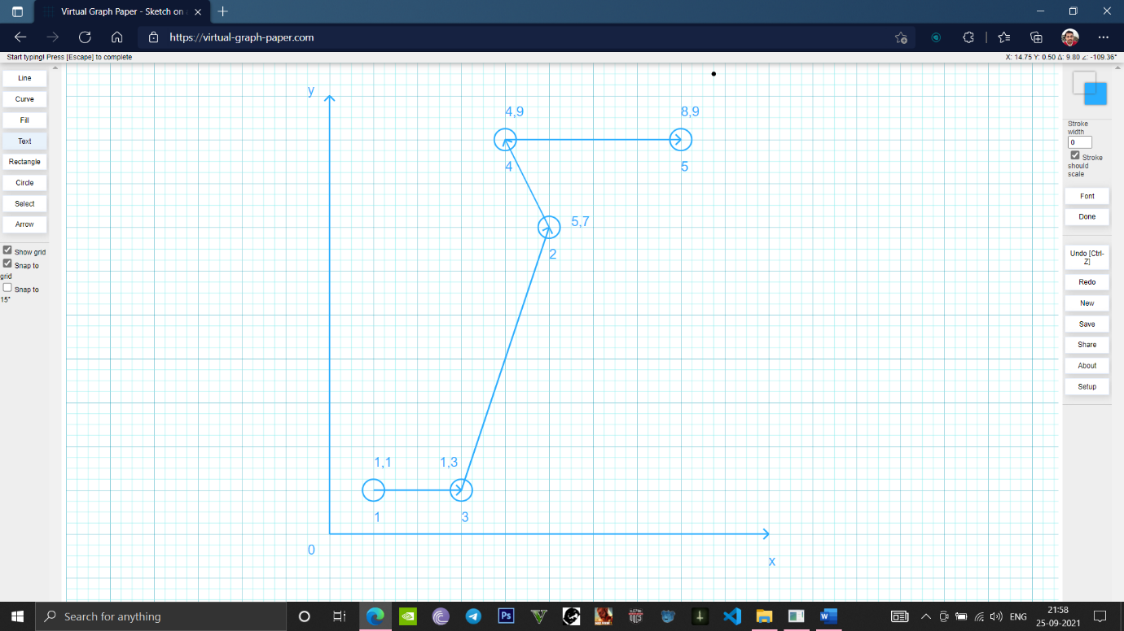Now, if we plot them on a graph, we get the following result

Now, according to Voyager’s Guide, the output is

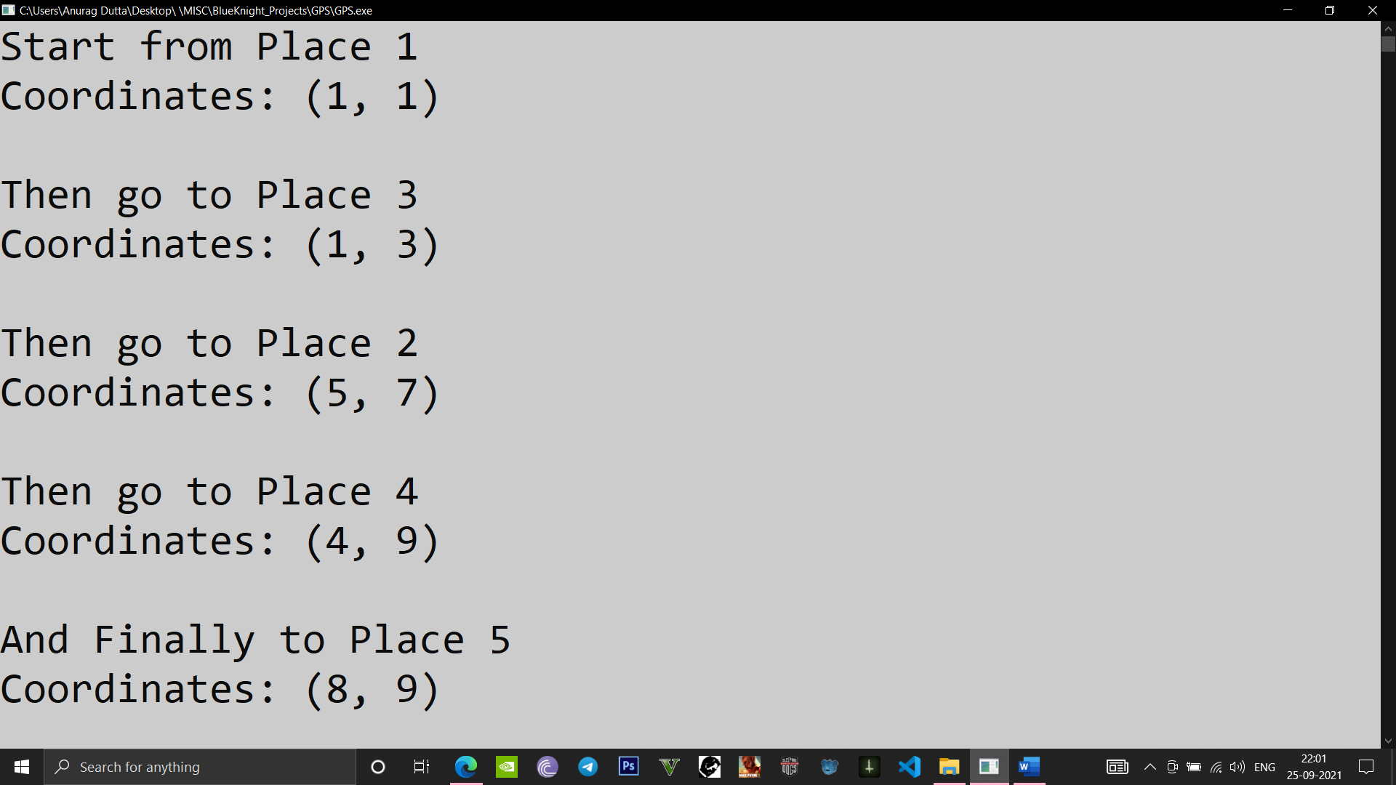

which is actually the shortest route possible amongst 120 possibilities…Sounds amazing isn’t it? Yes this program can easily choose the shortest path amongst thousands of possibilities.

Hyperlinks

GitHub: [Projects/GPS at main · Anurag-Dutta/Projects (github.com)](https://github.com/Anurag-Dutta/Projects/tree/main/GPS)

G-Drive: <https://rb.gy/otwkgh>