Investigating the fall of the Silicon Valley Bank *vis-à-vis* Benford’s Law

Anurag Dutta 1[](https://orcid.org/0000-0002-5787-3860), Liton Chandra Voumik 2*[](https://orcid.org/0000-0002-9612-7350) and Lakshmanan Kumarasankaralingam 3[](https://orcid.org/0000-0002-1426-204X)

1 Undergraduate, Department of Computer Science, Government College of Engineering and Textile Technology, Serampore, Calcutta 712201, India, Email- [anuragdutta.research@gmail.com](mailto:anuragdutta.research@gmail.com); ORCID: 0000-0002-5787-3860

2 Assistant Professor, Department of Economics, Noakhali Science and Technology University, Noakhali, Bangladesh 3814; Email- [litonvoumik@gmail.com](mailto:litonvoumik@gmail.com); ORCID: 0000-0002-9612-7350

3 Professor, Department of Mathematics, Kuwait American School of Education, Salmiya 22062, Kuwait; Email- [coprime65@gmail.com](mailto:coprime65@gmail.com); ORCID: 0000-0002-1426-204X

|  |
| --- |
| **Citation:** Lastname, F.; Lastname, F.; Last-name, F. Title. *Journal Name.* **2023**, x, x. https://doi.org/10.3390/xxxxx  Received: date  Accepted: date  Published: date  Publisher’s Note: MDPI stays neutral with regard to jurisdictional claims in published maps and institutional affiliations.    **Copyright:** © 2023 by the authors. Submitted for possible open access publication under the terms and conditions of the Creative Commons Attribution (CC BY) license (http://creativecommons.org/licenses/by/4.0/). |

**\*** Correspondence: [litonvoumik@gmail.com](mailto:litonvoumik@gmail.com)

**Abstract:** Data is produced every instant in the modern era of technological breakthroughs we live in today. In actuality, data is the lifeblood of today's world; whether it's Google or Meta, everyone depends on data to survive. There are several cases where data is altered to encrypt reliable details. Recently, in the March of 2023, Silicon Valley Bank collapsed following unrest prompted by increasing rates. Silicon Valley Bank ran out of money as entrepreneurial investors pulled investments to maintain their businesses afloat in a frigid backdrop for IPOs as well as individual financing. The bank's collapse was really the biggest since the financial meltdown of 2008 and the second-largest commercial catastrophe in American history. By confirming the "Silicon Valley Bank" Stock Price Data, we would delve further into the actual condition in this article. To accomplish the very same, we applied a very well-known statistical paradigm, Benford's Law. We have cross-validated the results using comparable statistics to corroborate the findings. The Validation will indeed serve as the basis for evaluating the circumstance. In addition to these, Benford's Law has several temporal proximities, known as conformal ranges, which provide a closer examination of the extent of data morphing that has occurred in the data presented by the various organizations. We would rather apply Benford's Law to ascertain the Silicon Valley Bank Stocks' Price's validity proximity, which would provide us a much better overview of what to expect in this current event of the catastrophe. Alongside, the result in validated using Zipf’s Law. The Opening Price of Stocks (the Price at Which the Market Opened), the Closing Price of Stocks (the Price at Which the Market Closed), and the Highest Price of Stocks (the Price at Which Stocks reached their Highest Point During the Trading Day) were Subjected to Validation within the timeframe of 36 years, between 1987 and 2023. In addition, it is imperative that readers of this article take note of the fact that the conclusion that is formed about the topic discussed in this article is objective and is entirely based on statistical analysis and factual figures that have been presented by the Silicon Valley Bank Group.

**Keywords:** Benford’s Law; Stock Price; ChaosNet; Silicon Valley Bank; Data Validation

1. Introduction

Fraud [1] refers to activities, techniques, or organizations that fail to conform with laws that have been established for the welfare of the civilization's youth. Almost nothing has altered since the initial swindle, which transpired approximately 300 B.C. Time went, civilization [2] evolved, colonization [3] occurred, the commerce [4] surged and plummeted, but mankind's [5] most fundamental motivation remained constant. Evolution's principles cannot be modified, no matter how sophisticated con artists are. The conundrum appears to come from the fact that authoritarian regimes are able to accomplish this, as Russia did in 2008, by erecting non - quantifiable, spectacular government bureaucracy [6] obstructions that rationally assume and come to the realization that each and every objective and impartial and feasible oversight is an insurmountable challenge of an intruder, or, as occurred in Ukraine in 2004, both stakeholders of a disagreement can paddock their possess cadre of observers affirming or disputing the authenticity of the other's observations.

Benford's law [7] has the ability to supply us with dependable data points on the overwhelming bulk of forgeries that transpire in our everyday routines, such as vote rigging, GDP falsification, credit card fraud, and income embezzlement.

The first digit law is a logarithmic [8] likelihood function hypothesis for the first digits of a randomized, vast, and diversified sample. It is also known as the law of aberrant numerals or Benford's law. The number's first significant digit is the first non-zero digit on the far left, such as 1 for 18297, 9 for 9099, and 0 for 0.00789545. According to the proposed Benford's law, the chances of a given number occurring as the initial figure decrease logarithmically as the digit's value increases from 1 to 9. The expected probability is indicated in the table below.

**Table 1.** Numbers' likelihood of occurring according to Benford's law. General Distribution of Numbers in nature, is supposed to follow this likelihood table in most case, if not tampered.

|  |  |
| --- | --- |
| **Digit** | **Probability** |
| 1 | 0.301029 |
| 2 | 0.176091 |
| 3 | 0.124938 |
| 4 | 0.096910 |
| 5 | 0.079181 |
| 6 | 0.066946 |
| 7 | 0.057991 |
| 8 | 0.051152 |
| 9 | 0.045757 |

Mark J. Nigrini [9] was the first to use Benford's technique in the domains of exploratory investigation and embezzlement monitoring. His evaluation included cutting edge relevant theories on Benford's law in addition to the intricate legal procedures surrounding fraud judgements. Mark J. Nigrini discusses how to utilize tests like Benford's rule to detect prejudices, inaccuracies, and deception in economic and electioneering data in his book Investigative Analytics, published by Wiley Publishing. He was hailed by both the Wall Street Journal and the national media, and he produced multiple research projects on Benford's law.

As per Arno Berger as well as Theodore P. Hill's research paper [10] on the unpredictability of Benford's law, in order to provide accurate and persuasive findings, this principle ought to be restricted to a small amount of distinctive datasets; alternatively, it presents a greater number of problems than positives.

Hill, Theodore [11] endeavored to outline the various implications of Benford's law in fields like computer design, computer simulation, and the monitoring of unethical conduct in accounting reporting in his research report.

Jan H. P. Eloff's [12] examination of Innocent Mbona was centered on providing a solution to combat malicious social networking sites bots. The study found that, while an equal option on an evil bot compendium violated Benford's law, a regular intelligent sample evenly resembled it. According to the aforementioned study, the recognized possibilities in Benford's law domain are coherent and, as a result, correspond to the data obtained by PCA as well as the Randomly assigned Forest methodology on a corresponding dataset.

Aleksandar Toi and Jernej Vii's research emphasizes the implementation of Benford's law to collaborative intellectual networks [13]. The report provided a unique way to assess the academic organization's performance. The report goes thoroughly into the disparities amongst Slovenia's diverse and varied scientific disciplines.

Zipf's law was originally developed for the study of anomalous word occurrences in linguistics, asserting that given a lexicon or analysis of the data of natural language happenings, the occurrence frequency of any phrase is inversely related to its rank in the frequency distribution table. Thus, the most commonly encountered word will occur roughly twice as consistently as the second most occurring more frequently phrase, three times as frequently as the third most occurring more frequently phrase, and so on. In the Brown Corpus of American English text, for example, the word "the" serves as the most commonly occurring phrase, accounting for nearly 7.0% of all happenings of the words. The statute is designated after American cognitive scientist George Kingsley Zipf. Even as he was not the one who gave birth to that logic, or more accurately, the law. Jean-Baptiste Estoup, a French stenographer, had acknowledged this sequence long before Zipf did. We would extend the applicability of the Zipf’s Law apart from linguistics in Criminology.

Silicon Valley Bank was a California state-chartered banking system with their headquarters in Santa Clara. It had offices in California as well as Massachusetts. Silicon Valley Bank Group, a market capitalization bank investment group with operations in 15 U.S. states and more than a dozen overseas countries, owned the financial institution. Being a Bay Area regional bank, Silicon Valley Bank offered tailored solutions exclusively to the demands of the technology industry, and it quickly became the largest financial institution by holdings in Silicon Valley as well as the chosen bank of 50 percent of all private equity startup companies. After central bank-endorsed raises in interest rates as during 2021-2023 wage growth surge, the nation experienced a liquidity crisis on its reserves in March 2023, leading to its dissolution and confiscation by the “California Department of Financial Protection and Innovation”, its regulatory, on March 10, 2023. The “California Department of Financial Protection and Innovation” designated the “Federal Deposit Insurance Corporation” as the receiver of the bank, citing insufficient assets and financial distress. This was the second-largest banking collapse in US annals, following the collapse of Washington Mutual in 2008.

2. Remembrance – a dive into the past

During the “*dot-com bubble*,” a surge of information technology startups produced an infusion of revenue for Silicon Valley Bankers, which was known for its propensity to finance to managers and the shareholders who were not yet lucrative. In 1995, amongst 2,000 clients were telecommunications pioneers *Cisco Systems* [14] и *Bay Networks* [15]. The Silicon Valley Bank relocated its offices from San Jose to Santa Clara that year. The stock price of the holding firm rose throughout the bubble but plunged 50% after it crashed. The bank expanded its presence in technological hotspots [16] around the globe. Ken Wilcox took over as CEO in the year 2000 and decided to keep the company's exclusive emphasis on technology providers instead of broadening into a commercial and industrial financial institution. Silicon Valley Bank joined the personal financial services sector explicitly in 2002, capitalizing on existing knowledge and ties with affluent pioneering investors and entrepreneurs. In 2003, the financial institution funded multiple high global trade deployments to Bengaluru as well as Bombay, Tel Aviv, and Shanghai and Beijing, introducing with them a deputation of two dozen Silicon Valley venture capitalist class to satisfy to financial institutions, business owners, and government representatives in preparation for the attempting to open of worldwide operations. In 2004, it unveiled an internationalization strategy campaign, with new offices in Bangalore, London, Beijing, and Israel. During the 2007-2008 financial crisis, the federal government invested $235 million in Silicon Valley Bank Financial Group in compensation for preference shares and incentives underneath the "*Troubled Asset Relief Program*" [17]. It repaid the US Treasury $10 million in payments over 2 years, then utilized the profits of a $300 million stock offering to purchase back the government's stake. In April 2011, Greg Becker took over as CEO, succeeding Wilcox. In 2012, Silicon Valley Bank teamed with "*Shanghai Pudong Development Bank*" [18] to establish SPD Silicon Valley Bank, a distinct Shanghai-based financial institution that lends to indigenous entrepreneurs. The financial institution, which is held equally by the two corporations, has been approved by Chinese financial regulators to function in RMB, putting it one of only a few American-owned institutions to do so. Silicon Valley Bank's active participation in funding new venture capital merger and acquisition provided it with trade secrets about such takeovers, and Mounir Gad, an erstwhile vice president of finance and board member at the bank, agreed to plead guilty in June 2021 to breaching the laws governing insider trading in 2015 and 2016 once he nudged off a companion about 3 startup buyouts.

With the institution highly engaged on long-term Treasury securities, Silicon Valley Bank started to sustain heavy losses in 2022 as interest rates went up and the technology sector experienced a significant dip in development. Silicon Valley Bank  reported anticipated mark-to-market liabilities in addition of $15 billion regarding equity securities to expiration as of end of year. A confluence of circumstances, notably inadequate risk assessment and a banking collapse pushed by technology industry investors, prompted the institution to fail in early March of 2023. Utilization of social networking sites was said to have played a role during both the initial banking collapse and its repercussions, with all those concerned by the possible loss of money pleading with authorities to guarantee that unprotected balances remained restored.

Investigators from FDIC [19] came at Silicon Valley Bank's headquarters early on March 10 to analyze the company's financial performance. Some hours later, the "California Department of Financial Protection and Innovation" issued an order suspending Silicon Valley Bank and appointing the Federal Deposit Insurance Corporation as administrator, alleging insufficient cash and bankruptcy. The Federal Deposit Insurance Corporation subsequently established the Deposit Insurance National Bank of Santa Clara to restore the bank's facilities the following Monday and allow access to safeguarded assets. Greg Becker, the CEO of Silicon Valley Bank, formerly was a member of the board of trustees of the "*Federal Reserve Bank of San Francisco*" but resigned from that post. On March 12, a first bidding of Silicon Valley Bank assets drew a solitary bid from an unnamed buyer, following PNC Financial Services as well as RBC Bank declined to make bids. The Federal Deposit Insurance Corporation turned down this proposal and intends to run a second bidding to solicit proposals from major financial institutions following the announcement that the bank's systemically important categorization authorizes the Federal Deposit Insurance Corporation to cover all depositors. The Federal Deposit Insurance Corporation announced via press statement on March 13, 2023, that the agency had shifted Silicon Valley Bank holdings to a new bridge financial institution, Silicon Valley Bridge Bank, and selected *Tim Mayopoulos* as CEO. Silicon Valley Bridge Bank, is an FDIC-insured institution, and all Silicon Valley Bank depositors will become shareholders of the new bridge financial institution. The Federal Deposit Insurance Corporation stated that the goal is to offer an entirely new degree of safety to Silicon Valley Bank clients, which includes maintaining conventional banking hour shifts and anticipated banking transactions such as internet transactions, ATM access to customer deposits, and cheque writing, and the Federal deposit insurance corporation asserted that Silicon Valley Bank's official inspections will evident and loan consumers should continually make reimbursements. The FDIC further stated that their responsibility does not include protecting Silicon Valley Bank stockholders or uninsured debt holders. Silicon Valley Bank's erstwhile parent company, Silicon Valley Bank Financial Group, declared bankruptcy under *Chapter 11* on March 17, 2023. The remaining subsidiaries, Silicon Valley Bank Capital and Silicon Valley Bank Securities, were not included in the bankruptcy. Silicon Valley Bridge Bank, better known as Silicon Valley Bank Private, is not included in the insolvency petition because it is no longer linked with Silicon Valley Bank Financial Group. The repercussions have generated what organizational investors as well as entrepreneurs have described as a big gap in the ecosystem, the entire influence of which on entrepreneurs and technological enterprises is unknown. The Federal deposit insurance corporation made the announcement on March 26, 2023, that "*First Citizens BancShares*" will buy Silicon Valley Bank's commercial banking business. As part of the agreement, First Citizens purchased approximately $119 billion in accounts and $72 billion in Silicon Valley Bank loans, which were depreciated by $16.5 billion, whereas approximately $90 billion of Silicon Valley Bank securities remained in administration. The following day, Silicon Valley Bank's 17 branches relaunched as "*Silicon Valley Bank, a part of First Citizens Bank*," with all Silicon Valley Bank depositors turning First Citizens customers.

3. Benford’s Law

Benford's law was discovered in the 1800s, when Canadian-American astrophysicist Simon Newcomb [20] noted that the initial entries in his log file, specifically those beginning with "1," were in significantly poor state than the later ones. This revelation triggered a thinking impetus in him, that finally manifested as a notion. The probability of a single number λ being the initial digit, according to the law put forward by Newcomb, is equal to log(λ + 1) - log(λ).

In the early 1900s, a researcher called Frank Benford witnessed a similar scenario. He investigated the definitions on a wide assortment of data sets at the period and was surprised to find that practically all of these showed correlation with the notion. Benford employed around 20,000 specimens in all for his investigation, which was a vast number to analyze at the time. Nonetheless, Benford was subsequently awarded credit for this. In a brief, Benford's law acknowledges that a variety of methodologies or performance measures that offer ascent to figures such as investment gains, neighborhood of metropolitan areas, identifiers of locations, firm profits, and locations of emplacements and residences define dynamics in the digits that might otherwise show up counterintuitive where smaller points are far more ubiquitous than larger ones. Benford's law mathematical formulation is

$$π\left(δ\right)=\log_{10}\left(δ+1\right)-\log_{10}\left(δ\right)=\log_{10}\left(1 + \frac{1}{δ}\right)$$

where,

π(δ) = Probability of Occurrence of the digit δ as the first digit ∋∀ 1 ≤ δ ≤ 9

The graphical representation for Benford’s law subjected to the Initial digits is

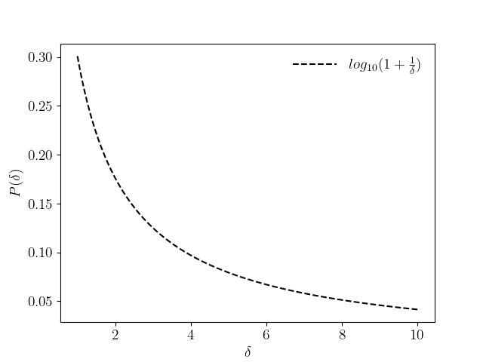

**Figure 1.** Graphic depicting Benford's law, with the initial values, δ on the x-axis and their related chance on the y-axis. In the picture above, P(δ) is constrained on the y-axes, while δ is constrained on the x-axes. The following ogives were created using the points shown in Table 1.

The aforementioned formulation works only for the occurrence of digit δ as the 1’st digit only, though another advanced formulation has been generated that tells us about the probability of occurrence of digit δ as the ζ’th digit. The phrase is written as follows:

$$π(δ) = \sum_{κ = {10}^{ζ-2}}^{{10}^{ζ-1}-1}{\log_{10}\left(1+\frac{1}{10κ+δ}\right)}$$

π(δ) = Probability of Occurrence of the digit δ as the ζ’th digit ∋∀ 0≤δ≤9 ∀ ζ>1

Generally speaking, Benford's law is as follows:

$$π(δ)=\left\{\begin{aligned}\log_{10}\left(1 + \frac{1}{δ}\right) ∋∀ 1≤δ≤9 and ζ=1 \\ \sum_{κ = {10}^{ζ-2}}^{{10}^{ζ-1}-1}{\log_{10}\left(1+\frac{1}{10κ+δ}\right) ∋∀ 0≤δ≤9}and ζ>1\end{aligned}\right.$$

In the late 1900s, Hal Varian, an analyst, advocated applying Benford's law to monitor for deceit in socioeconomic statistics [21], and this was accomplished. So why not? Benford's law grew to prominence for excellent purpose. After all, its operational scope was so extensive. Benford's law has applications in many different fields, including the following:

1. It is used to detect fraud by examining discrepancies in the election [22] dataset.
2. It is employed to look up pricing digits.
3. It is used to authenticate genetic sequences [23].
4. It is employed in order to inspect for mistakes in scientific publications [24].

4. A Scientific Mitigation

In this section, we would try to reach to a conclusion of the collapse following some well fledged scientific paradigms, especially, Benford’s Law. We have collected the Silicon Valley Bank Stock Value between 1987 and 2023. Now, to apply Benford’s Law in any dataset, we must perform some tests to confirm whether the collection is fit?. We have performed 3 tests on the collection, namely

1. *Mean Absolute Deviation Test*: The direct deviation from the origin. Suppose, we are having a dataset, $\left\{x_{1}, x_{2}, x_{3}, x_{4}, ..., x_{n}\right\}$. It’s Mean Absolute Deviation [25] is

$$\frac{1}{n}\sum_{i=1}^{n}{\left|x_{i}-\frac{1}{n}\left(\sum_{i=1}^{n}{x_{i}}\right)\right|}$$

To be appropriate for adopting Benford's law, a collection must meet the Mean Absolute Deviation requirement within a particular range. Table 2. Shows the conformity range [26] from a Paper by Mark. J. Nigrini

**Table 2.** First-digit conformity range

|  |  |
| --- | --- |
| **Conformity Range** | **First Digits** |
| Close Conformity | 0.000 - 0.006 |
| Acceptable Conformity | 0.006 - 0.012 |
| Marginal Conformity | 0.012 - 0.015 |
| Non-conformity | Above 0.015 |

1. *Mantissa Arc Test*: We may use this investigation to find the centroid of a set of mantissas that have wholly or partially distributed together around unit circle. The pivot point, or the average vector, is the vector that results if the mantissa of integers is spread evenly over the unit circle with central coordinates (0, 0).
2. $χ^{2}$*Test*: If there is a discrepancy in between conceptual stats and the actual data, it can be determined using Pearson's Chi-Squared test [27], a fitting experiment. Assuming that the null hypothesis is true as n approaches infinity, the $χ^{2}$ dispersion is as follows:

$$Z^{2}=\sum_{i=1}^{k}{\frac{{\left(z_{i}-m_{i}\right)}^{2}}{m_{i}}}= \sum_{i=1}^{k}{\left(\frac{{z_{i}}^{2}}{m_{i}}-n\right)}$$

$m_{i}= np_{i}$ $∀ i∈N_{n }$ where $p_{i}$ are the probabilities given by null hypothesis and $\sum_{i∈N_{n}}{p_{i}=1}$. If the pixels on the scatter diagram are roughly identical to zero, the "Difference" graph, or scatter plot, that represents the distinction in between Artificial Likelihood and also the The proposed equation's likelihood greatly conforms to the collection's legitimacy. Based on this scatter graph, we may examine the dataset's fairness by deciding if it contributes or diverts attention using our option of being able. The Mean Absolute Deviation analysis provides the most reliable method for determining the degree to which the data matches Benford's law. If the MAD test produces a score of "non-conformity" rather than "moderate conformity," the Chi-Square и Mantissa Arc tests serve to measure extra compliance.

* 1. *The SVB Stock Price Opening Value*

The Beginning Price refers to the price at which an asset is originally traded on a marketplace at the commencement of a transaction day. Table 3 shows a few instances of the Stock Opening Price between the time frame 1987 – 2023.

**Table 3.** Stock Opening Price for Silicon Valley Bank. The following segment have been sprapped from the whole dataset to make it easier to demonstrate.

|  |  |
| --- | --- |
| **Date** | **Stock Opening Price (USD)** |
| 26-10-1987 | 0.751429 |
| 27-10-1987 | 0.751429 |
| 28-10-1987 | 0 |
| 29-10-1987 | 0.751429 |
| 30-10-1987 | 0.751429 |
| 02-11-1987 | 0.722997 |
| 03-11-1987 | 0.722997 |
| 04-11-1987 | 0.701772 |
| 05-11-1987 | 0.701772 |
| 06-11-1987 | 0 |
| … | … |
| 03-03-2023 | 280.339996 |
| 06-03-2023 | 284.829987 |
| 07-03-2023 | 280.390015 |
| 08-03-2023 | 266.859985 |
| 09-03-2023 | 176.550003 |
| 10-03-2023 | 106.040001 |
| 13-03-2023 | 106.040001 |
| 14-03-2023 | 106.040001 |
| 15-03-2023 | 106.040001 |
| 16-03-2023 | 106.040001 |

The complete dataset is made available at <https://github.com/Anurag-Dutta/SVB/blob/main/open.csv>. Firstly, we have considered the first digit of the entries of Opening Stock Price Column. Table 4. shows the digit wise frequency of the same.

**Table 4.** Digit – wise frequency for 1’st Digit place for the Stock Opening Price.

|  |  |
| --- | --- |
| **Digit** | **Frequency** |
| 1 | 2031 |
| 2 | 2231 |
| 3 | 1152 |
| 4 | 1318 |
| 5 | 1032 |
| 6 | 375 |
| 7 | 183 |
| 8 | 196 |
| 9 | 268 |

Adding up all the entries of the Frequecny Column, we get,

$$\sum_{i=1}^{9}{f_{i}}=8786$$

Then, using the equation

$$P\left(i\right)=\frac{f_{i}}{\sum_{i=1}^{9}{f_{i}}}=\frac{f_{i}}{8786}$$

we estimated the artificial likelihood or, more accurately, the realistic likelihood and contrasted it to the mathematical likelihood by Benford’s Law. The theoretical probabilities have been demonstrated on the Table 1. Figure 2 contrasts the same.

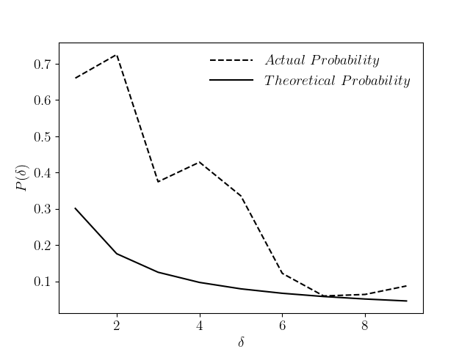

**Figure 2.** Contrast between Actual and Theoretical Probabilities taking into consideration, Opening Price of the Silicon Valley Bank Stocks

The mean squared error,

$$\sum_{i=1}^{9}{{\left(y_{i}-\hat{y_{i}}\right)}^{2}}$$

turns out to be 0.67412459, which is not in acceptable ranges.

Figure 3 shows the contrast of the same formulating the Zipf’s Law.

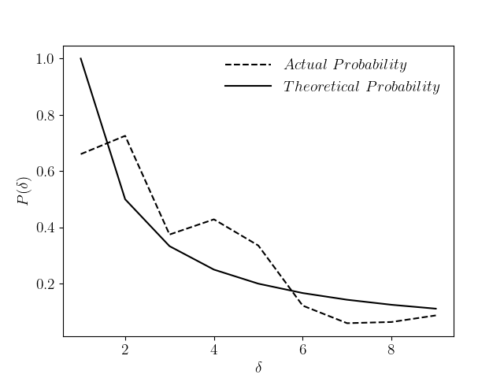

**Figure 3.** Contrast between Actual and Theoretical Probabilities taking into consideration, Daily Opening Price of the Silicon Valley Bank Stocks as per the Zipfian Distribution.

Here, the mean squared error turns out to be 0.025711589605446287, which is again a way behind than the permissible range.

* 1. *The SVB Stock Price Closing Value*

The final transaction price of a securities well before exchange formally shuts for regular trading is known as the closing price or cash value. Table 5 shows a few instances of the Stock Closing Price between the time frame 1987 – 2023.

**Table 5.** Stock Closing Price for Silicon Valley Bank

|  |  |
| --- | --- |
| **Date** | **Stock Opening Price (USD)** |
| 26-10-1987 | 0.751429 |
| 27-10-1987 | 0.751429 |
| 28-10-1987 | 0 |
| 29-10-1987 | 0.751429 |
| 30-10-1987 | 0.751429 |
| 02-11-1987 | 0.722997 |
| 03-11-1987 | 0.722997 |
| 04-11-1987 | 0.701772 |
| 05-11-1987 | 0.701772 |
| 06-11-1987 | 0 |
| … | … |
| 03-03-2023 | 284.410004 |
| 06-03-2023 | 283.040009 |
| 07-03-2023 | 267.390015 |
| 08-03-2023 | 267.829987 |
| 09-03-2023 | 106.040001 |
| 10-03-2023 | 106.040001 |
| 13-03-2023 | 106.040001 |
| 14-03-2023 | 106.040001 |
| 15-03-2023 | 106.040001 |
| 16-03-2023 | 106.040001 |

The complete dataset is made available at <https://github.com/Anurag-Dutta/SVB/blob/main/close.csv>. Firstly, we have considered the first digit of the entries of Closing Stock Price Column. Table 6. shows the digit wise frequency of the same.

**Table 6.** Digit – wise frequency for 1’st Digit place for the Stock Closing Price.

|  |  |
| --- | --- |
| **Digit** | **Frequency** |
| 1 | 2022 |
| 2 | 2226 |
| 3 | 1157 |
| 4 | 1337 |
| 5 | 1010 |
| 6 | 392 |
| 7 | 179 |
| 8 | 194 |
| 9 | 269 |

Adding up all the entries of the Frequency Column, we get,

$$\sum_{i=1}^{9}{f_{i}}=8786$$

Then, using the equation

$$P\left(i\right)=\frac{f_{i}}{\sum_{i=1}^{9}{f_{i}}}=\frac{f_{i}}{8786}$$

we estimated the artificial likelihood or, more accurately, the realistic likelihood and contrasted it to the mathematical likelihood by Benford’s Law. The theoretical probabilities have been demonstrated on the Table 1. Figure 4 contrasts the same.

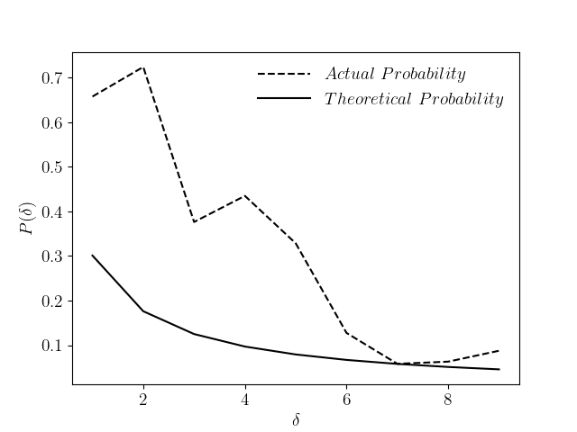

**Figure 4.** Contrast between Actual and Theoretical Probabilities taking into consideration, Closing Price of the Silicon Valley Bank Stocks

The mean squared error,

$$\sum_{i=1}^{9}{{\left(y_{i}-\hat{y_{i}}\right)}^{2}}$$

turns out to be 0.672226388, which is not in acceptable ranges.

Figure 5 shows the contrast of the same formulating the Zipf’s Law.

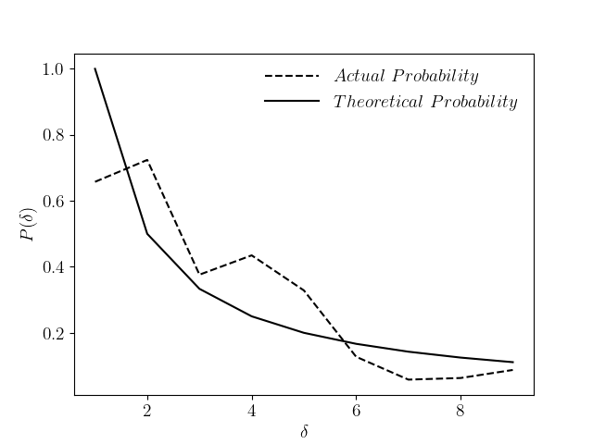

**Figure 5.** Contrast between Actual and Theoretical Probabilities taking into consideration, Daily Closing Price of the Silicon Valley Bank Stocks as per the Zipfian Distribution.

Here, the mean squared error turns out to be 0.025886887426978263, which is again a way behind than the permissible range.

* 1. *The SVB Stock Price Highest Value*

Table 7 shows a few instances of the Stock Highest Price between the time frame 1987 – 2023.

**Table 7.** Stock Highest Price for Silicon Valley Bank

|  |  |
| --- | --- |
| **Date** | **Stock Opening Price (USD)** |
| 26-10-1987 | 0.84353 |
| 27-10-1987 | 0.84353 |
| 28-10-1987 | 0 |
| 29-10-1987 | 0.84353 |
| 30-10-1987 | 0.84353 |
| 02-11-1987 | 0.772647 |
| 03-11-1987 | 0.772647 |
| 04-11-1987 | 0.751429 |
| 05-11-1987 | 0.751429 |
| 06-11-1987 | 0 |
| … | … |
| 03-03-2023 | 285.5 |
| 06-03-2023 | 286.519989 |
| 07-03-2023 | 283.079987 |
| 08-03-2023 | 271.01001 |
| 09-03-2023 | 177.749893 |
| 10-03-2023 | 106.040001 |
| 13-03-2023 | 106.040001 |
| 14-03-2023 | 106.040001 |
| 15-03-2023 | 106.040001 |
| 16-03-2023 | 106.040001 |

The complete dataset is made available at <https://github.com/Anurag-Dutta/SVB/blob/main/high.csv>. Firstly, we have considered the first digit of the entries of Highest Stock Price Column. Table 8. shows the digit wise frequency of the same.

**Table 6.** Digit – wise frequency for 1’st Digit place for the Stock Highest Price.

|  |  |
| --- | --- |
| **Digit** | **Frequency** |
| 1 | 2013 |
| 2 | 2202 |
| 3 | 1188 |
| 4 | 1296 |
| 5 | 1052 |
| 6 | 415 |
| 7 | 191 |
| 8 | 182 |
| 9 | 247 |

Adding up all the entries of the Frequecny Column, we get,

$$\sum_{i=1}^{9}{f_{i}}=8786$$

Then, using the equation

$$P\left(i\right)=\frac{f_{i}}{\sum_{i=1}^{9}{f_{i}}}=\frac{f_{i}}{8786}$$

we estimated the artificial likelihood or, more accurately, the realistic likelihood and contrasted it to the mathematical likelihood by Benford’s Law. The theoretical probabilities have been demonstrated on the Table 1. Figure 6 contrasts the same.

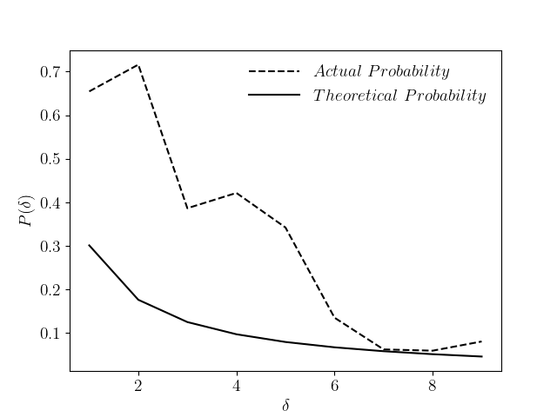

**Figure 6.** Contrast between Actual and Theoretical Probabilities taking into consideration, Highest Price of the Silicon Valley Bank Stock.

The mean squared error,

$$\sum_{i=1}^{9}{{\left(y_{i}-\hat{y_{i}}\right)}^{2}}$$

turns out to be 0.665344714, which is not in acceptable ranges.

Figure 7 shows the contrast of the same formulating the Zipf’s Law.

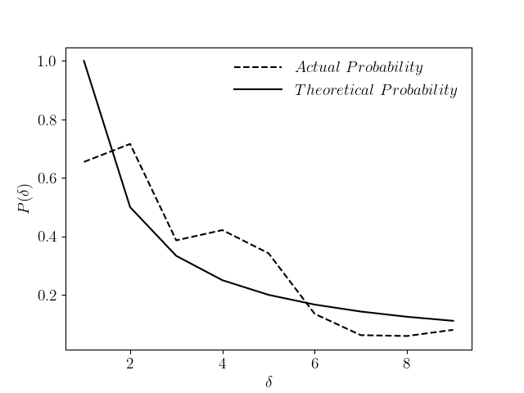

**Figure 7.** Contrast between Actual and Theoretical Probabilities taking into consideration, Daily Highest Price of the Silicon Valley Bank Stocks as per the Zipfian Distribution.

Here, the mean squared error turns out to be 0.025687288189744303, which is again a way behind than the permissible range.

1. Conclusion

The Silicon Valley Bank has now collapsed [28]. The stock price analysis by making use of Benford’s Law shows a clear deviation from the natural trend. Though, it won’t be justified to blame any of the authorities without evident records, still the results from this study, can be subjected as a motivation to carry on more investigations by the concerned authorities towards the unnatural perturbations in the Stock Price, and deviation from the Likelihood Plot as suggested by the Law of Benford. For each of the Opening, Closing and Highest Price of Stocks, the mean squred error is more than 0.5, which is not a healthy corformality. Further, comparison is laid with the Zipfian Distribution, which when addressed was again showing deviation beyond range of healthy conformality.

The authors suggest future work on the topic to obtain a more definitive conclusions using any additional indicators that may be far enough in the future to eliminate out the risk. Additional statistical laws, such as Pareto’s Law, Weber's Law, and so on, could be incorporated into the framework as a future effort.

**References**

1. M. J. Müller, B. Landsberg, and J. Ried, “Fraud in science: a plea for a new culture in research,” *European Journal of Clinical Nutrition*, vol. 68, no. 4, pp. 411–415, Apr. 2014, doi: https://doi.org/10.1038/ejcn.2014.17.
2. N. Koepke and J. Baten, “The biological standard of living in Europe during the last two millennia,” *European Review of Economic History*, vol. 9, no. 1, pp. 61–95, Apr. 2005, doi: https://doi.org/10.1017/s1361491604001388.
3. E. Annus, “The Problem of Soviet Colonialism in the Baltics,” *Journal of Baltic Studies*, vol. 43, no. 1, pp. 21–45, Mar. 2012, doi: https://doi.org/10.1080/01629778.2011.628551.
4. H. R. Varian, “Microeconomics,” *The New Palgrave Dictionary of Economics*, pp. 1–5, 1987, doi: https://doi.org/10.1057/978-1-349-95121-5_1212-1.
5. R. M. Ryan and E. L. Deci, “On Happiness and Human potentials: a Review of Research on Hedonic and Eudaimonic well-being,” *Annual review of psychology*, vol. 52, no. 1, pp. 141–66, 2001, doi: https://doi.org/10.1146/annurev.psych.52.1.141.
6. C. Dahlström and V. Lapuente, “Comparative Bureaucratic Politics,” *Annual Review of Political Science*, vol. 25, no. 1, Feb. 2022, doi: https://doi.org/10.1146/annurev-polisci-051120-102543.
7. Z. Cai, M. Faust, A. J. Hildebrand, J. Li, and Y. Zhang, “The Surprising Accuracy of Benford’s Law in Mathematics,” *The American Mathematical Monthly*, vol. 127, no. 3, pp. 217–237, Feb. 2020, doi: https://doi.org/10.1080/00029890.2020.1690387.
8. S. Dehaene, V. Izard, E. Spelke, and P. Pica, “Log or Linear? Distinct Intuitions of the Number Scale in Western and Amazonian Indigene Cultures,” *Science*, vol. 320, no. 5880, pp. 1217–1220, May 2008, doi: https://doi.org/10.1126/science.1156540.
9. M. J. Nigrini, *Benford’s law : applications for forensic accounting, auditing, and fraud detection*. Hoboken, New Jersey: Wiley, 2012.
10. A. Berger and T. P. Hill, “The mathematics of Benford’s law: a primer,” *Statistical Methods & Applications*, Jun. 2020, doi: https://doi.org/10.1007/s10260-020-00532-8.
11. T. P. Hill, “A Statistical Derivation of the Significant-Digit Law,” *Statistical Science*, vol. 10, no. 4, pp. 354–363, Nov. 1995, doi: https://doi.org/10.1214/ss/1177009869.
12. I. Mbona and J. H. P. Eloff, “Feature selection using Benford’s law to support detection of malicious social media bots,” *Information Sciences*, vol. 582, pp. 369–381, Jan. 2022, doi: https://doi.org/10.1016/j.ins.2021.09.038.
13. A. Tošić and J. Vičič, “Use of Benford’s law on academic publishing networks,” *Journal of Informetrics*, vol. 15, no. 3, p. 101163, Aug. 2021, doi: https://doi.org/10.1016/j.joi.2021.101163.
14. H. Chen, “The Success of Cisco Systems, Inc.’s Human Resource Management Strategy,” *Journal of Service Science and Management*, vol. 10, no. 03, pp. 206–215, 2017, doi: https://doi.org/10.4236/jssm.2017.103018.
15. “Bay Networks, Inc. - 1998 ( Now Nortel ),” *Scripophily.com | Collect Stocks and Bonds | Old Stock Certificates for Sale | Old Stock Research | RM Smythe |*. https://scripophily.net/bay-networks-inc-1998-now-nortel/ (accessed Mar. 31, 2023).
16. X. Yang and X. Yu, “Preventing Patent Risks in Artificial Intelligence Industry for Sustainable Development: A Multi-Level Network Analysis,” *Sustainability*, vol. 12, no. 20, p. 8667, Oct. 2020, doi: https://doi.org/10.3390/su12208667.
17. L. Puente and L. Wilson, “Racial Discrimination in TARP Investments,” *SSRN Electronic Journal*, 2013, doi: https://doi.org/10.2139/ssrn.2247043.
18. F. Li, “Internal Control of Commercial Banks—Based on Case Study of Shanghai Pudong Development Bank,” *Modern Economy*, vol. 11, no. 02, pp. 230–238, 2020, doi: https://doi.org/10.4236/me.2020.112020.
19. M. J. Maura-Pérez and H. Romero-Perez, “Factors related to the failure of FDIC-insured US banks,” *Journal of Financial Regulation and Compliance*, vol. ahead-of-print, no. ahead-of-print, Aug. 2021, doi: https://doi.org/10.1108/jfrc-08-2020-0075.
20. ‌S. Newcomb, “Note on the Frequency of Use of the Different Digits in Natural Numbers,” *American Journal of Mathematics*, vol. 4, no. 1/4, p. 39, 1881, doi: https://doi.org/10.2307/2369148.
21. J. Michael. Oakes and P. H. Rossi, “The measurement of SES in health research: current practice and steps toward a new approach,” *Social Science & Medicine*, vol. 56, no. 4, pp. 769–784, Feb. 2003, doi: https://doi.org/10.1016/s0277-9536(02)00073-4.
22. M. Moore and T. Colley, “Two International Propaganda Models: Comparing RT and CGTN’s 2020 US Election Coverage,” *Journalism Practice*, pp. 1–23, Jun. 2022, doi: https://doi.org/10.1080/17512786.2022.2086157.
23. R. S. Waples, “Guidelines for genetic data analysis,” *J. Cetacean Res. Manage*., vol. 18, no. 1, pp. 33–80, Jan. 2023, doi: https://doi.org/10.47536/jcrm.v18i1.421.
24. C. Salemi, M. T. Canola, and E. K. Eck, “Hand Washing and Physicians: How to Get Them Together,” *Infection Control & Hospital Epidemiology*, vol. 23, no. 1, pp. 32–35, Jan. 2002, doi: https://doi.org/10.1086/501965.
25. S. Yitzhaki and P. J. Lambert, “The Relationship between the Gini and the Mean Absolute Deviation,” *SSRN Electronic Journal*, 2011, doi: https://doi.org/10.2139/ssrn.1945705.
26. D. K. Campbell-Meiklejohn et al., “Structure of orbitofrontal cortex predicts social influence,” *Current Biology*, vol. 22, no. 4, pp. R123–R124, Feb. 2012, doi: https://doi.org/10.1016/j.cub.2012.01.012.
27. W. Cash, “Parameter estimation in astronomy through application of the likelihood ratio,” *The Astrophysical Journal*, vol. 228, p. 939, Mar. 1979, doi: https://doi.org/10.1086/156922.
28. ‌M. Ferrary and M. Granovetter, “The role of venture capital firms in Silicon Valley’s complex innovation network,” *Economy and Society*, vol. 38, no. 2, pp. 326–359, May 2009, doi: https://doi.org/10.1080/03085140902786827.