**RESEARCH PROJECT**

Exploring Cases of Suicides in Germany and Brazil.

**Anurag Dutta**1, **Manan Roy Choudhury**1’  and Seemantini Chattopadhyay2

# Abstract

**Background:** Suicide, the act of self-hurting or killing intentionally is in great spurt these days. It is the result of mental disorders resulting from depression, anxiety, or stress.

**Methods:** In this study, we have analyzed the dataset of suicide cases for one developing country - “Brazil”, and one developed country - “Germany”, and have used Statistical Methods, along with Machine Learning techniques to obtain a clear idea.

**Results:** We discovered that the Suicide Rate in Brazil is quite high in comparison to the Suicide Rate in Germany.

**Conclusions:** Our results provide a shred of evidence that the development status of the country, along with some more factors, like Per - Capita Income, Employment, Literacy, etc. in some way or the other affects the suicide rate of a country.

**Keywords:** Suicide, Machine Learning, Statistics.

# 1 Introduction

Suicide is defined as a fatal self-injurious act with some evidence of intent to die (.). Worldwide, more than 800,000 people die due to suicide each year. The suicide mortality rate in 2015 was 10.7 per 100,000, which means about one death every 20 s. Suicide accounts for 1.4% of all deaths and is the 15th leading cause of death globally (., .). Many more men than women die by suicide. The male-to-female ratio varies between 4 to 1 (Europe and Americas) and 1.5 to 1 (Eastern Mediterranean and Western Pacific region) and is highest in richer countries (.). These suicide figures are probably still an underestimation of the real cases. Registering a suicide is a complicated process, often involving judicial authorities. Suicide deaths may not be recognized or maybe misclassified as an accident or another cause of death. Sometimes suicide is not acknowledged or reported, due to its sensitive nature and the taboo that still surrounds it (.). Suicide attempts, i.e., non-fatal suicidal behavior, are much more frequent and are estimated to be about 10–20 times more frequent than actual suicide. The estimated global annual prevalence of self-reported suicide attempts is approximately 3 per 1,000 adults.



**Fig. 1** About 2.5% of the population makes at least one suicide attempt during their lifetime (., .).

Suicide rates vary substantially between regions. About 80% of all suicides occur in low and middle-income countries (.). Suicide mortality rates vary from 15.6 per 100,000 inhabitants in South-East Asia to 5.6 per 100,000 in the Eastern Mediterranean region. Europe has an average suicide mortality rate of 14.1 per 100,000, way above the global average of 10.7 per 100,000. There is wide variation between the European countries, from about 3.3 per 100,000 in Azerbaijan to tenfold that figure, 32.7 per 100,000, in Lithuania.

Suicide affects all age groups in the population, but worldwide, rates rise with increasing age. In almost all regions in the world, the highest rates are found among the oldest people aged 80+ (60.1 per 100,000 men and 27.8 per 100,000 women), 70–79 years (42.2 and 18.7 respectively), and 60–69 years (28.2 and 12.4 respectively). In younger people, these figures are much

lower: 15.3 and 11.2 per 100,000 males and females aged between 15–29 years and 0.9 and 1.0 per 100,000 for the age category of 5–14 years. In comparison, suicide is not even in the top ten most frequent causes of death in the older age groups. These facts, together with the finding that overall, these figures have not tended to decline clearly and steadily over recent decades, have caused growing concern among scientists and policymakers.

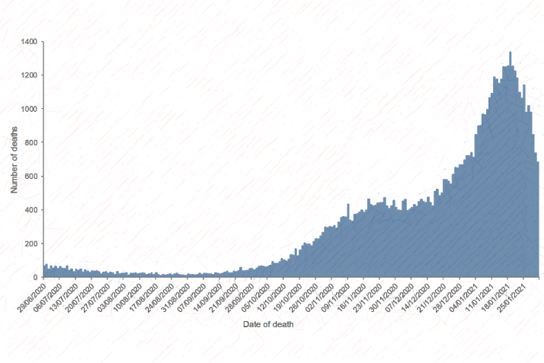

**Fig. 2** Number of Deaths in England (confirmed by <https://www.gov.uk/>) in the last year.

# 2 Brazil

Brazil is the largest country in both South America and Latin America. At 8.5 million square kilometers (3,300,000 sq. mi) and with over 211 million people, Brazil is the world's fifth-largest country by area and the sixth-most populous. Its capital is Brasília, and its most populous city is São Paulo. The federation is composed of the union of the 26 states and the Federal District. It is the largest country to have Portuguese (namely Brazilian Portuguese) as an official language and the only one in the Americas. It is also one of the most multicultural and ethnically diverse nations, due to over a century of mass immigration from around the world as well as the most populous Roman Catholic-majority country. Bounded by the Atlantic Ocean on the east, Brazil has a coastline of 7,491 kilometers (4,655 mi). It borders all other countries in South America except Ecuador and Chile and covers 47.3% of the continent's land area. Its Amazon basin includes a vast tropical forest, home to diverse wildlife, a variety of ecological systems, and extensive natural resources spanning numerous protected habitats. This unique environmental heritage makes Brazil one of 17 megadiverse countries, and is the subject of significant global interest, as environmental degradation through processes like deforestation has direct impacts on global issues like climate change and biodiversity loss.

Brazil was inhabited by numerous tribal nations before the landing in 1500 of explorer Pedro Álvares Cabral, who claimed the area for the Portuguese Empire. Brazil remained a Portuguese colony until 1808 when the capital of the empire was transferred from Lisbon to Rio de Janeiro. In 1815, the colony was elevated to the rank of kingdom upon the formation of the United Kingdom of Portugal, Brazil, and the Algarves. Independence was achieved in 1822 with the creation of the Empire of Brazil, a unitary state governed under a constitutional monarchy and a parliamentary system. The ratification of the first constitution in 1824 led to the formation of a bicameral legislature, now called the National Congress. The country became a presidential republic in 1889 following a military coup d'état. An authoritarian military junta came to power in 1964 and ruled until 1985, after which civilian governance resumed. Brazil's current constitution, formulated in 1988, defines it as a democratic federal republic. Due to its rich culture and history, the country ranks thirteenth in the world by several UNESCO World Heritage Sites.

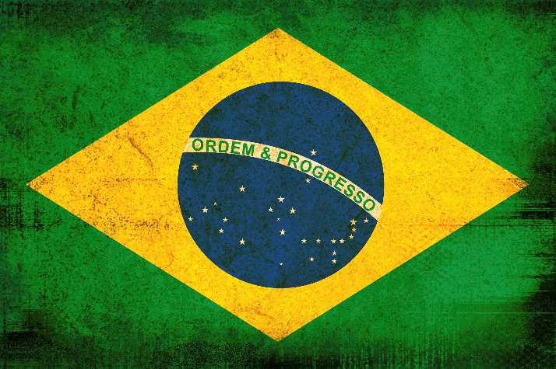

**Fig. 3** Brazilian National Flag

Brazil is a regional and middle power, and an emerging power. Brazil is classified as an upper-middle-income economy by the World Bank and a newly industrialized country, with the largest share of global wealth in South America. It is considered an advanced emerging economy, having the twelfth largest GDP in the world by nominal, and eighth by PPP measures. It is one of the world's major breadbaskets, being the largest producer of coffee for the last 150 years. However, the country maintains high amounts of corruption, crime, and social inequality. Brazil is a founding member of the United Nations, the G20, BRICS, Mercosul, Organization of American States, Organization of Ibero-American States, and the Community of Portuguese Language Countries.

# 3 Germany

Germany is a country in Central Europe. It is the second-most populous country in Europe after Russia and the most populous member state of the European Union. Germany is situated between the Baltic and North seas to the north, and the Alps to the south; it covers an area of 357,022 square kilometers (137,847 sq. mi), with a population of over 83 million within its 16 constituent states. Germany borders Denmark to the north, Poland and the Czech Republic to the east, Austria and Switzerland to the south, and France, Luxembourg, Belgium, and the Netherlands to the west. The nation's capital and largest city are Berlin, and its financial center in Frankfurt; the largest urban area is the Ruhr.

Various Germanic tribes have inhabited the northern parts of modern Germany since classical antiquity. A region named Germania was documented before AD 100. In the 10th century, German territories formed a central part of the Holy Roman Empire. During the 16th century, northern German regions became the center of the Protestant Reformation. Following the Napoleonic Wars and the dissolution of the Holy Roman Empire in 1806, the German Confederation was formed in 1815. In 1871, Germany became a nation-state when most of the German states unified into the Prussian-dominated German Empire. After World War I and the German Revolution of 1918–1919, the Empire was replaced by the semi-presidential Weimar Republic. The Nazi seizure of power in 1933 led to the establishment of a dictatorship, World War II, and the Holocaust. After the end of World War II in Europe and a period of Allied occupation, Germany was divided into the Federal Republic of Germany, generally known as West Germany, and the German Democratic Republic, East Germany. The Federal Republic of Germany was a founding member of the European Economic Community and the European Union, while the German Democratic Republic was a communist Eastern Bloc state and member of the Warsaw Pact. After the fall of communism, German reunification saw the former East German states join the Federal Republic of Germany on 3 October 1990 - becoming a federal parliamentary republic.

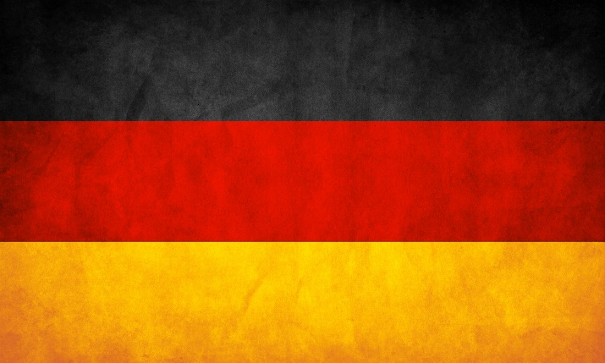

**Fig. 4** German National Flag

Germany is a great power with a strong economy; it has the largest economy in Europe, the world's fourth-largest economy by nominal GDP, and the fifth-largest by PPP. As a global leader in several industrial, scientific and technological sectors, it is both the world's third-largest exporter and importer of goods. As a developed country, which ranks very high on the Human Development Index, it offers social security and a universal health care system, environmental protection, and tuition-free university education. Germany is a member of the United Nations, NATO, the G7, the G20, and the OECD. It has the third-greatest number of UNESCO World Heritage Sites.

# 4 Statistical Analysis

In this section, we will perform a statistical analysis of the suicide cases in both Brazil, which is under development status and Germany, which has surpassed the threshold of its development.

Firstly, we will be looking into the statistics of Brazil for a time window of 26 years (1990 - 2015).

# 

# 4.1 Analytics of Brazil

Given below is the tabular representation of the number of suicides, accounting for different age groups in the developing

country of Brazil.

**Table. 1** Tabular representation of the number of deaths in Brazil from 1990 to 2015

|  |  |  |  |  |  |  |  |  |  |  |  |  |
| --- | --- | --- | --- | --- | --- | --- | --- | --- | --- | --- | --- | --- |
| *Year* | *F (15-24)* | *F (25-34)* | *F (35-54)* | *F (5-14)* | *F (55-74)* | *F (75+)* | *M (15-24)* | *M (25-34)* | *M (35-54)* | *M (5-14)* | *M (55-74)* | *M(75+)* |
| 1990 | 304 | 250 | 394 | 32 | 196 | 38 | 731 | 945 | 1127 | 34 | 601 | 151 |
| 1991 | 303 | 266 | 331 | 35 | 222 | 38 | 771 | 1002 | 1334 | 41 | 660 | 153 |
| 1992 | 283 | 262 | 391 | 36 | 166 | 36 | 861 | 981 | 1408 | 39 | 643 | 146 |
| 1993 | 334 | 261 | 346 | 31 | 182 | 33 | 917 | 1183 | 1374 | 51 | 628 | 168 |
| 1994 | 372 | 291 | 369 | 46 | 174 | 39 | 988 | 1228 | 1436 | 48 | 725 | 180 |
| 1995 | 347 | 318 | 450 | 36 | 208 | 42 | 1084 | 1318 | 1703 | 38 | 812 | 180 |
| 1996 | 347 | 299 | 448 | 50 | 202 | 52 | 1164 | 1265 | 1827 | 70 | 798 | 176 |
| 1997 | 327 | 282 | 507 | 55 | 202 | 44 | 1102 | 1349 | 1856 | 53 | 895 | 219 |
| 1998 | 364 | 324 | 458 | 47 | 197 | 55 | 1089 | 1288 | 1902 | 50 | 931 | 217 |
| 1999 | 281 | 259 | 426 | 37 | 188 | 35 | 1103 | 1199 | 1897 | 50 | 818 | 214 |
| 2000 | 345 | 271 | 456 | 43 | 220 | 45 | 1037 | 1200 | 1989 | 42 | 900 | 215 |
| 2001 | 393 | 286 | 578 | 53 | 206 | 41 | 1262 | 1398 | 2227 | 58 | 964 | 244 |
| 2002 | 411 | 334 | 607 | 55 | 225 | 62 | 1226 | 1388 | 2178 | 55 | 937 | 219 |
| 2003 | 413 | 325 | 559 | 45 | 212 | 51 | 1259 | 1394 | 2299 | 60 | 1002 | 220 |
| 2004 | 403 | 347 | 606 | 59 | 237 | 51 | 1275 | 1475 | 2230 | 48 | 994 | 270 |
| 2005 | 405 | 369 | 664 | 54 | 259 | 53 | 1247 | 1464 | 2490 | 52 | 1175 | 297 |
| 2006 | 387 | 333 | 708 | 61 | 265 | 47 | 1293 | 1537 | 2536 | 64 | 1112 | 275 |
| 2007 | 379 | 392 | 723 | 51 | 275 | 51 | 1267 | 1609 | 2516 | 67 | 1220 | 305 |
| 2008 | 398 | 365 | 745 | 49 | 309 | 52 | 1375 | 1706 | 2608 | 55 | 1204 | 318 |
| 2009 | 343 | 351 | 768 | 52 | 301 | 58 | 1270 | 1838 | 2737 | 62 | 1271 | 295 |
| 2010 | 368 | 404 | 835 | 48 | 339 | 79 | 1288 | 1832 | 2586 | 56 | 1236 | 358 |
| 2011 | 413 | 400 | 805 | 47 | 352 | 71 | 1335 | 1907 | 2754 | 63 | 1323 | 352 |
| 2012 | 383 | 455 | 877 | 41 | 418 | 80 | 1313 | 1930 | 2885 | 79 | 1458 | 376 |
| 2013 | 362 | 393 | 897 | 50 | 433 | 88 | 1317 | 2004 | 3053 | 72 | 1474 | 370 |
| 2014 | 371 | 457 | 871 | 62 | 389 | 83 | 1358 | 1982 | 3050 | 84 | 1534 | 390 |
| 2015 | 397 | 466 | 910 | 56 | 479 | 89 | 1389 | 1897 | 3238 | 79 | 1693 | 470 |
|  |  |  |  |  |  |  |  |  |  |  |  |  |

If we consider the analytics for females, the rate has been quite low in comparison to the males.

Given below is the scatter plot diagram for the death counts for females during the time 2006 - 2015.

**Fig. 5** **Death counts for Females in Brazil**

An incremental bar plot analytics for the statistics mentioned above can be accessed from here.

For males, the scatter plot diagram is somewhat like this, with data in each entry being much higher than that of the females.

**Fig. 6** **Death counts for Males in Brazil**

The only similarity between both the genders is that the rate of suicides for the age group 35 - 54 is highest throughout the time window, and is lowest for the age group 5 -14. There exists a nearly constant ratio $φ$ in the death count for males and females.

Mathematically,

$${\left.\frac{δ_{Males}}{δ_{Females}}\right|}_{γ}=φ_{γ},1≤φ_{γ}≤5 ∀ 2006≤γ≤2015 ...(i)$$

where, $γ$ is the respective year.

# 4.2 Analytics of Germany

Given below is the tabular representation of the number of suicides, accounting for different age groups in the developed

country of Germany.

**Table. 2** Tabular representation of the number of deaths in Germany from 1990 to 2015

|  |  |  |  |  |  |  |  |  |  |  |  |  |  |  |  |  |  |
| --- | --- | --- | --- | --- | --- | --- | --- | --- | --- | --- | --- | --- | --- | --- | --- | --- | --- |
| *Year* | *F (15-24)* | *F (25-34)* | *F (35-54)* | *F (5-14)* | *F (55-74)* | *F (75+)* | *M (15-24)* | *M (25-34)* | | *M (35-54)* | | *M (5-14)* | | *M (55-74)* | | *M(75+)* | |
| 1990 | 228 | 434 | 1128 | 9 | 1417 | 1174 | 800 | 1488 | | 3302 | | 22 | | 2406 | | 1516 | |
| 1991 | 185 | 411 | 1200 | 5 | 1400 | 1153 | 775 | 1523 | | 3427 | | 27 | | 2445 | | 1459 | |
| 1992 | 163 | 384 | 1093 | 12 | 1375 | 1105 | 674 | 1576 | | 3250 | | 26 | | 2405 | | 1395 | |
| 1993 | 157 | 371 | 1009 | 13 | 1296 | 884 | 632 | 1467 | | 3033 | | 47 | | 2485 | | 1296 | |
| 1994 | 170 | 350 | 971 | 17 | 1261 | 819 | 682 | 1541 | | 3154 | | 30 | | 2527 | | 1196 | |
| 1995 | 176 | 343 | 983 | 14 | 1266 | 884 | 630 | 1452 | | 3251 | | 38 | | 2597 | | 1254 | |
| 1996 | 157 | 351 | 937 | 13 | 1249 | 790 | 589 | 1441 | | 3021 | | 36 | | 2463 | | 1176 | |
| 1997 | 142 | 363 | 931 | 8 | 1175 | 802 | 600 | 1345 | | 3177 | | 28 | | 2550 | | 1135 | |
| 1998 | 155 | 298 | 855 | 16 | 1048 | 701 | 589 | 1251 | | 3039 | | 34 | | 2542 | | 1126 | |
| 1999 | 133 | 265 | 877 | 9 | 1045 | 749 | 595 | 1132 | | 2863 | | 26 | | 2421 | | 1045 | |
| 2000 | 137 | 240 | 834 | 8 | 1020 | 698 | 575 | 1002 | | 2937 | | 25 | | 2528 | | 1069 | |
| 2001 | 124 | 221 | 868 | 11 | 983 | 764 | 593 | 985 | | 3060 | | 37 | | 2415 | | 1106 | |
| 2002 | 141 | 219 | 905 | 8 | 1013 | 773 | 609 | 903 | | 3088 | | 16 | | 2354 | | 1147 | |
| 2003 | 155 | 225 | 887 | 6 | 925 | 775 | 537 | 868 | | 3157 | | 17 | | 2416 | | 1187 | |
| 2004 | 129 | 180 | 827 | 7 | 906 | 746 | 518 | 820 | | 3001 | | 16 | | 2413 | | 1178 | |
| 2005 | 117 | 171 | 840 | 8 | 939 | 664 | 479 | 730 | | 2875 | | 18 | | 2269 | | 1160 | |
| 2006 | 112 | 154 | 832 | 9 | 826 | 611 | 455 | 629 | | 2653 | | 20 | | 2314 | | 1160 | |
| 2007 | 110 | 145 | 742 | 9 | 796 | 595 | 448 | 654 | | 2539 | | 15 | | 2213 | | 1143 | |
| 2008 | 130 | 157 | 761 | 6 | 768 | 592 | 456 | 632 | | 2598 | | 11 | | 2199 | | 1149 | |
| 2009 | 121 | 146 | 788 | 9 | 789 | 520 | 443 | 637 | | 2628 | | 12 | | 2277 | | 1209 | |
| 2010 | 132 | 177 | 805 | 6 | 851 | 588 | 474 | 735 | | 2605 | | 22 | | 2358 | | 1277 | |
| 2011 | 122 | 188 | 757 | 9 | 802 | 624 | 461 | 684 | | 2582 | | 12 | | 2538 | | 1374 | |
| 2012 | 121 | 187 | 810 | 9 | 873 | 607 | 439 | 699 | | 2408 | | 11 | | 2302 | | 1430 | |
| 2013 | 111 | 188 | 808 | 12 | 875 | 641 | 391 | 739 | | 2423 | | 6 | | 2379 | | 1518 | |
| 2014 | 121 | 182 | 801 | 8 | 855 | 621 | 397 | 750 | | 2444 | | 20 | | 2420 | | 1608 | |
| 2015 | 136 | 193 | 800 | 13 | 908 | 635 | 376 | 721 | | 2267 | | 6 | | 2304 | | 1729 | |
|  |  |  |  |  |  |  |  |  |  | |  | |  | |  | |

If we consider the analytics for females, the rate has been quite low in comparison to the males.

Given below is the scatter plot diagram for the death counts for females during the time 2006 - 2015.

**Fig. 7** **Death counts for Females in Germany**

For males, the scatter plot diagram is somewhat like this, with data in each entry being much higher than that of the females.

**Fig. 8** **Death counts for Males in Germany**

The only similarity between both the genders is that the rate of suicides for the age group 35 - 74 is highest throughout the time window, and is lowest for the age group 5 -14. There exists a nearly constant ratio $φ$ in the death count for males and females.

Mathematically,

where, is the respective year.