**RESEARCH PROJECT**

Is the Knight puff worth it?

**Anurag Dutta**1, and **Manan Roy Choudhury**1’

# **Abstract**

**Background:** Chess is a 2 - dimensional board game, which in its general form is played between 2 players.

**Methods:** The Game consists of a board of 64 squares, 16 black pieces, and 16 white pieces. The White is allowed to play the first move. Amongst 16 pieces of each player, there are 6 suites, namely

* 8 Pawns
* 2 Bishops
* 2 Knights
* 2 Rooks
* 1 Queen
* 1 King

The relative values of pieces are

* 1 for Pawns
* 3 for Bishops and Knights
* 5 for Rooks
* 9 for Queen
* $∞$ for King

**Results:** We have found that the relative value of the Bishop is greater than that of the Knight with Mathematical Rigour.

**Conclusions:** Our justifications provide a concrete aptness of the result and we have proved that the relative value of Bishop is $\frac{5}{3}$ times the relative value of Knight.

**Keywords:** Probability, Chess, Bishop, Knight

# **1 Introduction**

Chess is a board game played between two players. It is sometimes called Western chess or international chess to distinguish it from related games such as xiangqi and shogi. The current form of the game emerged in Southern Europe during the second half of the 15th century after evolving from chaturanga, a similar but much older game of Indian origin. Today, chess is one of the world's most popular games, played by millions of people worldwide.

Chess is an abstract strategy game and involves no hidden information. It is played on a square chessboard with 64 squares arranged in an eight-by-eight grid. At

the start, each player (one controlling the white pieces, the other controlling the black pieces) controls sixteen pieces: one king, one queen, two rooks, two bishops, two knights, and eight pawns. The object of the game is to checkmate the opponent's king, whereby the king is under immediate attack (in "check") and there is no way for it to escape. There are also several ways a game can end in a draw.

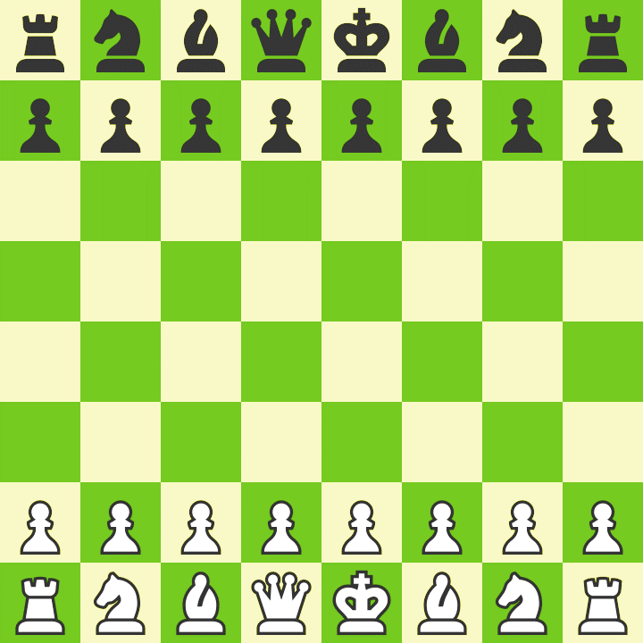

**Fig. 1** A typical chessboard

Organized chess arose in the 19th century. Chess competition today is governed internationally by FIDE (International Chess Federation). The first universally recognized World Chess Champion, Wilhelm Steinitz, claimed his title in 1886; Magnus Carlsen is the current World Champion. A huge body of chess theory has developed since the game's inception. Aspects of art are found in chess composition, and chess in its turn influenced Western culture and art and has connections with other fields such as mathematics, computer science, and psychology.

One of the goals of early computer scientists was to create a chess-playing machine. In 1997, Deep Blue became the first computer to beat the reigning World Champion in a match when it defeated Garry Kasparov. Today's chess engines are significantly stronger than the best human players and have deeply influenced the development of chess theory.

# **2 History**

The earliest texts referring to the origins of chess date from the beginning of the 7th century. Three are written in Pahlavi (Middle Persian)[1] and one, the Harshacharita, is in Sanskrit[2]. One of these texts, the Chatrang-namak, represents one of the earliest written accounts of chess. The narrator Bozorgmehr explains that Chatrang, the Pahlavi word for chess, was introduced to Persia by 'Dewasarm, a great ruler of India' during the reign of Khosrow I.[3]

The oldest known chess manual was in Arabic and dates to about 840, written by al-Adli ar-Rumi (800–870), a renowned Arab chess player, titled Kitab ash-shatranj (The Book of Chess). This is a lost manuscript but is referenced in later works. Here also, al-Adli attributes the origins of Persian chess to India, along with the eighth-century collection of fables Kalīla wa-Dimna. By the twentieth century, a substantial consensus developed regarding chess's origins in northwest India in the early 7th century. More recently, this consensus has been the subject of further scrutiny.

The early forms of chess in India were known as chaturaṅga (Sanskrit: चतुरङ्ग), literally four divisions [of the military] – infantry, cavalry, elephants, and chariotry ─ represented by pieces that would later evolve into the modern pawn, knight, bishop, and rook, respectively. Chaturanga was played on an 8×8 uncheckered board, called ashtāpada. Thence it spread eastward and westward along the Silk Road. The earliest evidence of chess is found in the nearby Sasanian Persia around 600 A.D., where the game came to be known by the name chatrang. Chatrang was taken up by the Muslim world after the Islamic conquest of Persia (633–51), where it was then named shatranj, with the pieces largely retaining their Persian names. In Spanish, "shatranj" was rendered as ajedrez ("al-shatranj"), in Portuguese as xadrez, and in Greek as ζατρίκιον (zatrikion, which comes directly from the Persian chatrang), but in the rest of Europe it was replaced by versions of the Persian shāh ("king"), from which the English words "check" and "chess" descend.[note 3] The word "checkmate" is derived from the Persian shāh māt ("the king is dead").[4]

Antique Indian chess set made from sandalwood. Here the pieces are represented by riders upon elephants, horses & camels predating the European Staunton design.

Knights Templar playing chess, Libro de los juegos, 1283

Xiangqi is the form of chess best-known in China. The eastern migration of chess, into China and Southeast Asia, has even less documentation than its migration west, making it largely conjectured. The word xiàngqí 象棋 was used in China to refer to a game from 569 A.D. at the latest, but it has not been proven if this game was or was not directly related to chess.[5][6] The first reference to Chinese chess appears in a book entitled Xuán guaì lù 玄怪錄 ("Record of the Mysterious and Strange"), dating to about 800. A minority view holds that western chess arose from xiàngqí or one of its predecessors, although this has been contested.[7] Chess historians Jean-Louis Cazaux and Rick Knowlton contend that xiangqi's intrinsic characteristics make it easier to construct an evolutionary path from China to India/Persia than the opposite direction.[8]

The oldest archaeological chess artifacts ─ ivory pieces ─ were excavated in ancient Afrasiab, today's Samarkand, in Uzbekistan, Central Asia, and date to about 760, with some of them possibly being older. Remarkably, almost all findings of the oldest pieces come from along the Silk Road, from the former regions of the Tarim Basin (today's Xinjiang in China), Transoxiana, Sogdiana, Bactria, Gandhara, to Iran on one end, and India through Kashmir on the other.

The game reached Western Europe and Russia via at least three routes, the earliest being in the 9th century. By the year 1000, it had spread throughout both the Muslim Iberia and Latin Europe. A Latin poem called de scachis, dated to the late 10th century, has been preserved at the Einsiedeln Abbey.

**3 Mathematical Rigour**

Now, in this section we will scrutinize and develop some relation between the relative values of the Bishop and the Knight. Though, in many planes, even in classical games, the relative value of both Knight and the Bishop are considered same.

The bishop is a 2’nd order piece in the game that can move along the diagonals.

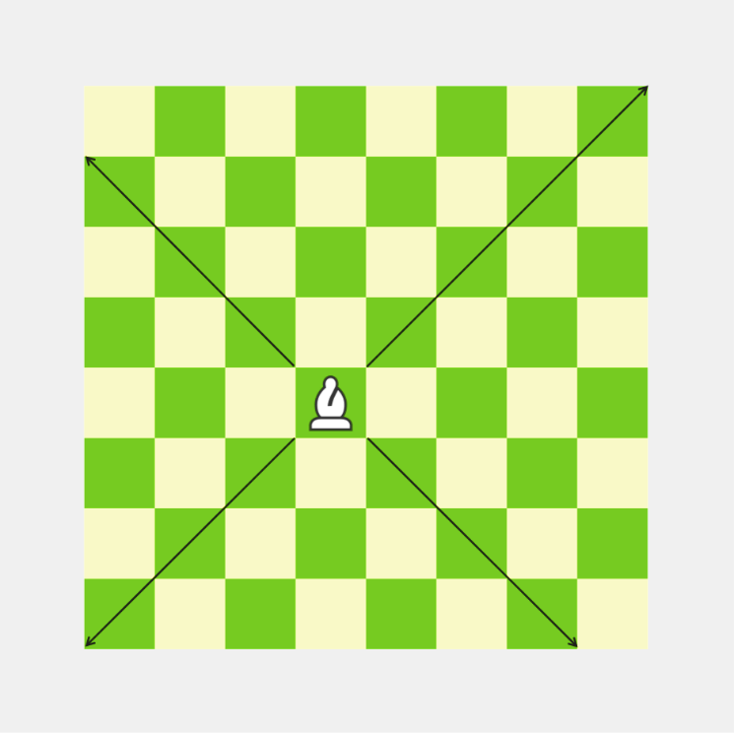

**Fig. 2** Bishops’ Trail

The knight is a 2’nd order piece in the game that can move in 8 direction shown in the diagram below.

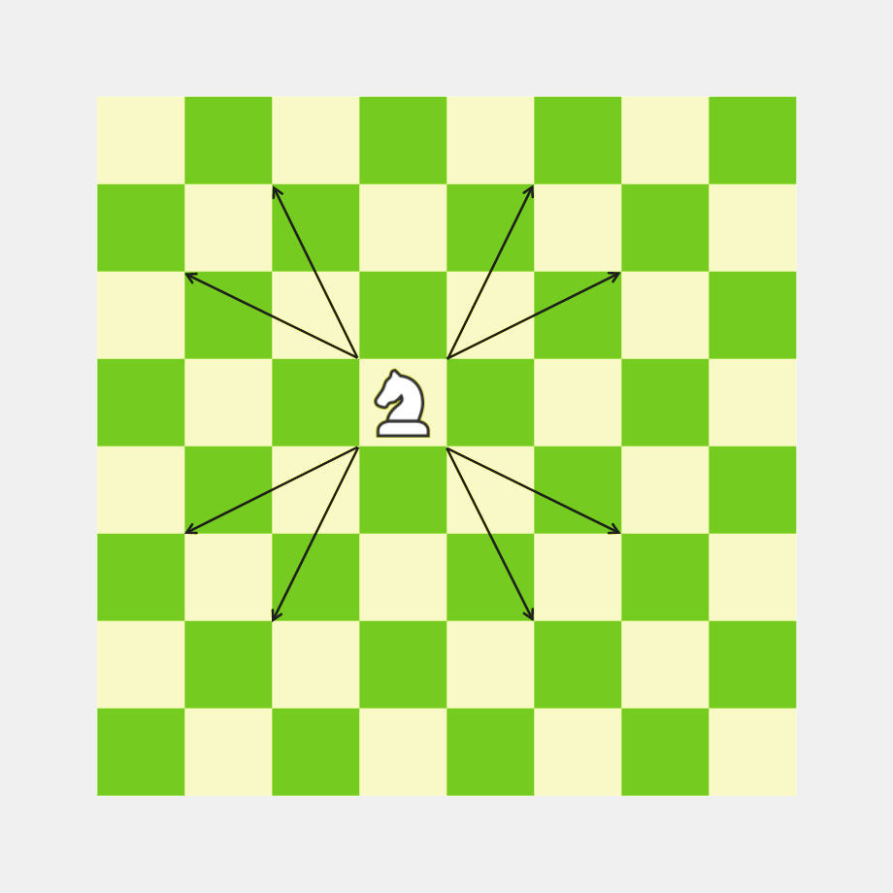

**Fig. 3** Knights’ Trail

Now, depending on the placement of the bishop and the knight, they will influence different number of squares.

Based on the placements, we can have 3 cases:

* Best Case
* Average Case
* Worst Case

Best Case will be the scenario where, the pieces will have an influence on maximum number of squares.

Worst Case will be the scenario where the pieces will have an influence on the minimum number of squares.

The Cases apart from the Best and Worst Case will be termed as Average Case.

**3.1 Best Case Analysis**

The Best case common for both the bishop and the knight will be the 4 squares of the center



**Fig. 4.1** Best Case Squares (Common to Bishop and Knight)

But in accordance to the Best Case common to both the pieces - Bishop and Knight, the Knight has a greater domain of Best Case.



**Fig. 4.2** Best Case Squares for Knight

In best case, the bishop will have influence on 13 squares (ignoring the square where the piece is kept) that are situated in diagonal manner with respect to the square where the bishop is placed.

In best case, the knight will have influence on 8 squares that are situated in 2 $\frac{1}{2}$ squares with respect to the square where the knight is placed.

Relative Piece Value $={\left.\frac{I\left(Bishop\right)}{I\left(Knight\right)}\right|}_{Best}=\frac{13}{8}$

where $I(P)$ is the influence function.

**3.2 Worst Case Analysis**

The Worst case for both the bishop and the knight will be the 4 squares of the corner

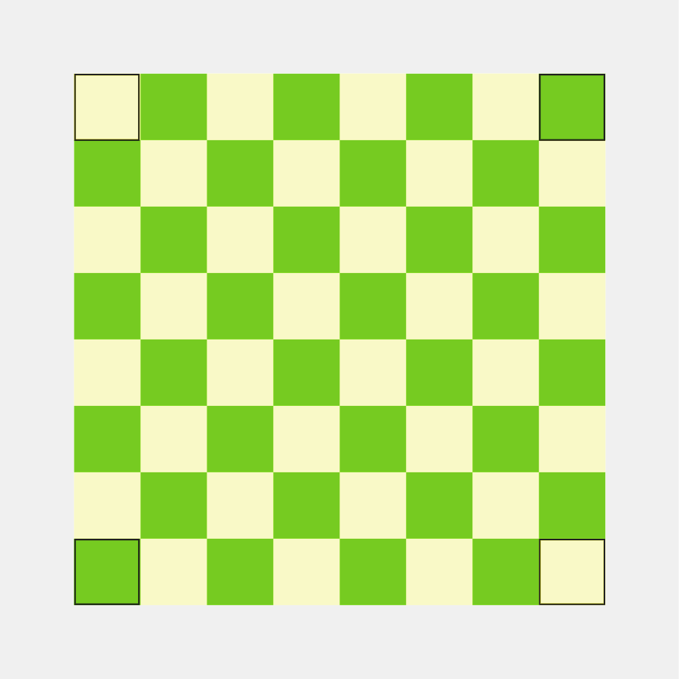

**Fig. 5** Worst Case Squares

In worst case, the bishop will have influence on 7 squares (ignoring the square where the piece is kept) that are situated in diagonal manner with respect to the square where the bishop is placed.

In best case, the knight will have influence on 2 squares that are situated in 2 $\frac{1}{2}$ squares with respect to the square where the knight is placed.

Relative Piece Value $={\left.\frac{I\left(Bishop\right)}{I\left(Knight\right)}\right|}_{Worst}=\frac{7}{2}$

where $I(P)$ is the influence function.

**3.3 Average Case Analysis**

The squares other than the 4 squares of the center (for Bishop and Knight) and the 4 squares of the corners will correspond to the Average Case.

In average, the number of squares, under the influence of Bishop will be of the form $7+2b ∀b∈\{0, 1, 2, 3\}$

In average, the number of squares, under the influence of Knight will be of the form $8-k∀k∈0,2,4,5,6$

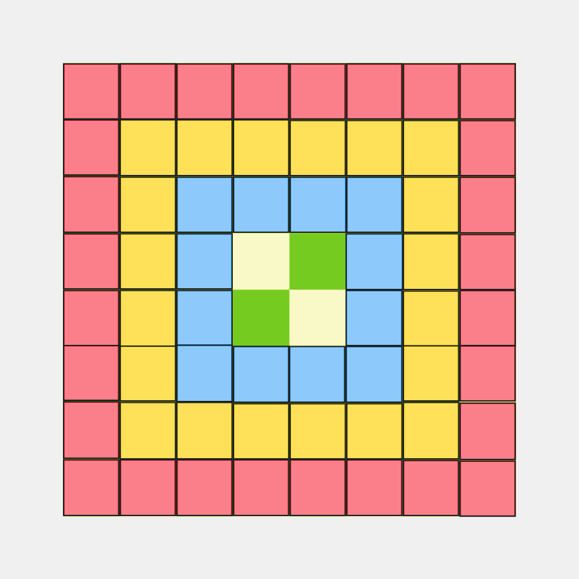

**Fig. 6** Influence Mapping for the Knights (Red maps to 7 squares, Yellow maps to 9 squares, Blue maps to 11 squares, Rest maps to 13 squares)

$${\left.I\left(Bishop\right)\right|}_{avg}=\frac{14×7+10×9+6×11+2×13}{14+10+6+2}=\frac{98+90+66+26}{32}=\frac{280}{32}=\frac{35}{4}$$

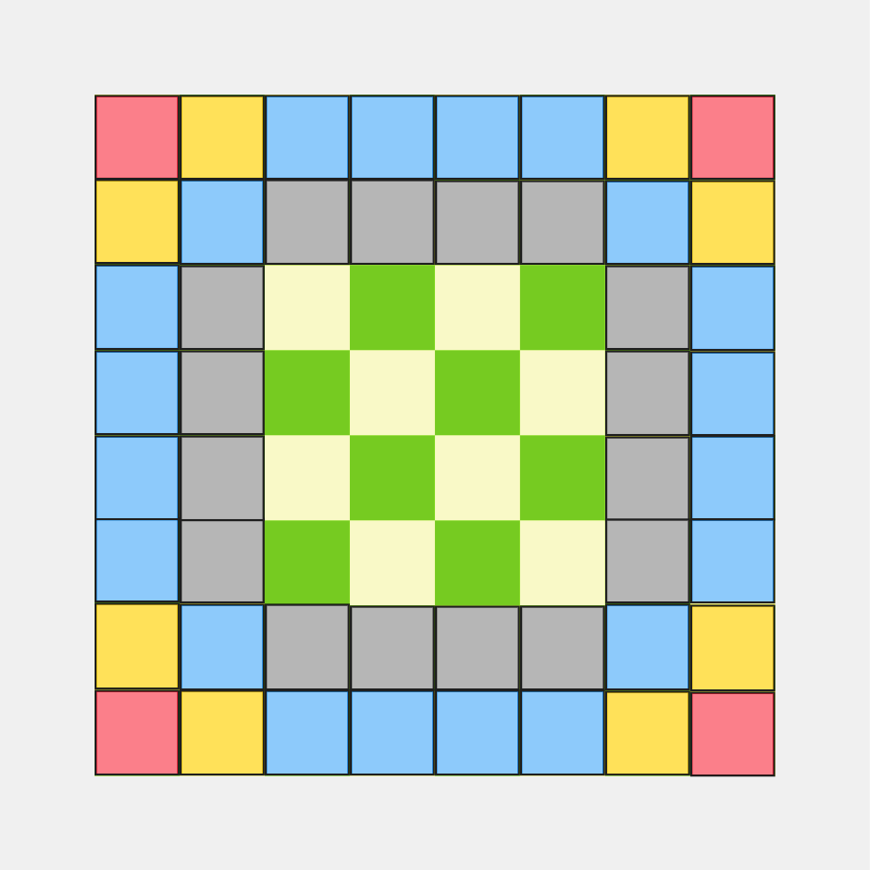

**Fig. 7** Influence Mapping for the Knights (Red maps to 2 squares, Yellow maps to 3 squares, Blue maps to 4 squares, Grey maps to 6 squares, Rest maps to 8 squares)

$${\left.I\left(Knight\right)\right|}_{avg}=\frac{4×2+8×3+20×4+16×6+16×8}{4+8+20+16+16}=\frac{8+24+80+96+128}{64}=\frac{336}{64}=\frac{21}{4}$$

Relative Piece Value $={\left.\frac{I\left(Bishop\right)}{I\left(Knight\right)}\right|}_{avg}=\frac{\frac{35}{4}}{\frac{21}{4}}=\frac{5}{3}$

where $I(P)$ is the influence function.

# **6 Conclusion**

Though in numerous scenario, the relative piece value of Bishop and Knight is considered the same, but mathematically, it can be proven that the relative piece value of Bishop is greater than that of the Knight. This fact has also been mentioned on the masterpiece creation - “Bobby Fischer Teaches Chess”, but insufficient justification was added from his side. This fact can also be utilized in various humanoid chess engines by training their model using ML and AI.

# **References**

1. Panaino, Antonio (1999). La novella degli scacchi e della tavola reale. Milano: Mimesis. ISBN 88-87231-26-5.
2. Andreas Bock-Raming, The Gaming Board in Indian Chess and Related Board Games: a terminological investigation, Board Games Studies 2, 1999
3. Warner (2000), pp. 381
4. Harper, Douglas; Dan McCormack. "Online Etymology Dictionary". Archived from the original on 2 November 2012. Retrieved 2 May 2020.
5. Peter Banaschak, Facts on the origin of Chinese chess (Xiangqi), 4th Symposium of the Initiative Gruppe Königstein, Wiesbaden, August 1997
6. Png Hau Cheng, Jim (2016). Understanding the Elephant, Part 1: History of Xiangqi. New Taipei City. ISBN 978-957-43-3998-3.
7. Banaschak, Peter. "A story well told is not necessarily true: a critical assessment of David H. Li's The Genealogy of Chess". Archived from the original on 11 May 2013.
8. Cazaux, Jean-Louis; Knowlton, Rick (2017). A World of Chess, Its Development and Variations through Centuries and Civilisations. McFarland. pp. 334–353 (The origins of chess, approaching the question from several angles). ISBN 9-780786-494279.