Comparing Profitability of different Machine Learning Algorithms in Financial Markets

Akshat  2020172  IIITD ECE | Anurag Gulati  2020176  IIITD ECE | Ayush Madan  2020187  IIITD ECE | Kabir D. V. Baghel  2020564  IIITD CSAI

Abstract

Until the late 1990s, trading decisions across all asset classes entirely depended on a person’s analysis. Around the turn of the century, with the advent of faster machines, trading was automated with hard-coded strategies. Around the same time, machines learned to generate trading signals based on past data and strategies using learning algorithms. This project analyzes the trading signals generated by different machine learning algorithms and compares their potential profits to the original strategy given in the dataset and to each other. The learning and testing have been done specifically for the Indian stock market, but one can extrapolate them to other asset classes and markets.

Introduction
Traders worldwide rely on fundamental and technical analysis while on the trading floor of an exchange. For instance, in stock markets, the former is based on understanding the financial records of a given company. In the forex market, it deals with the underlying economic and political policies of the two nations. In contrast, demand and supply analysis can be taken under the fundamental umbrella of the commodities market. On the other hand, technical analysis always deals with the patterns and statistics of price movement in any market. These statistical parameters are standard across different asset classes, making technical analysis consistent in them.
Performing technical analysis and manually generating trade signals can be tedious, especially for intraday and swing traders. Instead, one can turn a trading strategy into an algorithm and let the machine handle the task timely. Nevertheless, there always remains a remote possibility of overlooking a pattern in the movement, a checkpoint where the opportunity to develop intelligent trading systems lies. Over the past decades, researchers have employed machine learning algorithms to generate profitable trade signals. Through this project, the authors provide a comparative study on the profitability of learning algorithms in the arena of the Indian stock market, the stock choice for which is Tata Consultancy Services (TCS), listed on the Bombay Stock Exchange (BSE) as well as the National Stock Exchange (NSE) of India.

Related work
Since the mid-2000s, researchers have been developing intelligent trading systems using countless learning algorithms. In [1], the author proposes a hybrid model that uses decision trees to enhance the conventional filter rule. [2] proposes a better approach to [1] by incorporating future information into the criteria for clustering the trading points. The authors of [3] have used a nearest neighbors classifier built on conventional technical analysis.
The most recent developments in the field have been using deep learning for signal generation. Although neural networks are computationally expensive algorithms, they give out some of the most innovative trading rules. The authors of [4] study the use of artificial neural networks (ANNs) in this field, while [5] proposes the use of ensemble learning based on neural networks.
More advanced studies focus on using genetic algorithms and programming for trading. Incorporating news-based analysis using natural language processing is another approach that, when combined with one of the above methods, can give out a mix of fundamental and technical analysis. However, these advanced techniques are well beyond the scope of this project.

Overview
This project provides a comparative study of the below-mentioned machine learning algorithms and their profitability in the Indian stock market:
- Logistic Regression
- Naïve Bayes
- Decision Tree
- Random Forest
- Multilayer Perceptron
The benchmark stock chosen for the same is Tata Consultancy Services (TCS), one of the largest companies by market cap on both BSE and NSE. Starting off with some basic concepts of technical analysis and the abovementioned algorithms, the authors go on applying them and finally comparing their profitability.

Technical indicators
“Technical indicators are heuristic or pattern-based signals produced by the price, volume, and/or open interest of a security or contract used by traders who follow technical analysis” (Investopedia [6]). Broadly, technical indicators can be divided into four main categories: trend, volume, volatility, and momentum indicators.
From a wide range of indicators available, this project utilizes a dataset that contains 15 of them.
- Trend indicators
- Commodities Channel Index (CCI)
- Exponential Moving Average (EMA)
- Moving Average Convergence Divergence
- Simple Moving Average (SMA)
- Volume Weighted Moving Average (VWMA)
- Volume indicators
- Accumulation/Distribution Index (ADI)
- Ease of Movement (EMV)
- Money Flow Index (MFI)
- Volatility indicators
- Average True Range (ATR)
- Momentum indicators
- Awesome Oscillator (AO)
- Rate of Change (ROC)
- Relative Strength Index (RSI)
- Stochastic RSI %D
- Stochastic RSI %K
- William’s %R
The above indicators are calculated over a period of n days. Usually for short term, n = 12 or 26, while for mid-term and long-term n = 50 and 200 respectively. Sometimes, traders also use n = 125 for mid or long term.

The Data

Dataset
The raw dataset obtained from [7] contains the price action data for TCS from January 14, 2002, to June 5, 2020. This includes the day-wise open price, close price, high, low, adjusted close price, and volume. Using the raw data, the authors have calculated the technical indicators mentioned in section 1.3 and created a new dataset for analysis and learning, which contains a total of 40 features (volume and the abovementioned indicators calculated over different time periods). Based on the general rule of thumb, buy low and sell high, the new dataset adds another column, Signal, that will serve as the label for all supervised learning algorithms.

EDA and feature selection
Exploratory data analysis (EDA) is a technique that helps extract insights from the data. In order to select the most important features out of the 40 present, EDA is an essential step. Based on the mutual information gain of the features, the project selects the top 15 for further analysis. Out of these, the ones that are fully correlated (correlation coefficient = 1) are dropped, and only one of them is kept intact.

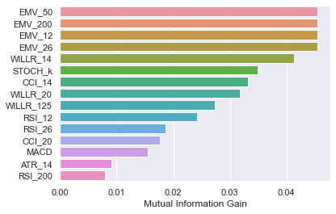
Figure 1: Top 15 features based on mutual information gain.

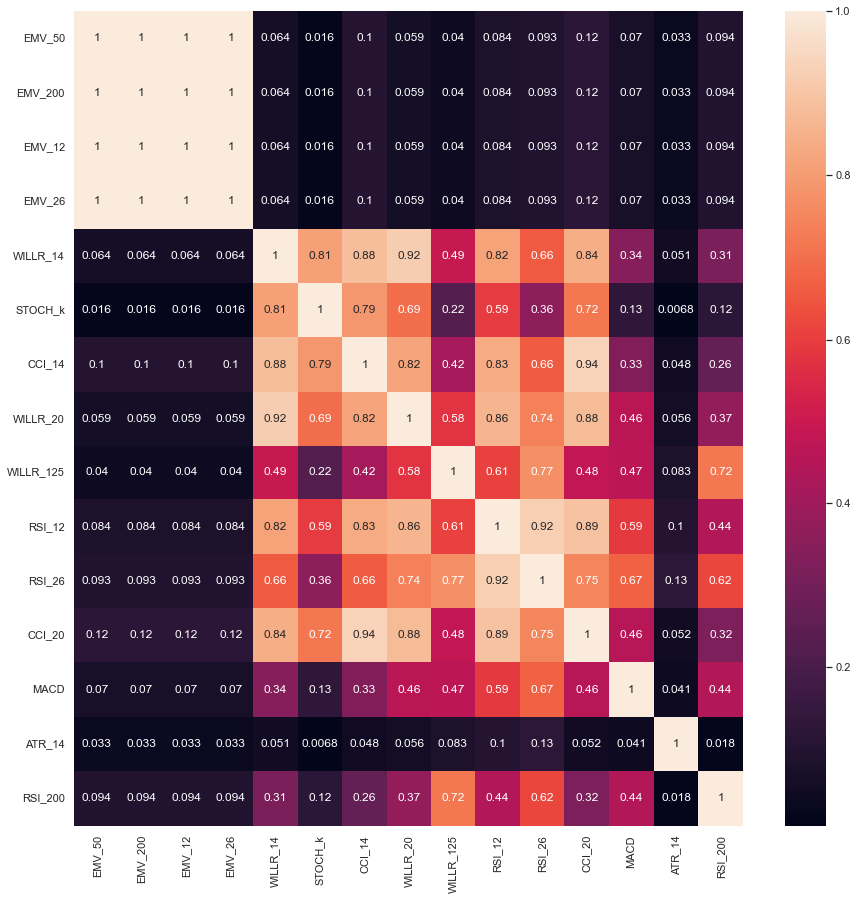
Figure 2: Observing the absolute correlation among the top 15 features. It is visible that EMV values over different time periods are fully correlated, hence selecting only one of these columns shall be sufficient for learning.

From the abovementioned analysis, the features finally selected for learning, in decreasing order of information gain, are as follows:
- 50-days Ease of Movement
- 14-days William’s %R
- Stochastic RSI %K
- 14-days Commodities Channel Index
- 20-days William’s %R
- 125-days William’s %R
- 12-days Relative Strength Index

Learning and Analysis
It is worth reiterating that this project aims to compare the profitability of different machine learning algorithms in the financial markets, and that the experimental focus is on the Indian stock market but the concepts can be extrapolated to other asset classes and markets. In the upcoming sections of this manuscript, the following learning algorithms have been deployed and analyzed for profits:
- Logistic Regression
- Decision Trees
- Random Forests
- AdaBoost
- Naïve Bayes
- Multilayer Perceptron

Margins and page numbering
Figure 2: Short captions should be centred.
All printed material, including text, illustrations, and charts, must be kept within a print area 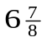 inches (17.5 cm) wide by 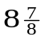inches (22.54 cm) high. Page numbers should be in footer with page numbers, centered and .75 inches from the bottom of the page and make it start at the correct page number rather than the 4321 in the example (how to do that depends on your version of word or open office. Failure to use the correct page number, or place it properly, could result in the paper not being included in Xplore, (even if it passes PDF express (which does not check page number)

Type-style and fonts
Wherever Times is specified, Times Roman may also be used. If neither is available on your word processor, please use the font closest in appearance to Times to which you have access.
MAIN TITLE. Center the title 1-3/8 inches (3.49 cm) from the top edge of the first page. The title should be in Times 14-point, boldface type. Capitalize the first letter of nouns, pronouns, verbs, adjectives, and adverbs; do not capitalize articles, coordinate conjunctions, or prepositions (unless the title begins with such a word). Leave two blank lines after the title.
AUTHOR NAME(s) and AFFILIATION(s) are to be centered beneath the title and printed in Times 12-point, non-boldface type. This information is to be followed by two blank lines.
The ABSTRACT and MAIN TEXT are to be in a twocolumn format.
MAIN TEXT. Type main text in 10-point Times, singlespaced. Do NOT use double-spacing. All paragraphs should be indented 1 pica (approx. 1/6 inch or 0.422 cm). Make sure your text is fully justified—that is, flush left and flush right. Please do not place any additional blank lines between paragraphs.
Figure and table captions should be 9-point Roman type as in Figures 1 and 2. Short captions should be centred. Callouts should be 9-point Helvetica, non-boldface type. Initially capitalize only the first word of section titles and first-, second-, and third-order headings.
FIRST-ORDER HEADINGS. (For example, 1. Introduction) should be Times 12-point boldface, initially capitalized, flush left, with one blank line before, and one blank line after.
SECOND-ORDER HEADINGS. Should be Times 11-point boldface, initially capitalized, flush left, with one blank line before, and one after. If you require a third-order heading (we discourage it), use 10-point Times, boldface, initially capitalized, flush left, preceded by one blank line, followed by a period and your text on the same line.

Footnotes
Please use footnotes sparingly. Indeed, try to avoid footnotes altogether and include necessary peripheral observations in the text (within parentheses, if you prefer, as in this sentence). If you wish to use a footnote, place it at the bottom of the column on the page on which it is referenced. Use Times 8-point type, single-spaced.

References
List and number all bibliographical references in 9-point Times, single-spaced, at the end of your paper. When referenced in the text, enclose the citation number in square brackets, for example [4]. Where appropriate, include the name(s) of editors of referenced books.

Illustrations, graphs, and photographs
All graphics should be centered. Please ensure that any point you wish to make is resolvable in a printed copy of the paper. Resize fonts in figures to match the font in the body text, and choose line widths which render effectively in print. Many readers (and reviewers), even of an electronic copy, will choose to print your paper in order to read it.
You cannot insist that they do otherwise, and therefore must not assume that they can zoom in to see tiny details on a graphic. When placing figures in LATEX, it’s almost always best to use \includegraphics, and to specify the figure width as a multiple of the line width as in the example below

\usepackage[dvips]{graphicx} ...
\includegraphics[width=0.8\linewidth]
{myfile.eps}

Color
Please refer to the author guidelines on the CVPR 2019 web page for a discussion of the use of color in your document.

Final copy
You must include your signed IEEE copyright release form when you submit your finished paper. We MUST have this form before your paper can be published in the proceedings. Please direct any questions to the production editor in charge of these proceedings at the IEEE Computer Society Press: Phone (714) 821-8380, or Fax (714) 761-1784.

References
- Lin, C. H. (2004). Profitability of a filter trading rule on the Taiwan stock exchange market. Master thesis, Department of Industrial Engineering and Management, National Chiao Tung University
- Wu, M. C., Lin, S. Y., & Lin, C. H. (2006). An effective application of decision tree to stock trading. Expert Systems with applications, 31(2), 270-274.
- Teixeira, L. A., & De Oliveira, A. L. I. (2010). A method for automatic stock trading combining technical analysis and nearest neighbor classification. Expert systems with applications, 37(10), 6885-6890.
- Fernandez-Rodrıguez, F., Gonzalez-Martel, C., & Sosvilla-Rivero, S. (2000). On the profitability of technical trading rules based on artificial neural networks: Evidence from the Madrid stock market. Economics letters, 69(1), 89-94.
- Chang, P. C., Liu, C. H., Fan, C. Y., Lin, J. L., & Lai, C. M. (2009, September). An ensemble of neural networks for stock trading decision making. In International conference on intelligent computing (pp. 1-10). Springer, Berlin, Heidelberg.
- Investopedia: www.investopedia.com/terms/t/technicalindicator.asp
- Yahoo Finance: https://finance.yahoo.com/
- Technical Analysis Library: https://technical-analysis-library-in-python.readthedocs.io/en/latest/

This is what a footnote looks like. It often distracts the reader from the main flow of the argument.

