**EXPERIMENT 1**

**AWS VS AZURE VS GCP**

1. Account Setup

AWS:

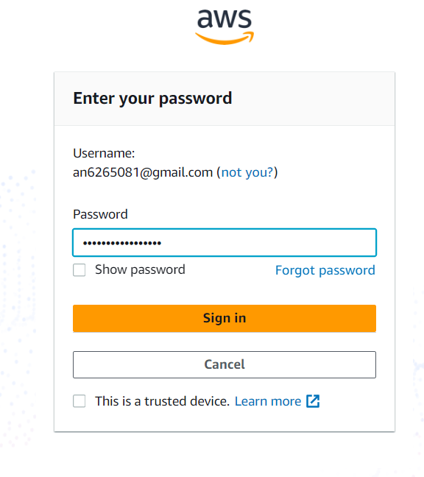

Email, personal info, credit card, phone verificatio

GCP:

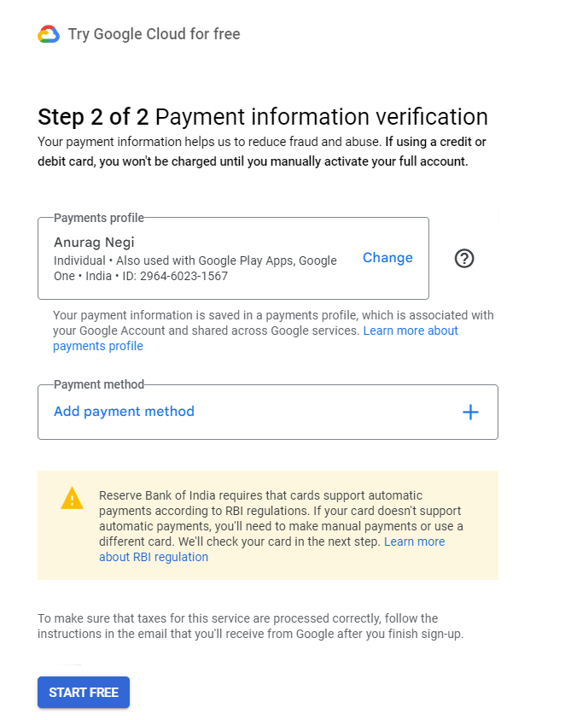

Google account, payment details for ID verification

Azure:

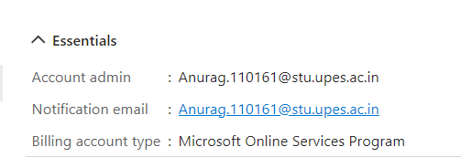

Microsoft account, payment details for ID verification

1. Free Tier

AWS:

Offers 12 month of free services with limited usage (e.g., 750 hours/month of EC2, 5GB of S3 storage).

GCP:

Always-free usage limits on 20+ products (e.g., 1 f1-micro instance per month, 5GB of cloud Storage) and $300 in credits for new users.

Azure:

Offers 12 months of popular services for free (e.g., 750 hours/month of B1S VM, 5 GB of Blob storage) and 25+ services that are always free.

1. Pricing and Cost management:

AWS:

**Pricing Model:** Pay-as-you-go with on-demand, reserved, and spot instances.

**Cost Management:** AWS offers tools like AWS Budgets, AWS Cost Explorer, and Reserved Instances (for savings).

**Free Credits:** $100-$300 in credits via promotions or education accounts.

GCP:

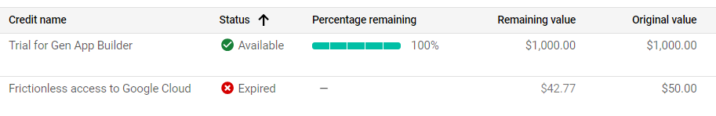

**Pricing Model:** Pay-as-you-go with sustained use discounts and committed use contracts.

**Cost Management:** Google Cloud Cost Management tools, including Committed Use Contracts for savings.

**Free Credits:** $300 in credits for the first 90 days.

Azure:

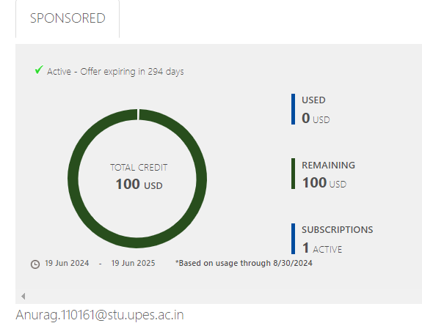

**Pricing Model:** Pay-as-you-go with reserved and spot instances.

**Cost Management:** Azure Cost Management and Billing, with Reserved VM Instances for savings.

**Free Credits:** $200 in credits for the first 30 days.

1. Storage:

AWS:

**Storage Types:** S3 (object storage), EBS (block storage), Glacier (archival storage).

**Unique Offering:** S3 Glacier for low-cost, long-term archival.

GCP:

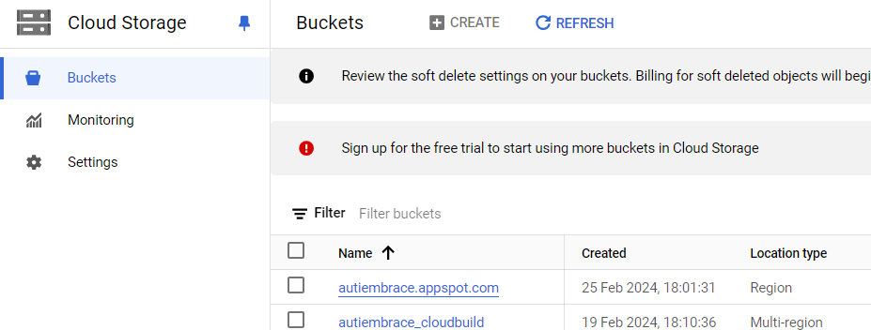

**Storage Types:** Google Cloud Storage (object storage), Persistent Disks (block storage), Filestore (file storage).

**Unique Offering:** Google Cloud Spanner for globally distributed databases.

Azure:

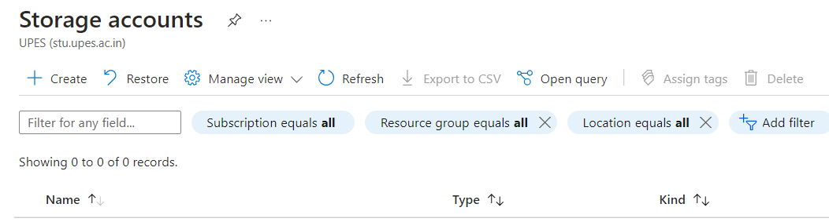

**Storage Types:** Azure Blob Storage (object storage), Azure Disk Storage (block storage), Azure Files (file storage).

**Unique Offering:** Azure Data Lake Storage optimized for big data analytics.

1. Services:

AWS:

**Compute:** EC2, Lambda, Elastic Beanstalk.

**Database:** RDS, DynamoDB, Redshift, Aurora.

**Developer Tools:** CodePipeline, CodeDeploy, CodeBuild.

GCP:

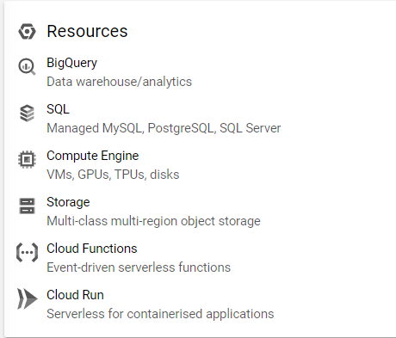

**Compute:** Compute Engine, Cloud Functions, App Engine.

**Database:** Cloud SQL, Bigtable, Firestore, BigQuery.

**Developer Tools:** Cloud Build, Container Registry, Cloud Source Repositories.

Azure:

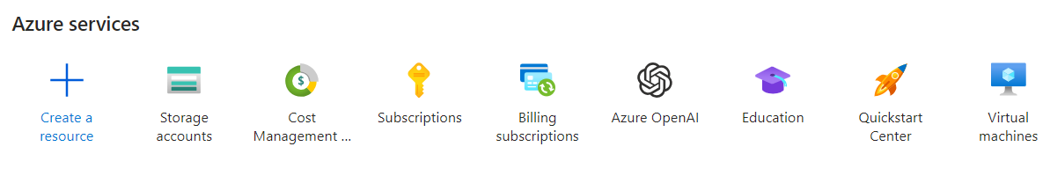

**Compute:** Virtual Machines, Azure Functions, App Services.

**Database:** Azure SQL Database, Cosmos DB, Azure Database for PostgreSQL.

**Developer Tools:** Azure DevOps, GitHub Actions, Visual Studio integration.

1. AI & Machine Learning:

AWS:

**AI Services:** AWS SageMaker, Rekognition, Polly, Lex, Transcribe, Translate.

**Unique Offering:** Deep Learning AMIs and Elastic Inference.

GCP:

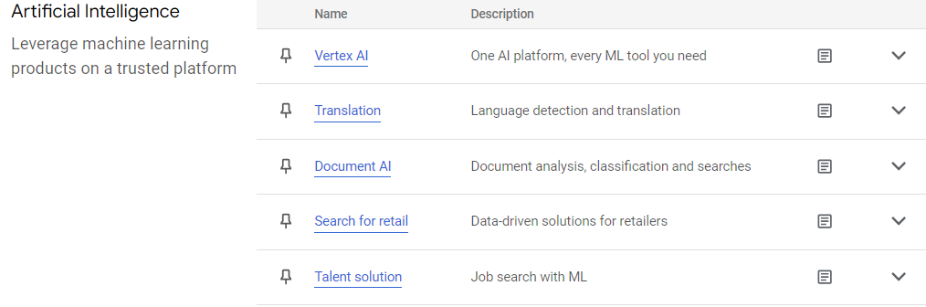

**AI Services:** Google AI Platform, AutoML, TensorFlow, Vision AI etc.

**Unique Offering:** Deep integration with Google’s research tools like Tensor flow.

Azure:

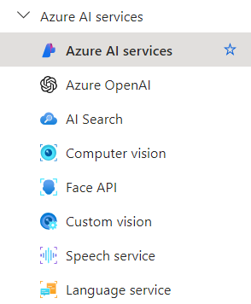

**AI Services:** Azure Machine Learning, Cognitive Services (e.g., Vision, Speech, Language), Bot Service.

**Unique Offering:** AI integrations with Office 365 and other Microsoft products.