

CLOUD COMPUTING

LAB FILE SUBMMITED BY:SUBMMITED TO:

NAME: ANURAG NEGI DR. AMBIKA AGGARWAL SAP ID: 500101861

BATCH: 2

**Experiment-1**

**Introduction to AWS Identity and Access management**

After logging into the AWS account, we will begin by searching the IAM service in the console.

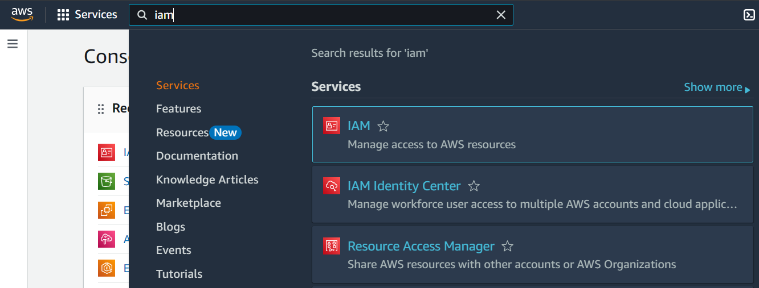

Our first task is to create 3 different IAM users. While creating the users, we will allocate the permissions accordingly.

**User1:**

* First, we are creating an IAM user with the name “anurag-user1”. Here, we have assigned a custom password to sai-user1.

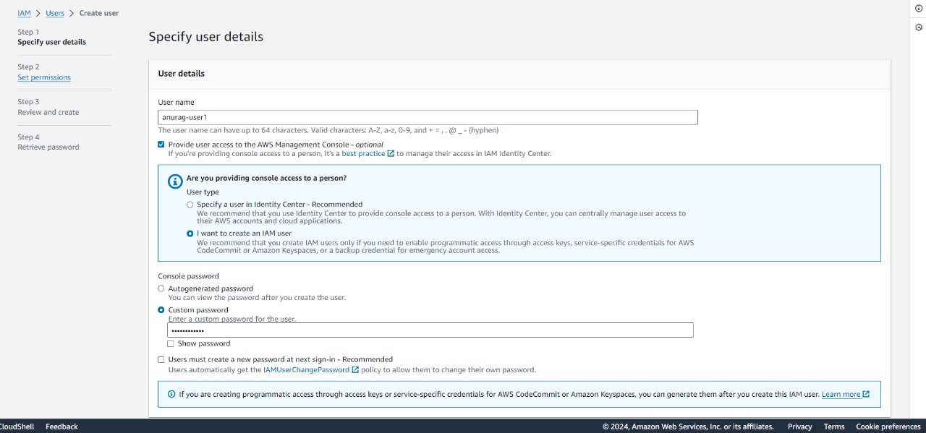

* Here, we are setting up the permissions for anurag-user1.

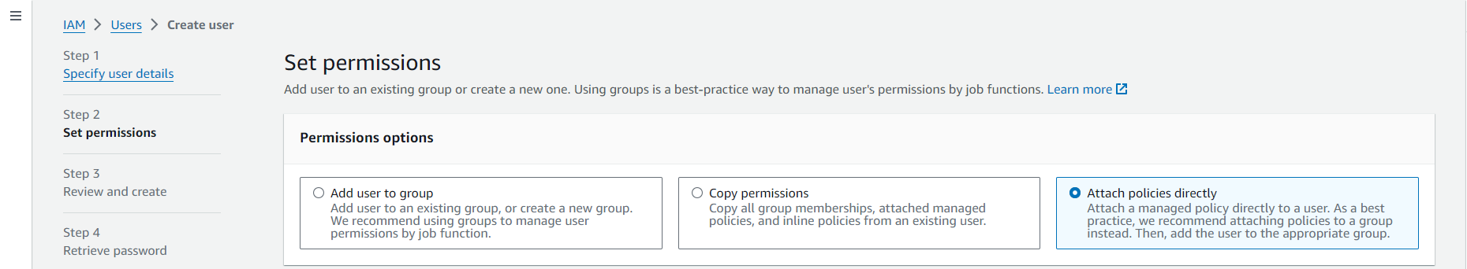

* We will be creating an EC2 instance further for which user-1 will only have the read only access to it.

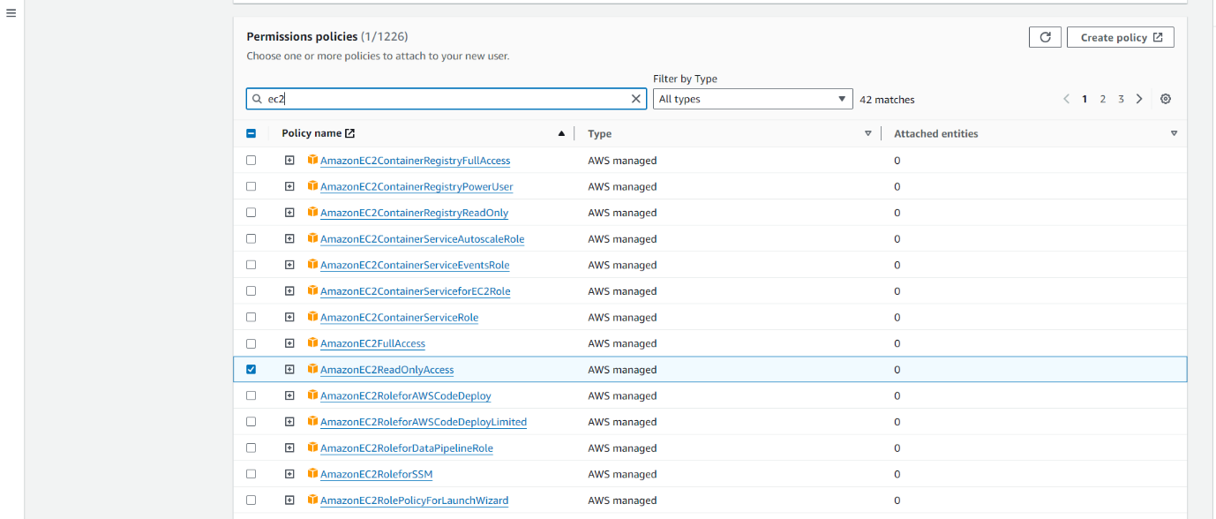

* After creation of anurag-user1 as IAM user we will be copying the URL and sign in to AWS account as an IAM user.

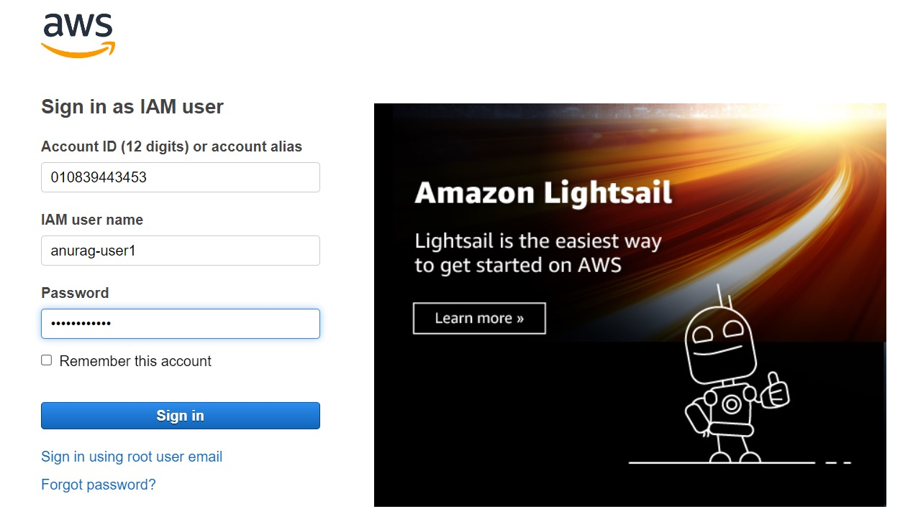

* After logging in as IAM user this is the look of console.

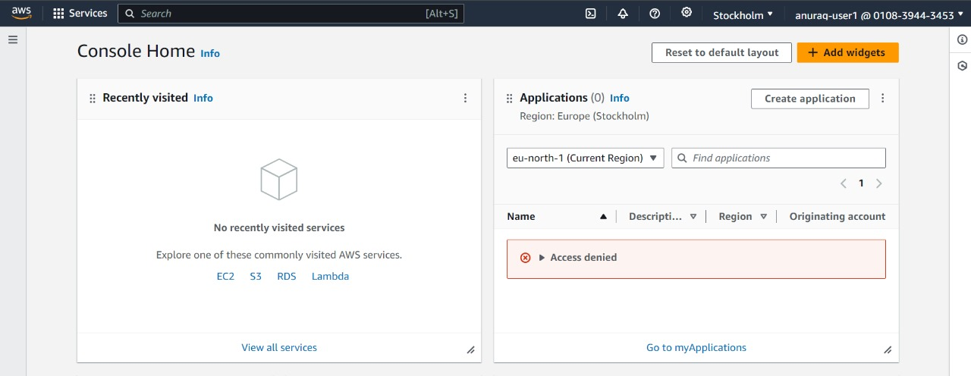

* Now we will try to launch an EC2 instance, with anurag-user1.



* Since we have given EC2ReadOnlyAccess to sai-user1, it will not be able to launch an EC2 instance.

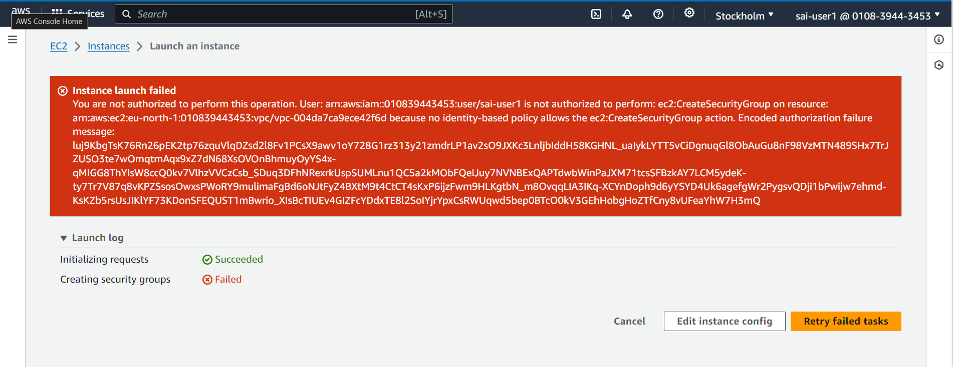

**User 2:**

* Now, we are creating an IAM user with the name “anurag-user2”. Here, we have assigned a custom password to sai-user2.

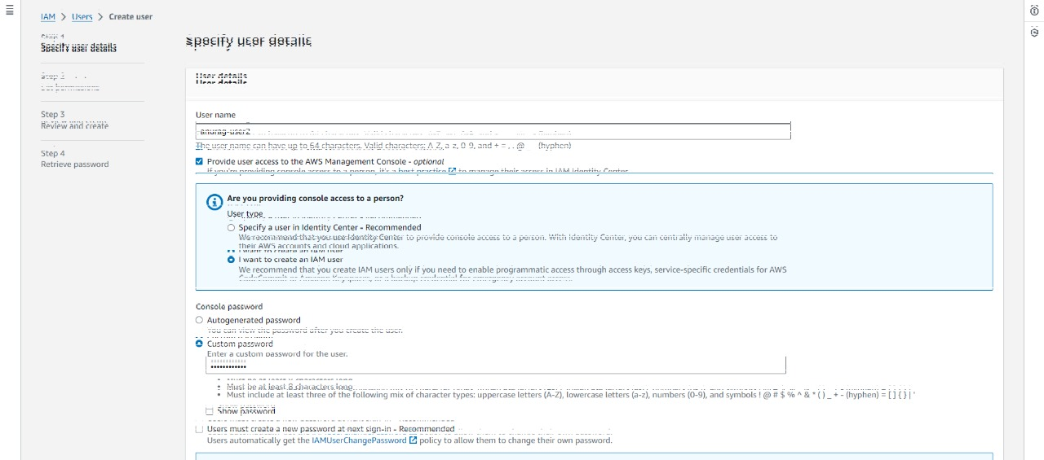

* Here, we are setting up the permissions for anurag-user2. We will be creating an EC2 instance further for which user-2 will have full access now.

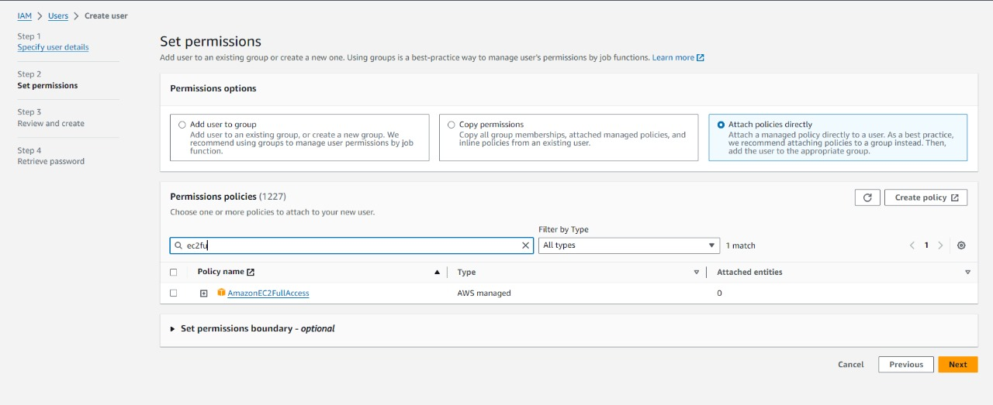

* anurag-user2 is successfully created.

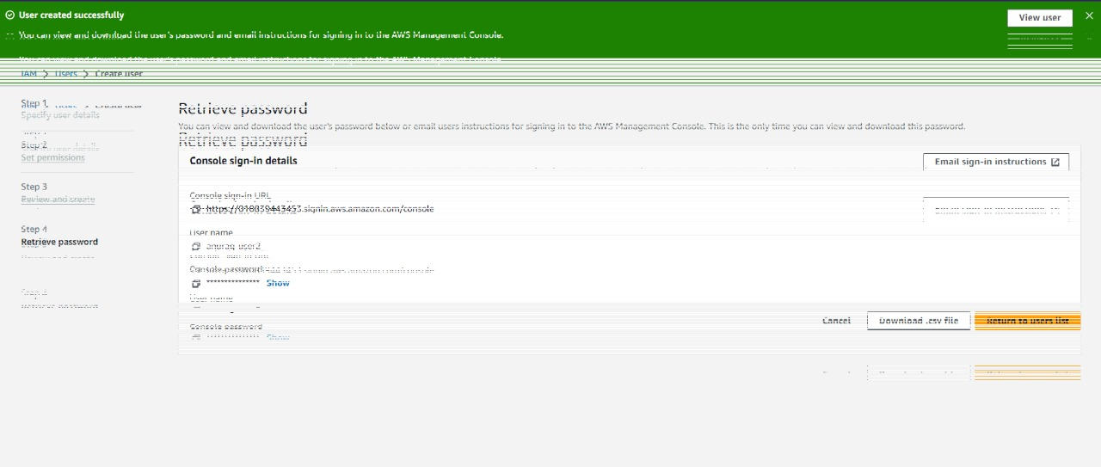

* After creation of anurag-user2 as IAM user we will be copying the URL and sign in to AWS account as an IAM user.

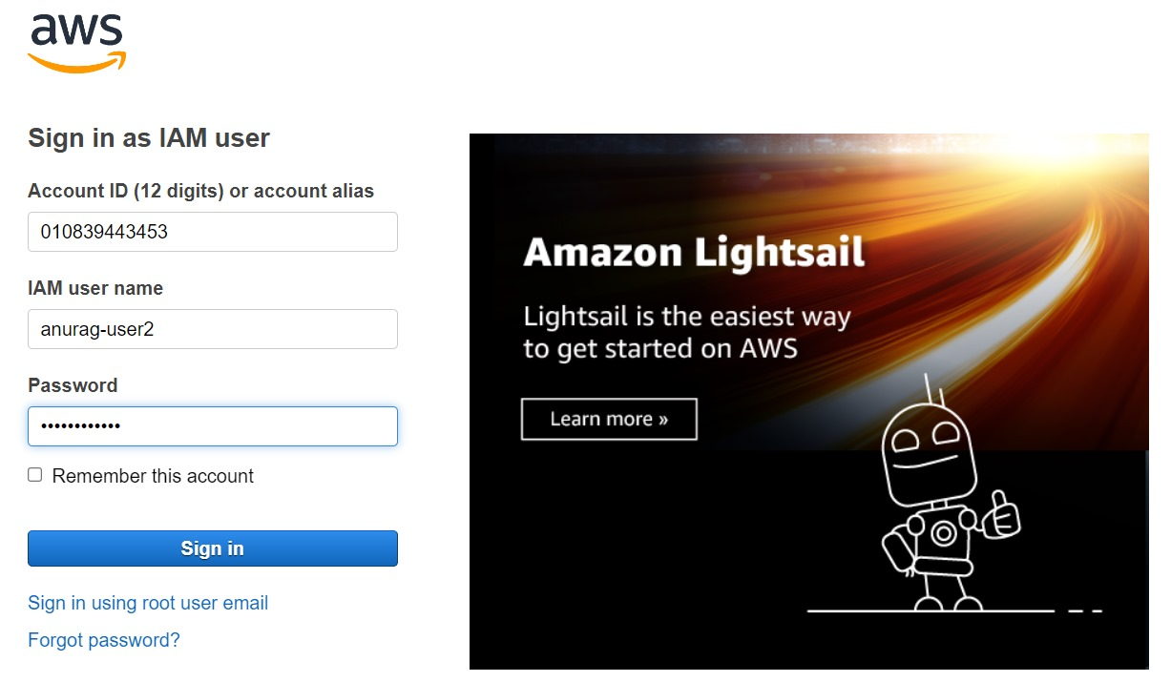

* After logging in as IAM user this is the look of console.



* Now we will try to launch an EC2 instance, with sai-user2.

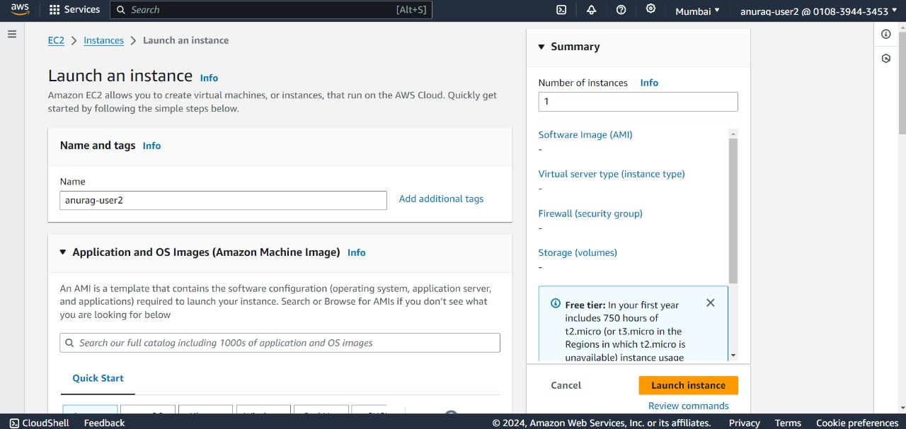

* Here, as we have given the EC2FullAccess to anurag-user2, we were able to launch a EC2 instance.



**User 3:**

* Now, we are creating an IAM user with the name “anurag-user3”. Here, we have assigned a custom password to sai-user3.

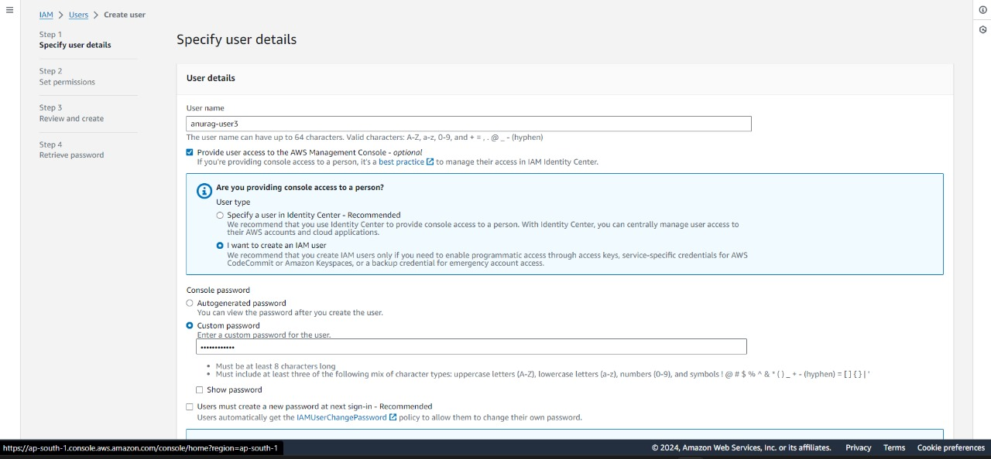

* Here, we are setting up the permissions for anurag-user3. We will be creating a S3 bucket further for which user-3 will have full access now.

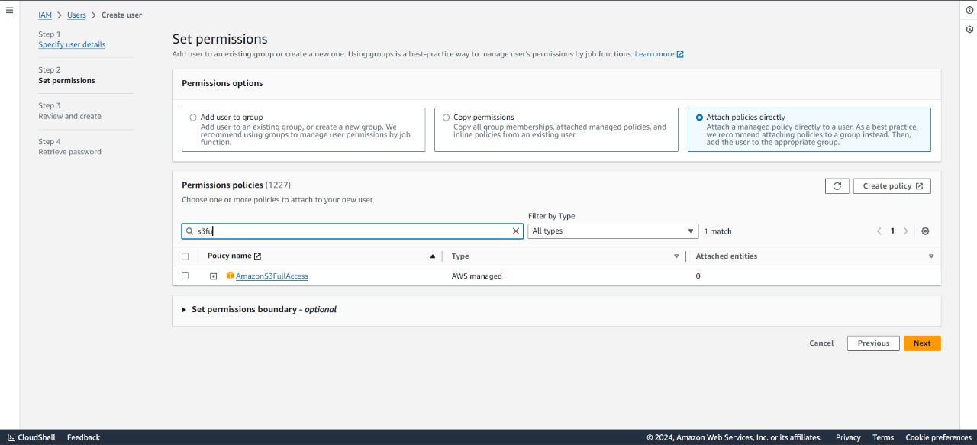

* anurag-user3 is successfully created.

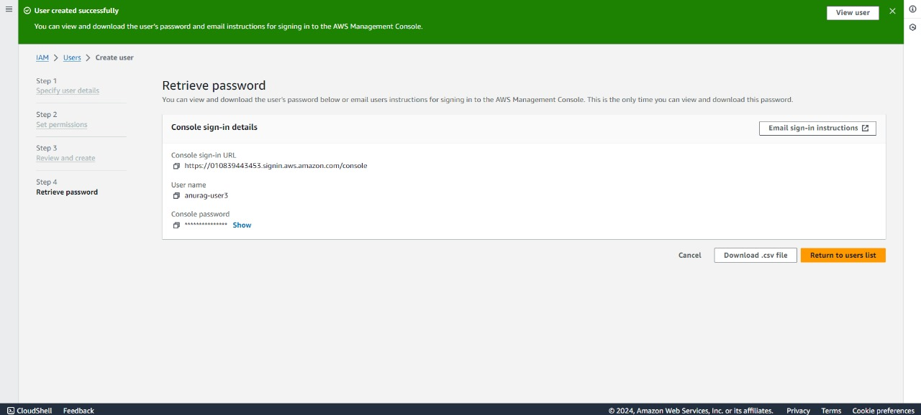

* After creation of anurag-user3 as IAM user we will be copying the URL and sign in to AWS account as an IAM user.

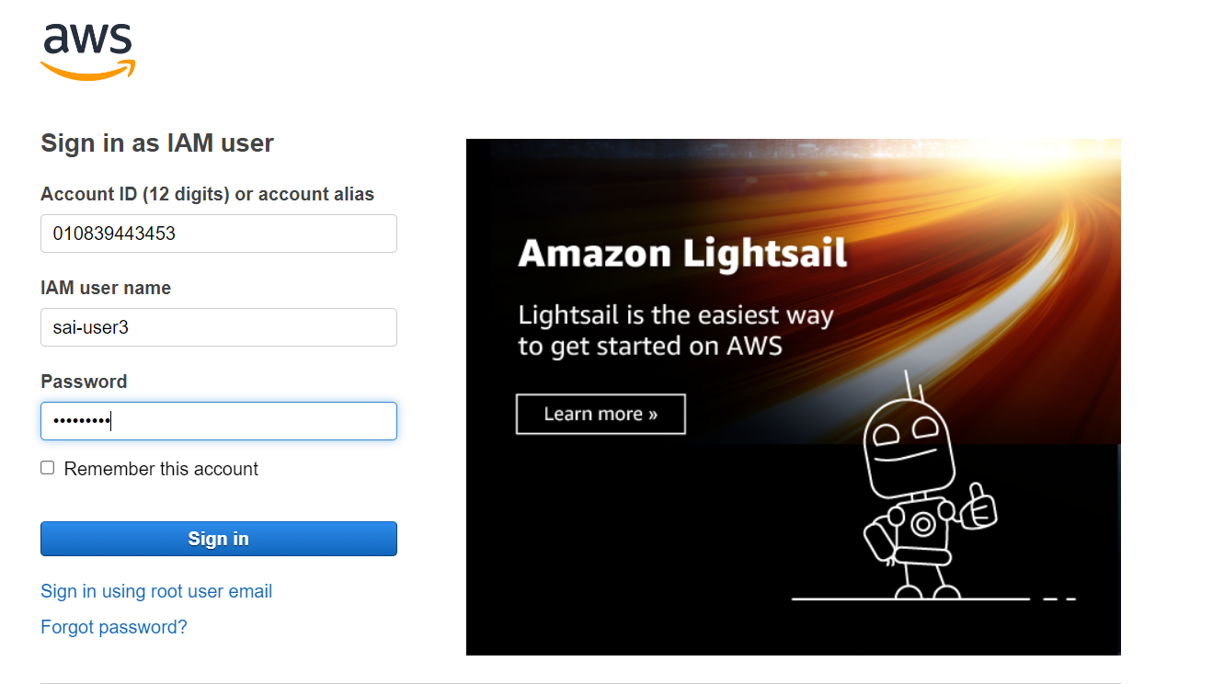

anurag-user3



* After logging in as IAM user this is the look of console.

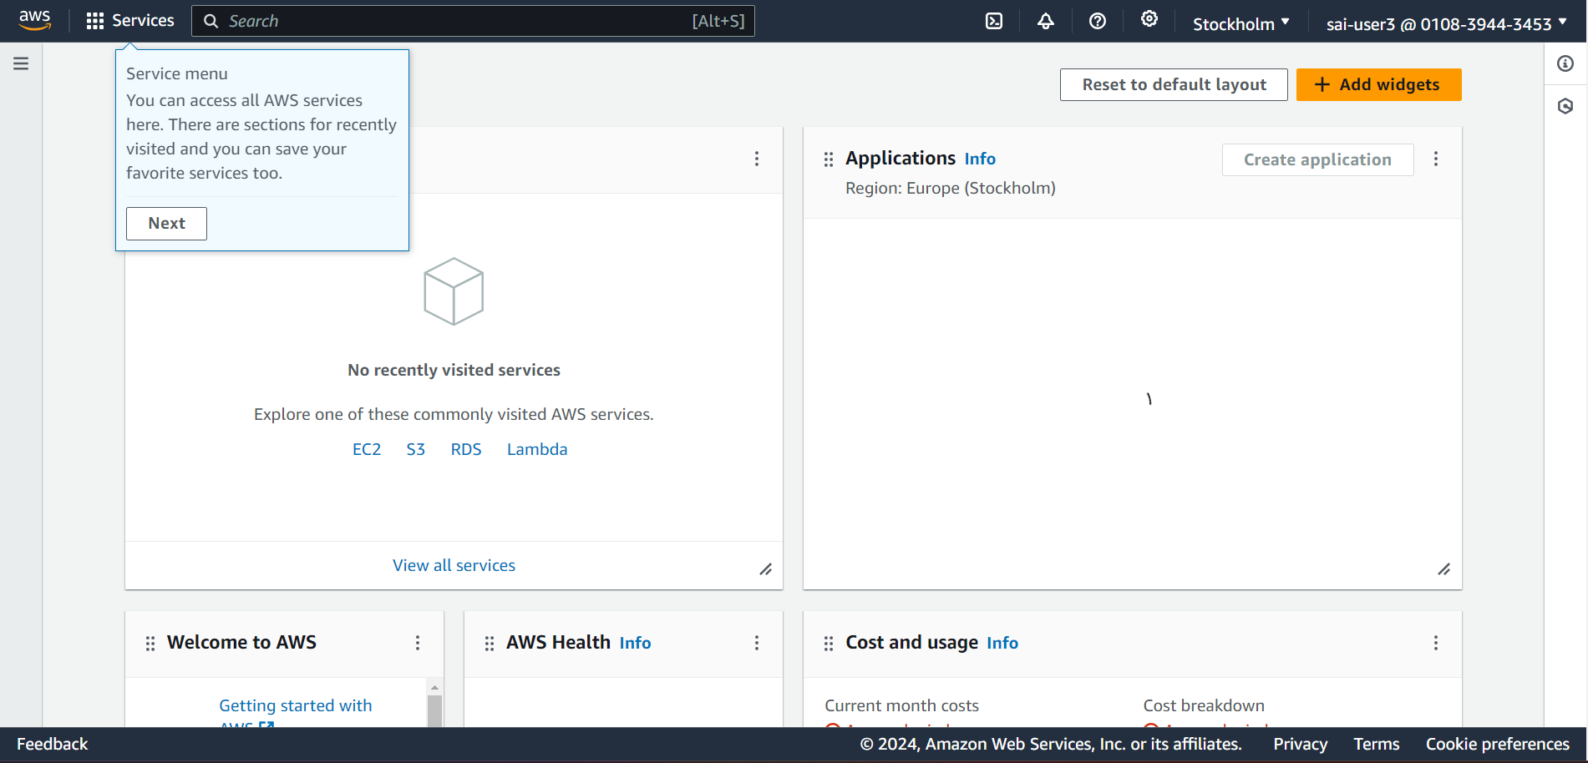

* Now we will create a S3 bucket, with anurag-user3.

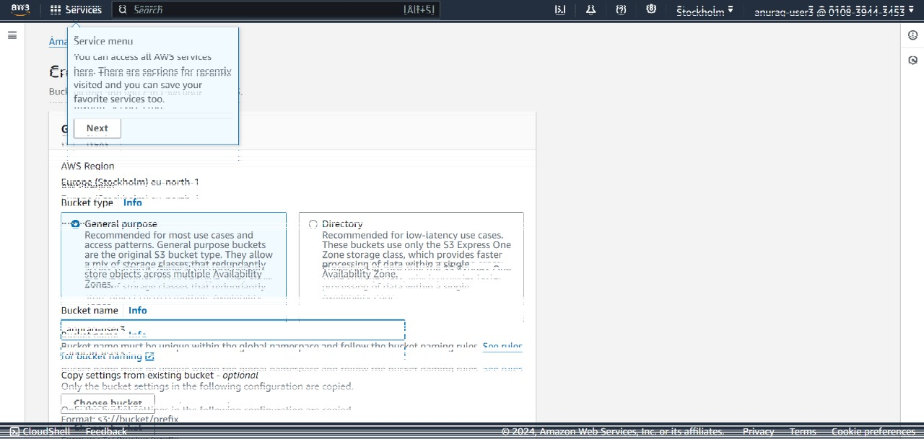

* We have successfully created the S3 bucket as we have already given S3FullAccess to it while creating the user.



* Here, we are creating a user group with all the three IAM users and giving EC2FullAccess permission to the group.

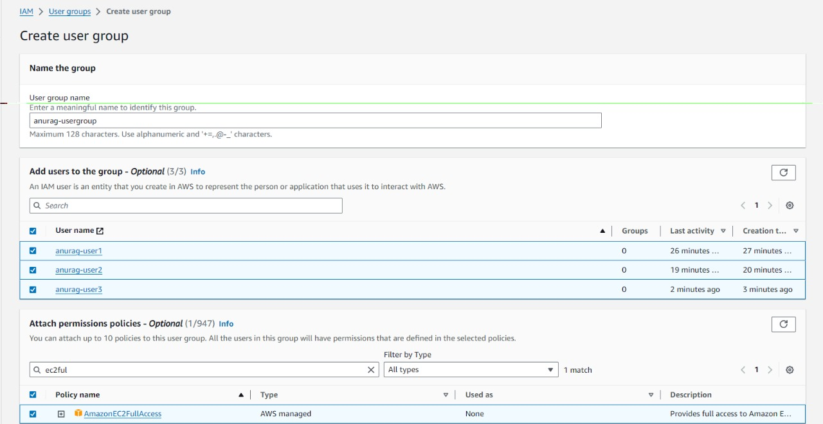

* Checking the anurag-user1 whether the EC2FullAccess permission has been set or not.



* Now, we are checking if we are able to launch EC2 instance with anurag-user1, since we were unable to launch it before. Here, we are now able to launch EC2 instance.

