**1. Introduction**

**1.1 Existing System**

The current job portal systems allow candidates to search and apply for jobs and recruiters to post jobs. These platforms generally support basic functionalities like job search, resume upload, and application tracking. However, they fall short in several areas:

• **Limited Candidate Insights:** Recruiters have minimal tools to filter or analyze candidates based om skills and experience.  
• **Manual Application Management:** Candidates often lack real-time updates on application status, causing uncertainty.  
• **Poor Communication:** Platforms provide limited ways for recruiters and candidates to communicate effectively.  
• **Unstructured Resume Handling:** Resumes are stored without proper management or analytics.  
• **Lack of Skill Analytics:** Candidates cannot see their skill match vs applied jobs, and recruiters cannot analyze applicant skill distribution.

**Example:** A candidate may apply to multiple jobs but cannot see how well their skills match each role, while a recruiter may struggle to identify the best-fit candidates without manually filtering applications.

**1.2 Limitation of Existing System**

The limitations of existing systems include:  
• **Delayed Updates:** Candidates may not receive timely updates on their applications.  
• **Generic Candidate Search:** Recruiters struggle to find candidates with specific skills efficiently.  
• **No Analytics:** Both candidates and recruiters have limited insights into skill gaps and success rates.  
• **Fragmented Communication:** Messaging between recruiters and candidates is often external, via email or phone.  
• **Scalability Issues:** High traffic can cause slow response times and performance degradation.

**Example:** A recruiter hiring for a React.js developer may have to manually sift through hundreds of applications without being able to automatically filter by skill, experience, or resume content.

**1.3 Proposed System Introduction**

The proposed system, **HireVerse**, addresses the shortcomings of existing systems by providing a comprehensive, user-centric platform for candidates and recruiters.

**Key highlights include:**  
• **Real-Time Application Tracking:** Candidates can see status updates instantly.  
• **Advanced Candidate Filtering:** Recruiters can search and filter applicants by skills, experience, and keywords.  
• **Resume Management:** Resumes are stored, downloaded, and analyzed efficiently.  
• **Candidate Analytics:** Provides skill match insights and success rates for candidates.  
• **Integrated Communication:** Enables messaging within the platform for seamless recruiter-candidate interaction.

**Example:** A recruiter can filter candidates by required skills and experience, view matched analytics, and contact candidates directly through the platform, all in real-time.

**1.4 Project Profile**

• **Project Name:** HireVerse

• **Project Type:** Web Application

• **Technology Stack:**

* **Frontend:** React.js, HTML5, Tailwind CSS
* **Backend:** Node.js, Express.js
* **Database:** MongoDB
* **Authentication:** JWT for secure login
* **File Handling:** Multer for resume uploads

• **Key Features:**

* Candidate registration, profile creation, resume upload
* Job posting and management for recruiters
* Application tracking and status updates
* Messaging system between recruiters and candidates
* Skill-based analytics for candidates and recruiters

**1.5 Scope of Proposed System**

The proposed system aims to:  
• **Enhance Candidate Experience:** Easy application process, portfolio management, and skill insights.  
• **Empower Recruiters:** Advanced search, candidate analytics, and messaging.  
• **Enable Real-Time Interaction:** Instant notifications and communication between users.  
• **Support Scalability:** Efficient handling of large numbers of jobs and applicants.  
• **Ensure Data Security:** Secure authentication and encrypted communication.

**Example:** A candidate can upload a resume, apply to multiple jobs, and view analytics about their skill match for each role.

**1.6 Objective of Proposed System**

The objectives of HireVerse include:  
• **Streamlined Recruitment Process:** Efficient job posting, candidate search, and application management.  
• **Enhanced Candidate Insights:** Skill analysis and success rate tracking.  
• **Improved Communication:** Built-in messaging system for recruiter-candidate interaction.  
• **Data-Driven Decision Making:** Analytics for both candidates and recruiters to make informed choices.  
• **Security & Reliability:** Secure handling of user data and documents.

**Example:** Recruiters can quickly shortlist candidates with the right skills and experience, while candidates can monitor their applications and improve their profiles based on analytics.

**1.7 System Environment Description**

• **Frontend Environment:**

* React.js for dynamic, responsive web interfaces
* HTML5 and Tailwind CSS for structure and styling
* JavaScript for interactivity

• **Backend Environment:**

* Node.js for server-side operations
* Express.js for routing and APIs

• **Database Environment:**

* MongoDB for scalable, document-based storage

• **File Handling:**

* Multer for secure resume uploads

• **Security Features:**

* JWT for authentication
* HTTPS/SSL for secure data transmission

• **Hosting Environment:**

* Cloud deployment on AWS/Google Cloud for scalability and high availability

**2. Detail Description of Technology Used**

**2.1 What is Node.js and Express.js**

**Node.js** is a JavaScript runtime built on Chrome’s V8 engine that allows server-side execution of JavaScript. It is event-driven, non-blocking, and suitable for building scalable applications.  
**Express.js** is a minimalist web framework for Node.js that simplifies routing, middleware handling, and API creation.

**Example:** Using Express.js, we can create RESTful APIs to manage jobs, candidates, and applications, enabling fast communication between frontend and backend.

**2.2 Why Node.js and Express.js**

• **High Performance:** Non-blocking I/O ensures efficient handling of multiple requests.  
• **Scalability:** Supports handling large volumes of data and concurrent users.  
• **JavaScript Unified Stack:** Both frontend (React.js) and backend use JavaScript, simplifying development.  
• **Community Support:** Rich ecosystem of packages through npm for rapid development.

**Example:** Real-time messaging between recruiters and candidates is efficiently handled using Node.js event-driven architecture.

**2.3 HTML5**

HTML5 is the standard markup language for creating web pages and web applications. It provides semantic elements, multimedia support, and improved accessibility.

**Example:** Semantic tags like <header>, <footer>, and <section> are used in HireVerse landing page and dashboards to structure content clearly for both users and search engines.

**2.4 JavaScript**

JavaScript is a client-side scripting language used to create interactive web elements. In HireVerse, it is used alongside React.js to create dynamic and responsive user interfaces.

**Example:** The “Apply Now” button dynamically updates the application status without requiring a full page reload.

**2.5 React.js**

React.js is a frontend library for building component-based, reusable UI elements. It enables a virtual DOM for faster rendering and state management.

**Key Highlights:**  
• **Component-Based Architecture:** Each UI element (job card, profile dialog, message dialog) is a reusable component.  
• **State Management:** Local state and API data are managed efficiently.  
• **Responsive Design:** Works seamlessly on desktop, tablet, and mobile.

**Example:** Candidate dashboards, recruiter job management pages, and messaging modals are built as React components for modularity and maintainability.

**2.6 Tailwind CSS & Styling**

Tailwind CSS is a utility-first CSS framework that allows rapid UI development with pre-defined classes. It promotes consistent design and responsive layouts.

**Example:** Buttons, cards, badges, and dialogs in HireVerse are styled using Tailwind classes, ensuring consistency and mobile responsiveness without writing custom CSS for each element.

**2.7 MongoDB**

MongoDB is a NoSQL, document-oriented database that stores data in JSON-like documents. It is ideal for flexible and scalable applications like HireVerse.

**Features Used:**  
• Collections for Users, Jobs, Applications, and Messages  
• Embedded documents for skill lists and resumes  
• Indexing for faster candidate searches

**Example:** A recruiter can quickly query candidates by skills using MongoDB’s indexing and aggregation features, improving performance.

**2.8 File Upload & Resume Handling (Multer)**

**Multer** is a middleware for handling multipart/form-data, primarily used for uploading files. In HireVerse, it manages candidate resumes securely.

**Example:** Candidates can upload their resume during profile creation, which is stored in the /uploads folder with a hashed filename for uniqueness, while the original filename is saved in the database for downloading.

**2.9 Security & Authentication**

HireVerse uses:  
• **JWT (JSON Web Tokens):** For secure authentication and session management.  
• **HTTPS/SSL:** To encrypt data in transit.  
• **Role-Based Access Control:** Candidates and recruiters have separate permissions.

**Example:** Only recruiters can post or edit jobs, and only candidates can apply for jobs or update their portfolio.

**3. System Planning**

**3.1 Feasibility Study**

Before building HireVerse, a feasibility study was conducted to ensure the system is viable technically, economically, and operationally.

**Technical Feasibility:**   
• MERN stack (MongoDB, Express.js, React.js, Node.js) provides a modern, scalable architecture.  
• Real-time messaging is achievable with WebSocket or Socket.io.  
• Cloud deployment ensures high availability and responsiveness.

**Economic Feasibility:**  
• Open-source technologies reduce development cost.  
• Cloud services (like MongoDB Atlas, Netlify) offer cost-effective hosting.

**Operational Feasibility:**  
• Intuitive dashboards for candidates and recruiters ensure ease of use.  
• Role-based access ensures proper segregation of functionalities.

**Example:** The system can handle hundreds of concurrent users applying for jobs while recruiters manage postings efficiently without performance issues.

**3.2 Risk Management**

Identifying potential risks and planning mitigation strategies ensures smooth project execution.

**Key Risks & Mitigation:**  
• **Data Breach Risk:** Use JWT authentication, SSL encryption, and secure file storage.  
• **Performance Issues:** Optimize database queries, indexing, and API response times.  
• **User Adoption Risk:** Create an intuitive UI/UX and provide clear instructions.  
• **Integration Risk:** Thorough testing of candidate-recruiter interactions and real-time messaging.

**Example:** Regular backups and MongoDB Atlas cloud features minimize data loss in case of system failures.

**3.3 Project Plan**

The project plan outlines the development phases and deliverables for HireVerse.

#### **3.3 Project Plan**

|  |  |  |  |  |  |  |  |  |  |
| --- | --- | --- | --- | --- | --- | --- | --- | --- | --- |
| | **Task** |  |  |  |  | | --- | --- | --- | --- | --- | | **Start Planned** | **Start Actual** | **Complete Planned** | **Complete Actual** |
| |  |  |  |  |  | | --- | --- | --- | --- | --- | | **1) Requirement Gathering** |  |  |  |  | |  |  |  |  |
| |  | | --- | | Collected requirement from our guide | | Day 1 | Day 1 | Day 1 | Day 1 |
| |  | | --- | | Analyze gathered information | | Day 1 | Day 1 | Day 1 | Day 1 |
| |  |  | | --- | --- | | Determine different modules |  | | Day 1 | Day 1 | Day 1 | Day 1 |
| |  |  |  |  |  | | --- | --- | --- | --- | --- | | **2) Planning & Analysis** |  |  |  |  | |  |  |  |  |
| |  | | --- | | Analyze data for possible risk | | Day 2 | Day 2 | Day 2 | Day 2 |
| |  |  | | --- | --- | | Identify technical risk |  | | Day 2 | Day 2 | Day 2 | Day 2 |
| |  |  | | --- | --- | | Determine different modules |  | | Day 2 | Day 2 | Day 2 | Day 2 |
| |  |  |  |  |  | | --- | --- | --- | --- | --- | | **3) Designing** |  |  |  |  | |  |  |  |  |
| |  |  |  | | --- | --- | --- | | Design database tables |  |  | | Day 2 | Day 2 | Day 2 | Day 3 |
| |  |  | | --- | --- | | Design basic interface of the site |  | | Day 2 | Day 3 | Day 2 | Day 4 |
| |  |  | | --- | --- | | Design web form for modules |  | | Day 3 | Day 3 | Day 3 | Day 3 |
| |  |  |  |  |  |  | | --- | --- | --- | --- | --- | --- | | **4) Coding and Development Project** |  |  |  |  |  | |  |  |  |  |
| |  | | --- | | Implement logic for different modules | | Day 4 | Day 4 | Day 4 | Day 4 |
| |  | | --- | | Implement database connectivity | | Day 4 | Day 4 | Day 4 | Day 4 |
| |  |  | | --- | --- | | Implement Report |  | | Day 5 | Day 5 | Day 5 | Day 5 |
| |  |  | | --- | --- | | Integrate different modules |  | | Day 4 | Day 4 | Day 4 | Day 4 |
| |  |  |  |  |  | | --- | --- | --- | --- | --- | | **5) Testing** |  |  |  |  | |  |  |  |  |
| |  |  | | --- | --- | | Validate input control and check accuracy of Reports |  | | Day 5 | Day 5 | Day 5 | Day 5 |

**Phases:**

1. **Requirement Analysis:** Gathered functional and non-functional requirements from stakeholders.
2. **Design Phase:** Designed UI mockups, database schema, and API endpoints.
3. **Development Phase:** Implemented frontend, backend, database, and integrations.
4. **Testing Phase:** Conducted unit testing, integration testing, and UAT.

**Example:** The development phase involved building candidate dashboards, recruiter job management, and messaging features in parallel for faster delivery.

**3.4 Process Model**

HireVerse followed an **Agile Development Model** to ensure iterative progress and early feedback.

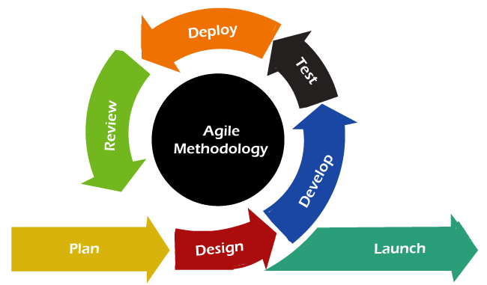

**Key Features of Agile Model Used:**  
• **Iterative Development:** Features like job posting, candidate profile, and messaging were developed in sprints.  
• **Continuous Feedback:** Stakeholder reviews after each sprint guided feature improvements.  
• **Incremental Releases:** Core functionalities were deployed first, followed by advanced features.  
• **Collaboration Tools:** GitHub for version control and issue tracking; Trello/Notion for task management.

**Example:** After developing the candidate application workflow, feedback from potential users was incorporated to improve the resume upload and job search functionality.

**4. System Design**

**4.1 Task Dependency Diagram**

The Task Dependency Diagram illustrates the relationships and dependencies between various modules of HireVerse. 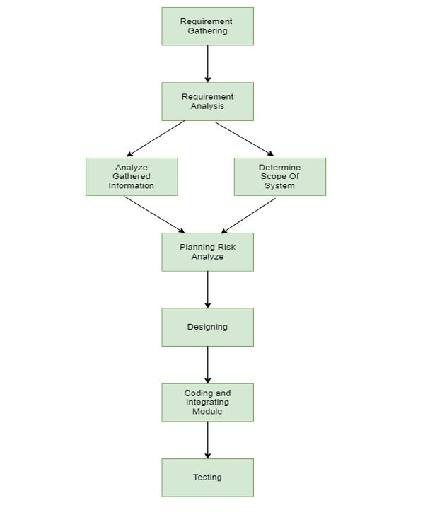

**4.2 Timeline Chart**

A Gantt-style timeline ensures project tasks are completed on schedule.

|  |  |  |  |  |  |
| --- | --- | --- | --- | --- | --- |
| Working Tasks | Day 1 | Day 2 | Day 3 | Day 4 | Day 5 |
| **1)Requirement Gathering** |  |  |  |  |  |
| Collected requirement from our guide |  |  |  |  |  |
| Analyze gathered information |  |  |  |  |  |
| Determine different modules |  |  |  |  |  |
| **2)Planning & analysis** |  |  |  |  |  |
| Analyze data for possible risk |  |  |  |  |  |
| Identify technical risk |  |  |  |  |  |
| Determine different modules |  |  |  |  |  |
| **3)Designing** |  |  |  |  |  |
| Design database tables |  |  |  |  |  |
| Design basic interface of the site |  |  |  |  |  |
| Design web form for modules |  |  |  |  |  |
| **4)Coding and development project** |  |  |  |  |  |
| Implement logic for different modules |  |  |  |  |  |
| Implement database connectivity |  |  |  |  |  |
| Implement Report |  |  |  |  |  |
| Integrate different modules |  |  |  |  |  |
| **5)Testing** |  |  |  |  |  |
| Validate input control and check accuracy of Reports |  |  |  |  |  |

**4.3 Sequence Diagram**

The Sequence Diagram shows interaction between components for a typical user action, such as a candidate applying for a job.

**Steps:**

1. Candidate logs in → Auth API validates credentials.
2. Candidate selects a job → Job API fetches details from MongoDB.
3. Candidate submits application → Application API stores application record.
4. Recruiter receives notification → Messaging API triggers real-time notification.

**Example:** Real-time feedback ensures recruiters instantly know when a new candidate applies, improving response times.

**4.4 Data Flow Diagram (DFD) / UML**

**Level 0 DFD (Context Level):**  
• External Entities: Candidate, Recruiter, Admin.  
• Processes: Authentication, Job Management, Application Management, Messaging.  
• Data Stores: Users Collection, Jobs Collection, Applications Collection, Messages Collection.

**Level 1 DFD (Detailed):**  
• **Candidate Flow:** Candidate submits profile → Profile API → MongoDB → Candidate Dashboard.  
• **Recruiter Flow:** Recruiter posts job → Job API → MongoDB → Job Listing API → Candidate Dashboard.

**UML Considerations:**  
• Class diagrams represent User, CandidateProfile, RecruiterProfile, Job, and Application objects.  
• Relationships include one-to-many between Recruiter and Job, one-to-many between Candidate and Application.

**Example:** The DFD ensures clear visibility of data movement, such as candidate details being securely stored and accessible only to authorized recruiters.

**4.5 Entity Relationship Diagram (ERD)**

The ERD illustrates relationships between MongoDB collections:

**Entities & Relations:**  
• **User**: Stores login credentials and role (candidate/recruiter).  
• **CandidateProfile**: Linked one-to-one with User.  
• **RecruiterProfile**: Linked one-to-one with User.  
• **Job**: Linked one-to-many with RecruiterProfile (a recruiter can post multiple jobs).  
• **Application**: Linked many-to-one with Job and CandidateProfile.  
• **Message**: Linked many-to-many between Users.

**Example:** A candidate can apply to multiple jobs, and each job can have multiple applicants, allowing dynamic querying and analysis of applications.

1. **User Interface**

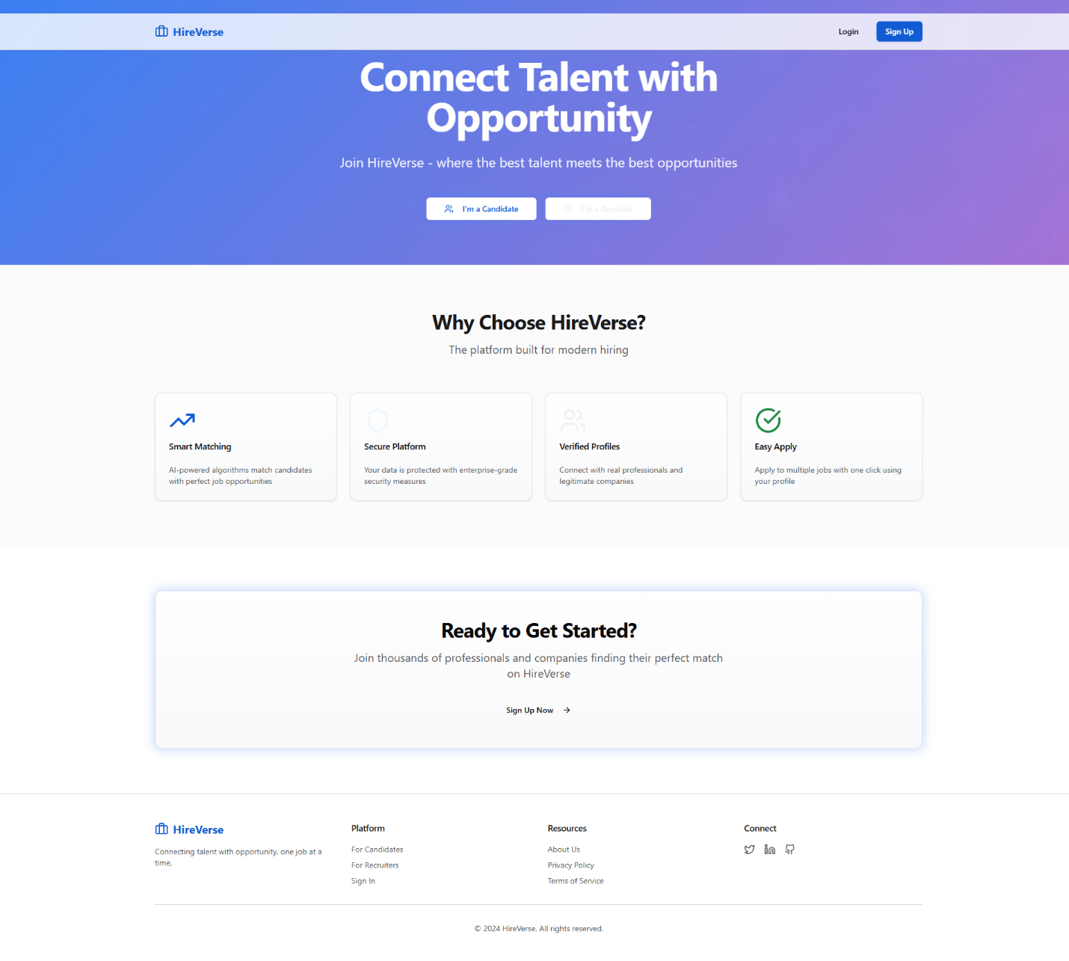**5.1 Landing Page:**

**5.2 Auth Page:**

**5.3 Candidate:**

5.3.1 Dashboard:

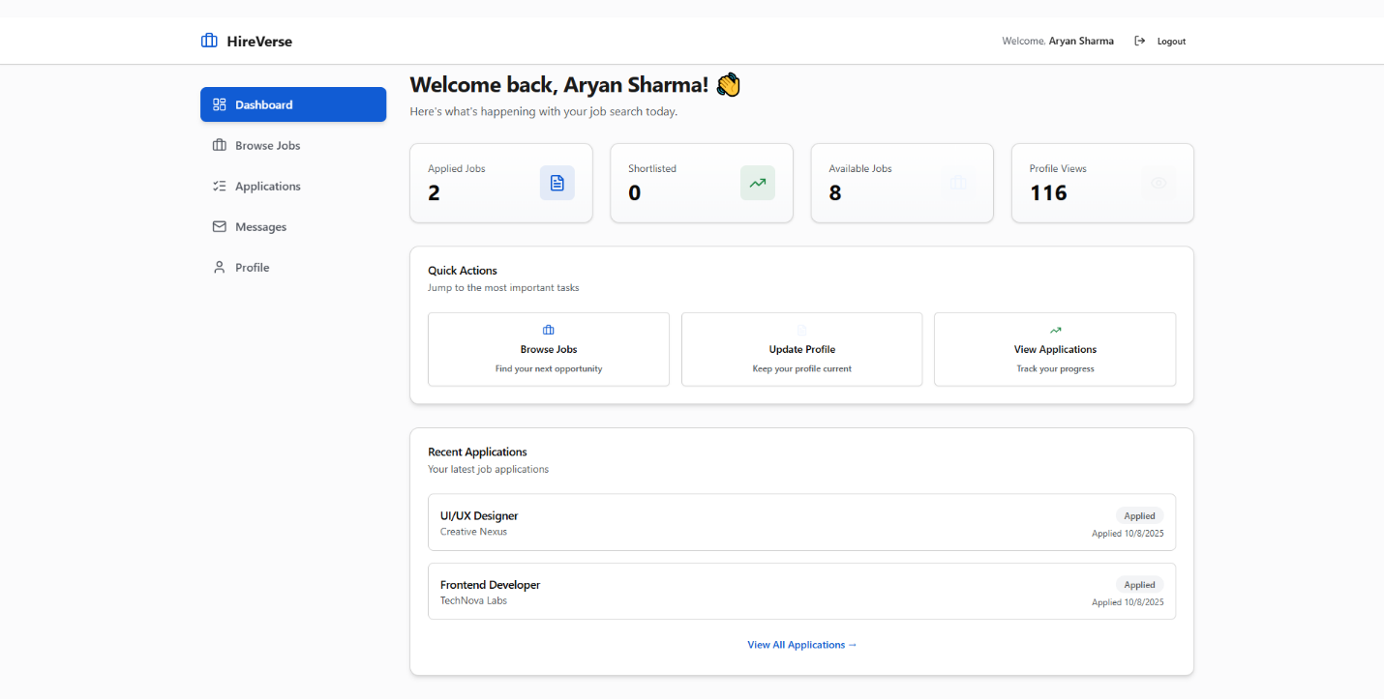

5.3.2 Browse Job:

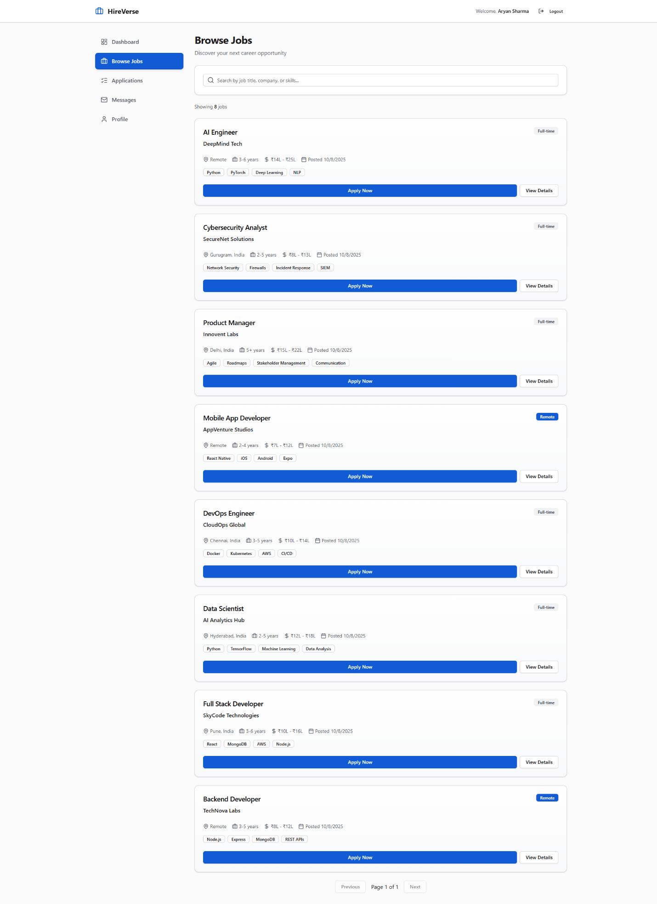

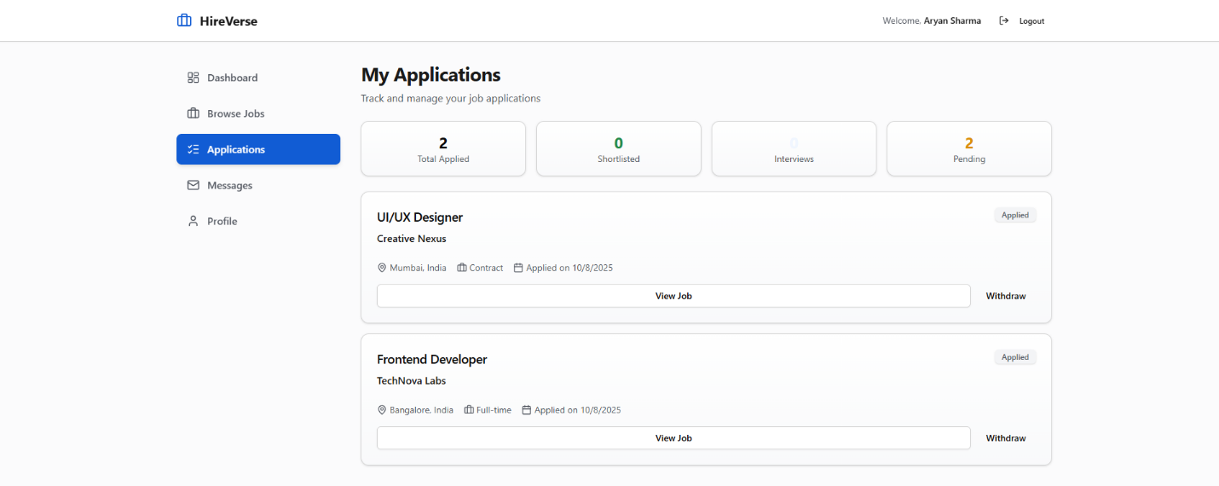5.3.3 Applications

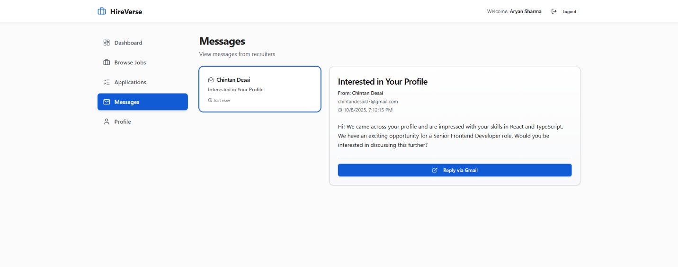5.3.4 Messages

5.3.5 Profile

5.3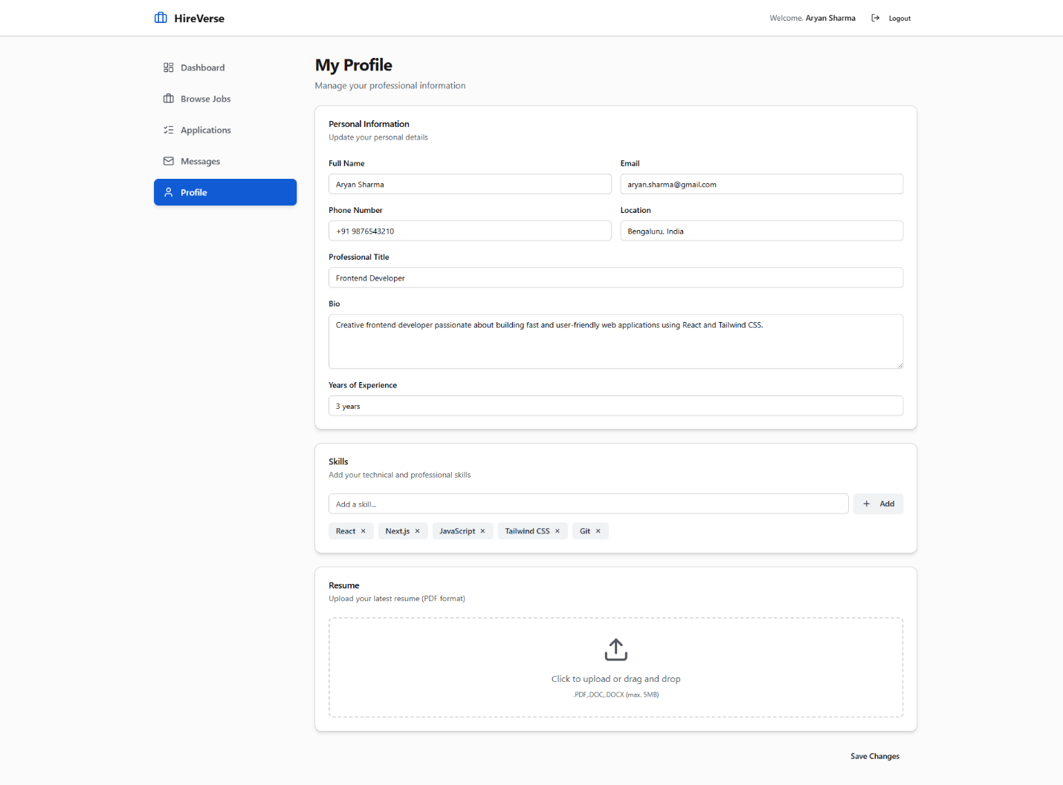.6 Job detail

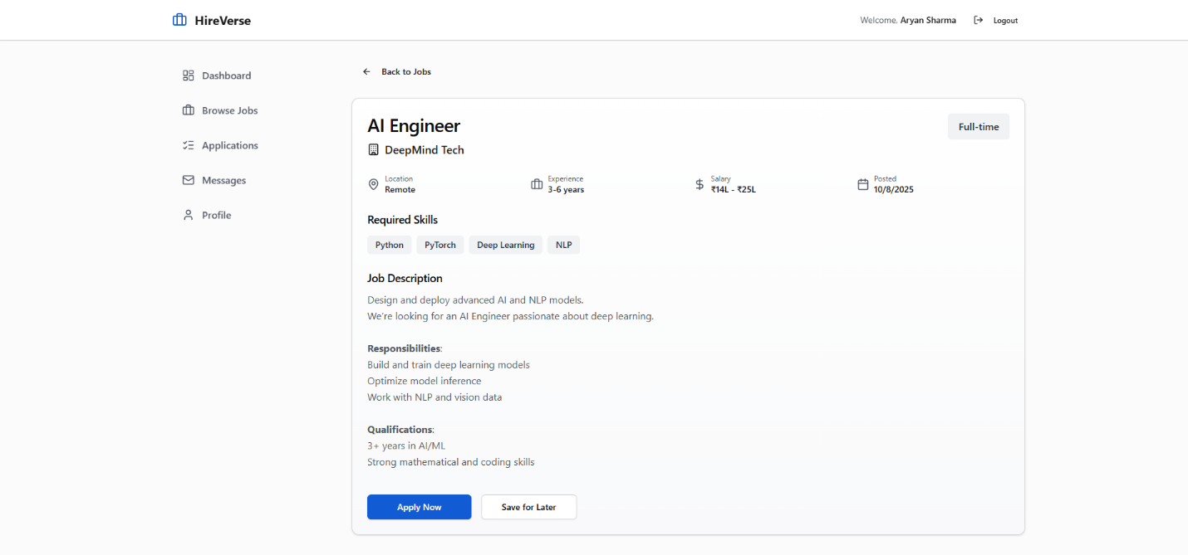

**5.4 Recruiter:**

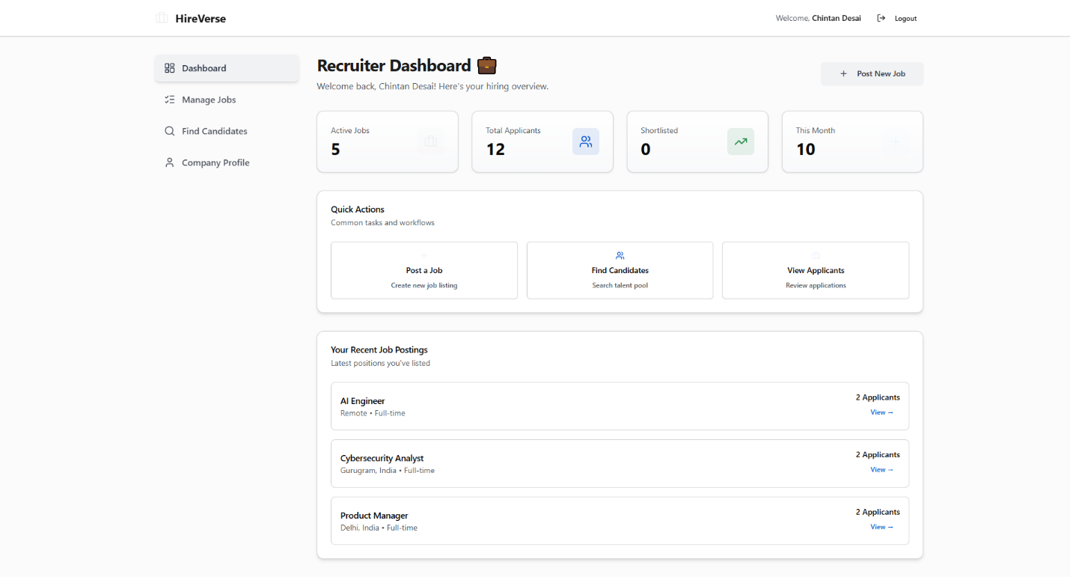5.4.1 Dashboard:

5.4.2 Manage Jobs

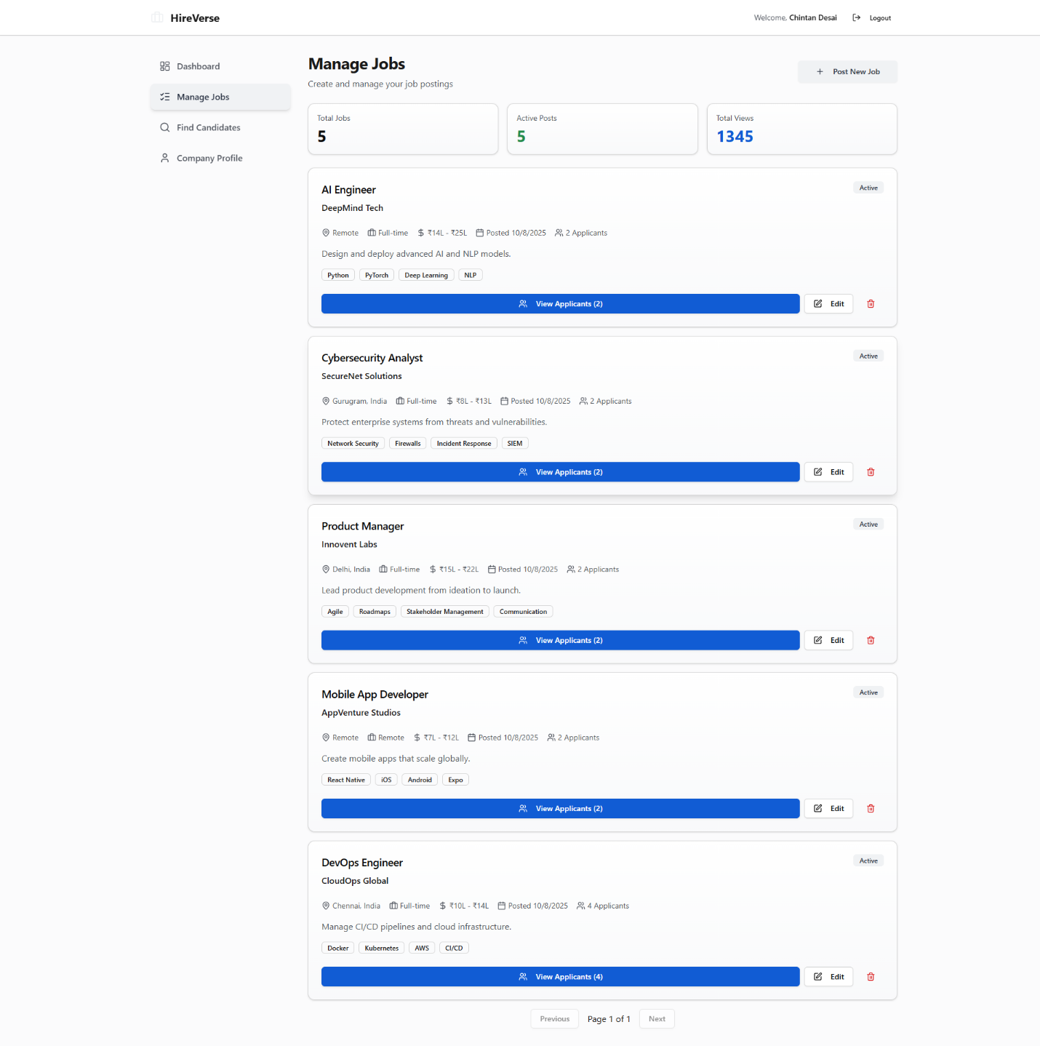5.4.3 Find candidates

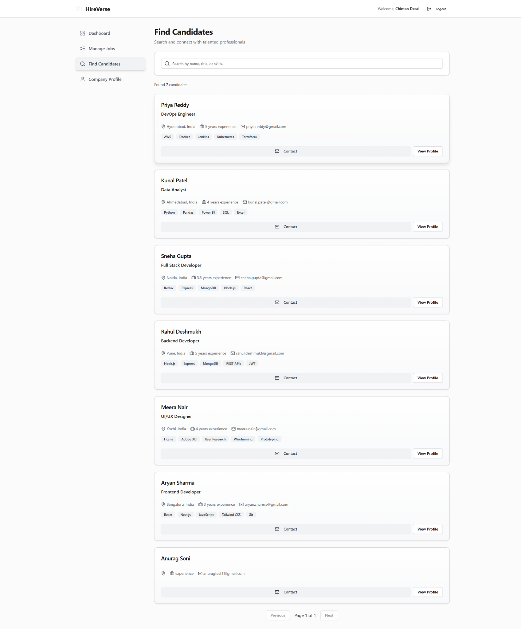5.4.4 Company profile

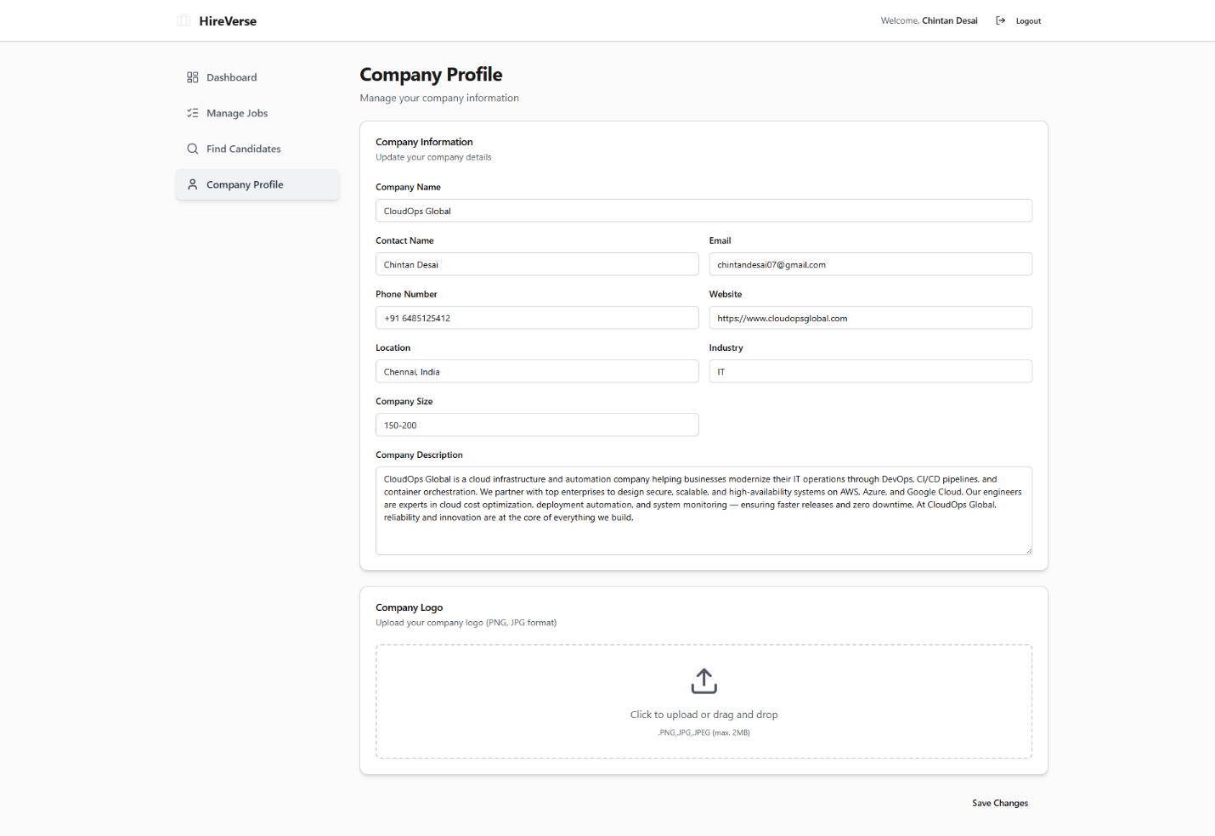

5.4.5 Post new job

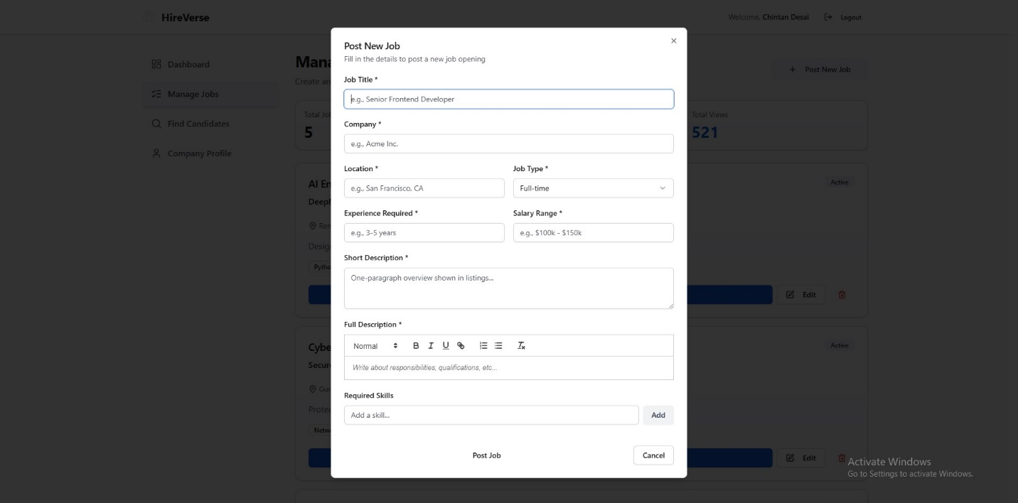

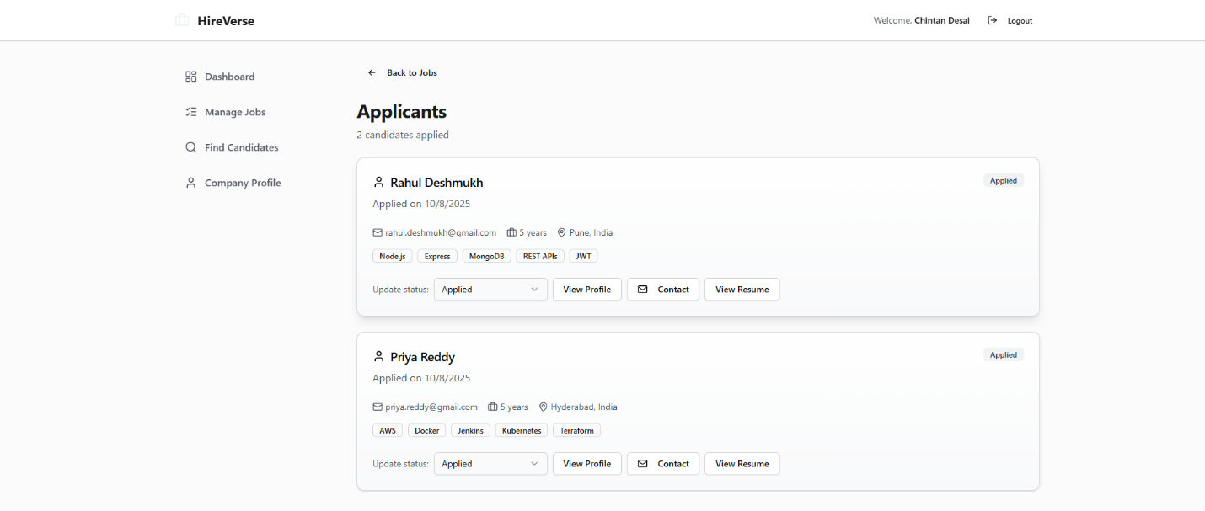5.4.6 View Applicants

5.4.7 View Candidate Profile

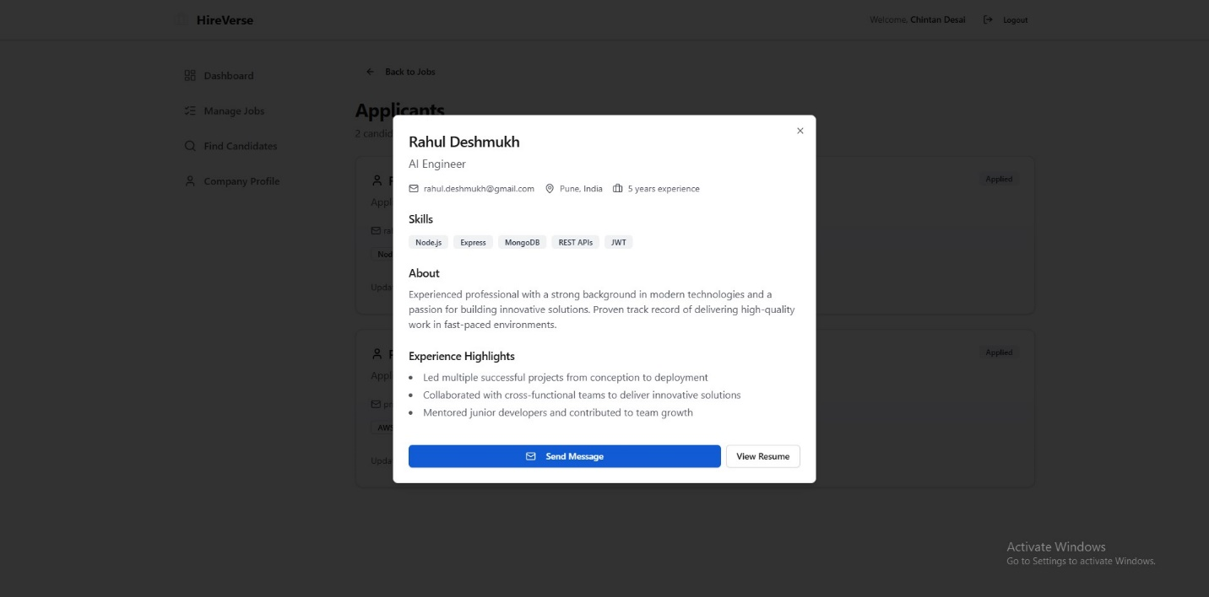

5.4.8 Send Message

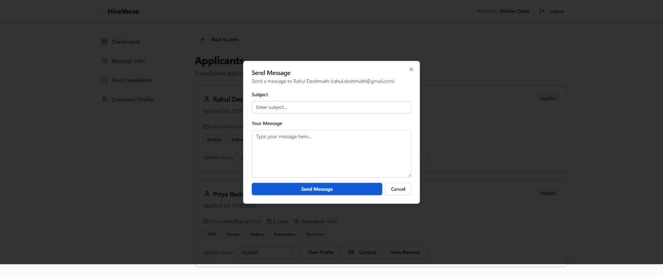

**6. Testing**

**6.1 Testing Approach**

HireVerse follows a combination of **manual and automated testing** to ensure robustness, security, and usability.

**Testing Levels:**  
• **Unit Testing:** Each backend API and frontend component is tested independently.  
• **Integration Testing:** Ensures seamless communication between frontend and backend.  
• **System Testing:** Tests the complete workflow for candidates and recruiters.  
• **User Acceptance Testing (UAT):** Conducted with a sample group of users to validate real-world usability and workflow accuracy.

**Tools Used:**  
• **Backend:** Jest, Supertest for API testing.  
• **Frontend:** React Testing Library for component behavior.  
• **Database:** MongoDB test instances to verify data integrity.  
• **Manual:** Test cases executed on Chrome, Firefox, and Edge browsers to check responsiveness and cross-browser compatibility.

**Example:** Ensuring that a candidate cannot apply to a job without logging in, or that a recruiter cannot post a job without proper validation.

**6.2 Testing Cases**

Sample test cases for major functionalities:

**Candidate Features:**

1. **Signup/Login:**
   * Verify valid credentials allow access.
   * Invalid credentials display appropriate error.
2. **Profile Creation:**
   * Test adding personal details, skills, and resume upload.
   * Confirm updates are saved in MongoDB.
3. **Job Application:**
   * Candidate can view job listings.
   * Applying updates both Application collection and recruiter dashboard.
4. **Dashboard & Analysis:**
   * Verify applied jobs appear correctly.
   * Skill analysis charts show accurate data.

**Recruiter Features:**

1. **Job Posting:**
   * Create, edit, and delete job listings.
   * Ensure job appears in candidate search.
2. **Candidate Search:**
   * Filtering by skills, location, and experience returns accurate results.
3. **Messaging:**
   * Sending messages triggers notifications.
   * Messages are stored correctly in the database.

**Example:** A candidate attempting to apply to the same job twice should see a validation error preventing duplicate applications.

**6.3 Implementation Approaches**

**Continuous Integration & Testing:**  
• **CI/CD:** Use GitHub Actions to run tests automatically on every push to main branch.  
• **Test Data Management:** Separate test database to avoid affecting production data.

**Error Handling and Debugging:**  
• API responses include descriptive error messages for easier debugging.  
• Frontend validations prevent empty form submissions or invalid inputs.

**Performance Testing:**  
• Load testing on job search and application submission to ensure system handles multiple simultaneous users.  
• Stress testing on messaging module for concurrent real-time notifications.

**Example:** Using automated scripts, 50 simultaneous candidates applying to different jobs are handled without any loss of data or system crashes, ensuring stability under load.

**7. Conclusion**

The HireVerse Job Portal project successfully demonstrates a **robust and user-friendly web application** for both candidates and recruiters. The system addresses the limitations of existing job portals by providing:

**Key Achievements:**  
• **Candidate-Centric Features:** Candidates can create a complete profile, upload resumes, track job applications, and view analytics for their applied jobs.  
• **Recruiter-Centric Features:** Recruiters can post jobs, filter candidates based on skills and experience, and communicate directly with applicants.  
• **Seamless User Experience:** Intuitive and responsive UI for both web and mobile devices ensures accessibility and ease of navigation.  
• **Real-Time Functionality:** Messaging, notifications, and status updates are handled efficiently, providing instant feedback to users.  
• **Secure and Scalable Architecture:** Implemented using MERN stack with secure authentication, data validation, and cloud-hosted backend services.

**Future Enhancements:**  
• Adding **AI-based job recommendations** for candidates.  
• Implementing **advanced analytics dashboards** for recruiters.  
• Integrating **payment gateway** for premium job postings.  
• Multi-language support and mobile app optimization for wider reach.

**Conclusion Statement:**  
HireVerse provides a comprehensive solution for bridging the gap between candidates and recruiters, offering both **efficiency and scalability** in modern recruitment processes. The system is designed to adapt and expand with evolving recruitment needs, ensuring long-term usability and growth potential.

**8. Bibliography**

# **8. Bibliography**

1. **MongoDB Documentation:** <https://www.mongodb.com/docs/>
2. **Express.js Documentation:** https://expressjs.com/
3. **React.js Documentation:** https://reactjs.org/docs/getting-started.html
4. **Node.js Documentation:** https://nodejs.org/en/docs/
5. **WebSocket Protocol:** https://developer.mozilla.org/en-US/docs/Web/API/WebSockets_API
6. **MERN Stack Tutorials and Guides:**
   * freeCodeCamp: https://www.freecodecamp.org/news/mern-stack-tutorial
   * MongoDB University: https://university.mongodb.com/
7. **Tailwind CSS Documentation:** <https://tailwindcss.com/docs>
8. **RESTful API Design Principles:** https://restfulapi.net/
9. **JWT Authentication Guide:** https://jwt.io/introduction/
10. **Deployment & Hosting References:**
    * AWS Documentation: https://aws.amazon.com/documentation/
    * Google Cloud Docs: https://cloud.google.com/docs