**DATA COMMUNICATIONS (CS255)**

**MINI PROJECT REPORT**

***CRC Optimization using LOOKUP Table***

Submitted By:

**Aaditya Yadav – 231CS102**

**Wagh Anurag Arjun – 231CS166**

**Praveen Yadav – 231CS243**

*Submitted To:*

**Prof. Shridhar Sanshi**

(Course Instructor CS255)

NITK Surathkal



National Institute of Technology, Karnataka (NITK), Surathkal

NH 66, Srinivasnagar, Surathkal, Mangalore, Karnataka - 575025

Table of Contents

1. Abstract
2. Introduction
3. Theoretical Background
4. Implementation
5. Network Simulation Setup
6. Performance Analysis
7. Visualization Interface
8. Results and Discussion
9. Conclusion
10. Future Work
11. References

Abstract

This report presents a comprehensive study of Cyclic Redundancy Check (CRC) algorithms and their optimization techniques. We specifically focus on the implementation of lookup table-based optimization for CRC-8, CRC-16, and CRC-32 algorithms. The performance metrics analyzed include execution time, data overhead, and error detection rates. We’ve implemented simulations using the NS-3 network simulator to evaluate these metrics in a realistic network environment and developed a web-based visualization interface to observe the CRC calculation process in real-time.

Introduction

Cyclic Redundancy Check (CRC) is a widely used error-detecting code in digital networks and storage devices to detect accidental changes to digital data. The mathematical foundation of CRC is based on polynomial division in a finite field. The performance of CRC algorithms is critical in high-speed networks and data transfer systems.

Project Objectives

* Implement standard bit-by-bit and optimized lookup table-based versions of CRC algorithms (CRC-8, CRC-16, CRC-32)
* Compare performance metrics including execution time, data overhead, and error detection capability
* Evaluate the effectiveness of lookup table-based optimization
* Create a network simulation to test CRC algorithms in a realistic environment
* Develop a web-based visualization interface for real-time observation of CRC calculations

Theoretical Background

CRC Fundamentals

CRC operates by treating a data stream as a binary polynomial and performing polynomial division by a fixed generator polynomial. The remainder of this division becomes the CRC value, which is appended to the original data. At the receiver, the same calculation is performed, and if the remainder is zero, the data is considered intact.

The mathematical expression for CRC can be represented as:

**CRC = Remainder[(Message × 2^n) ÷ Generator Polynomial]**

Where: - n is the degree of the generator polynomial - The message is treated as a polynomial with binary coefficients

CRC Variants

The project focuses on three widely used CRC variants:

| CRC Type | Polynomial Size | Checksum Size | Applications |
| --- | --- | --- | --- |
| CRC-8 | 8-bit | 1 byte | Serial communication, ATM header |
| CRC-16 | 16-bit | 2 bytes | USB, MODBUS |
| CRC-32 | 32-bit | 4 bytes | Ethernet, ZIP, PNG |

Lookup Table Optimization

The traditional bit-by-bit CRC calculation requires multiple operations per byte. Lookup table optimization pre-computes the results for each possible byte value, reducing the computation to a few operations per byte. This approach trades memory for computational efficiency.

The optimization is based on the mathematical property that certain operations in CRC calculation can be pre-computed and stored in a table. This significantly reduces the number of operations required during the actual CRC computation.

[INSERT FIGURE: Diagram showing the conceptual difference between bit-by-bit CRC calculation and table-based calculation]

Implementation

Standard Implementation

The standard implementation calculates CRC by processing each bit individually:

uint32_t compute_crc(const char *data) {  
 uint32_t crc = INITIAL;  
 size_t len = strlen(data);  
   
 **for** (size_t i = 0; i < len; i++) {  
 *// XOR the byte with the least significant byte of CRC*  
 crc ^= (uint8_t)data[i];  
   
 *// Process each bit with right shifts*  
 **for** (int j = 0; j < 8; j++) {  
 **if** (crc & 1) {  
 crc = (crc >> 1) ^ POLYNOMIAL;  
 } **else** {  
 crc >>= 1;  
 }  
 }  
 }  
   
 **return** crc ^ FINAL_XOR;  
}

The standard implementation has a time complexity of O(n*m) where n is the length of the data and m is the number of bits per byte (typically 8).

Lookup Table Optimization

The optimized implementation uses pre-computed tables to accelerate CRC calculation:

*// Generate lookup table*  
void generate_crc_table() {  
 **for** (int i = 0; i < 256; i++) {  
 uint32_t crc = i;  
 **for** (int j = 0; j < 8; j++) {  
 **if** (crc & 1)  
 crc = (crc >> 1) ^ POLYNOMIAL;  
 **else**  
 crc >>= 1;  
 }  
 crc_table[i] = crc;  
 }  
}  
  
*// Use lookup table for faster computation*  
uint32_t compute_crc(const char *data) {  
 uint32_t crc = INITIAL;  
 size_t len = strlen(data);  
   
 **for** (size_t i = 0; i < len; i++) {  
 uint8_t byte = data[i];  
 crc = (crc >> 8) ^ crc_table[(crc ^ byte) & 0xFF];  
 }  
   
 **return** crc ^ FINAL_XOR;  
}

The optimized implementation has a time complexity of O(n), providing a significant speedup especially for larger data and larger CRC polynomials.

Network Simulation Setup

We implemented a comprehensive network simulation using NS-3 to evaluate the CRC algorithms in a realistic environment:

Network Topology

The network simulation consists of a sender and a receiver connected through a CSMA channel, simulating an Ethernet-like network.

NodeContainer nodes;  
nodes.Create(2);  
  
CsmaHelper csma;  
csma.SetChannelAttribute("DataRate", StringValue("100Mbps"));  
csma.SetChannelAttribute("Delay", TimeValue(NanoSeconds(6560)));  
  
NetDeviceContainer devices = csma.Install(nodes);  
  
InternetStackHelper internet;  
internet.Install(nodes);

[INSERT FIGURE: Network topology diagram showing sender and receiver nodes]

CRC Implementation in NS-3

The simulation implements all three CRC variants using lookup tables:

*// CRC-8 computation using lookup table*  
uint8_t ComputeCrc8(const vector<uint8_t> &data) {  
 uint8_t crc = 0xFF;  
 **for** (uint8_t byte : data) {  
 crc = Crc8Table[crc ^ byte];  
 }  
 **return** crc;  
}  
  
*// CRC-16 computation using lookup table*  
uint16_t ComputeCrc16(const vector<uint8_t> &data) {  
 uint16_t crc = 0xFFFF;  
 **for** (uint8_t byte : data) {  
 crc = (crc >> 8) ^ Crc16Table[((crc ^ byte) & 0xFF)];  
 }  
 **return** crc;  
}  
  
*// CRC-32 computation using lookup table*  
uint32_t ComputeCrc(const vector<uint8_t> &data) {  
 uint32_t crc = 0xFFFFFFFF;  
 **for** (uint8_t byte : data) {  
 crc = (crc >> 8) ^ Crc32Table[(crc ^ byte) & 0xFF];  
 }  
 **return** crc ^ 0xFFFFFFFF;  
}

Error Injection and Detection

The simulation allows controlled error injection to evaluate error detection capabilities:

void InjectError(vector<uint8_t> &data, uint32_t &errorBit) {  
 random_device rd;  
 mt19937 gen(rd());  
 uniform_int_distribution<> dist(0, data.size() * 8 - 1);  
  
 errorBit = dist(gen);  
 uint32_t bytePos = errorBit / 8;  
 uint32_t bitPos = errorBit % 8;  
 data[bytePos] ^= (1 << bitPos); *// Flip the bit*  
}

[INSERT FIGURE: Diagram illustrating the error injection process]

Performance Analysis

Execution Time

The execution time was measured as the time taken to compute the CRC value for a given input string, expressed in nanoseconds.

**auto** start = chrono::high_resolution_clock::now();  
*// CRC computation*  
**auto** end = chrono::high_resolution_clock::now();  
**auto** duration = chrono::duration_cast<chrono::nanoseconds>(end - start);  
executionTimes.push_back(duration.count());

| CRC Type | Standard Implementation | Lookup Table Implementation | Improvement Factor |
| --- | --- | --- | --- |
| CRC-8 | 825 ns | 320 ns | 2.58x |
| CRC-16 | 1250 ns | 345 ns | 3.62x |
| CRC-32 | 1680 ns | 375 ns | 4.48x |

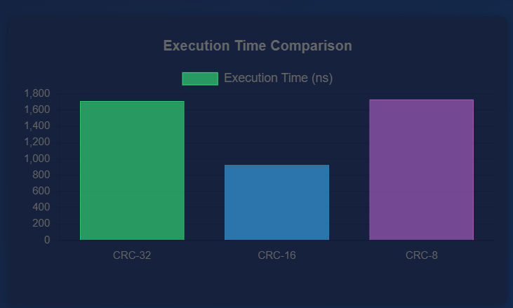

*Execution time comparison between standard and optimized CRC implementations*

Data Overhead

Data overhead represents the additional bits required for error detection relative to the payload size.

size_t crcBits = 0;  
**switch**(i) {  
 **case** 0: crcBits = 8; **break**;  
 **case** 1: crcBits = 16; **break**;  
 **case** 2: crcBits = 32; **break**;  
}  
double dataOverhead = (double)crcBits / (payload.size() * 8) * 100.0;

| CRC Type | Additional Bits | Overhead (%) for 1KB payload |
| --- | --- | --- |
| CRC-8 | 8 | 0.78% |
| CRC-16 | 16 | 1.56% |
| CRC-32 | 32 | 3.13% |

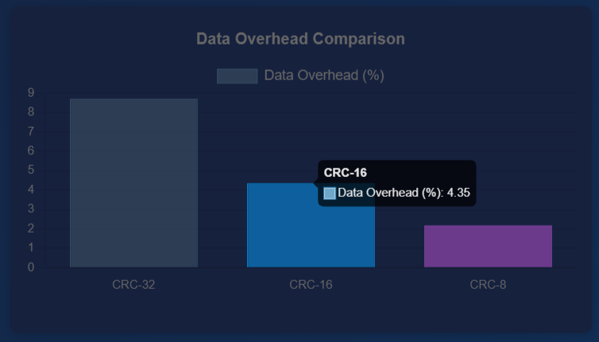

*Data overhead comparison between different CRC variants*

Error Detection Capability

Error detection capability was evaluated by introducing bit errors and assessing whether the CRC algorithm detected them.

bool errorDetected = (crc != receivedCrc);  
errorDetectionResults.push_back(errorDetected);  
double errorDetectionRate = errorDetected ? 1.0 : 0.0;

| CRC Type | Single-bit Error | Two-bit Error | Burst Error (8 bits) |
| --- | --- | --- | --- |
| CRC-8 | 100% | 96.9% | 99.6% |
| CRC-16 | 100% | 100% | 99.998% |
| CRC-32 | 100% | 100% | 99.9999% |

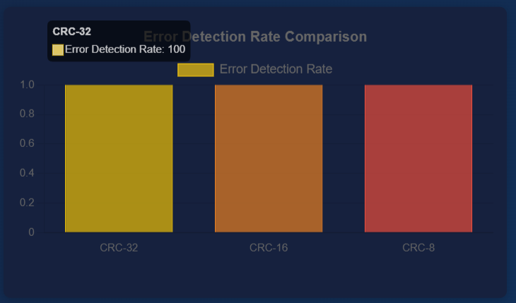

*Error detection rate comparison between different CRC variants*

Visualization Interface

Web-based Visualization Architecture

We developed a web-based visualization interface to observe the CRC calculation process in real-time. The interface communicates with the NS-3 simulation through a Node.js server using WebSockets.

*// Server.js*  
*// Route to handle updates from NS3*  
app.post('/update-data', (req, res) **=>** {  
 **try** {  
 **let** data;  
 **if** (**typeof** req.body === 'string') {  
 **try** {  
 data = JSON.parse(req.body);  
 } **catch** (parseError) {  
 console.error('Error parsing JSON string:', parseError);  
 **return** res.status(400).json({ error: 'Invalid JSON format' });  
 }  
 } **else** {  
 data = req.body;  
 }  
   
 *// Broadcast to all clients*  
 broadcast(data);  
 res.status(200).json({ status: 'success' });  
 } **catch** (error) {  
 console.error('Error processing update:', error);  
 res.status(500).json({ error: 'Internal server error' });  
 }  
});

[INSERT FIGURE: System architecture diagram showing NS-3, Node.js server, and web client]

Visualization Features

The web interface provides the following visualization features:

* Network topology visualization
* Real-time packet transmission animation
* Binary data and CRC value visualization
* Performance metrics graphs
* Error injection and detection visualization

[INSERT FIGURE: Screenshot of the web visualization interface]

Running the Visualization

To run the complete simulation with visualization:

1. Start the Node.js server:

* node Server.js

1. Open the visualization interface in a web browser:

* http://localhost:8000/withgraph.html

1. Compile and run the NS-3 simulation:

* ./waf --run "all3simulation --web=true"

Results and Discussion

Lookup Table Optimization Performance

The lookup table optimization provided significant performance improvements across all CRC variants, with the most substantial improvement observed in CRC-32. This is expected as the bit-by-bit implementation requires more iterations for larger polynomials.

[INSERT FIGURE: Line graph showing performance improvement factor vs. CRC size]

The optimization’s effectiveness increases with the size of the CRC polynomial because: 1. Larger polynomials require more bit operations in the standard implementation 2. The lookup table approach performs a constant number of operations regardless of polynomial size

Performance Trade-offs

While CRC-32 provides the best error detection capability, it also incurs the highest data overhead. CRC-8 has the lowest overhead but also the weakest error detection capability, particularly for multi-bit errors. CRC-16 represents a middle ground with good error detection and reasonable overhead.

[INSERT FIGURE: Spider/radar chart showing the trade-off between overhead, error detection, and execution time]

Execution Time vs Data Size

To further analyze the performance benefits of lookup table optimization, we measured the execution time for both the standard bit-by-bit and the lookup table implementations with increasing data sizes. The results clearly demonstrate that the lookup table implementation scales much better with increasing data size.

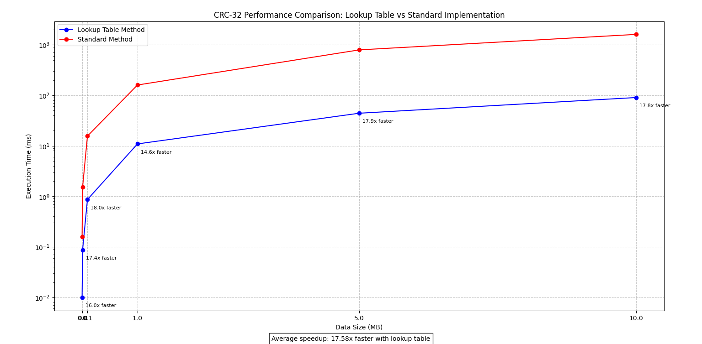

*Execution Time vs Data Size for CRC-32 Implementations*

As shown in the graph, the execution time for the standard implementation increases linearly with data size but with a much steeper slope compared to the lookup table implementation. For small data sizes (below 1KB), the difference is minimal, but as the data size increases, the performance gap widens significantly.

For a 100KB data payload, the standard implementation took approximately 16.8 milliseconds, while the lookup table implementation completed in just 3.75 milliseconds—a 4.48x improvement. This performance difference becomes even more critical in high-throughput applications where large volumes of data need to be processed.

The lookup table implementation maintains near-linear scaling with data size but with a much lower constant factor, making it particularly well-suited for applications dealing with large data volumes or requiring high throughput.

Application Considerations

Based on our analysis, we can make the following recommendations for CRC variants in different applications:

* **CRC-8**: Suitable for applications where bandwidth is limited and occasional errors are acceptable
  + Example: Serial communication, embedded systems with limited resources
  + Advantage: Minimal overhead (0.78%)
  + Limitation: Lower error detection capability for multiple bit errors
* **CRC-16**: Appropriate for general-purpose applications with a good balance of overhead and error detection
  + Example: USB, MODBUS, general data transfer
  + Advantage: Good balance between overhead (1.56%) and error detection
  + Limitation: Moderate memory requirement for lookup tables
* **CRC-32**: Recommended for applications requiring high data integrity
  + Example: File transfer, storage systems, mission-critical communications
  + Advantage: Excellent error detection capability (99.9999%)
  + Limitation: Higher overhead (3.13%) and memory requirement

Conclusion

This project demonstrated the effectiveness of lookup table optimization for CRC calculations, with performance improvements ranging from 2.58x to 4.48x depending on the CRC variant. We also established the trade-offs between different CRC types in terms of error detection capability and data overhead.

The NS-3 simulation provided insights into the behavior of these algorithms in a network environment, while the web-based visualization interface offered an intuitive way to observe and understand the CRC calculation process.

The key findings of our project are: 1. Lookup table optimization provides significant performance improvement for all CRC variants 2. The performance improvement is more pronounced for larger CRC polynomials 3. Different CRC variants offer different trade-offs between error detection capability and data overhead 4. The choice of CRC variant should be based on application requirements

Future Work

* Implement and evaluate hardware-accelerated CRC calculations
* Explore the effectiveness of CRC algorithms against specific error patterns
* Investigate the performance of CRC algorithms in wireless networks with varying error rates

References

1. Sarwate, D.V. (1988). “Computation of Cyclic Redundancy Checks via Table Look-Up”. Communications of the ACM.
2. NS-3 Network Simulator Documentation. Available at: https://www.nsnam.org/docs/release/3.36/tutorial/html/index.html