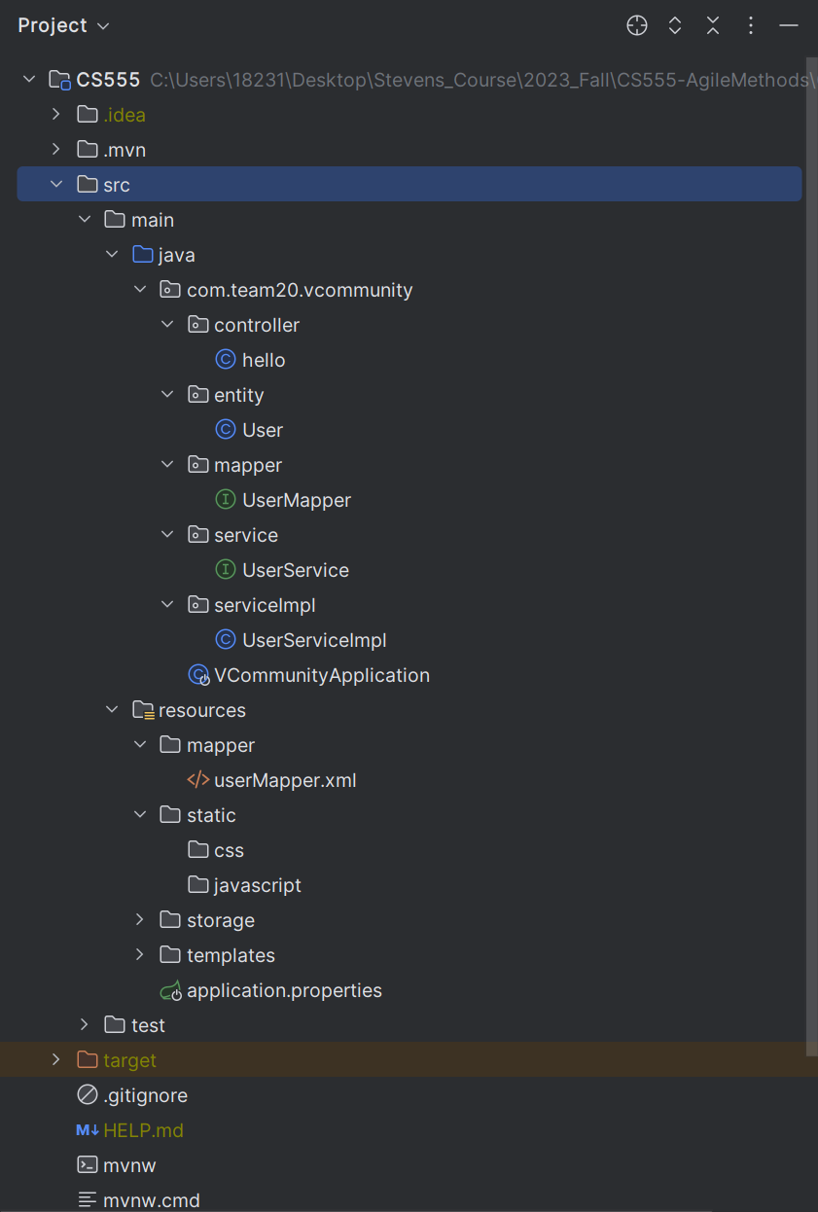

**VCommunityApplication:** run it to launch the project

**resources:**

templates: html

Static: css & javascript

storage: sql file for database

mapper: to store sql command for database operations

application.properties: properties of spring .etc

**pom.xml:** dependencies of project

**Java/com.team20.vcommunity:** (back-end code)

Controller: interact with front end

Entity: entity objects to reflect data in database (e.g user, community, post .etc)

Mapper: transfer sql command into java

Service: interfaces that store specific functions (e.g login, create posts .etc)

ServiceImpl: classes implement interfaces in service