1. create new project🡪class library

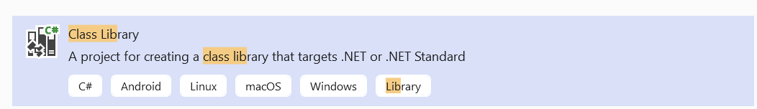

2.right click on project🡪manage nuGet package🡪browse🡪

Use 6.0.0 version

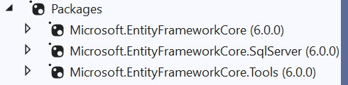

3.create 3 classes

Category

Product

ShoppingContext

4.migration steps:

Tools🡪NuGet Package Manager🡪Package Manager Console🡪

add-migration firstmig

update-database

5.right click on solution🡪Add🡪New Project🡪select Console App

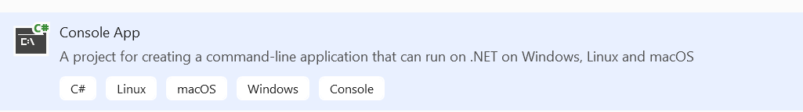

6.right click on Console App🡪Add🡪Project Reference🡪

Select classlibrary project🡪OK

7.complete code

8.right click on consoleApp🡪set as startup project