1.create new project🡪 classlibrary

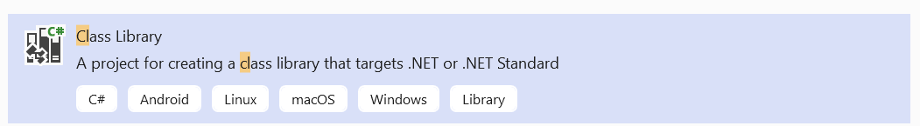

3.in classlibrary project🡪add 2 folders🡪models and repository

4.In Models folders add 2 classes 🡪AdminUser and Product

5.In Repoistory Folders add 3 files🡪IShopRepo,ShopRepo,ShoppingContext

6.right click on classlibrary🡪manage nuget package🡪browse🡪install

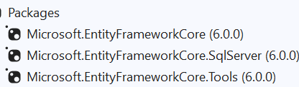

Complete AdminUser,Product,ShoppingContext classes then perform migration

7.migration:

Tools🡪Nudget Package Manager🡪package Manager Console🡪

Add-migration firstmig

Update-database

8.complete repository code(IShopRepo and ShopRepo)

9.right click on solution🡪add🡪new project🡪MVC project🡪give name MVCshop

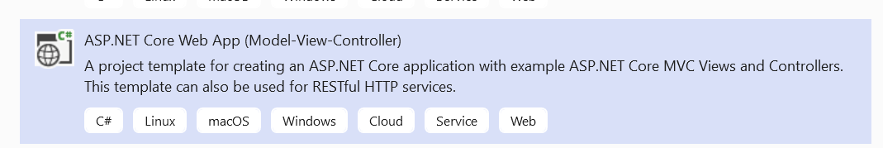

10.In Mvc project🡪in models folders🡪add 2 classes AdminUser and Product.

11.delete homecontroller

12.right click on controller🡪add new AdminController

13.right click on mvc project🡪add🡪project reference🡪add classlibrary reference(check the checkbox)

14.In Program.cs file 🡪change default controller name to Admin

15.add below line to program.cs file

builder.Services.AddSingleton<IShopRepo,ShopRepo>();

16.complete adminController

17.In AdminController🡪create httpget method for index

18.inside index method🡪right click add view🡪razor view🡪

19.in Index.cshtml,change (input type=submit button) value to login

<input type="submit" value="Login" class="btn btn-primary" />

20.in program.cs file enable the session by following code

builder.Services.AddDistributedMemoryCache();

builder.Services.AddSession();

app.UseSession();

21.complete post method of Index(AdminController)

22.in index view—add below code at last

<h1>@ViewBag.myerror</h1>

23.add ProductController

24.right click on mvc project🡪set as startup project

25.in layout file add below code

<ul class="navbar-nav flex-grow-1">

<li class="nav-item">

<**a** class="nav-link text-dark" **asp-area**="" **asp-controller**="Product" **asp-action**="Index">Products</**a**> </li>

<li class="nav-item"> <**a** class="nav-link text-dark" **asp-area**="" **asp-controller**="Admin" **asp-action**="Logout">Logout</**a**>

</li>

</ul>

26.In product controller, add dependencies injection code and complete Index method

27.add view for Index method as below and complete the code

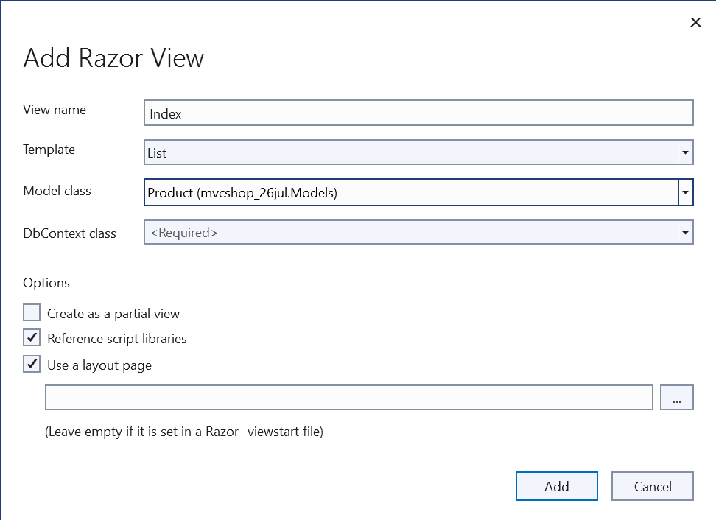

28.create httpget method for Create() ,add view as below

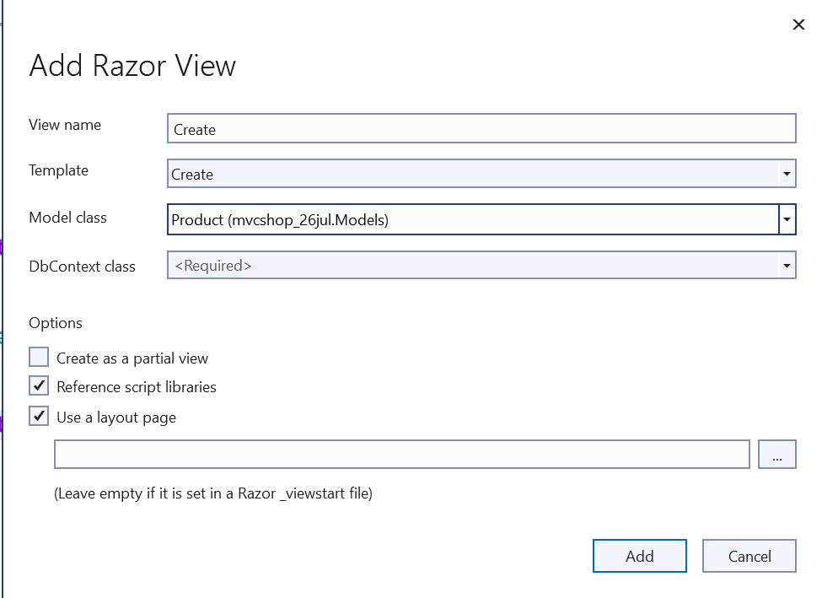

29.complete the post method of create()

30.in Create.cshtml page(view)—comment ProductId div

31.in Index.cshtml(product) change below code

@Html.ActionLink("Edit", "Edit", new { id=item.ProductId }) |

@Html.ActionLink("Details", "Details", new { id=item.ProductId }) |

@Html.ActionLink("Delete", "Delete", new { id=item.ProductId })

32. edit,delete,details—get method code is same

33.