Smart Irrigation System for Optimal Crop Management

……………………………………………………………………………………………………………………………………………………………………………………………………………….

……………………………………………………………………………………………………………………………………………………………………………………………………………….

………………………………………………………………………………………………………………………………………………………………………………

………………………………………………………………………………………………………………………………………………………………………………

………………………………………………………………………………………………………………………………………………………………………………………………………………

………………………………………………………………………………………………………………………………………………………………………………………………………………

# *Abstract*— Efficient irrigation is critical for sustainable agriculture, especially with increasing resource constraints and challenges like irregular electricity supply. This paper presents a Smart Irrigation System for Optimal Crop Management, integrating IoT technologies to automate and optimize irrigation. The system utilizes soil moisture sensors, water pumps, an ESP8266 microcontroller, and cloud platforms such as Firebase, allowing farmers to control irrigation remotely via a mobile app. The mobile application features crop and soil type configuration, manual irrigation control, and automated irrigation based on a priority algorithm that considers soil moisture, crop type, and soil type. Additionally, the system includes a crop condition management function to prioritize irrigation for moderately stressed crops. By combining IoT-based monitoring and decision-making, the proposed system reduces water wastage, saves time, and addresses challenges faced by farmers in traditional irrigation practices. This study highlights the potential of IoT in transforming agriculture and ensuring sustainable irrigation practices.

## Keywords— Smart Irrigation, Internet of Things (IoT), Automated irrigation, Soil Moisture, Crop Management, Water Conservation, Sustainable Agriculture, MIT App Inventor, Firebase.

1. Introduction

Water scarcity poses a significant challenge to agricultural productivity and sustainability. Traditional irrigation methods often lead to inefficient water usage, resulting in both over-irrigation and under-irrigation, which adversely affect crop health and yield. These inefficiencies are primarily due to the lack of real-time monitoring and control systems, where irrigation practices are not tailored to the specific needs of different crops. Consequently, valuable water resources are wasted, and the overall effectiveness of

irrigation is reduced, ultimately impacting crop productivity[1], [2].

Smart irrigation systems, which integrate IoT technology, provide an innovative solution to this problem by enabling real-time monitoring and automated control of irrigation practices. By utilizing sensors (e.g., soil moisture, temperature), these systems adjust irrigation based on real- time environmental conditions, significantly reducing water wastage and improving crop yields [3], [4], [5].

Recent advancements have paved the way for the integration of various technologies, such as cloud computing, wireless sensor networks, and machine learning, into smart irrigation systems. For instance, platforms like ThingSpeak and Firebase allow for real-time data storage, analysis, and control, providing a robust infrastructure for smart agriculture [6], [7]. These technologies enable better decision-making by continuously monitoring environmental variables like soil moisture, temperature, and humidity, which play a critical role in optimizing irrigation schedules. A study on systems utilizing Raspberry Pi, ESP32, and other microcontrollers demonstrated how IoT and cloud-based systems can automate and optimize irrigation, enhancing water usage efficiency[2], [8], [9].

This research focuses on the development of a smart irrigation system that automates irrigation based on key parameters such as soil moisture levels, crop water requirements, and soil suitability. By employing IoT technology, the system improves irrigation efficiency, reduces water consumption, and contributes to more sustainable agricultural practices. The integration of IoT- enabled sensors and cloud computing makes this system scalable, adaptable, and highly efficient, addressing both current and future challenges in water management for agriculture [10], [11], [12].

Given the increasing global demand for food, it is essential to adopt innovative solutions that optimize resource usage

while maintaining or improving crop yield. This study introduces an automated irrigation system that prioritizes irrigation based on real-time data, ensuring that the right amount of water is delivered to crops when needed. By adapting irrigation schedules to specific crop needs and environmental conditions, this system aims to prevent water wastage and improve crop productivity. Studies have shown that systems leveraging machine learning algorithms like SVM, random forests, and kNN for irrigation prediction can greatly enhance the accuracy and efficiency of irrigation systems [11], [13], [14].

Moreover, some systems integrate [15] fuzzy logic to optimize water usage further, adapting irrigation decisions based on fluctuating environmental conditions and crop- specific water requirements [8], [16]. These intelligent algorithms ensure that the system adjusts in real time to variables such as rainfall, temperature, and soil moisture levels, leading to more precise and effective water management. Several implementations of IoT-based smart irrigation systems also incorporate weather forecasting, allowing for proactive adjustments to irrigation schedules, further optimizing water use and reducing wastage [6], [17], [18].

The growing focus on precision farming techniques highlights the potential of smart irrigation systems in modernizing agriculture and improving sustainability. IoT- based systems not only reduce the dependence on manual labor but also allow for remote monitoring and control through mobile applications, enabling farmers to make data- driven decisions. These advancements in automation and data analytics are crucial for ensuring sustainable water management practices and improving agricultural productivity in the face of growing global food demand [19], [20], [21].

1. Related Work

Recent advancements in smart irrigation systems leveraging IoT technology have shown significant potential in enhancing agricultural management and efficiency. These systems employ a variety of technologies, including sensors, cloud platforms, and machine learning algorithms, to monitor and optimize irrigation practices in real time. Early research into smart irrigation systems focused on integrating Raspberry Pi, Arduino, and ESP32 microcontrollers with sensors like soil moisture, temperature, and humidity to automate irrigation based on environmental data [2], [13], [18]. One such system, which uses ThingSpeak for real-time data analysis and NodeMCU for control, demonstrated the effectiveness of automating irrigation to reduce water consumption and improve crop yield [3], [6], [7].

The integration of wireless sensor networks (WSNs) into smart irrigation systems has significantly improved the ability to manage water resources efficiently. For instance, Bluetooth-based communication and Wi-Fi connectivity

have been widely used to transmit data from field sensors to cloud platforms for analysis and decision-making [10], [12], [17]. A notable example includes the use of IoT-enabled sensors to track key parameters such as soil moisture, temperature, and humidity, allowing for better real-time decision-making regarding irrigation needs [11], [14], [20].

Recent studies have incorporated machine learning algorithms like Support Vector Machines (SVM), Random Forest, and K-Nearest Neighbors (KNN) to predict irrigation needs based on sensor data and environmental conditions. These algorithms improve the accuracy of irrigation predictions, ensuring that water is applied only when necessary, thus reducing wastage and enhancing water use efficiency [11], [14], [22]. The introduction of fuzzy logic systems also offers a more flexible approach to managing irrigation by adjusting decisions based on real-time environmental changes, such as rain detection, solar radiation, and wind speed [8], [9], [16].

The role of cloud computing and mobile applications in smart irrigation is also a major area of focus. Platforms such as Firebase and ThingSpeak have been successfully integrated into IoT-based irrigation systems to allow for seamless data storage, analysis, and control of irrigation equipment. These cloud platforms enable real-time access to data and facilitate remote monitoring of irrigation systems, which can be controlled through mobile applications, reducing the need for manual labour [6], [7], [21].

Several studies have explored the potential of weather forecasting and data analytics to optimize irrigation schedules. By incorporating weather data into irrigation systems, water usage can be adjusted dynamically, ensuring that irrigation is only activated when needed based on predicted rainfall or temperature changes [6], [18], [23]. This approach, combined with real-time sensor data, provides an efficient method for reducing water waste and improving crop management[24].

Smart irrigation systems have also been enhanced with the use of solar energy and [25] energy-efficient sensors to reduce operating costs and promote sustainability. Solar- powered irrigation systems offer a promising solution for areas with limited access to the power grid, allowing farmers to continue efficient irrigation practices without relying on external energy sources [8], [10], [11].

In terms of practical implementation, the use of smartphone applications for monitoring and controlling irrigation systems has gained traction in both developed and developing countries. These apps allow farmers to adjust irrigation schedules based on real-time data, manage multiple irrigation zones, and receive alerts when system malfunctions or parameters deviate from set thresholds [13], [22], [26].

The scalability and flexibility of these systems are crucial for their widespread adoption, especially in small-scale farming where traditional irrigation methods are often inefficient and costly. Several IoT-based systems have been designed to be

scalable and adaptable to a variety of crops, climate conditions, and farm sizes. Systems that integrate Arduino and Raspberry Pi microcontrollers with cloud platforms are particularly promising due to their low cost and ease of customization for specific agricultural needs [21], [27], [28].

A key advantage of IoT-based smart irrigation systems is the ability to integrate them into precision farming systems. These systems can gather and analyse large amounts of data to optimize not only irrigation but also fertilization, pest control, and overall crop health management. By continuously monitoring environmental variables, these systems can help reduce resource use, minimize labour, and improve overall crop productivity [9], [19], [29].

In addition to these benefits, the adoption of smart irrigation systems has shown significant potential in addressing challenges such as climate change and urbanization, which are increasing the pressure on water resources. By implementing real-time data collection, weather data integration, and automated irrigation, smart systems can make agricultural practices more resilient to changing environmental conditions [8], [9], [22].

Finally, advancements in artificial intelligence (AI) and machine learning have made it possible to develop even more sophisticated smart irrigation systems. These systems use neural networks, such as Long Short-Term Memory (LSTM) models, to predict water needs with greater accuracy, improving both system reliability and performance in dynamic environments [23], [30], [31]. The integration of AI enables irrigation systems to adapt autonomously to changing conditions without human intervention, offering long-term sustainability and cost savings[32].

In the Proposed System, we expand upon these studies by integrating additional features such as cloud-based analytics, predictive modelling, and mobile access. We also utilize diverse sensor types for comprehensive monitoring, automate irrigation processes with adaptive learning. This multifaceted approach aims to further optimize water management practices and promote sustainable agricultural development.

1. Objetcives

The primary objectives of this project are as follows:

1. **Optimized Water Usage**: To minimize water wastage by automating irrigation based on real-time soil moisture levels and crop-specific water requirements, ensuring efficient water utilization in agriculture.
2. **Remote Control and Convenience**: To reduce manual labour and improve convenience for farmers by providing remote access and control over irrigation systems through a mobile application,

thereby eliminating the need for physical presence in the field.

1. **Prioritized and Adaptive Irrigation**: To implement an automated priority-based system that prioritizes irrigation for crops based on real-time soil moisture, crop conditions, and water availability. This includes dynamic adjustments to irrigation schedules based on changing soil and crop needs.
2. **Energy Efficiency and Optimal Scheduling**: To optimize energy usage by automating irrigation during periods of available electricity, thus addressing the challenges posed by inconsistent power supply and minimizing nighttime operations.
3. **Real-Time Monitoring and Scalability**: To provide real-time monitoring of soil moisture, water levels, and pump status using IoT integration with Firebase, and ensure scalability and modularity of the system to accommodate different farm sizes, crop types, and soil conditions.
4. Design Methodology

The design methodology for the Proposed System follows a structured approach that integrates hardware, software, and cloud components to create an automated and efficient irrigation solution. The system is designed to monitor critical environmental parameters, such as soil moisture and crop condition, using IoT devices. These data are processed in real time through a mobile application and cloud infrastructure, allowing farmers to manage irrigation remotely and optimize water usage. The methodology focuses on scalability, accuracy, and ease of use, ensuring that the system can be adapted to different farm types and crop requirements while reducing manual intervention and resource consumption.

## System Architecture:

The Smart Irrigation System is designed with three main layers: the IoT Layer, the Cloud Layer, and the Application Layer.

# IOT Layer:

Comprises hardware components like soil moisture sensors, ESP8266, and water pumps, which collect data and control irrigation processes based on real-time soil conditions.

# Cloud Layer:

Firebase acts as a middleware, synchronizing data between the IoT devices and the mobile application. It is used for real- time data visualization and monitoring.

# Application Layer:

The mobile app, developed using MIT App Inventor, enables farmers to set crop and soil types, manually control pumps, and monitor real-time data. Automation is triggered through predefined algorithms stored in Firebase.

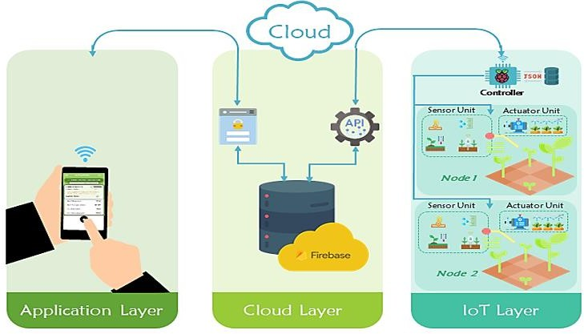

**Figure 1.** The System Architecture of the proposed system

## Hardware Design

The hardware design of the Smart Irrigation System utilizes an integrated IoT approach to enable efficient irrigation management. The system is comprised of several key components that work together to collect real-time data, control irrigation, and communicate with cloud services. These components include the ESP8266 microcontroller, soil moisture sensors, water pumps, relay modules, and water level sensors. Together, they form the IoT layer, which ensures seamless communication and automation of the irrigation system.

* **ESP8266**: Central controller for processing sensor data and controlling pumps.
* **Soil Moisture Sensors**: Four sensors connected to digital pins D0, D2, D3, and D4 of ESP8266 to monitor soil moisture levels for each crop zone.
* **Relay Module**: A 4-channel relay module connected to ESP8266 pins D1, D5, D6, and D7 for controlling four water pumps.
* **Water Pumps**: Each pump irrigates a specific crop zone based on sensor readings, connected via the relay module.
* **Water Level Sensor**: Monitors reservoir water availability, connected to the analogy pin A0 of ESP8266.

This hardware setup ensures efficient irrigation through real- time monitoring and automated control.

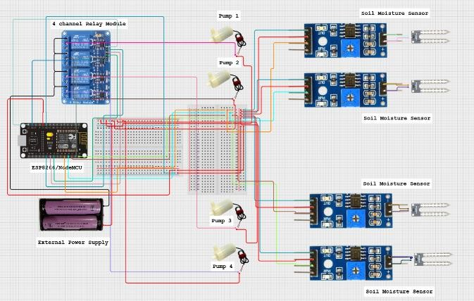

**Figure 2.** The Circuit Diagram of the proposed system.

**Table. 1.** Connections between the IOT components.

|  |  |
| --- | --- |
| **Component** | **Connections** |
| ESP8266 | Central controller; connects to all sensors, relays, and  pumps. |
| Soil Moisture Sensors | Connected to ESP8266  digital pins: D0, D2, D3, D4. |
| Relay Module | Connected to ESP8266  pins: D1, D5, D6, D7. |
| Water Pumps | Connected to the relay module’s COM and NO  terminals. |
| Water Level Sensor | Connected to the ESP8266  analog pin: A0. |

The system is designed to use as little energy as possible. The ESP8266 microcontroller is energy-efficient. To make the system even more eco-friendly, solar panels can be used to power the pumps and controller, especially in places with limited electricity.

## Software Design

The software design combines the **Application Layer**, **Cloud Layer** and **IOT Layer** to enable real-time control and monitoring of the Smart Irrigation System. It includes the mobile application, cloud services, and microcontroller programming to ensure efficient irrigation management.

More sensors and pumps can be added easily to cover larger areas or more crops. The software is also flexible, making it simple to adjust for different types of crops, soils, and weather conditions, so it can work well in many farming setups.

# Mobile Application (Application Layer)

Developed using MIT App Inventor, the mobile app allows farmers to input crop and soil types, store them in Firebase, and control irrigation manually or automatically. The app displays real-time data such as soil moisture levels and pump status. It also features a Crop Condition Management tool for prioritizing irrigation based on crop health (e.g., "green," "moderate," or "dry").

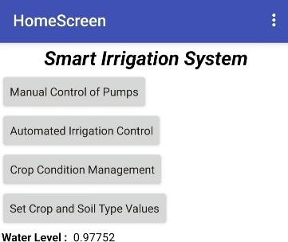

**Figure 3.1.** Home Screen displaying options for Irrigation.

This screen displays all the options available for the farmer. The farmer can choose based on their requirements: three

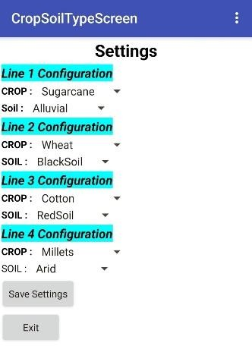options are for irrigation, and one option is for setting up the crop and soil in the field.

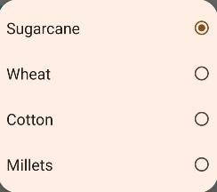

# (b)

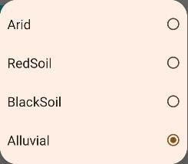

**(a) (c)**

**Figure 3.2. (a)** Selecting Crop and Soil Types **(b)** Crop Types

**(c)** Soil Types.

On this screen, the farmer can set up the soil and crop type and save them, which will be stored in Firebase, as shown in Figure (a). Figure (b) displays different types of crops, while Figure (c) shows various types of soils.

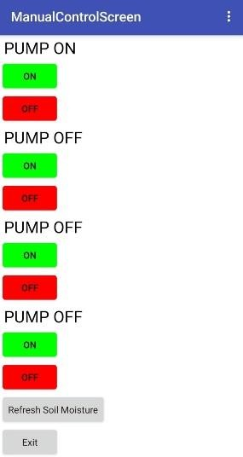

**Figure 3.3.** Manually Controlling Pumps.

This screen represents one of the irrigation options, specifically manual control of the pump. Here, the farmer can turn a particular pump on or off for a specific irrigation line and when the farmer clicks on the "Refresh Soil Moisture" or “Exit” option in the app, all pumps are automatically turned off. This ensures accurate soil moisture readings without interference from ongoing irrigation, saving the farmer time and improving efficiency.

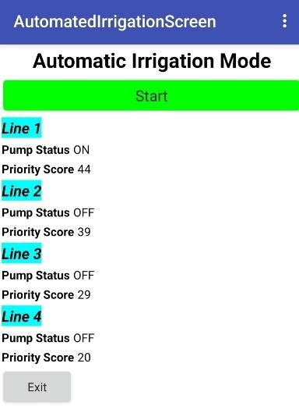

**Figure 3.4.** Automation in Irrigation on the basis of Priority Score.

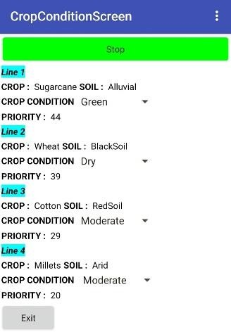This screen represents another irrigation method where irrigation starts with a single click based on the priority score. It displays the priority score, pump status, and line number.

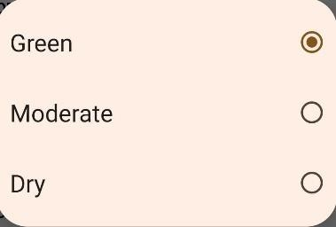

# (b)

**(a)**

**Figure 3.5. (a)** Irrigating Crops automatically on the basis of Crop Condition and Priority Score. **(b)** Crop Condition.

This screen offers another irrigation method that also starts with a single click. Here, irrigation is determined based on the combination of crop condition status (Green, Moderate, or Dry) and the priority score. The screen displays the line number, crop condition, priority score, soil type, and crop type in Figure (a). In Figure (b), the crop condition can be inserted.

# Cloud Services (Cloud Layer)

Firebase stores user settings and sensor data, enabling bi- directional communication between the app and hardware. Real-time sensor readings are updated in Real Time Database in Firebase, providing the farmer with a live overview of soil moisture, water usage, and pump activity.

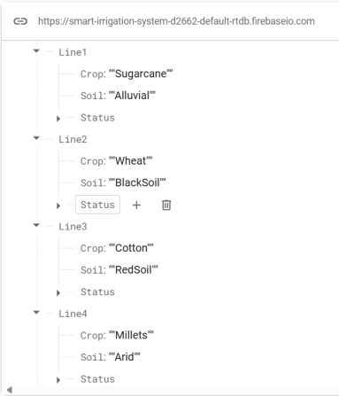

**Figure 4.** Crop and Soil Type values stored inside firebase.

* Percentage (Y): 30%

*c) Soil Suitability (Z%):*

* Soil type matters, but it’s slightly less important compared to moisture level and crop water demand.
* Percentage (Z): 20%

Formula Breakdown:

The total irrigation priority score for each line would be calculated as:

Priority Score = (𝑋 × 𝑆𝑜𝑖𝑙 𝑀𝑜𝑖𝑠𝑡𝑢𝑟𝑒 𝐿𝑒𝑣𝑒𝑙) + (𝑌

× 𝐶𝑟𝑜𝑝 𝑊𝑎𝑡𝑒𝑟 𝑅𝑒𝑞𝑢𝑖𝑟𝑒𝑚𝑒𝑛𝑡) + (𝑍

× 𝑆𝑜𝑖𝑙 𝑆𝑢𝑖𝑡𝑎𝑏𝑖𝑙𝑖𝑡𝑦)

# Control Logic and Priority Algorithms

Irrigation is prioritized based on a score derived from:

* Soil moisture (50%)
* Crop type (30%)
* Soil type (20%)



**Figure 5.** Priority Score Calculation.

The system automatically irrigates the lines with the highest priority and uses crop conditions to further adjust the watering sequence.

# Microcontroller Programming (IoT Layer)

The ESP8266 microcontroller is responsible for reading sensor data, sending it to Firebase, and controlling the pumps based on user inputs or priority calculations. It ensures real- time synchronization between the hardware, mobile app, and cloud platform.

This software design integrates the application, cloud, IOT layers to provide real-time control, data synchronization, and automated irrigation, ensuring an efficient and responsive Smart Irrigation System.

1. ***Equations:***

# Priority-based Irrigation Control

The irrigation prioritization algorithm is based on the following factors:

* + 1. *Soil Moisture Level (X%):*
* Since soil moisture level is the most immediate indicator of water need, let’s assign it the highest weight.
* Percentage (X): 50%
  + 1. *Crop Water Requirement (Y%):*

Where:

X = 50%, Y = 30%, Z = 20%

Whichever line has the highest score across the four will receive irrigation first.

**Table. 2.** As shown in Table, the values for crops and soil types are used in the calculation of the Priority Score.

|  |  |  |  |
| --- | --- | --- | --- |
| **Crop Type** | **Water Requirement** | **Soil Type** | **Suitability** |
| Sugarcane | 90 | Alluvial  Soil | 85 |
| Wheat | 80 | Black Soil | 75 |
| Cotton | 60 | Red Soil | 55 |
| Millets | 40 | Arid Soil | 40 |

# Soil Moisture Measurement (Digital Pin)

The soil moisture sensor outputs a binary value: 0 (wet) or 1 (dry). This value determines whether irrigation is required. If the soil is dry, irrigation is triggered.

# Irrigation Control Based on Moisture

Irrigation is activated when soil moisture falls below a predefined threshold:

Pump Control = {1 𝑖𝑓 𝑆𝑜𝑖𝑙 𝑀𝑜𝑖𝑠𝑡𝑢𝑟𝑒 < 𝑇ℎ𝑟𝑒𝑠ℎ𝑜𝑙𝑑

0 𝑖𝑓 𝑆𝑜𝑖𝑙 𝑀𝑜𝑖𝑠𝑡𝑢𝑟𝑒 ≥ 𝑇ℎ𝑟𝑒𝑠ℎ𝑜𝑙𝑑

This formula turns the pump on when irrigation is needed.

# Water Level Monitoring (Analog Pin)

The water level is monitored using an analog sensor, providing a value between 0 and 1024. The water level percentage is calculated as:

𝐴𝑛𝑎𝑙𝑜𝑔 𝑉𝑎𝑙𝑢𝑒

* Crop type and its water need should also play an important role but not as much as the current

𝑊𝑎𝑡𝑒𝑟 𝐿𝑒𝑣𝑒𝑙 = (

) × 100

1024

moisture levels.

This determines the available water in the reservoir, ensuring irrigation stops if the water level is too low.

## System Workflow



Option 4: Crop Condition Management

Select Green, Moderate or Dry Crop Condition

Monitor Real Time Data on Firebase

Return to farmer choosing Option or End

End

Activate Pump for Highest Priority Line to Lowest

Prioritize Moderate > Green > Dry

Control Pump On/Off Manually

Option 1: Set Crop and Soil Type

Option 2: Manually Control Pump

Option 3: Automated Irrigation

Farmer Chooses an Option

Start

Set Crop and Soil Type (Only Once at Beginning)

Farmer Opens Mobile App

Calculate Priority Score

Retrieve Soil, Crop and Moisture Data

**Figure 6.** Work Flow of the Proposed System.

1. Results and Discussions

The table below presents data on the crop type, soil type, and crop condition recorded during the testing phase. Using these inputs, the priority score is calculated to determine the irrigation needs effectively.

**Table. 3.** Crop type, Soil Type, Crop Condition for testing.

|  |  |  |  |  |
| --- | --- | --- | --- | --- |
| **Line Number** | **Crop Type** | **Soil Type** | **Crop Condition** | **Priority Score** |
| 1 | Sugarcane | Alluvial Soil | Green | 44 |
| 2 | Wheat | Black Soil | Moderate | 39 |
| 3 | Cotton | Red Soil | Moderate | 29 |
| 4 | Millets | Arid Soil | Dry | 20 |

**Table. 4.** Soil moisture sensor and pump status during Automation Option testing.

|  |  |  |  |  |  |  |  |  |
| --- | --- | --- | --- | --- | --- | --- | --- | --- |
| **Timestamp** | **Soil Moisture Sensor 1** | **Soil Moisture Sensor 2** | **Soil Moisture Sensor 3** | **Soil Moisture Sensor 4** | **Pump 1 Status** | **Pump 2 Status** | **Pump 3 Status** | **Pump 4 Status** |
| 2024-11-15  10:00:00 AM | 0 | 0 | 0 | 0 | OFF | OFF | OFF | OFF |
| 2024-11-15  10:00:15 AM | 0 | 0 | 0 | 0 | ON | OFF | OFF | OFF |
| 2024-11-15  10:00:30 AM | 1 | 0 | 0 | 0 | OFF | ON | OFF | OFF |
| 2024-11-15  10:00:45 AM | 1 | 1 | 0 | 0 | OFF | OFF | ON | OFF |
| 2024-11-15  10:01:00 AM | 1 | 1 | 1 | 0 | OFF | OFF | OFF | ON |
| 2024-11-15  10:01:20 AM | 1 | 1 | 1 | 1 | OFF | OFF | OFF | OFF |

**Table. 5.** Soil moisture sensor and pump status during Optimal Option testing.

|  |  |  |  |  |  |  |  |  |
| --- | --- | --- | --- | --- | --- | --- | --- | --- |
| **Timestamp** | **Soil Moisture Sensor 1** | **Soil Moisture Sensor 2** | **Soil Moisture Sensor 3** | **Soil Moisture Sensor 4** | **Pump 1 Status** | **Pump 2 Status** | **Pump 3 Status** | **Pump 4 Status** |
| 2024-11-15  11:10:00 AM | 0 | 0 | 0 | 0 | OFF | OFF | OFF | OFF |
| 2024-11-15  11:10:20 AM | 0 | 0 | 0 | 0 | OFF | ON | OFF | OFF |
| 2024-11-15  11:10:40 AM | 0 | 1 | 0 | 0 | OFF | OFF | ON | OFF |
| 2024-11-15  11:11:00 AM | 0 | 1 | 1 | 0 | ON | OFF | OFF | OFF |
| 2024-11-15  11:11:20 AM | 1 | 1 | 1 | 0 | OFF | OFF | OFF | ON |
| 2024-11-15  11:11:40 AM | 1 | 1 | 1 | 1 | OFF | OFF | OFF | OFF |

Crops in moderate condition with the highest priority score are irrigated first, followed by crops in green condition, and finally those in dry condition. In this case, Line 2 and Line 3 are in moderate condition, but Line 2 has a higher priority score, so it is irrigated first, followed by Line 3. Next, Line 1 is irrigated due to its green condition, and lastly, Line 4 is irrigated because of its dry condition.

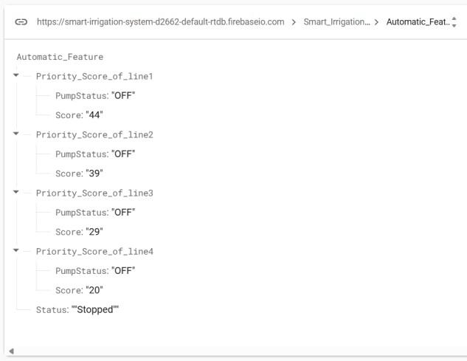

**Figure 7.1.** Displaying the Priority Score and pump status for particular line during Automation.

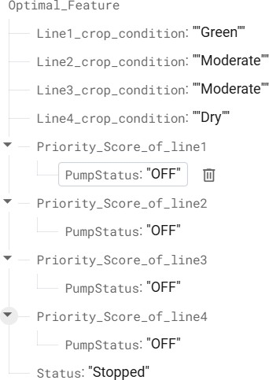

**Figure 7.2.** Displaying Crop Condition and Pump Status During Optimal Irrigation.

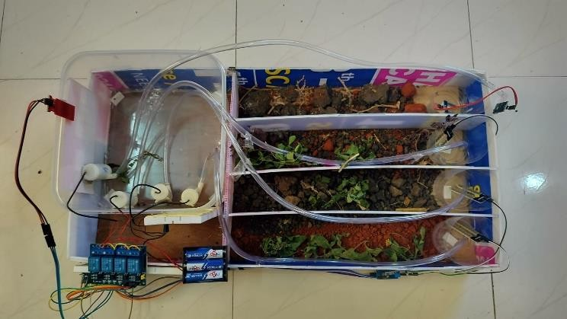

**Figure 8.** Proposed System with different crops, soils, crop conditions.

1. FUTHUR WORK

The device can be customized for various crops based on the season. For example, rice and wheat are grown in different seasons and have different water needs. We can also add a GSM module for internet connectivity, eliminating the need for Wi-Fi in the field. Also can insert some data science concepts so that crops, soils and crop conditions are automatically inserted into the columns of Crop, Soil and Crop Condition. Then can use extra IOT sensors such as LCD Display, Rain detection sensor, Temperature and Humidity Sensor, more accurate soil moisture sensor, then buttons to operate irrigation process physically on that field and integrate this system with Thingspeak to have more accurate real time data. Additionally, improving security measures is important to protect the system from potential hacking.

1. Conclusion

The Smart Irrigation System effectively addresses water scarcity and inefficiencies in traditional farming practices by integrating IoT, real-time monitoring, and automated control. It minimizes water wastage, optimizes crop health, and reduces manual effort through a user-friendly mobile application and real-time data visualization on Firebase. The system’s priority-based irrigation and crop condition management ensure efficient resource utilization and adaptability to varying conditions. This project demonstrates the potential of IoT in agriculture, contributing to sustainable practices and providing a foundation for future advancements in smart farming technologies.

References

1. Miss. B. A. Tapakire and Dr. M. M. Patil, “IoT based Smart Agriculture using Thingspeak,” *International Journal of Engineering Research & Technology*, vol. 8, no. 12, Dec. 2019, doi: 10.17577/IJERTV8IS120185.
2. men M. Badreldeen, M. A. Ragab, A. Sedhom, W.

M. Mamdouh, and M. Ali Ragab, “IoT based Smart Irrigation System,” *International Journal of Industry and Sustainable Development (IJISD)*, vol. 3, no. 1, 2022, [Online]. Available: [http://ijisd.journals.ekb.eg](http://ijisd.journals.ekb.eg/)

1. M. D. A. Mohammad Daffa Ananda, Y. S. Yuliarman Saragih, R. S. H. Ridwan Satrio Hadikusuma, and A.
2. K. Ahmad Fadhlul Kamal, “Design of Smart Agricultural Systems Using MIT App and Firebase,” *Techné : Jurnal Ilmiah Elektroteknika*, vol. 22, no. 2,

pp. 183–196, Dec. 2023, doi: 10.31358/TECHNE.V22I2.366.

1. Y. Kim, R. G. Evans, and W. M. Iversen, “Remote sensing and control of an irrigation system using a distributed wireless sensor network,” *IEEE Trans Instrum Meas*, vol. 57, no. 7, pp. 1379–1387, 2008, doi: 10.1109/TIM.2008.917198.
2. N. Penchalaiah, J. Nelson Emmanuel, S. Suraj Kamal, and C. V. Lakshmi Narayana, “IoT Based Smart Farming Using Thingspeak and MATLAB,” in

*Lecture Notes in Electrical Engineering*, Springer Science and Business Media Deutschland GmbH, 2021, pp. 1273–1295. doi: 10.1007/978-981-15-

7961-5_117.

1. W. HAMDOON and A. ZENGİN, “A NEW IOT- BASED SMART IRRIGATION MANAGEMENT

SYSTEM,” *Middle East Journal of Science*, vol. 9, no. 1, pp. 42–56, Jun. 2023, doi: 10.51477/mejs.1142136.

1. N. Patankar, M. Charmal, N. Bhaskar, S. Janrao, and
   1. Kamble, “A Wi-Fi Based Smart Irrigation Monitoring for an Agricultural Environment,” *Advances in Parallel Computing*, vol. 39, pp. 513– 522, 2021, doi: 10.3233/APC210237.
2. R. S. Krishnan *et al.*, “Fuzzy Logic based Smart Irrigation System using Internet of Things,” *J Clean Prod*, vol. 252, Apr. 2020, doi: 10.1016/j.jclepro.2019.119902.
3. M. Ayaz, M. Ammad-Uddin, Z. Sharif, A. Mansour, and E. H. M. Aggoune, “Internet-of-Things (IoT)- based smart agriculture: Toward making the fields talk,” *IEEE Access*, vol. 7, pp. 129551–129583, 2019, doi: 10.1109/ACCESS.2019.2932609.
4. M. Syafiq *et al.*, “Monitoring and Controlling Water Pumping System Using IoT for Agriculture Purpose,” *Journal of Advanced Research in Applied Mechanics Journal homepage*, vol. 62, pp. 1–15, 2019, [Online]. Available: [www.akademiabaru.com/aram.html](http://www.akademiabaru.com/aram.html)
5. A. Kaur, D. P. Bhatt, and L. Raja, “Developing a Hybrid Irrigation System for Smart Agriculture Using IoT Sensors and Machine Learning in Sri Ganganagar, Rajasthan,” *J Sens*, vol. 2024, 2024, doi: 10.1155/2024/6676907.
6. C. Kumar Sahu and P. Behera, “A low cost smart irrigation control system,” in *2nd International Conference on Electronics and Communication Systems, ICECS 2015*, Institute of Electrical and Electronics Engineers Inc., Jun. 2015, pp. 1146– 1151. doi: 10.1109/ECS.2015.7124763.
7. D. Prakash, A. Kumar, and K. Venkata Ramanan, “IoT Based Smart Irrigation for Multi Cropping System.” [Online]. Available: [www.rspsciencehub.com](http://www.rspsciencehub.com/)
8. A. Vij, S. Vijendra, A. Jain, S. Bajaj, A. Bassi, and

A. Sharma, “IoT and Machine Learning Approaches for Automation of Farm Irrigation System,” in *Procedia Computer Science*, Elsevier B.V., 2020, pp. 1250–1257. doi: 10.1016/j.procs.2020.03.440.

1. L. García, L. Parra, J. M. Jimenez, J. Lloret, and P. Lorenz, “IoT-based smart irrigation systems: An overview on the recent trends on sensors and iot systems for irrigation in precision agriculture,” Feb. 02, 2020, *MDPI AG*. doi: 10.3390/s20041042.
2. B. Alomar and A. Alazzam, “A Smart Irrigation System Using IoT and Fuzzy Logic Controller,” in *ITT 2018 - Information Technology Trends: Emerging Technologies for Artificial Intelligence*, Institute of Electrical and Electronics Engineers Inc., Jul. 2018, pp. 175–179. doi: 10.1109/CTIT.2018.8649531.
3. Asaad Yaseen Ghareeb, S. K. Gharghan, A. H. M. Mutlag, and Rosdiadee Nordin, “Wireless Sensor Network-Based Artificial Intelligent Irrigation System: Challenges and Limitations,” *Journal of Techniques*, vol. 5, no. 3, pp. 26–41, Aug. 2023, doi: 10.51173/jt.v5i3.1420.
4. M. Swapnali, B. Pawar, P. Rajput, and A. Shaikh, “Smart Irrigation System Using IOT And Raspberry Pi,” *International Research Journal of Engineering and Technology*, p. 1163, 2008, [Online]. Available: [www.irjet.net](http://www.irjet.net/)
5. E. Said Mohamed, A. A. Belal, S. Kotb Abd- Elmabod, M. A. El-Shirbeny, A. Gad, and M. B. Zahran, “Smart farming for improving agricultural management,” Dec. 01, 2021, *Elsevier B.V.* doi: 10.1016/j.ejrs.2021.08.007.
6. N. Ismail *et al.*, “Smart irrigation system based on internet of things (IOT),” in *Journal of Physics: Conference Series*, Institute of Physics Publishing, Dec. 2019. doi: 10.1088/1742-6596/1339/1/012012.
7. A. Satish, R. Nandhini, S. Poovizhi, P. Jose, R. Ranjitha, and S. Anila, “ARDUINO BASED SMART IRRIGATION SYSTEM USING IOT,”

2017. [Online]. Available: https://[www.researchgate.net/publication/32185429](http://www.researchgate.net/publication/32185429) 6

1. K. Sekaran, M. N. Meqdad, P. Kumar, S. Rajan, and

S. Kadry, “Smart agriculture management system using internet of things,” *Telkomnika (Telecommunication Computing Electronics and Control)*, vol. 18, no. 3, pp. 1275–1284, 2020, doi: 10.12928/TELKOMNIKA.v18i3.14029.

1. H. Chen *et al.*, “A deep learning CNN architecture applied in smart near-infrared analysis of water pollution for agricultural irrigation resources,” *Agric Water Manag*, vol. 240, Oct. 2020, doi: 10.1016/j.agwat.2020.106303.
2. J. Kwok and Y. Sun, “A smart IoT-based irrigation system with automated plant recognition using deep learning,” in *ACM International Conference Proceeding Series*, Association for Computing Machinery, Jan. 2018, pp. 87–91. doi: 10.1145/3177457.3177506.
3. F. Caetano, R. Pitarma, and P. Reis, “Advanced system for garden irrigation management,” in *Advances in Intelligent Systems and Computing*, Springer Verlag, 2015, pp. 565–574. doi: 10.1007/978-3-319-16486-1_55.
4. V. L. Akubattin, A. P. Bansode, T. Ambre, A. Kachroo, and P. Saiprasad, “Smart Irrigation System,” vol. 5, no. 2, pp. 343–345, 2016, [Online].

Available: [www.ijsrst.com](http://www.ijsrst.com/)

1. S. Gnanavel, M. Sreekrishna, N. D. Murugan, M. Jaeyalakshmi, and S. Loksharan, “The Smart IoT based Automated Irrigation System using Arduino UNO and Soil Moisture Sensor,” in *Proceedings - 4th International Conference on Smart Systems and Inventive Technology, ICSSIT 2022*, Institute of Electrical and Electronics Engineers Inc., 2022, pp. 188–191. doi: 10.1109/ICSSIT53264.2022.9716368.
2. M. H. Saibaba, A. Kumar Sai Pavan, S. Manideep, K. Venkatesh, and A. Professor, “SMART

AGRICULTURE SYSTEM USING THINGSPEAK

AND MOBILE NOTIFICATION,” *International Research Journal of Engineering and Technology*, 2019, [Online]. Available: [www.irjet.net](http://www.irjet.net/)

1. A. Goap, D. Sharma, A. K. Shukla, and C. Rama Krishna, “An IoT based smart irrigation management system using Machine learning and open source technologies,” *Comput Electron Agric*, vol. 155, pp. 41–49, Dec. 2018, doi:

10.1016/j.compag.2018.09.040.

1. R. Kanmani, S. Muthulakshmi, K. S. Subitcha, M. Sriranjani, R. Radhapoorani, and N. Suagnya, “Modern Irrigation System using Convolutional Neural Network,” in *2021 7th International Conference on Advanced Computing and Communication Systems, ICACCS 2021*, Institute of Electrical and Electronics Engineers Inc., Mar. 2021,

pp. 592–597. doi: 10.1109/ICACCS51430.2021.9441917.

1. M. Sami *et al.*, “A Deep Learning-Based Sensor Modeling for Smart Irrigation System,” *Agronomy*, vol. 12, no. 1, Jan. 2022, doi: 10.3390/agronomy12010212.
2. C. K. G. Albuquerque, S. Polimante, A. Torre-Neto, and R. C. Prati, “Water spray detection for smart irrigation systems with Mask R-CNN and UAV footage,” in *2020 IEEE International Workshop on Metrology for Agriculture and Forestry, MetroAgriFor 2020 - Proceedings*, Institute of Electrical and Electronics Engineers Inc., Nov. 2020,

pp. 236–240. doi: 10.1109/MetroAgriFor50201.2020.9277542.