Inheritance
- Code reusability

Disadvantage
- Tight couple
- Heavy loading of all the parent classes.
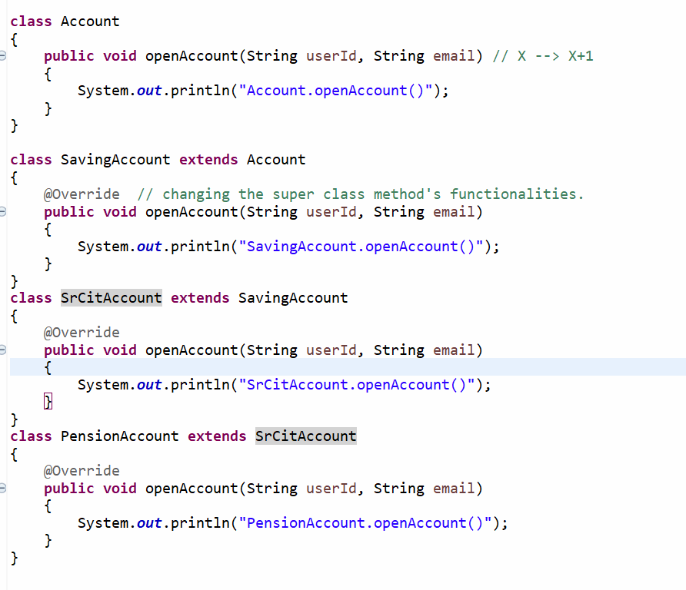

Type of Inheritance
- Single
- Multilevel
- Hierarchical
- Multiple

