Data Type
- Read the data
- Process the data
- Share the data(Response)
Data Info
Order id, Address, Pin code, Credit Card, amount ,

- Primitive byte, short, int, long, float, double, boolean, char

Byte -128 to 127

<Type> <Name> = <Value>;

int amount = 20;

- Non Primitive Object type String , Array, Person, Employee, System, Account, Payment
class Payment
{
}
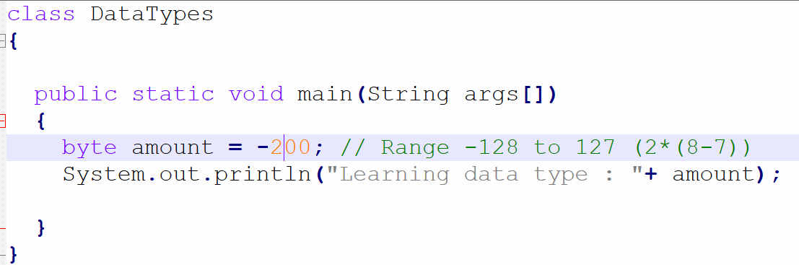

int minAmount= 25;

byte b1 = 12;
byte b2 = 32;
int value = b1+b2;
100k small number

Int[] values = new int[100000]; 40 MB space
Byte[] values = new byte[100000]; 10 MB

byte 0
short 16 bits or 2 Bytes 0
int 32 bits 0
long 64 bits 0
123.20
float value = 123.30f; 32 bits
double value = 5432.543d;

. boolean status= true;
boolean isValid = false;
char A , D S

char status = ‘A’;
‘\00uc’

Research : What is the purpose of byte data type?

150 crore
12, 4, 0, 4, 3, 99,

- Primitive data types :
Default : byte int short long 0
Boolean false
Float double 0.0 f/d

Int age = 22;

