Data Type :
- Primitive Data Type byte, short, int , long, float, double, char and Boolean

- Non Primitive Data default value as null;

int amount; 0
DataTypes data; null
AddNumber numbers = null;
AccountInfo info = null;
String name=null;
System class = null;

Variable

int amount = 100;

S.O.P(amount)

amount=200;

Data(Variables) + Biz Logic(Apply operation on data).

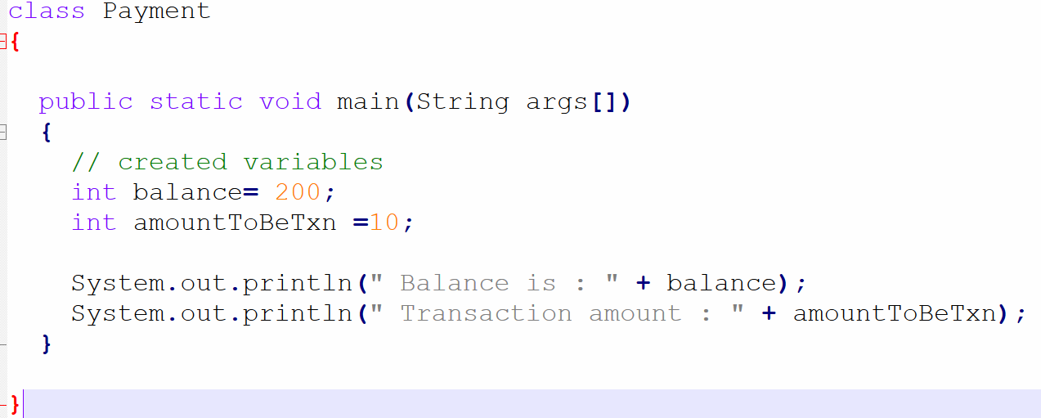

Variable Types
- Local Variables Local to something.(Method, block, constructor etc)
- Instance Variable
- Static Variable

{
Int amount = 100; // local variable

}

void m1()
{
Int balance = 200; // local variable
}
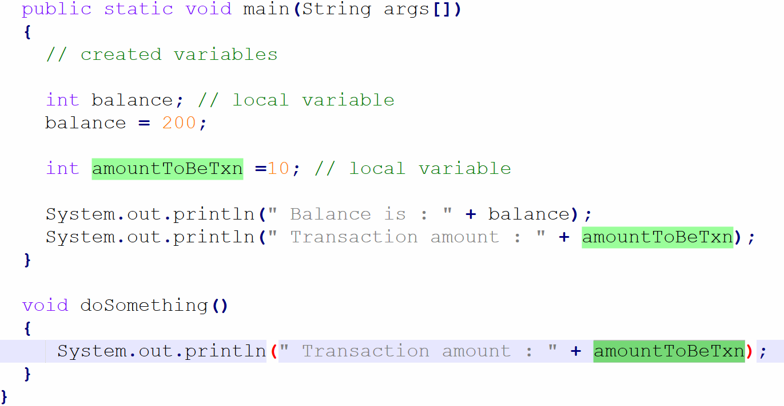

Method call frame will be stored inside Stack and local variables.

Instance variable variable declared outside method and inside class.

Static class level

Local belongs to method / block.
Instance belongs to object
Static belongs to class

