Software Engineer Software development and maintenance(enhancement + bug fixing + monitoring and Health)
Car Sale you purchase the car Service centre

Data + Biz Logic(add two numbers, fund transfer, send email, register user )
Work/Task Method /

- Name for the method pay(int amount, String accountNumber)
- Input parameters int amount, String accountNumber
- Body { …. } some logic to perform txn
- Biz logic which will perform the work or task.
- Return value/output paid successfully true/false
- ---

Develop a functionality to transfer the fund between the accounts.
Input : amount to be transferred , sender account, receiver account
Output : true/false

673425678765432

Sender got 100 and he/she sending 10 rupees to someone and someone current balance is 200.
Int senderBalance = 100;
Int recBalance = 200;
Int txnamount=10;
senderBalance = senderBalance – txnamount; 100 – 10 -- > 90
recBalance = recBalance + txnamount 200 +10 210;

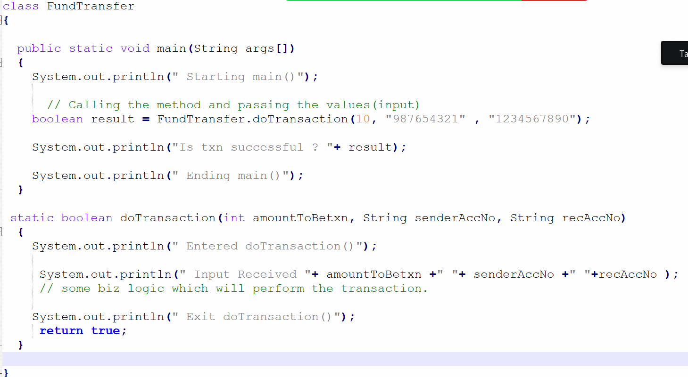

Task :
Write a program to add two number. User will provide the number from command line args. Method should return the sum.

Note : Follow Java Naming Convention.

Type
- In built methods already provided by Sun/Oracle
- User defined based on the requirement developer will write the method.

