OOPs
- Encapsulation Hiding Data
- Inheritance(Overriding and Polymorphism) Code reusability
- Abstraction Hiding implementation

Expose the required functionality and
hide the core functionalities
(What ? openAccount()) How(Core functionalities)
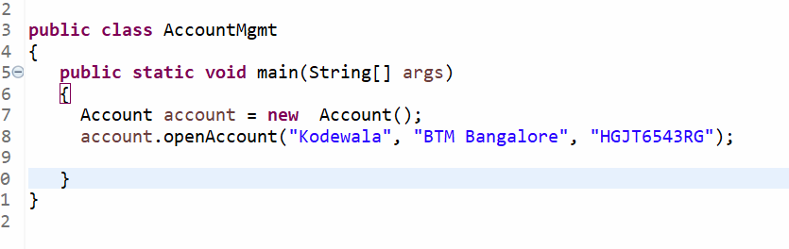
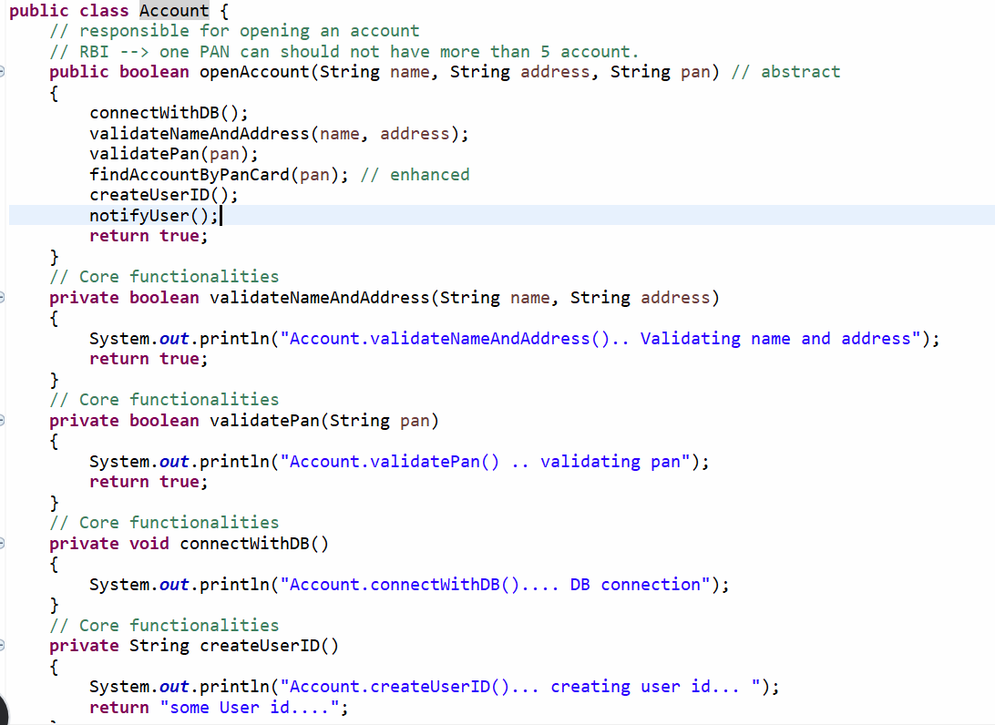

Task: (10 mins)
Write a program and achieve abstraction.

Requirement:
- Place order will be used by other classes to place an order
- Hide the core functionalities and expose only required functionality
- Explore if core functionalities are exposed to other classes and do the impact analysis.

