String Sequence of characters

Abcd String
A char
Mohit String
Object of String class
Public class String
{

}

int a = 100;
Immutable once created you can not change it.

String Object are immutable once String object is created, you can not change it. If you try to change, in result you get new object.

How to Create String Objects?
- using literals String s = “Hello”;
- using new keyword String s2 = new String(“Hello”); // Normal object creation

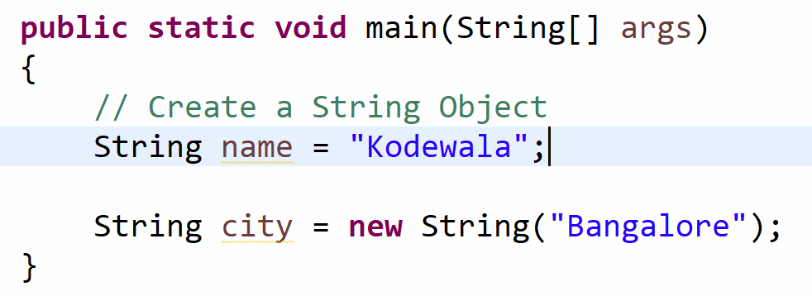

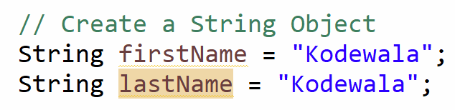

- Order Id – String
- Name - String
- Item Name - String
- Address - String
- PIN Code – String 560076
- City Name
- Area Name
- Country
- Veg/ Non Veg
- Product description
- SBI Acc Number String 78653245678

90% Objects are Type of String

1 M 10 Lakh 9 lakh objects are String

10k X String pinCode =”560076”;
String city = “Bangalore”; X 100k

