A PROJECT REPORT
On

Vikram Aur Betaal

Submitted to
KIIT Deemed to be University
In Partial Fulfilment of the Requirement for the Award of

BACHELOR’S DEGREE IN
COMPUTER SCIENCE AND ENGINEERING

 | BY
ANURAG PANDA |  | 2105181
ANKIT HATI |  | 21052897
PRAJNABRATA MOHANTY |  | 2105049

UNDER THE GUIDANCE OF
MR. N. BIRAJA ISAAC



SCHOOL OF COMPUTER ENGINEERING

KALINGA INSTITUTE OF INDUSTRIAL TECHNOLOGY
BHUBANESWAR, ODISHA -751024

KIIT Deemed to be University
School of Computer Engineering Bhubaneswar, ODISHA 751024

CERTIFICATE
This is certified that the project entitled

“VIKRAM & BETAAL”

submitted by

ANURAG PANDA | 2105181
ANKIT HATI | 21052897
PRAJNABRATA MOHANTY | 2105049

is a record of bonafide work carried out by them, in the partial fulfilment of the requirement for the award of Degree of Bachelor of Engineering (Computer Science & Engineering) at KIIT Deemed to be university, Bhubaneswar. This work is done during year 2025, under our guidance.

Project Guide

MR. N BIRAJA ISAAC

Acknowledgements

We are profoundly grateful to MR. N BIRAJA ISAAC of Affiliation for his expert guidance and continuous encouragement throughout to see that this project rights its target since its commencement to its completion.

A special word of appreciation goes to all the participants whose active involvement and provision of valuable data and insights have been pivotal in shaping this study. Their cooperation and willingness have significantly contributed to the project's success.

We also extend our gratitude to our colleagues and friends for their continuous support and motivation throughout the duration of this endeavor. Their constructive feedback and suggestions have played a crucial role in enhancing the quality of this report.

Lastly, we express our heartfelt thanks to our families for their unwavering support, encouragement, and understanding. Their love and encouragement have served as a constant source of inspiration, and we deeply appreciate their presence in our lives.

We sincerely thank everyone for their support and guidance, as this project would not have been possible without their collective efforts

ANURAG PANDA
ANKIT HATI
PRAJNABRATA MOHANTY

ABSTRACT

‘Vikram and Betaal’ is a classic collection of Indian tales rooted in ancient folklore and moral philosophy. The stories revolve around the legendary King Vikramaditya and the ghostly spirit Betaal, who resides in a corpse hanging from a tree. Each night, as Vikram attempts to capture Betaal and carry him away, the spirit tells him a gripping story that ends with a riddle or moral dilemma. Bound by a condition that he must answer the question if he knows the answer, Vikram repeatedly solves the puzzles, causing Betaal to escape and restart the cycle. These tales are known not just for their rich narrative style, but also for exploring complex themes of justice, duty, wisdom, and human nature. Blending suspense, ethical inquiry, and folklore, ‘Vikram and Betaal’ remains an enduring part of Indian literature and storytelling tradition.

Keywords: Vikramaditya, Betaal, Indian folklore, moral stories, riddles, ethical dilemmas, ancient literature, wisdom, justice, storytelling.

Contents

1 | Chapter 1: Introduction |  | 1
2 | Chapter 2: Basics Concepts/ Literature Review |  | 2
 | 2.1  2.2  2.3  2.4  2.5  2.6  2.7  2.8 | HTML CSS  Bootstrap Java Script  Python  Flask  FastAPI  SQLite | 2,3
3 | Chapter 3: Requirement Specifications |  | 4
4 | Chapter 4: Concepts Used |  | 4,5
5 | Chapter 5: Implementation |  | 6
 | 5.1 | Layout | 6
 | 5.2 | Mobile Optimization | 7
 | 5.3 | Colors | 9
 | 5.4 | Fonts | 9
6 | Chapter 6: Conclusion |  | 10
7 | Chapter 7: References |  | 11

School of Computer Engineering, KIIT, BBSR VIKRAM AND BETAAL

Chapter 1 Introduction

Vikram and Betaal is one of the most iconic story cycles in Indian literature, blending elements of fantasy, morality, and suspense. Originating from the ancient Sanskrit work Baital Pachisi, attributed to the scholar Somdev Bhatt, these tales date back over a thousand years and have been retold across generations in various regional languages and cultural forms. The central characters are King Vikramaditya, a just and fearless ruler known for his wisdom and bravery, and Betaal, a witty and mysterious ghost who inhabits a corpse hanging from a tree in a dense forest.
The premise of the stories is simple yet captivating. Vikramaditya is tasked by a tantric sage to retrieve Betaal, but every time the king tries to carry the ghost, Betaal tells him a strange and thought-provoking story that ends with a riddle or a moral dilemma. If Vikram knows the answer and remains silent, he risks death; if he answers, Betaal escapes and returns to the tree, forcing Vikram to start over. This recurring cycle forms the narrative framework of the series.
Each of Betaal’s stories presents a unique scenario that explores complex human emotions, ethical conflicts, and social values. From tales of loyalty and betrayal to stories about justice, sacrifice, and cleverness, the narrative structure encourages the listener or reader to reflect deeply on right and wrong. Despite being rooted in folklore, the themes remain relevant in modern times and offer timeless wisdom.
The Vikram and Betaal tales have been widely popularized through books, television series, plays, and even comic books, making them accessible to both children and adults. They not only serve as entertainment but also act as a cultural and moral compass, emphasizing the importance of intellect, integrity, and courage.
This project explores the origins, structure, major themes, and cultural significance of the Vikram and Betaal stories, shedding light on why they continue to captivate minds even today.
.

1
School of Computer Engineering, KIIT, BBSR VIKRAM AND BETAAL

Chapter 2
Basic Concepts/ Literature Review
This section contains the basic concepts about the related tools and techniques used in this project.

  - HTML
HTML, or Hypertext Markup Language, is the core language used to structure and present text on web browsers. It defines how web content is organized and displayed, often working alongside technologies like CSS for styling and JavaScript for interactivity.
Web browsers retrieve HTML files from either a server or local storage and render them into interactive, multimedia web pages. HTML defines the semantic layout of a page and can include basic styling cues to influence its appearance.

  - CSS
CSS, or Cascading Style Sheets, is a language used to define the visual appearance and formatting of documents written in markup languages such as HTML or XML. Alongside HTML and JavaScript, it forms one of the core technologies that power the World Wide Web.
across multiple web pages through an external .css file. It also reduces redundancy in HTML structure and improves loading speed by enabling browsers to cache the shared CSS file.

  - BOOTSTRAP
Bootstrap is a framework based on HTML, CSS, and JavaScript that streamlines the development of content-focused web pages rather than full web applications. Its main purpose is to provide a range of pre-designed color schemes, font styles, sizing, and layout tools that can be easily applied to a web project. As a result, the most important element is if the developers in charge like the selections. Once included in a project, Bootstrap provides basic style definitions for all HTML components. The ultimate effect is a uniform display of text, tables, and form components across all web browsers. Developers may also use Bootstrap's CSS classes to further customise the look of their content. For example, Bootstrap has provisioned for light- and dark-colored tables, page headings, more prominent pull quotes, and text with a highlight.

2

School of Computer Engineering, KIIT, BBSR

  - JAVASCRIPT

JavaScript, sometimes known as JS, is a computer language and key technology of the Web, alongside HTML and CSS. On the client side, JavaScript is used by 99% of websites to control page behaviour. JavaScript is a high-level, just-in-time compiled language that adheres to the ECMAScript standard. It enables dynamic typing, prototype-based object orientation, and first-class functions. It supports a variety of programming paradigms, including event-driven, functional, and imperative. It includes APIs for working with text, dates, regular expressions, standard data structures, and the Document Object Model (DOM). The ECMAScript standard does not include any input/output (I/O) functions, such as networking, storage, or graphics. In actuality, the web browser or a comparable runtime system offers JavaScript I/O APIs.
Although Java and JavaScript have similar names, syntax, and standard libraries, they are vastly distinct in design.

  - PYTHON
Python is a high-level, interpreted programming language often praised for its simplicity and readability. It supports multiple programming paradigms, including object-oriented, functional, and procedural styles. Python features dynamic typing, automatic memory management, and a comprehensive standard library for tasks like file handling, data manipulation, and web services. Widely used in web development, data science, artificial intelligence, and automation, it is supported by an extensive ecosystem of libraries and frameworks. Although Python excels in ease of use and versatility, it differs significantly in design and application from languages like Java or JavaScript.

2.6 FLASK

Flask is a lightweight web framework written in Python. It is classified as a microframework because it does not require particular tools or libraries, offering simplicity and flexibility for developers. Flask includes built-in support for routing, templating via Jinja2, and a WSGI server through Werkzeug.
Flask is commonly used for building RESTful APIs and small to medium-sized web applications. Its modular design allows developers to add extensions for tasks like database integration, authentication, and form validation. While Flask provides a minimal starting point, it is scalable and well-suited for projects requiring fine-grained control over application architecture.

3

FAST API

FastAPI is a high-performance web framework for developing APIs in Python 3.7+, utilising standard

type hints. FastAPI, developed by Sebastián Ramírez, is user-friendly, efficient,

and compliant with OpenAPI (previously Swagger) and JSON Schema standards.

It is developed on top of Starlette (for web parts) and Pydantic (for data validation), thus it is both

lightweight and powerful. FastAPI enables developers to quickly create powerful, production-ready

RESTful APIs with automated documentation.

SQLite

SQLite is a lightweight, fast, and self-contained relational database management system (RDBMS).

Unlike other database systems like MySQL or PostgreSQL, SQLite is serverless—which means it doesn’t require a separate server process or system to operate. Instead, the entire database is stored in a single

file on disk.

It’s written in C and is open-source, making it widely used across many platforms including mobile apps, embedded systems, browsers, and small desktop applications.

Chapter 3
Requirement Specifications

The requirement specification for the website to operate smoothly:

- Internet Explorer 9 & 10
- Firefox 7 and higher
- Chrome 14 and higher
- Safari 5 and higher
- Opera 11 and higher

4

School of Computer Engineering, KIIT, BBSR VIKRAM AND BETAAL

Chapter 4

Concepts Used
MACHINE LEARNING
Machine Learning (ML) is a type of artificial intelligence that enables computers to learn from data, detect patterns, and make predictions or judgements without requiring human intervention. In this project, machine learning is used to analyse the Bhagavad Gita and Vikram and Betaal datasets, which serve as the foundation for the chatbot embedded into the website's backend. The dataset was pre-processed to arrange the text in a way suited for model training. This ensured efficient interpretation and response production.
Using Natural Language Processing (NLP) techniques, the ML model is capable of understanding user queries, identifying key themes, and mapping them to the teachings of the Bhagavad Gita. Supervised learning was employed to train the model on labeled data, enabling it to provide contextually accurate and insightful responses. The integration of this trained ML model into the website's backend facilitates real-time interaction, ensuring a seamless and meaningful user experience.
This implementation demonstrates the application of Machine Learning in transforming philosophical and spiritual texts into a dynamic, interactive platform, making complex teachings accessible and engaging for users.

SENTIMENTAL ANALYSIS

Sentiment Analysis is a Machine Learning (ML) technique that interprets the emotional tone of text to classify it into categories like positive, negative, or neutral sentiments. In this project, sentiment analysis was implemented to enable the chatbot to understand the emotional state of users based on their inputs and provide relevant morals and stories with respect to Bhagwat Geeta and Vikram and Betaal.

5

School of Computer Engineering, KIIT, BBSR VIKRAM AND BETAAL
The chatbot analyzes user inputs by identifying specific keywords and expressions indicative of emotions such as anger, sadness, happiness, or anxiety. A curated dataset mapping emotional expressions to corresponding shlokas was used to train the ML model. By leveraging Natural Language Processing (NLP) techniques, the model extracts features from the user input, determines the user's mood, and retrieves appropriate shlokas that align with the identified sentiment.
For example, if a user types, "I’m feeling angry," the chatbot detects the emotion as anger and suggests shlokas that provide guidance on managing anger. This integration of sentiment analysis ensures that the chatbot delivers a personalized and meaningful experience, making the teachings of the Bhagavad Gita accessible and applicable to users' emotional contexts.

Chapter 5 Implementation
5.1 LAYOUT

The homepage serves as both the initial page visitors see and a landing page that encourages a specific action. In this case, the 'Cantos' link is the main call to action, distinguished by a uniquely colored border to make it stand out from other links and guide users' decisions. Although other links are present, the call to action is strategically placed beneath a key element and again at the bottom of the page, increasing its visibility. Based on the Gutenberg Diagram, this call to action sits in the terminal area—where users typically make decisions—while the navigation bar occupies the primary optical area, where attention naturally falls. This helps users quickly understand the site’s purpose and easily access other pages. A parallax scrolling design was chosen to keep the site modern and engaging. It appeals to younger users familiar with scrolling interfaces on mobile devices, offering a more intuitive and interactive experience.

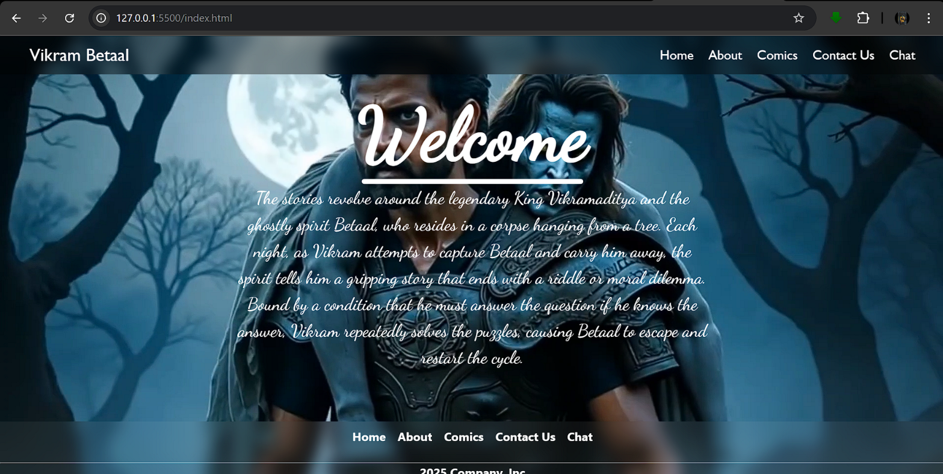

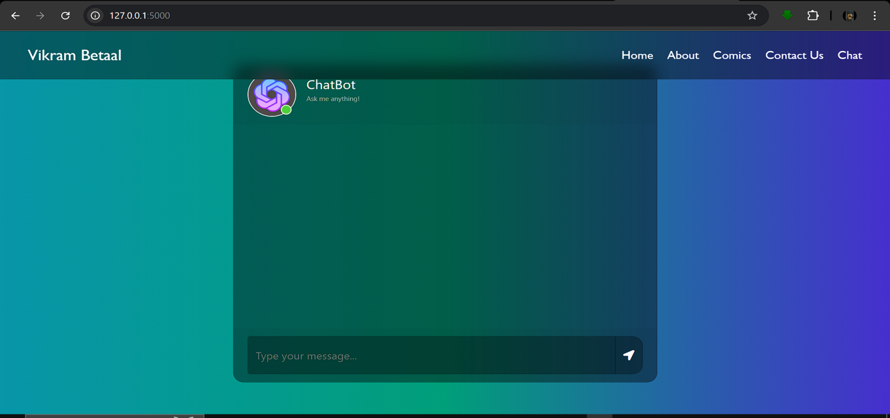

  - MOBILE OPTIMIZATION

To increase the amount of prospective audience members, this site employs media
queries. This website is responsive to three distinct sizes of devices:

- Smartphones >500px
- Tablets >960px
- Desktop / Laptops <960px

According to Kemp (2017), more than half of the world's population now has a smartphone, and smartphones account for more than half of global web traffic, making it critical that a website be mobile-friendly. However, not only are sites being accessed by more people on more devices, “customers are returning to our sites at different times using different devices.” Therefore, having a responsive website is a key trend that modern websites must incorporate. To minimize loading times on smaller devices, the background video changes to a still image on devices under 960px. The call to action adapts to have a background color to keep the user’s attention as there is no ability to hover a mouse on anything other than desktops or laptops.

8

School of Computer Engineering, KIIT, BBSR VIKRAM AND BETAAL

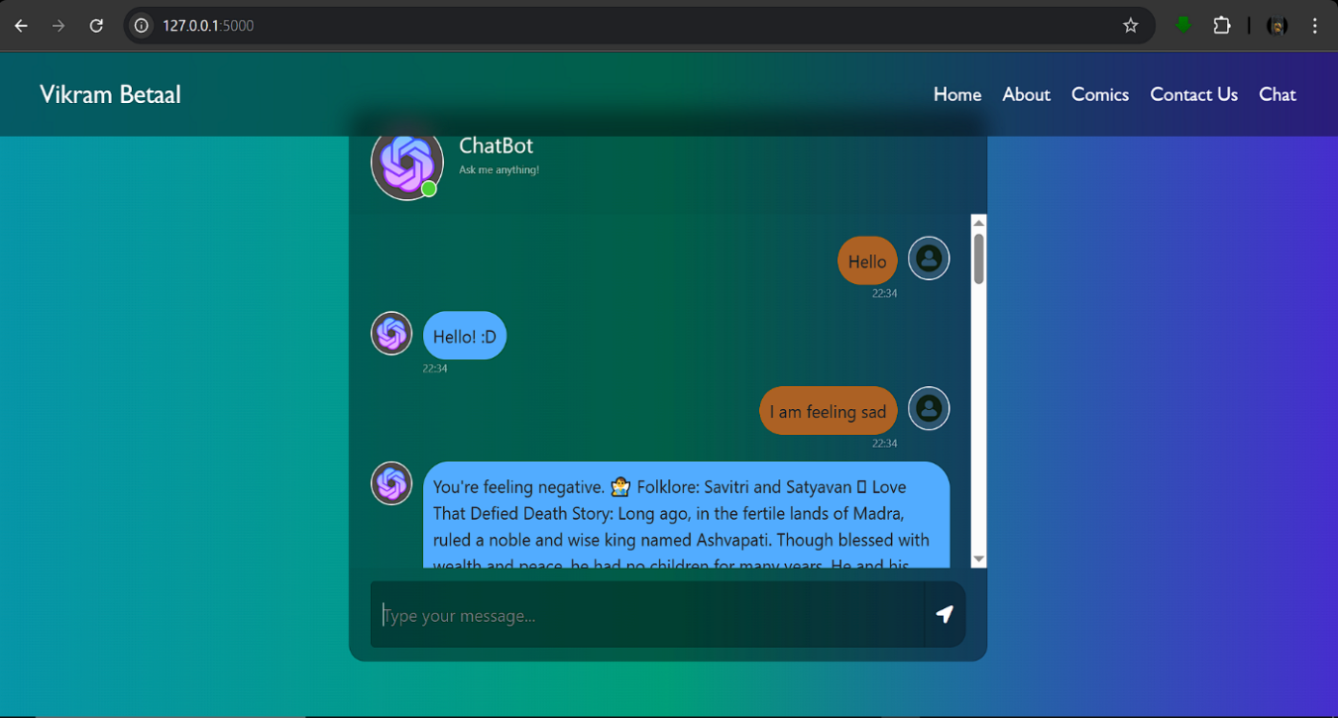

9
School of Computer Engineering, KIIT, BBSR VIKRAM AND BETAAL

5.3 COLORS

Colour has a significant impact on the entire appearance and feel of a website, and it is typically the first impression visitors have of you, deciding whether they want to remain or go. Colors have different meanings in different cultures and countries, so understanding the meaning of color in your target market can be important. The color palette used for the website was kept really clean and simple.

The colors used for the website:
white
- rgba (0, 0, 0, 0.6) [BLACK/ 60% opacity]
- rgba (255, 255, 255, 0.2) [WHITE/ 20% opacity]
- rgba (0, 0, 0, 0.25) [BLACK/ 25% opacity]
- rgba (255, 255, 255, 0.3) [WHITE/ 30% opacity]
- #000000 [BLACK]
- rgba (255, 255, 255, 0.85) [WHITE/ 85% opacity]
- rgba (0,0,0,0.1) [BLACK/ 10% opacity]
- #e3963e [TIGER ORANGE]

Background colors used in the Chatbot:
Gradient 1: -webkit-linear-gradient (rgb(40, 59, 34), rgb(70, 61, 54), rgb(32, 32, 43)).
Gradient 2: Linear-gradient (rgb(168, 146, 37), rgb(255, 131, 22), rgb(146, 46, 37)).
White for clean sections.
Transparent Overlay: rgba(0,0,0,0.3).

5.4 FONTS

To avoid looking messy, the best is to use a maximum of two or three fonts on a page. For the main font, the one used for the title, we wanted something modern but again not too distracting.

The fonts used here:
- 'Poppins', sans-serif
- Regular

All the fonts used are used within a list of fallback fonts because not every computer or every browser will have the same fonts available. In this case, if the first font in the list is not available, the browser will try to use the next font specified, and so on.

10
School of Computer Engineering, KIIT, BBSR VIKRAM AND BETAAL

Chapter 6

Conclusion

The goal of this project is to make the timeless teachings of the Bhagavad Gita and the moral wisdom found in Vikram and Betaal accessible and relevant to today’s generation. Many young individuals remain unaware of the deep philosophical insights embedded within these ancient texts, which address universal themes such as duty, fear, self-inquiry, and moral choice.

By leveraging Machine Learning and Sentiment Analysis, this project introduces a chatbot that recommends personalized shlokas from the Gita and stories or riddles inspired by Vikram and Betaal, based on the user's emotional state. Whether a user is feeling anxious, lost, curious, or reflective, the chatbot offers contextual guidance—helping them face inner conflicts, ethical dilemmas, and moments of doubt with clarity and strength.

Just as Krishna guides Arjuna to embrace his dharma with courage, and Betaal challenges Vikram with questions that demand wisdom and introspection, this project uses modern technology to simulate that same journey of self-awareness
and moral reasoning. Ultimately, the aim is to foster courage, discernment, and inner growth while reconnecting users with the rich spiritual and intellectual
heritage of Indian storytelling and philosophy.

11
School of Computer Engineering, KIIT, BBSR VIKRAM AND BETAAL

Chapter 7

References

[1 ]S. M. Metev and V. P. Veiko, Laser Assisted Microtechnology, 2nd ed., R. M. Osgood, Jr., Ed. Berlin, Germany: Springer-Verlag, 1998.

Breckling, Ed., The Analysis of Directional Time Series: Applications to Wind Speed and Direction, ser. Lecture Notes in Statistics. Berlin, Germany: Springer, 1989, vol. 61.

S. Zhang, C. Zhu, J. K. O. Sin, and P. K. T. Mok, “A novel ultrathin elevated channel low-temperature poly-Si TFT,” IEEE Electron Device Lett., vol. 20, pp. 569–571, Nov. 1999.

M. Wegmuller, J. P. von der Weid, P. Oberson, and N. Gisin, “High resolution fiber distributed measurements with coherent OFDR,” in Proc. ECOC’00, 2000, paper 11.3.4, p. 109.

R. E. Sorace, V. S. Reinhardt, and S. A. Vaughn, “High-speed digital-to-RF converter,” U.S. Patent 5 668 842, Sept. 16, 1997.

(2002) The IEEE website. [Online]. Available: http://www.ieee.org/

[7] M. Shell. (2002) IEEEtran homepage on CTAN. [Online]. Available: http://www.ctan.org/tex- archive/macros/latex/contrib/supported/IEEEtran/

12

CONTRIBUTION

ANURAG PANDA (2105181):
- Home Page
- Comics Page
- Integration of complete website.

ANKIT HATI (21052897):
- Chatbot Frontend & Backend.
- Data Research and Data frame Creation.

PRAJNABRATA MOHANTY (2105049):
- About Us Page.
- Contact Us Page.
- Front-end and Back-end for both.

PLAGIARISM REPORT

