##### A PROJECT REPORT

On

### Shrimad Bhagavad

Submitted to

KIIT Deemed to be University

In Partial Fulfilment of the Requirement for the Award of

#### BACHELOR’S DEGREE IN

**COMPUTER SCIENCE AND ENGINEERING**

|  |  |  |
| --- | --- | --- |
|  | BY |  |
| **ANURAG PANDA** |  | 2105181 |
| **ANKIT HATI** |  | 21052897 |
| **PRAJUKTA SAHOO** |  | 21051231 |
| **SAUMYA** |  | 2129100 |

UNDER THE GUIDANCE OF

**MR. N. BIRAJA ISAAC**



SCHOOL OF COMPUTER ENGINEERING

##### KALINGA INSTITUTE OF INDUSTRIAL TECHNOLOGY

BHUBANESWAR, ODISHA -751024

#### KIIT Deemed to be University

School of Computer Engineering Bhubaneswar, ODISHA 751024



## CERTIFICATE

This is certified that the project entitled

##### “SHRIMAD BHAGAVAT”

submitted by

**ANURAG PANDA**

**ANKIT HATI**

**PRAJUKTA SAHOO**

**SAUMYA**

2105181

21052897

21051231

2129100

is a record of bonafide work carried out by them, in the partial fulfilment of the requirement for the award of Degree of Bachelor of Engineering (Computer Science & Engineering) at KIIT Deemed to be university, Bhubaneswar. This work is done during year 2024, under our guidance.

Project Guide

MR. N BIRAJA ISAAC

**Acknowledgements**

We are profoundly grateful to **MR. N BIRAJA ISAAC** of **Affiliation** for his expert guidance and continuous encouragement throughout to see that this project rights its target since its commencement to its completion.

A special word of appreciation goes to all the participants whose active involvement and provision of valuable data and insights have been pivotal in shaping this study. Their cooperation and willingness have significantly contributed to the project's success.

We also extend our gratitude to our colleagues and friends for their continuous support and motivation throughout the duration of this endeavour. Their constructive feedback and suggestions have played a crucial role in enhancing the quality of this report.

Lastly, we express our heartfelt thanks to our families for their unwavering support, encouragement, and understanding. Their love and encouragement have served as a constant source of inspiration, and we deeply appreciate their presence in our lives.

We sincerely thank everyone for their support and guidance, as this project would not have been possible without their collective efforts

**ANURAG PANDA**

**ANKIT HATI**

**PRAJUKTA SAHOO**

**SAUMYA**

### ABSTRACT

‘Bhagavad Gita’ is one of the essential Indian ancient scriptures like Vedas, Puranas and Upanishads. It guides us by showing various spiritual paths through which we can gain self-knowledge as well as inner-peace. Many of our legendary leaders like Mahatma Gandhi, Dr.

Radhakrishnan, Lokmanya Tilak and many more was

influenced by the philosophy of ‘Bhagavad Gita’. This study showcases that, how ‘Gita’ influences the life of modern

human society especially ‘Y’ and ‘Z’ generation. It also tries to analyse and highlight, how Bhagavad Gita supports and develops certain management vision and thoughts, which has created a benchmark in the modern world as a key source for success to any organization or an individual.

**Keywords:** Bhagavad Gita, Management Thoughts, Organization, Inner-peace, Self-Knowledge.

## Contents

|  |  |  |  |
| --- | --- | --- | --- |
| 1 | Chapter 1: Introduction | | 1 |
| 2 | Chapter 2: Basics Concepts/ Literature Review | | 2 |
|  | 2.1  2.2  2.3  2.4  2.5  2.6 | HTML CSS  Bootstrap Java Script  Python  Flask | 2  3 |
| 3 | Chapter 3: Requirement Specifications | | 4 |
| 4 | Chapter 4: Concepts Used | | 4,5 |
| 5 | Chapter 5: Implementation | | 6 |
|  | 5.1 | Layout | 6 |
|  | 5.2 | Mobile Optimization | 7 |
|  | 5.3 | Colors | 9 |
|  | 5.4 | Fonts | 9 |
| 6 | Chapter 6: Conclusion | | 10 |
| 7 | Chapter 7: References | | 11 |

*School of Computer Engineering, KIIT, BBSR SHRIMAD BHAGAVAT*

## Chapter 1 Introduction

The **Bhagavad Gita** , often referred to as the **Gita** is a 700-verse [Hindu](https://en.wikipedia.org/wiki/Hindu_texts) [scripture](https://en.wikipedia.org/wiki/Hindu_texts), which is part of the [epic](https://en.wikipedia.org/wiki/Hindu_epic) [*Mahabharata*](https://en.wikipedia.org/wiki/Mahabharata). It forms the chapters 23–40 of book 6 of the Mahabharata called the [Bhishma Parva](https://en.wikipedia.org/wiki/Bhishma_Parva). The work is dated to the second half of the [first millennium BCE](https://en.wikipedia.org/wiki/First_millennium_BCE).

The Bhagavad Gita is set in a narrative framework of dialogue between the Pandavas prince Arjuna and his charioteer guide Krishna, an avatar of [Vishnu](https://en.wikipedia.org/wiki/Vishnu). At the start of the [Kurukshetra War](https://en.wikipedia.org/wiki/Kurukshetra_War) between the [Pandavas](https://en.wikipedia.org/wiki/Pandava) and the [Kauravas](https://en.wikipedia.org/wiki/Kaurava), Arjuna despairs thinking about the violence and death the war will cause in the battle against his kin and becomes emotionally preoccupied with a dilemma.[[3]](https://en.wikipedia.org/wiki/Bhagavad_Gita#cite_note-4) Wondering if he should renounce the war, Arjuna seeks the counsel of Krishna, whose answers and discourse constitute the Bhagavad Gita. Krishna counsels Arjuna to "fulfil

his [Kshatriya](https://en.wikipedia.org/wiki/Kshatriya) (warrior) duty" for the upholding of [dharma](https://en.wikipedia.org/wiki/Dharma).[[4]](https://en.wikipedia.org/wiki/Bhagavad_Gita#cite_note-FOOTNOTEEaswaran2007111%E2%80%93122-5) The Krishna– Arjuna dialogue covers a broad range of spiritual topics, touching upon moral and ethical dilemmas, and philosophical issues that go far beyond the war that Arjuna faces.[[1](https://en.wikipedia.org/wiki/Bhagavad_Gita#cite_note-FOOTNOTEDavis20142-1)[][5](https://en.wikipedia.org/wiki/Bhagavad_Gita#cite_note-FOOTNOTEEliot_DeutschRohit_Dalvi200460%E2%80%9362-6)[][6]](https://en.wikipedia.org/wiki/Bhagavad_Gita#cite_note-FOOTNOTESargeant2009x%E2%80%93xviii-7) The setting of the text in a battlefield has been interpreted as an allegory for the struggles of human life.

Summarizing the [Upanishadic](https://en.wikipedia.org/wiki/Upanishad) conceptions of God, the Gita posits the existence of an individual self ([Atman](https://en.wikipedia.org/wiki/%C4%80tman_(Hinduism))) and the supreme self ([Brahman](https://en.wikipedia.org/wiki/Brahman)) within each being. The dialogue between the prince and his charioteer has been interpreted as a metaphor for an immortal dialogue between the human self and God. Commentators of [Vedanta](https://en.wikipedia.org/wiki/Vedanta) read varying notions in the Bhagavad Gita about the relationship between

the [Atman](https://en.wikipedia.org/wiki/%C4%80tman_(Hinduism)) (individual Self) and [Brahman](https://en.wikipedia.org/wiki/Brahman) (supreme Self); [Advaita](https://en.wikipedia.org/wiki/Advaita_Vedanta) [Vedanta](https://en.wikipedia.org/wiki/Advaita_Vedanta) affirms on the [non-dualism](https://en.wikipedia.org/wiki/Nondualism) of Atman and Brahman, [Vishishtadvaita](https://en.wikipedia.org/wiki/Vishishtadvaita) asserts qualified non-dualism with Atman and Brahman being related but different in certain aspects, while [Dvaita](https://en.wikipedia.org/wiki/Dvaita_Vedanta)

[Vedanta](https://en.wikipedia.org/wiki/Dvaita_Vedanta) declares the complete duality of Atman and Brahman.

Per [Hindu mythology](https://en.wikipedia.org/wiki/Hindu_mythology), the Bhagavad Gita was written by the

god [Ganesha](https://en.wikipedia.org/wiki/Ganesha), as told to him by the sage [Veda Vyasa](https://en.wikipedia.org/wiki/Veda_Vyasa). The Bhagavad Gita presents a synthesis of various Hindu ideas about

dharma, [theistic](https://en.wikipedia.org/wiki/Theism) [bhakti](https://en.wikipedia.org/wiki/Bhakti), and the yogic ideal of [moksha](https://en.wikipedia.org/wiki/Moksha). The text

covers [Jñāna](https://en.wikipedia.org/wiki/Jnana_yoga), [Bhakti](https://en.wikipedia.org/wiki/Bhakti_yoga), [Karma](https://en.wikipedia.org/wiki/Karma_yoga), and [Rāja yogas](https://en.wikipedia.org/wiki/R%C4%81ja_yoga), while incorporating ideas from the [Samkhya](https://en.wikipedia.org/wiki/Samkhya)-[Yoga](https://en.wikipedia.org/wiki/Yoga) philosophy.

1

*School of Computer Engineering, KIIT, BBSR SHRIMAD BHAGAVAT*

## Chapter 2

Basic Concepts/ Literature Review

This section contains the basic concepts about the related tools and techniques used in this project.

* 1. HTML

**Hypertext Markup Language** or **HTML** is the standard [markup language](https://en.wikipedia.org/wiki/Markup_language) for documents designed to be displayed in a [web browser](https://en.wikipedia.org/wiki/Web_browser). It defines the content and structure of [web content](https://en.wikipedia.org/wiki/Web_content). It is often assisted by technologies such as [Cascading Style](https://en.wikipedia.org/wiki/CSS) [Sheets](https://en.wikipedia.org/wiki/CSS) (CSS) and [scripting languages](https://en.wikipedia.org/wiki/Scripting_language) such as [JavaScript](https://en.wikipedia.org/wiki/JavaScript).

[Web browsers](https://en.wikipedia.org/wiki/Web_browser) receive HTML documents from a [web server](https://en.wikipedia.org/wiki/Web_server) or from local storage and [render](https://en.wikipedia.org/wiki/Browser_engine) the documents into multimedia web pages. HTML describes the structure of a [web page](https://en.wikipedia.org/wiki/Web_page) [semantically](https://en.wikipedia.org/wiki/Semantic_Web) and originally included cues for its appearance.

* 1. CSS

**Cascading Style Sheets** (**CSS**) is a [style sheet language](https://en.wikipedia.org/wiki/Style_sheet_language) used for specifying the [presentation](https://en.wikipedia.org/wiki/Presentation_semantics) and styling of a document written in a [markup language](https://en.wikipedia.org/wiki/Markup_language) such as [HTML](https://en.wikipedia.org/wiki/HTML) or [XML](https://en.wikipedia.org/wiki/XML). CSS is a cornerstone technology of the [World Wide Web](https://en.wikipedia.org/wiki/World_Wide_Web), alongside HTML and [JavaScript](https://en.wikipedia.org/wiki/JavaScript).

CSS is designed to enable the [separation of content and presentation](https://en.wikipedia.org/wiki/Separation_of_content_and_presentation),

including [layout](https://en.wikipedia.org/wiki/Page_layout), [colors](https://en.wikipedia.org/wiki/Color), and [fonts](https://en.wikipedia.org/wiki/Typeface). This separation can improve content [accessibility](https://en.wikipedia.org/wiki/Accessibility); provide more flexibility and control in the specification of presentation characteristics; enable multiple [web pages](https://en.wikipedia.org/wiki/Web_page) to share formatting by specifying the relevant CSS in a separate .css file, which reduces complexity and repetition in the structural content; and enable the .css file to be [cached](https://en.wikipedia.org/wiki/Cache_(computing)) to improve the page load speed between the pages that share the file and its formatting.

* 1. BOOTSTRAP

**Bootstrap** is an HTML, CSS and JS library that focuses on simplifying the development of informative web pages (as opposed to [web applications](https://en.wikipedia.org/wiki/Web_application)). The primary purpose of adding it to a web project is to apply Bootstrap's choices of color, size, font and layout to that project. As such, the primary factor is whether the developers in charge find those choices to their liking. Once added to a project, Bootstrap provides basic style definitions for all [HTML elements](https://en.wikipedia.org/wiki/HTML_element). The result is a uniform appearance for prose, tables and form elements across [web browsers](https://en.wikipedia.org/wiki/Web_browser). In addition, developers can take advantage of CSS classes defined in Bootstrap to further customize the appearance of their contents. For example, Bootstrap has provisioned for light- and dark-colored tables, page headings, more prominent [pull quotes](https://en.wikipedia.org/wiki/Pull_quote), and text with a highlight.

2

*School of Computer Engineering, KIIT, BBSR SHRIMAD BHAGAVAT*

* 1. JAVASCRIPT

**JavaScript** , often abbreviated as **JS**, is a [programming language](https://en.wikipedia.org/wiki/Programming_language) and core technology of [the Web](https://en.wikipedia.org/wiki/World_Wide_Web), alongside [HTML](https://en.wikipedia.org/wiki/HTML) and [CSS](https://en.wikipedia.org/wiki/CSS). 99% of [websites](https://en.wikipedia.org/wiki/Website) use JavaScript on the [client](https://en.wikipedia.org/wiki/Client_(computing)) side for [webpage](https://en.wikipedia.org/wiki/Web_page) behavior. JavaScript is a [high-level](https://en.wikipedia.org/wiki/High-level_programming_language), often [just-in-time](https://en.wikipedia.org/wiki/Just-in-time_compilation) [compiled](https://en.wikipedia.org/wiki/Just-in-time_compilation) language that conforms to the [ECMAScript](https://en.wikipedia.org/wiki/ECMAScript) standard.[[11]](https://en.wikipedia.org/wiki/JavaScript#cite_note-tc39-11) It has [dynamic](https://en.wikipedia.org/wiki/Dynamic_typing) [typing](https://en.wikipedia.org/wiki/Dynamic_typing), [prototype-based](https://en.wikipedia.org/wiki/Prototype-based_programming) [object-orientation](https://en.wikipedia.org/wiki/Object-oriented_programming), and [first-class functions](https://en.wikipedia.org/wiki/First-class_function). It is [multi-](https://en.wikipedia.org/wiki/Programming_paradigm) [paradigm](https://en.wikipedia.org/wiki/Programming_paradigm), supporting [event-driven](https://en.wikipedia.org/wiki/Event-driven_programming), [functional](https://en.wikipedia.org/wiki/Functional_programming), and [imperative](https://en.wikipedia.org/wiki/Imperative_programming) [programming styles](https://en.wikipedia.org/wiki/Programming_paradigm). It has [application programming interfaces](https://en.wikipedia.org/wiki/Application_programming_interface) (APIs) for working with text, dates, [regular](https://en.wikipedia.org/wiki/Regular_expression) [expressions](https://en.wikipedia.org/wiki/Regular_expression), standard [data structures](https://en.wikipedia.org/wiki/Data_structure), and the [Document Object Model](https://en.wikipedia.org/wiki/Document_Object_Model) (DOM). The ECMAScript standard does not include any [input/output](https://en.wikipedia.org/wiki/Input/output) (I/O), such

as [networking](https://en.wikipedia.org/wiki/Computer_network), [storage](https://en.wikipedia.org/wiki/Data_storage), or [graphics](https://en.wikipedia.org/wiki/Computer_graphics) facilities. In practice, the web browser or other runtime system provides JavaScript APIs for I/O.

Although [Java](https://en.wikipedia.org/wiki/Java_(programming_language)) and JavaScript are similar in name, [syntax](https://en.wikipedia.org/wiki/Syntax_(programming_languages)), and respective [standard](https://en.wikipedia.org/wiki/Standard_library) [libraries](https://en.wikipedia.org/wiki/Standard_library), the two languages are distinct and differ greatly in design.

* 1. PYTHON

**Python** is a [high-level](https://en.wikipedia.org/wiki/High-level_programming_language), [interpreted](https://en.wikipedia.org/wiki/Interpreter_(computing)) programming language often praised for its [simplicity](https://en.wikipedia.org/wiki/Simplicity) and [readability](https://en.wikipedia.org/wiki/Readability). It supports multiple [programming paradigms](https://en.wikipedia.org/wiki/Programming_paradigm), including [object-oriented](https://en.wikipedia.org/wiki/Object-oriented_programming), [functional](https://en.wikipedia.org/wiki/Functional_programming), and [procedural](https://en.wikipedia.org/wiki/Procedural_programming) styles. Python features [dynamic typing](https://en.wikipedia.org/wiki/Type_system#Dynamic_typing), [automatic memory management](https://en.wikipedia.org/wiki/Automatic_memory_management), and a comprehensive [standard library](https://en.wikipedia.org/wiki/Python_standard_library) for tasks like [file handling](https://en.wikipedia.org/wiki/File_system), [data manipulation](https://en.wikipedia.org/wiki/Data_manipulation_language), and [web services](https://en.wikipedia.org/wiki/Web_service). Widely used in [web development](https://en.wikipedia.org/wiki/Web_development), [data science](https://en.wikipedia.org/wiki/Data_science), [artificial intelligence](https://en.wikipedia.org/wiki/Artificial_intelligence), and [automation](https://en.wikipedia.org/wiki/Automation), it is supported by an extensive [ecosystem](https://en.wikipedia.org/wiki/Software_ecosystem) of [libraries](https://en.wikipedia.org/wiki/Library_(computing)) and [frameworks](https://en.wikipedia.org/wiki/Framework). Although Python excels in ease of use and versatility, it differs significantly in [design](https://en.wikipedia.org/wiki/Software_design) and [application](https://en.wikipedia.org/wiki/Application_software) from languages like [Java](https://en.wikipedia.org/wiki/Java_(programming_language)) or [JavaScript](https://en.wikipedia.org/wiki/JavaScript).

2.6 FLASK

[**Flask**](https://en.wikipedia.org/wiki/Flask_(web_framework)) is a [lightweight](https://en.wikipedia.org/wiki/Lightweight_software) [web framework](https://en.wikipedia.org/wiki/Web_framework) written in [Python](https://en.wikipedia.org/wiki/Python_(programming_language)). It is classified as a [microframework](https://en.wikipedia.org/wiki/Microframework) because it does not require particular tools or libraries, offering simplicity and flexibility for developers. Flask includes built-in support for [routing](https://en.wikipedia.org/wiki/URL_redirection), [templating](https://en.wikipedia.org/wiki/Web_template_system) via [Jinja2](https://en.wikipedia.org/wiki/Jinja_(template_engine)), and a [WSGI](https://en.wikipedia.org/wiki/Web_Server_Gateway_Interface) server through [Werkzeug](https://en.wikipedia.org/wiki/Werkzeug).

Flask is commonly used for building [RESTful APIs](https://en.wikipedia.org/wiki/Representational_state_transfer) and small to medium-sized web applications. Its modular design allows developers to add extensions for tasks like [database integration](https://en.wikipedia.org/wiki/Database), [authentication](https://en.wikipedia.org/wiki/Authentication), and [form validation](https://en.wikipedia.org/wiki/Form_(HTML)). While Flask provides a minimal starting point, it is scalable and well-suited for projects requiring fine-grained control over application architecture.

3

*School of Computer Engineering, KIIT, BBSR SHRIMAD BHAGAVAT*

## Chapter 3

Requirement Specifications

The requirement specification for the website to operate smoothly:

* Internet Explorer 9 & 10
* Firefox 7 and higher
* Chrome 14 and higher
* Safari 5 and higher
* Opera 11 and higher

## Chapter 4

## Concepts Used

MACHINE LEARNING

**Machine Learning (ML)** is a field of artificial intelligence that enables systems to learn from data, identify patterns, and make predictions or decisions with minimal human intervention. In this project, ML plays a pivotal role in processing and analyzing the dataset of the **Bhagavad Gita**, which forms the foundation for the chatbot integrated into the website's backend. The dataset was pre-processed to structure the text in a format suitable for model training, ensuring efficient interpretation and response generation.

Using **Natural Language Processing (NLP)** techniques, the ML model is capable of understanding user queries, identifying key themes, and mapping them to the teachings of the Bhagavad Gita. Supervised learning was employed to train the model on labeled data, enabling it to provide contextually accurate and insightful responses. The integration of this trained ML model into the website's backend facilitates real-time interaction, ensuring a seamless and meaningful user experience.

This implementation demonstrates the application of Machine Learning in transforming philosophical and spiritual texts into a dynamic, interactive platform, making complex teachings accessible and engaging for users.

4

*School of Computer Engineering, KIIT, BBSR SHRIMAD BHAGAVAT*

SENTIMENTAL ANALYSIS

**Sentiment Analysis** is a Machine Learning (ML) technique that interprets the emotional tone of text to classify it into categories like positive, negative, or neutral sentiments. In this project, sentiment analysis was implemented to enable the chatbot to understand the emotional state of users based on their inputs and provide relevant shlokas from the **Bhagavad Gita**.

The chatbot analyzes user inputs by identifying specific keywords and expressions indicative of emotions such as anger, sadness, happiness, or anxiety. A curated dataset mapping emotional expressions to corresponding shlokas was used to train the ML model. By leveraging **Natural Language Processing (NLP)** techniques, the model extracts features from the user input, determines the user's mood, and retrieves appropriate shlokas that align with the identified sentiment.

For example, if a user types, "I’m feeling angry," the chatbot detects the emotion as anger and suggests shlokas that provide guidance on managing anger. This integration of sentiment analysis ensures that the chatbot delivers a personalized and meaningful experience, making the teachings of the Bhagavad Gita accessible and applicable to users' emotional contexts.

5

## Chapter 5 Implementation

5.1 LAYOUT

The initial page that the audience land on is the homepage but also acts as a landing page directing the audience to commit to an action. In this case, the ‘Cantos’ link is the call to action, therefore having the outline of the border in a different color to the other links on the page helps simplify the decision-making process for the audience. Although there are other links on this page, the call to action is positioned both under the <h1> tag and at the bottom of the page, giving more than one opportunity to approach it. According to the Gutenberg Diagram, the call to action is located in the terminal area, where the user will need to make a decision. In the primary optical area is the navigation bar. This is “where eyes will naturally focus,” and means that users will see it immediately and easily. This will aid them in understanding what the website has to offer and will guide users to pages beyond the homepage. To ensure the website was made as modern as possible, a parallax scrolling design has been used. This is interactive in nature and will therefore increase the level of engagement. It is common for the younger audience to be used to a scrolling design on their phones thus creating a recognizable feel to the website.

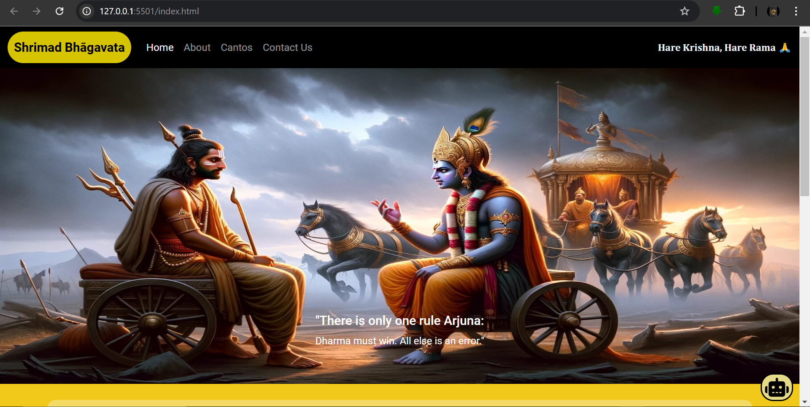

6

*School of Computer Engineering, KIIT, BBSR SHRIMAD BHAGAVAT*

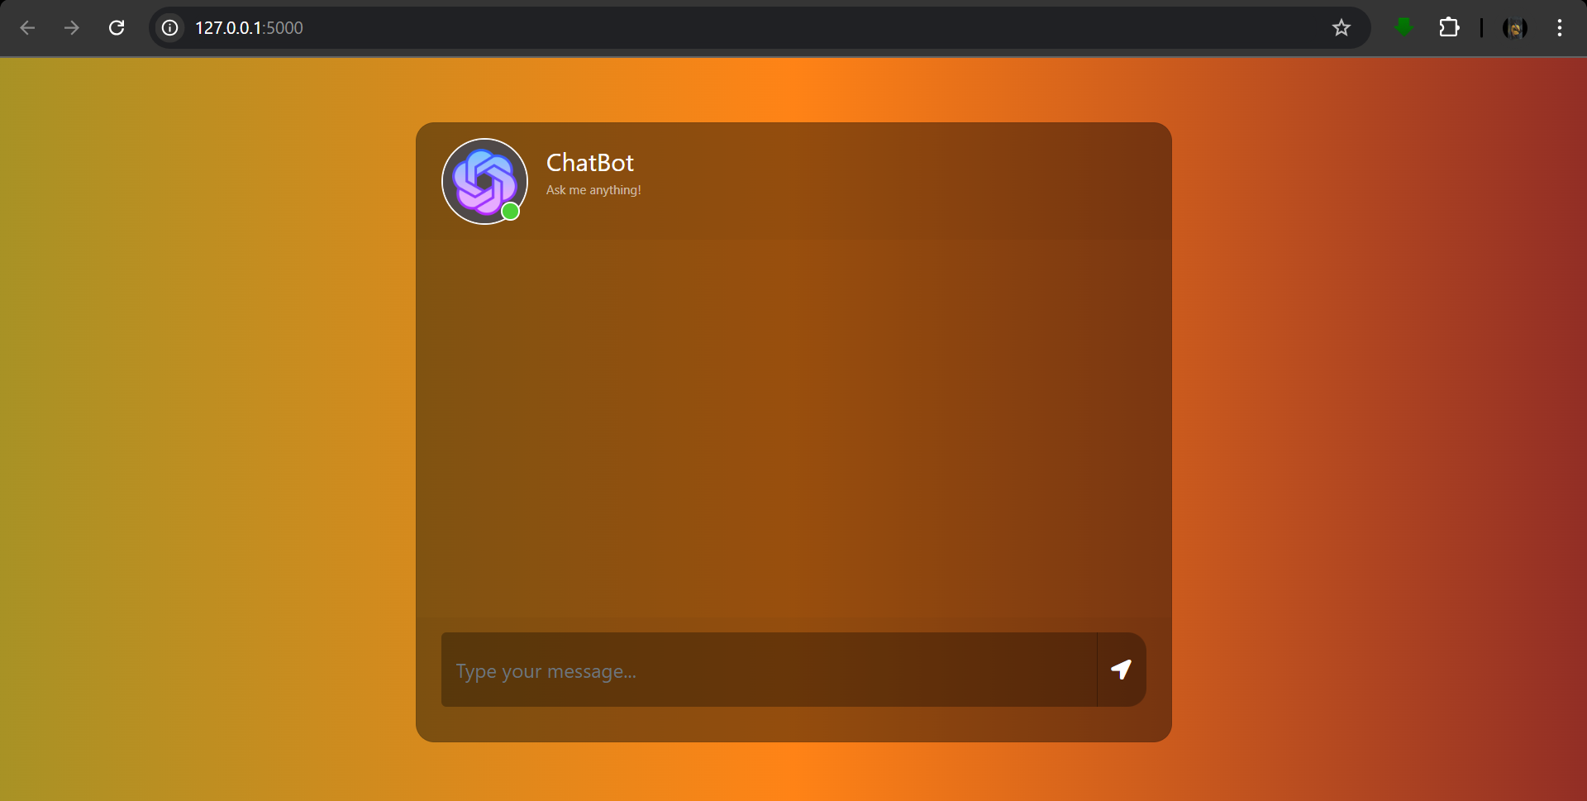

5.2 MOBILE OPTIMIZATION

In order to maximize the number of potential audience members this site uses media queries. This website is responsive on 3 different sizes of device:

* Smartphones >500px
* Tablets >960px
* Desktop / Laptops <960px

According to Kemp (2017), more than half of the world now use a smartphone, and more than half of the world’s web traffic now comes from smartphones, so it is of vital importance that a website can be viewed on mobile phones. However, not only are sites being accessed by more people on more devices, “customers

are returning to our sites at different times using different devices.” Therefore, having a responsive website is a key trend that modern websites must incorporate. To minimize loading times on smaller devices, the background video changes to a still image on devices under 960px. The call to action adapts to have a background color to keep the user’s attention as there is no ability to hover a mouse on anything other than desktops or laptops.

7

*School of Computer Engineering, KIIT, BBSR SHRIMAD BHAGAVAT*

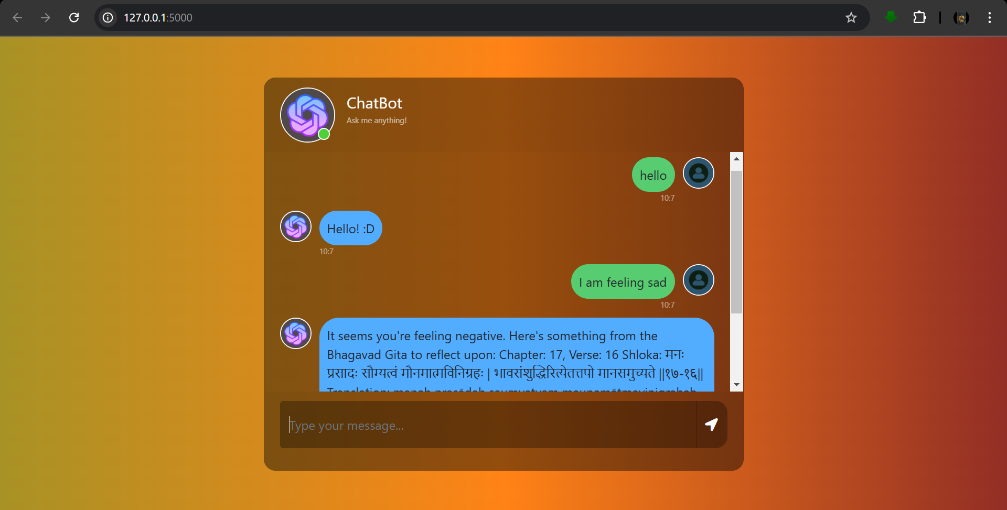

8

*School of Computer Engineering, KIIT, BBSR SHRIMAD BHAGAVAT*

5.3 COLORS

Color deeply influences the overall look and feel of a website and will be the first impression visitors will have about you, often decisive in making them want to stay or close their browser. Colors have different meanings in different cultures and countries, so understanding the meaning of color in your target market can be important. The color palette used for the website was kept really clean and simple.

The colors used for the website:

1. rgb (240, 201, 26) [DARK YELLOW]

2. rgb (214, 196, 0) [MEDIUM YELLOW] 3. rgb (255, 231, 122) [LIGHT YELLOW]

1. BLACK
2. #fff [WHITE shade]
3. #8ff2f9 [LIGHT BLUE]

7. rgb (133, 248, 71) [LIGHT GREEN]

8. #555 [DARK GREY]

Background colors used in the Chatbot:

**Gradient 1**: **-webkit-linear-gradient** (rgb(40, 59, 34), rgb(70, 61, 54), rgb(32, 32, 43)).

**Gradient 2**: **Linear-gradient** (rgb(168, 146, 37), rgb(255, 131, 22), rgb(146, 46, 37)).

**White** for clean sections.

**Transparent Overlay**: **rgba(0,0,0,0.3)**.

5.4 FONTS

To avoid looking messy, the best is to use a maximum of two or three fonts on a page. For the main font, the one used for the title, we wanted something modern but again not too distracting.

The fonts used here:

1. 'Poppins', sans-serif
2. Regular

All the fonts used are used within a list of fallback fonts because not every computer or every browser will have the same fonts available. In this case, if the first font in the list is not available, the browser will try to use the next font specified, and so on.

9

*School of Computer Engineering, KIIT, BBSR SHRIMAD BHAGAVAT*

## Chapter 6 Conclusion

The goal of this project is to make the teachings of the **Bhagavad Gita** more accessible to today’s generation, who may be unaware of the profound wisdom contained within our religious mythologies. By utilizing Machine Learning and sentiment analysis, the chatbot offers personalized shloka recommendations based on user emotions, providing guidance on overcoming challenges, self-doubt, and fear. The integration of these technologies helps users tap into their inner strength and connect with their true nature, just as the **Bhagavad Gita** encourages. Ultimately, this project aims to inspire courage, self-awareness, and conviction in the face of adversity, promoting a deeper understanding of our spiritual heritage.

10

*School of Computer Engineering, KIIT, BBSR SHRIMAD BHAGAVAT*

Chapter 7

***References***

[1 ]S. M. Metev and V. P. Veiko, Laser Assisted Microtechnology, 2nd ed., R. M. Osgood, Jr., Ed. Berlin, Germany: Springer-Verlag, 1998.

Breckling, Ed., The Analysis of Directional Time Series: Applications to Wind Speed and Direction, ser. Lecture Notes in Statistics. Berlin, Germany: Springer, 1989, vol. 61.

S. Zhang, C. Zhu, J. K. O. Sin, and P. K. T. Mok, “A novel ultrathin elevated channel low-temperature poly-Si TFT,” IEEE Electron Device Lett., vol. 20, pp. 569–571, Nov. 1999.

M. Wegmuller, J. P. von der Weid, P. Oberson, and N. Gisin, “High resolution fiber distributed measurements with coherent OFDR,” in Proc. ECOC’00, 2000, paper 11.3.4, p. 109.

R. E. Sorace, V. S. Reinhardt, and S. A. Vaughn, “High-speed digital-to-RF converter,” U.S. Patent 5 668 842, Sept. 16, 1997.

(2002) The IEEE website. [Online]. Available: <http://www.ieee.org/>

[7] M. Shell. (2002) IEEEtran homepage on CTAN. [Online]. Available: <http://www.ctan.org/tex-> archive/macros/latex/contrib/supported/IEEEtran/

11

# CONTRIBUTION

ANURAG PANDA (2105181):

1. Integration of frontend & backend.
2. Write the backend using python framework “Flask” for necessary API call & server management.
3. Push the project in the GitHub repository.
4. Deploy website in a free domain.

ANKIT HATI (21052897):

1. Integrate dataset in with the ML Model.
2. Create & train the ML model.
3. Integrate Sentimental Analysis for emotion detection.
4. Fix bugs in the model with every review session.

PRAJUKTA SAHOO (21051231):

1. Code the required APIs for the chatbot to fire the sentimental analysis.
2. Frontend integration with the APIs.
3. Research of appropriate dataset for proper training of the ML model.

SAUMYA (2129100):

1. Design the Chatbot layout.
2. Implement it through HTML and CSS.
3. Make the chatbot Responsive to all screen-types and devices.

# PLAGIARISM REPORT

